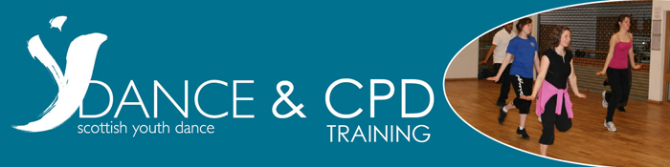

LET’S GET OLYMPIC – TUESDAY 24 JANUARY 2012
We’re running an Olympic themed CPD (for Primary Teachers) to give you the skills to inspire your pupils and explore some of the themes of this landmark event.

By the end of the day you’ll be able to lead the following sessions:
- Let’s explore sport through dance
- The Olympic Games bringing cultures together
- The Olympic Rings and the motto

You will also learn how to create:
- Warm ups
- Movement games
- Creative tasks linked to sport, culture & the Olympics
- A cool down

All of which you can take straight back to school and get your pupils moving!

COST: £60 per person (including VAT)
VENUE: Dance HQ, Glasgow
BOOK: email us or call 0141 552 7712

