Reliable/Unreliable Sources of Information

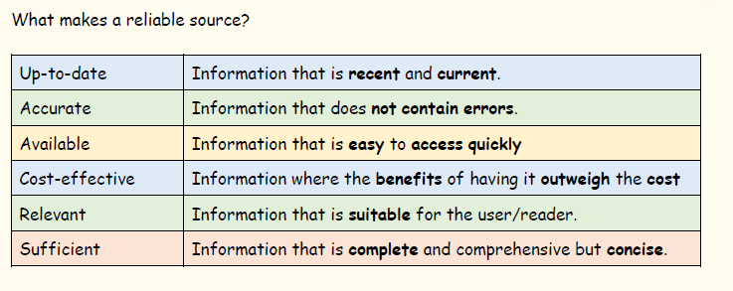

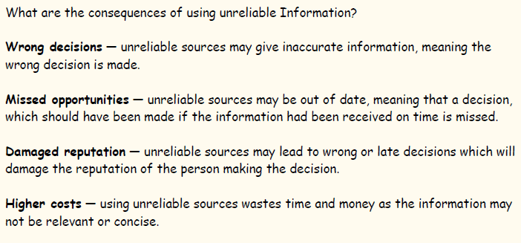

Task
Read the information provided above and then use the websites below to research activities that a tourist visiting Glasgow may wish to do. Create a top 5.
Write a short evaluation (no more than 2 paragraphs) on the reliability of the websites you used and rate them from most reliable to least reliable.
https://www.tripadvisor.co.uk/
https://www.visitscotland.com/
https://www.lonelyplanet.com/

