S2
Science
Microbiology and Biotechnology
Homework

Homework 1 – Microbes /15

- Name the 3 types of microorganism and put them in order of smallest to largest. (1)

- The table gives some information about disease causing bacteria. Use it to answer the questions that follow:
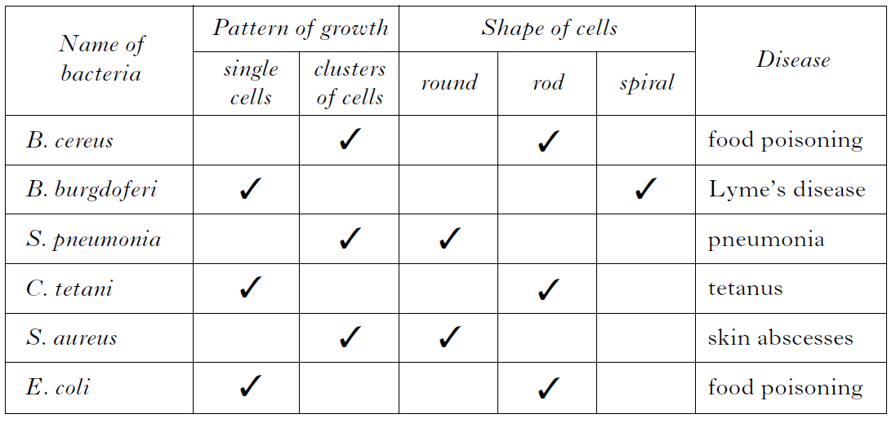

- Name the 2 diseases that are caused by bacteria which grow in clusters of cells and are round in shape. (2)
- Give 3 pieces of information about the bacteria B. burgdoferi. (3)
- A food sample caused food poisoning and was found to contain a bacterium that was rod shaped and grew as single cells.
Name the bacteria found. (1)

- Microbes that cause illness are known as pathogens.
- State one way which pathogens can spread and infect other people. (1)
- State one way we can reduce the spread of pathogens that are transmitted in the way you have described in part a). (1)
- Bacteria that cause illness are often treated using antibiotics. Put the information about antibiotics from the following passage into a table with appropriate headings.
(3)
Penicillin can be used to treat respiratory infections. Eye and skin infections can be treated with aminoglycides. Cephalosporins are used to treat urinary infections and acne is treated with tetracyclines.

- A microbiologist was counting how many microbes they had on their microscope slides. Their results are shown below.

Slide 1 = 36
Slide 2 = 42
Slide 3 = 12
Slide 4 = 30

- Calculate the average number of microbes found on all the slides. (1)
- Calculate the simple whole number ratio of microbes on slide 1 to slide 3. (1)
- 20% of the microbes found on slide 4 were bacteria. Calculate the number of bacteria present on slide 4. (1)

[END OF HOMEWORK 1]

Homework 2 – Controlling the Growth of Microbes /15

- Microbes reproduce by cell division when one microbe divides to produce 2 genetically identical microbes.
- What name is used to describe these genetically identical microbes. (1)
- One particular type of microbe has the ability to divide once every 30 minutes.
Calculate how many microbes would be present after 3 hours. (1)

- An experiment was carried out to investigate the effect of temperature on the growth of fungus.
Pieces of bread were placed in petri dishes without lids and left at different temperatures for several days.
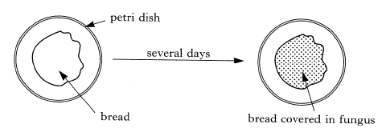
The results are shown below.
Number of days | Percentage of bread covered in fungus (%)
 | 0ºC | 20ºC | 40ºC
0 | 0 | 0 | 0
2 | 0 | 0 | 6
4 | 0 | 2 | 20
6 | 0 | 10 | 32
8 | 0 | 17 | 48
10 | 0 | 29 | 73
- What effect does increasing the temperature have on the growth of fungus. (1)
- What conclusion could be drawn about the growth of fungus when it is 0ºC. (1)
- Name 3 things (other than a warm temperature) that is important for the growth of microbes. (3)
- Microbes are often grown in large quantities. Name the large container used to grow microbes. (1)
- An investigation was carried out into the growth of bacteria. The number of bacteria were counted every 30 minutes for 2 hours and the results shown in the table:
Time (minutes) | Number of bacterial cells (per mm)
0 | 5
30 | 10
60 | 20
90 | 40
120 | 80

Draw a line graph of the investigation results shown in the table. (4)

- Antibiotics are commonly prescribed to treat various infections.
- Name the microbe which causes the infections antibiotics are used to treat. (1)
- The table shows the results of treating an infection in cows with various antibiotics.
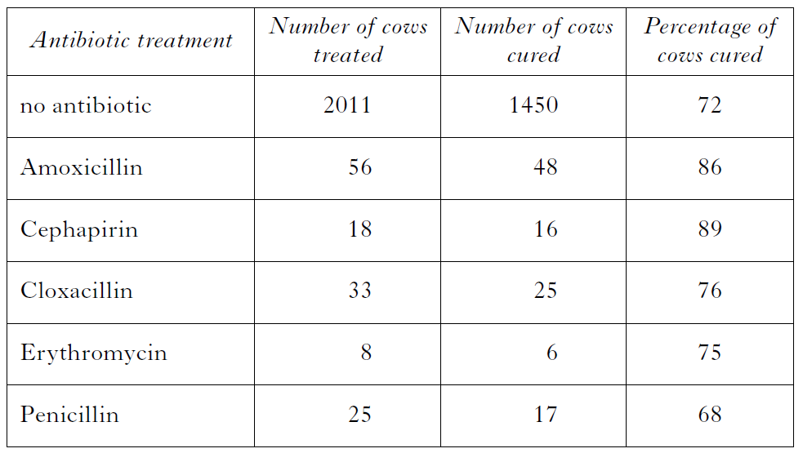
Name the antibiotic which would be considered the most effective. (1)
- The results for Erythromycin were not considered reliable. Describe how we could make the results more reliable. (1)

[END OF HOMEWORK 2]

Homework 3 – Biotechnology /15

- An investigation was carried out into the effects of various additives on dough. Yeast was mixed with flour and sugar solution to make the dough. The dough was then cut into four pieces and additives (X, Y or Z) were added to three of them. 20cm³ of each dough was put into measuring cylinders and the volumes of each were measured after 1 hour. The results are shown below:
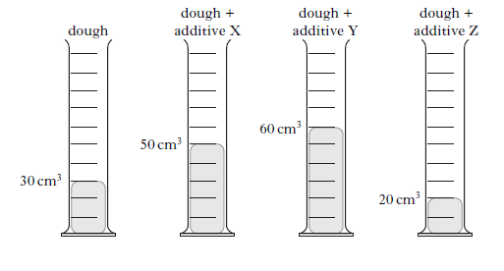
- Name the substance produced by yeast which makes the dough rise. (1)
- State the additive which caused the greatest increase in the volume of the dough. (1)
- State which additive may have prevented the yeast from fermenting. (1)
- To maintain the validity of the experiment certain variables must remain unchanged. Name 2 variables that must be kept the same when setting up the experiment. (2)
- The measuring cylinder that does not contain an additive is considered a control experiment. State the purpose of a control experiment. (1)

- A suspension of bacteria was spread evenly over the surface of a nutrient agar in a petri dish.
A multidisc containing 6 different antibiotics was placed on the agar. The diagram below shows the appearance of the petri dish after it had been incubated for 2 days.
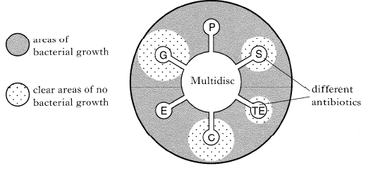
- State which antibiotics were effective against bacterial growth. (1)
- State which antibiotic was most effective at controlling growth of this bacteria and explain how you know this. (2)

- Read the passage below.
Adapted from Dairy Microbiology by the National Dairy Council.
Yoghurt is a fermented milk product that originated in the Middle East. In that part of the world, it tends to be more acidic and thinner than the yoghurt that has been developed in Britain.
Yoghurt can be made from whole milk, skimmed milk, evaporated milk or dried milk. Usually a mixture of these is blended together. The milk used for yoghurt manufacture must be free of all traces of antibiotics. This is to ensure successful fermentation. The blended milk is heated to between 85 and 95ºC before being cooled to 32 ºC. A starter culture containing bacteria is added and fermentation begins. After 12 hours, the lactic acid content reaches the desired level of between 0.8% and 1.8%.
The yoghurt is now stirred and then fruit may be added before the finished product is packaged and stored at 5 ºC. The slower bacterial growth at this temperature gives the yoghurt a shelf life of approximately 10 days. After this time bacterial growth, although restricted, will increase the level of acidity to such an extent as to change the flavour and make it unacceptable to most people.

Answer the questions based on the passage.
- Give 2 differences between Middle Eastern yoghurt and British yoghurt. (2)
- Other than whole milk, name 2 other types of milk used. (2)
- Name the acid produced during yoghurt production. (1)
- Explain how storage at 5 ºC increase the shelf life of the yoghurt. (1)

[END OF HOMEWORK 3]

