S2
Science
Biodiversity and
Interdependence
Homework
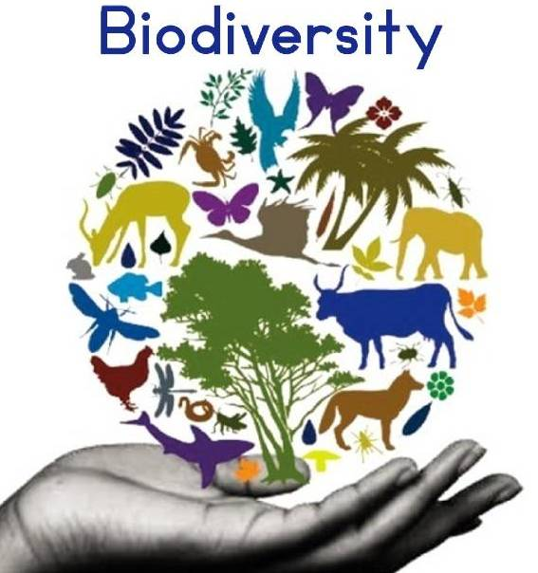

Homework 1 – Biodiversity & Sampling /10

- (a) Match the following words to their meanings:
Word | Meaning
Biome | 1. variety of living organisms in an ecosystem
Habitat | 2. regions of the planet distinguished by the climate, the animals and the plants
Biodiversity | 3. place where an organism lives
(3)
(b) Give 2 examples of human activities that are decreasing biodiversity (2)
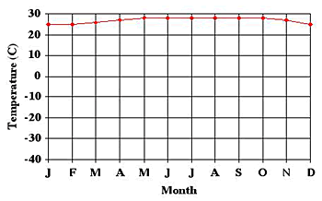
- Tropical rainforests are very biodiverse ecosystems. The graphs show information about rainforests (precipitation means rainfall)
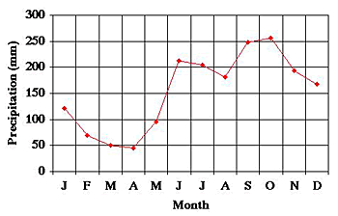
(a) What was the precipitation in March? (1)
(b) In which month was there 250mm of rainfall? (1)
(c) Using the temperature graph, why do think biodiversity of the rainforest is high all year round? (1)
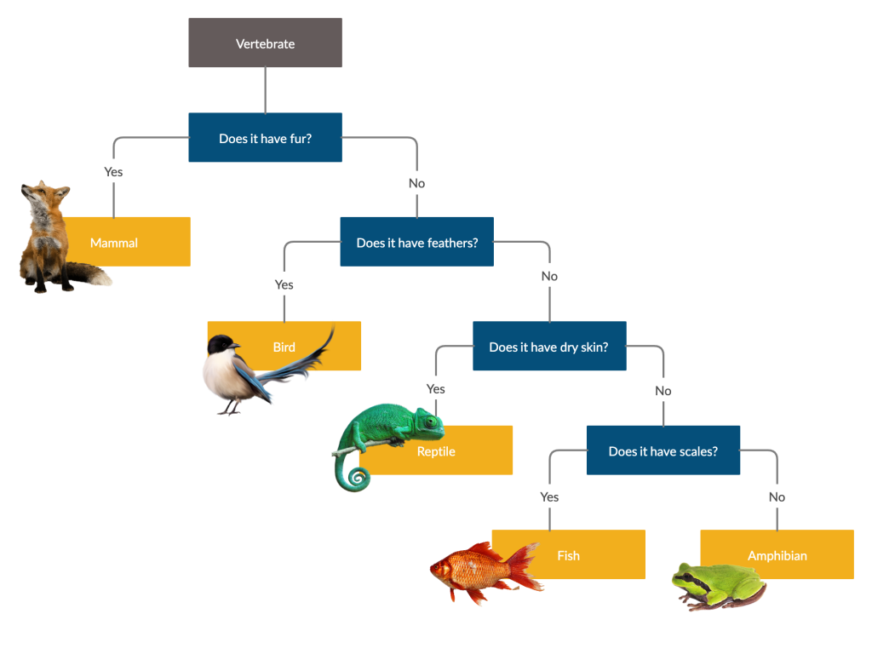
- (a) Identify a sampling technique that
could be used for small insects (1)
(b) Using the branched key,
identify what group a new
vertebrate species should
be classified in if it has no fur or feathers but does have dry skin? (1)

[END OF HOMEWORK 1]
Homework 2 – Photosynthesis /10

- Copy and complete the photosynthesis equation: (3)
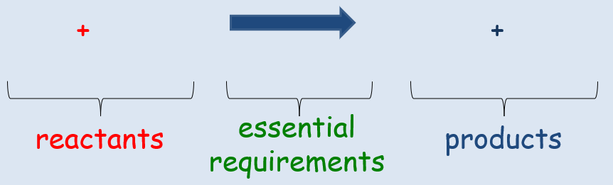
- Name the substance inside chloroplasts which traps sunlight (1)
- State the energy change that takes place in photosynthesis (1)
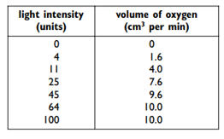
- The table shows the results from an experiment set up to investigate the effect of light intensity on the rate of photosynthesis by a water plant.
- How was the rate of photosynthesis measured? (1)
- Predict the volume of oxygen produced at a light intensity of 120 units (1)
- Read the passage below and answer the questions that follow:

At least 80% of the developed world’s food originated in the tropical rainforest. 3000 fruits are found in the world’s rainforests; of these, only 200 are now in use in the Western world. The natives of the rainforest use 2,000. There are many other fruits that have yet to be discovered that are threatened by extinction mainly by deforestation. Deforestation causes the loss of over 137 rainforest plant, animal and insect species per day. That is over 50,000 species per year!

- Calculate what % of rainforest fruits are used in the Western world (1)
- Calculate how many rainforest species could become extinct in 10 years (1)
- The passage discusses how humans make use of plants for food. Give two other uses we make of plants (1)
[END OF HOMEWORK 2]
Homework 3 – Food production /10

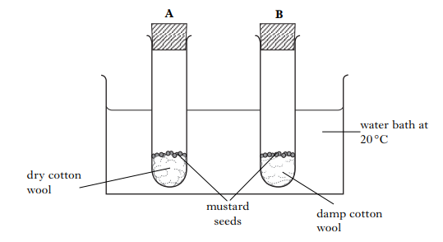
- An investigation into the conditions required for germination was carried out as shown:
- What variable is being investigated? (1)
- What are the other two conditions seeds need to germinate (2)
- Twelve of the fifteen seeds shown in B germinated. Calculate the % germination in that test tube (1)

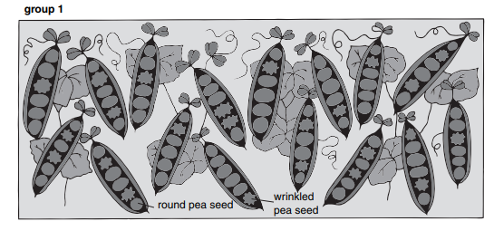
- A farmer planted two groups of peas to feed her family. The diagrams show the pea pods she grew and the seeds they contained.
- The farmer planted seeds – which part of seeds grows into the new plant? (1)
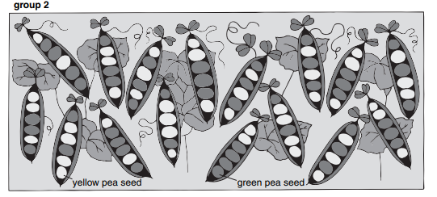
- Calculate the simplest whole number ratio of round to wrinkled seeds in group 1 (1)
- Calculate the simplest whole number ratio of yellow to green seeds in group 2 (1)
- The farmer noticed that some of the pea plants had poor roots. What nutrient were they short of? (1)
- What could she add to the soil to increase the quantity of crops she grows? (1)
- If the soil was short of magnesium, name a deficiency symptom of her plants (1)
[END OF HOMEWORK 3]

