Christmas Stall
Coltness High School Fundraising for Guide Dogs Scotland.
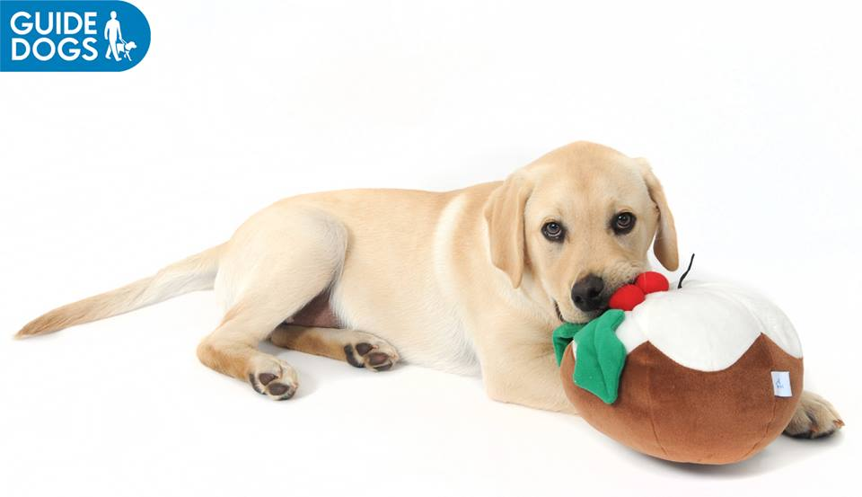
LIBRARY
Tuesday 10th December at Lunchtime
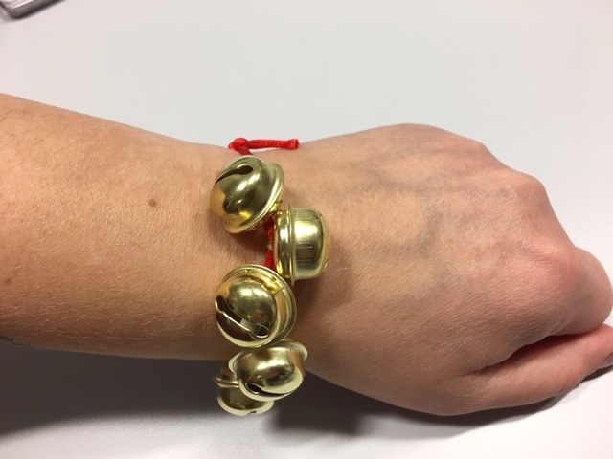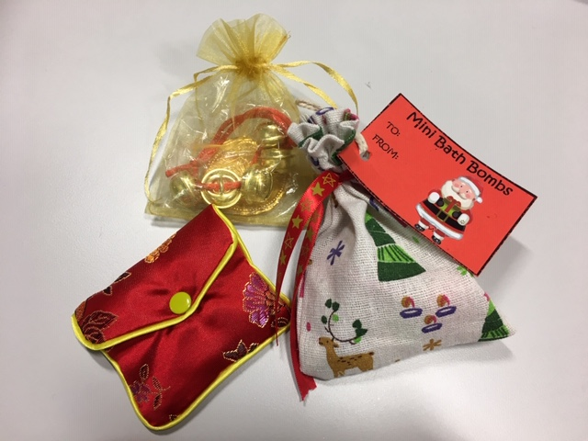
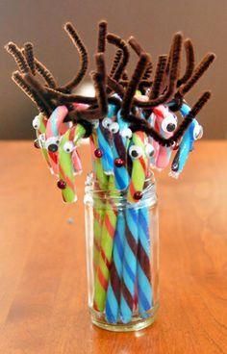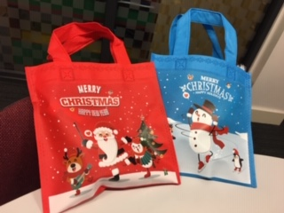
Jingle Bell Bracelets - Dog Treats – Cat Treats
Mini Bath Bombs - Sweets – Candy Canes
Other Items !!! - Prices from 50p

