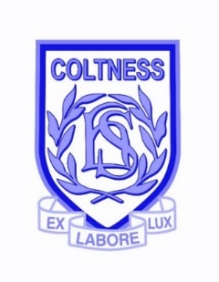
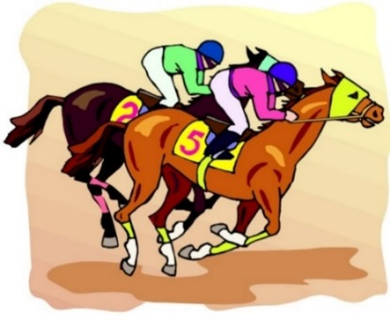
COLTNESS HIGH SCHOOL
PTA
RACE NIGHT

Friday 1st November 2019
Doors open for 7:30pm, first race 8:00pm
(11:30pm finish)
In Coltness High School Theatre
Ticket Cost £3.00
BYOB and SNACKS

