**Christmas Stall**

**Coltness High School Fundraising for Guide Dogs Scotland.**

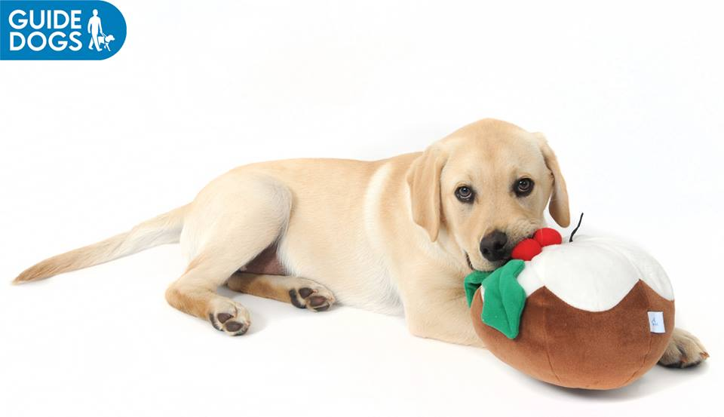

**LIBRARY**

**Thursday 14th December at Lunchtime**

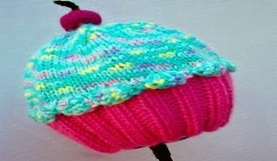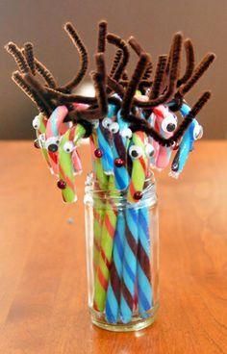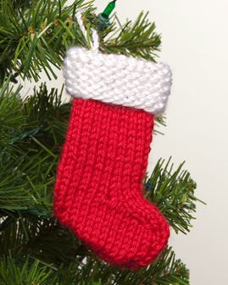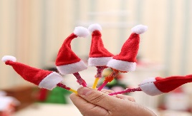

**Many other items including:-**

**Dog Treats – Cat Treats - Mini Bath Bombs - Sweets**

**Tea light Holders Gift Sets and other treats!!**

**Prices from 50p !!!**