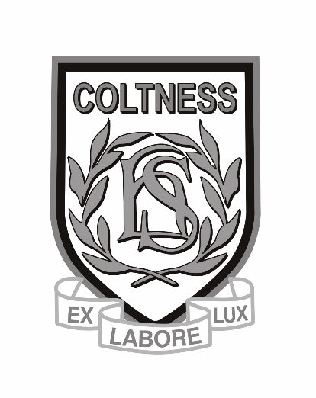**S4 PRELIM EXAM TIMETABLE**

**December 2015**

* **Exams begin on Thursday 10th December.**
* **S4 pupils must attend school as normal during the exams. There is NO study leave for pupils.**
* **Pupils will follow their normal timetable when they do not have exams.**
* **Pupils must attend exams promptly, with equipment etc and in full school uniform.**

**Please Note**

* **Please arrive at least 10 minutes before exam starts.**
* **SQA exam rules will be applied by invigilators – please listen carefully to all instructions.**

**January Exams**

**Please note that the following subjects will have exams in January (w/b 11th January) :**

**Mathematics, English, all subjects in BusICT**