
Cumbernauld Academy S5/6 Option Choice Form - Draft 2026-27

Name………………………………………... Class…..………….. Pupil Support Teacher……….……………………
 | Column A | Column B | Column C | Column D | Column E
Advanced Higher | On Request | On Request | On Request | On Request | On Request
Higher | English | Art & Design | Administration | Art & Design | Chemistry
Higher | English | Biology | Biology | Chemistry | German
Higher | English | Business Management | Design & Manufacture | Computing | Graphic Communication
Higher | English | Drama | French | Geography | History
 | Politics (S6) | Mathematics | History | Modern Studies | Mathematics
 | Politics (S6) | Music Technology | Mathematics -Applications | Physical Education | Modern Studies
 | Politics (S6) | Physical Education | Music | Spanish | Photography (S6)
 | Politics (S6) |  | Psychology (S6) | RMPS | Physics
 | S6 Skills Development | S6 Skills Development | S6 Skills Development | S6 Skills Development | S6 Skills Development
National 5 | English  Practical Cake Craft  (S6) | Business Management | `Administration | Art & Design | German
National 5 | English  Practical Cake Craft  (S6) | Drama | Design & Manufacture | Geography | Graphic Communication
National 5 | English  Practical Cake Craft  (S6) | Mathematics | History | Laboratory Science | History
National 5 | English  Practical Cake Craft  (S6) | Music Technology | Mathematics -Applications | Practical Woodwork | Mathematics
National 5 | English  Practical Cake Craft  (S6) |  | Practical Cookery | Spanish | Travel & Tourism
 |  |  |  | RMPS
National Progression Award/SfW courses  Level 4/5 & | Journalism NPA Level 5/6  PE) SFA Refereeing  NPA Level 6 & 7 | Drawing Skills (A & D)  NPA Level 5  Sports & Recreation  NPA Level 5 | Modern Languages for Life & Work NPA Level 4-6  Music Performing NPA  Level 5 | Early Ed and Childcare  Skills for Work Level 4/5  PE Sports Development  NPA Level 6 (S6) | Applied Science NPA Level 5  Criminology NPA Level 5  Retail & Customer Service  NPA Level 4/5

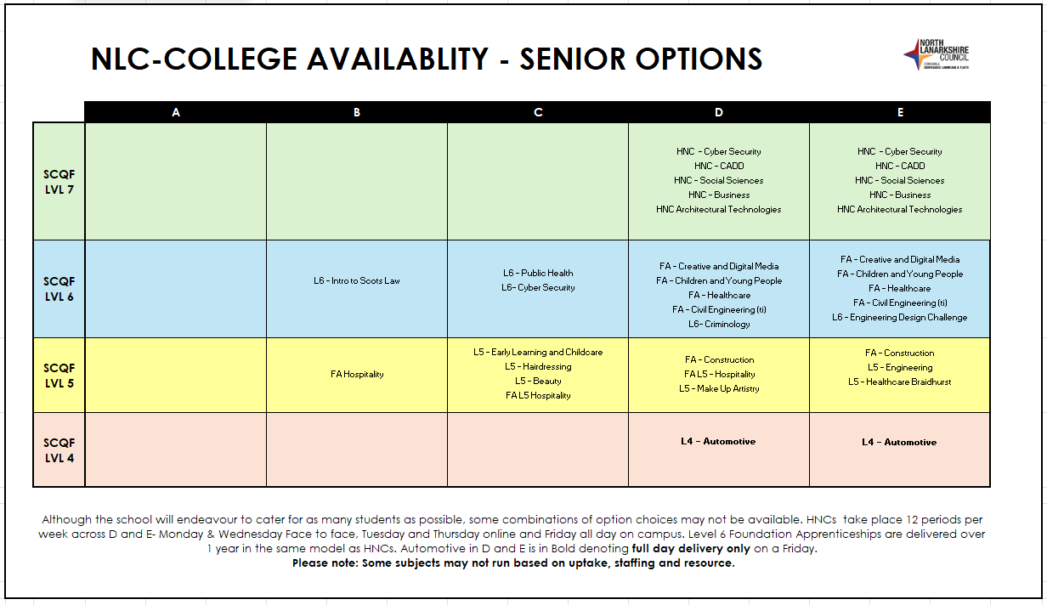

Pupils are required to complete the grid below detailing their 1st choice and also 2nd choice subjects for next session. 2nd choice will only be used should 1st choice subjects not have the uptake of pupils to run.

 | Choice(s) Column A | Choice(s) Column B | Choice(s) Column C | Choice(s) Column D | Choice(s) Column E
1st Choice
2nd Choice

Name………………………………………... Class…..………….. Pupil Support Teacher……….……………………

