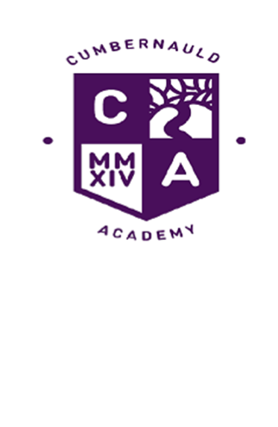

Dear Parent/Carer,

Generosity and Christmas
It is hard to believe, but we are now in our final week before the Christmas holiday. While this time of the year can be a great time for families to engage in quality experiences together, we all know that for some this can be a difficult and lonely time. The school has been able to support a number of families to be able to enjoy the forthcoming festive period. This has been down to the generosity of the parent council and the wider parent body who have supported them in raising the funds that have been used for this venture. The Parent Council has also subsidised the rewards trips this week for the hundreds of pupils attending. In addition, Mr and Mrs Brown, who live locally, have made a very generous donation to help make Christmas a little better for some families.

Uniform
We continue to work hard to ensure that all young people wear the school uniform through regular checks at house time. If your child is unable to get any items of uniform, then please contact their pupil support teacher and we will find a way to support them. We are able to give some practical support where it is needed. A full consultation on the school uniform will take place in the new year, involving young people, parents, and staff.

Reports and Learner Conversations
S1-3 reports are being issued via Parent Portal and will no longer, in normal circumstances, be issued via paper. A guide on how to do this can be accessed from the link below. Please remember that these tracker reports contain only progress levels and ratings. All learners will have experienced in depth learner conversations with their class teachers and the details of these conversations are contained within the pupil planners issued to all students at the start of the year. Please check and sign your child’s planner to ensure you are aware of the next steps your child needs to take to improve on their learning journey. Over the course of the remainder of this academic session, we will be reviewing learner conversations and reporting and we will be looking for input from parents on this.

Staffing changes
We recently appointed Peter Krausen to the post of Faculty Head of Numeracy and Maths. Peter is currently Faculty Head at Inveralmond Community High School and I look forward to him starting in Cumbernauld Academy in the new year. I would like to thank Chris Gibson for having done a brilliant job under very challenging circumstances and for continuing to lead the faculty until Peter arrives in person.
In addition, we are saying goodbye to one of our award winning science technicians. Joanne Watson, who along with Jim Cairney, our senior technician, won the award for excellence in secondary education from the Royal Society of Chemistry, has secured the senior technician’s post at St Ambrose High School. We will miss her very much but will welcome ~~~~~~ in January as her replacement.

Events on last week of term
Christmas Concert Monday 18th December
6th Year Christmas events Tuesday 19th December
Men’s mental health football Tuesday 19th December
Christmas Dance Wednesday 20th December
Reward Events Thursday 21st December
School closes Friday 22nd December 12.30pm
The vast majority of prelims for S4-6 students doing N5/H and AH have now taken place and hopefully everyone will have done well. Either way, the holidays are now a time for taking stock and for relaxing. We can all recharge the batteries ready for the sprint to the SQA exam finish line beginning in April.

