Dear Parent or Carer,

I would like, belatedly, to take this opportunity to highlight some of the events and work we are engaging in this year at Cumbernauld Academy. I plan also to make regular vlogs on Fridays to help keep you up to date with everything of interest in the school. Also, we have posted the curricular calendar onto the website as a helpful aid to planning for the year.

A major change for the school this year is around contact between the school and parents and carers. In recent years, due to Covid, there have been restrictions on those contacts and with some of these, such as parents’ meetings, being done virtually. This year, following consultation with the staff, young people, and the parent council, we have decided to make some changes.

All parents’ meetings will now take place on a face-face basis and are scheduled between 4pm and 6.30pm on the following dates

|  |  |
| --- | --- |
| S1 | Thursday 2nd November |
| S2 | Wednesday 21st February |
| S3 | Monday 5th February |
| S4 | Tuesday 21st January |
| S5/6 | Wednesday 15th November |

In addition we will now provide four tracking reports for S1-3 and three tracking reports for S4-6. (No tracking reports will be issued in the final term due to SQA exams). The tracking reports will provide an overview of the levels at which your child is working and of their general conduct and effort. These reports will also be supplemented with copies of the individual learner conversations that your child will undertake with each of their class teachers. Learner conversations are proving to be the most effective way for teachers to engage with young people around improving their learning. Please see the BGE (S1-3) template below.

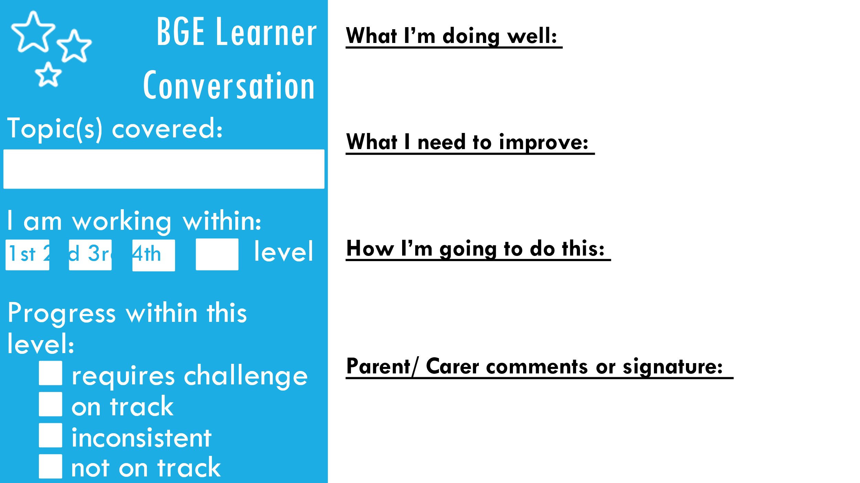

A similar template exists for the senior phase (S4-6). These will be completed in class and recorded in pupil diaries for you to see and engage with at home. When the tracking reports are issued, we will message you to remind you that the learner conversations have been completed and you should check your child’s diary and have a conversation with them. This should be done termly and we hope will provide a strong basis for improving learning and gaining qualifications.

We are also reintroducing reward events each term as you can see from the calendar on the website and plans for trips to London and Paris are also well underway. A programme of supported study is also underway already and the timetable is on the website. Combined with the extra-curricular activities on offer throughout the week, this provides a strong platform for all young people to get involved in the wider life of the school.

I would also like to take this opportunity to thank our very hardworking and generous parent council for their significant donation to allow the purchase of a number of blazers for the school in order that we can support every child to wear the full school uniform. During house time each day the teachers, pupil support teachers and SMT are engaging with everyone to ensure equity across the school in terms of uniform. I appreciate the challenges that some of you have persuading your child to wear the uniform that you have purchased and we will be doing everything we can to support you as parents in driving forward the highest standards. When young people have a sense of belonging to a school, they will thrive and that’s what, along with safety, the uniform is really all about. I am planning a series of curricular pathways workshops with parents of each year group over the next few months and hope to see as many of you as possible there. I will publish the dates for these as soon as I have them confirmed.

Thank you all for your continued support. If you have any concerns about anything then please contact your child’s pupil support teacher in the first instance.

Kind regards

Mark Cairns

Headteacher