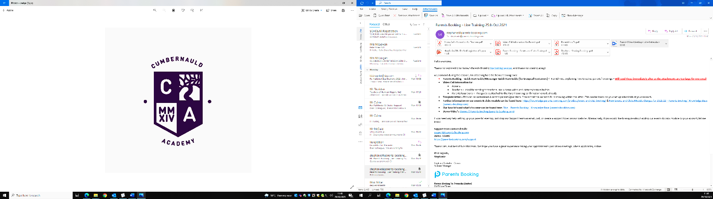
Cumbernauld Academy
Kildrum Ring Road, Cumbernauld, G67 2UF

Mr Mark Cairns Tel : 01236794864
Headteacher E-Mail : nlcairnsm@northlan.org.uk

30th January 2023
S4 Video Parent Meetings

Dear parent/guardian,

You are invited to make appointments for the school’s next parent-teacher meetings. These meetings will be booked online, and then held by video meeting rather than in-person at the school.

The parent-teacher meeting is on Thursday 9th February for S4

To make your appointments please login at: www.parents-booking.co.uk/cumbernauldacademy

To login you will need to enter:
- Your first name and surname
- Your child’s first name, surname and date of birth
The login details you enter must match those we have on record for you.

Appointments will be available to book from 8pm on Wednesday 1st February until 8pm on Wednesday 8th February.

After you have made your appointments you can choose to print or e-mail a confirmation.

On the day of your appointments, you need to re-login at the website address above. 10mins before your appointments are due to begin you will be able to join the video meeting room, where you can wait for your appointment(s).

Internet Browser Compatibility:
You must use one of the below device and internet browser combinations for the video meeting technology to work:
- Apple iPhone/iPad (iOS 11+): Safari
- Android phone/tablet: Chrome or Firefox
- Linux computer: Chrome or Firefox
- Microsoft Surface: Chrome or Firefox
- Mac computer: Safari, Chrome or Firefox
- Windows computer: Chrome, Firefox or Edge (Chromium)

Troubleshooting Tips
- If you cannot login please contact the school office.
- The email address field entered is only used to send your appointment confirmation. If you have problems logging in, it will not be because of the e-mail address you entered.

If you are unable to book at home, please contact the school office for help.

Kind regards,

Mr Cairns
Headteacher

