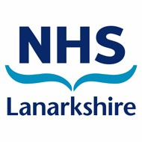

Kirklands HQ
Fallside Road
Bothwell
G71 8BB

Tuesday 1st June 2021

Dear parent/carer,

NHS Lanarkshire’s Test and Protect team have been carrying out contact tracing after an individual at Cumbernauld Academy tested positive for Covid-19. The individual is currently self-isolating at home.

Following the findings of a review, the risk to the wider school community is low and the school will remain open.

We are aware that there will be concern for children, their parents/carers and staff at this time, however, I want to continue to reassure you that North Lanarkshire Council has put in place all the recommended infection prevention and control measures and has a thorough cleaning programme for the school building.

It remains important to remember that mixing socially in the community without maintaining physical distancing measures helps the virus to spread widely. It is therefore important that people remain vigilant and follow physical distancing guidance, including during school drop off and pick up. Pupils and staff should wash their hands thoroughly and regularly using soap and water for 20 seconds.

Individuals who experience any Covid-19 symptoms such as a cough, fever or loss of taste or smell, even if they are mild, should stay off school or work and get tested. Information on how to access testing is available at: www.gov.uk/get-coronavirus-test

If you have any questions about coronavirus please visit www.nhsinform.scot in the first instance, or call the helpline on 0800 028 2816.

You can access FAQs about Covid-19 in schools here.

To respect and maintain patient confidentiality no further details will be released at this time.

Yours sincerely

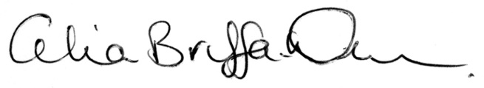

Celia Briffa-Watt FFPH
Consultant in Public Health
NHS Lanarkshire

