Orchard Nursery Class
NEWSLETTER
May 2018
CHILDREN’S LEARNING
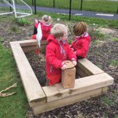
As usual we have been working very hard and learning across the curriculum indoors and outdoors. From the planning board in the foyer you will notice that our latest context is transport and holidays. This was an area the children had great interest in and are very keen to learn more. If you have any ideas for learning please feel free to add them to the planning board, your ideas matter! The better weather has provided more opportunities for imaginative play outdoors with children sailing round the world in pirate ships! The children have also been using a range of different resources to write and mark make. They even carried out an inspection of the Nursery cars!
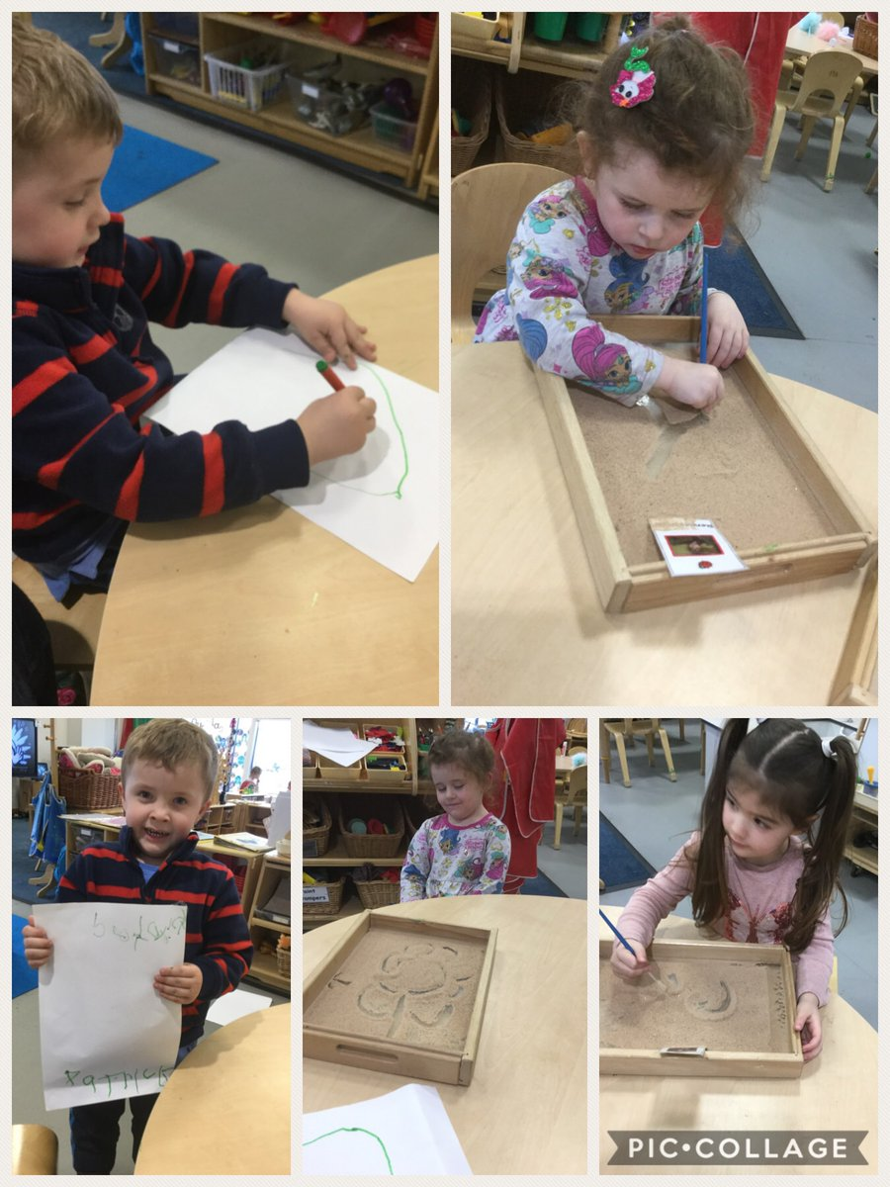
PARENTS NIGHT
As you will be aware this Thursday 17th May is Parents Night. You have the option to make an appointment with Louise or alternatively make an appointment after Nursery to see Jillian, Elaine or Fiona.
HMI
You are all probably aware that we had a visit from HMI a couple of weeks ago. The report is not yet published however HMI will, following consultation with the school and authority, publish an inspection report. The school will send this home to all. A document called Summarised Inspection Findings will also be published online at Education Scotland.
FOREST KINDERGARTEN
Our latest visit to the forest on the 2nd May was a big success, a huge thank you to all the parents and children who made it along. We are looking at ways of making the visits more accessible for everyone and we appreciate feedback that has been given. Please speak to any member of staff about difficulties you have around trips to the forest. There will be another couple of visits in the summer term, dates to follow.
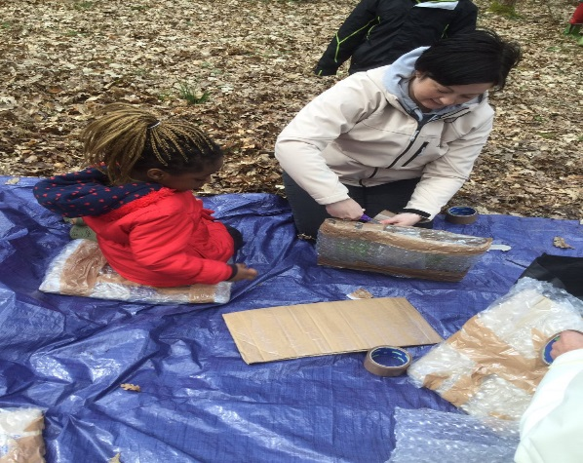
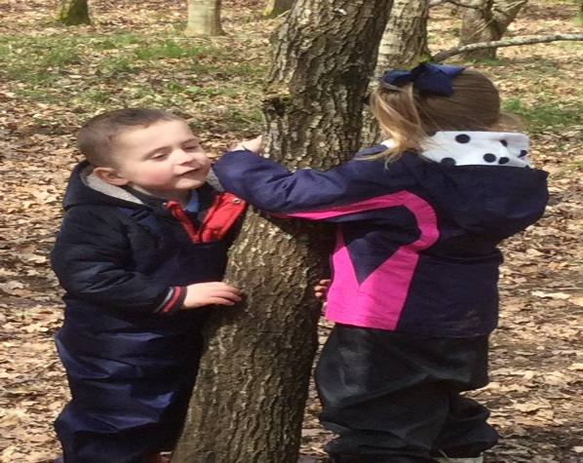

STORY SACK LENDING LIBRARY
This Friday, 18th May, we are starting our Story Sack lending library. Please come along and borrow one of our fantastic story sacks to share with your child at home. Morning parents are welcome at 10.45 am and afternoon parents at 3pm. We look forward to seeing you. If you would be interested in volunteering to help with the lending library please speak to Louise.

THREE READ
We are about to launch The Three Read approach in Nursery. This involves children in reading a book in a small group three times. Please see the information leaflet for further information.
SID AND SHANARRI
Another resource that we have been using in Nursery to support our Health and Wellbeing Programme is Sid and Shanarri, you may have heard your child talking about the characters. The packs are designed to facilitate discussion around wellbeing and more knowledge of GIRFEC and the wellbeing indicators (Safe, Healthy, Achieving, Nurtured, Active, Respectable, Responsible and Included). You and your child will also have the chance to take one of the Sid and Shanarri packs home to share.
GARDEN VOLUNTEERS
We are looking for some volunteers to help with our outdoor area, weeding and tidying up the different areas outside. Any time you could spare would be greatly appreciated. Please speak to a member of staff if you can help.
SUMMER TERM
There are a few events in the summer term that the Nursery children will be involved in. Our pre-school children are involved in a range of transition visits depending on which school they will be going to after the summer. The school Sports Day will be on Friday 15th June, details of times will follow. The Graduation Ceremony will be on Tuesday 26th June, again details of times will follow.
HOW TO FIND OUT WHAT’S HAPPENING IN OUR NURSERY CLASS
Please visit our nursery class blog as it will be regularly updated with information and photographs about our nursery learning activities. The blog can be accessed at
https://blogs.glowscotland.org.uk/nl/Orchard
Or by simply typing Orchard Primary and Nursery Class into your search engine.

ANY QUESTIONS OR ENQUIRIES
If you have any questions, concerns, worries or would like to give us any feedback please feel free to speak to any member of staff or alternatively contact our Head Teacher, Mrs Jill Woodward by email at
ht@orchard.n-lanark.sch.uk

DATES FOR YOUR DIARY
THURSDAY 17TH MAY – Parents Evening
FRIDAY 18th MAY – Story Sack Lending Library starts
FRIDAY 15th JUNE – Sports Day – all children attend Nursery in the morning
TUESDAY 22nd JUNE – Graduation Ceremony – all children attend in the afternoon
WEDNESDAY 27th JUNE – End of term service 9.30am
THURSDAY 28th JUNE – Nursery closes for summer holidays at 11.50am
THURSDAY 16TH AUGUST – Nursery re-opens at 8.40am

