Orchard Nursery Class
NEWSLETTER
February 2018
SNOW DAYS
Hope the children enjoyed the snow last week and I’m sure you’ll all agree it’s good to be back at Nursery!
CHILDREN’S LEARNING
This term the learning has mainly focussed on winter, shapes and writing. We have had a very interesting visit from Helen McPherson who lives on a farm and from the SSPCA and also a visit to Pets at Home. We have been learning about shapes in all areas of the Nursery, including Snack!! We have also been investigating lots of different ways and places to write.
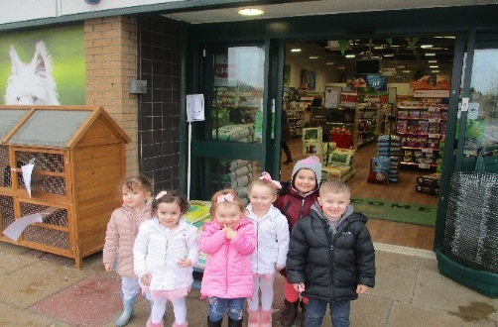
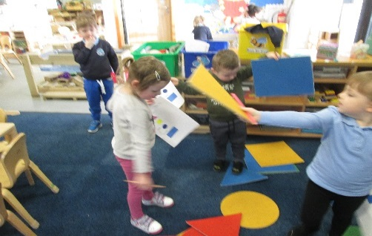

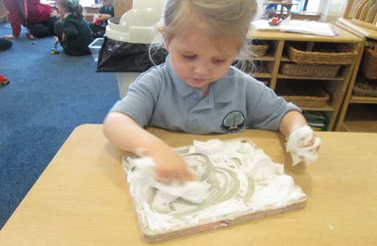
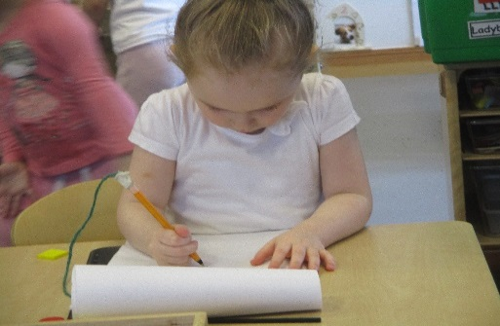

LEARNING JOURNALS
The Butterflies have been trialling the online Learning Journals and the feedback from staff and parents has been very positive. We have therefore decided to go ahead and switch from the folders to the online Learning Journals for the rest of the Nursery children. We are going to stagger the introduction, with the Ladybirds switching over after Easter and the Buzzy Bees in August. All new children next session will then use the online profiles. If we don’t have a current email address can you please hand it in to Nursery staff.
WORLD BOOK DAY
This Friday, 9th March we are celebrating World Book day. The aim of this year’s event is ‘Let’s share a story’. Nursery children can bring their favourite story to share with their friends. Staff will also plan a special story to share with the children and some fun follow up activities.
FOREST KINDERGARTEN
Our next visit down to the woods is on Tuesday 20th March. Again, we plan to meet at the Snack Bar at the bottom of Castlehill Road at 9.30am and 1.30pm. We would ask that on this day parents stay with their children in order to provide them with the best possible experience. If you have any questions please speak to any of the staff.
STAY AND PLAY SESSION
On Tuesday 27th March we are holding our next Stay and Play Session where parents/carers are invited along to join in with some Easter fun. Morning parents/carers will be welcome from 10.30am and afternoon from 1pm. We would really appreciate if just one adult attended for each child as we are quite tight for space. We look forward to seeing you.

HOW TO FIND OUT WHAT’S HAPPENING IN OUR NURSERY CLASS
Please visit our nursery class blog as it will be regularly updated with information and photographs about our nursery learning activities. The blog can be accessed at
https://blogs.glowscotland.org.uk/nl/Orchard
Or by simply typing Orchard Primary and Nursery Class into your search engine.

ANY QUESTIONS OR ENQUIRIES
If you have any questions, concerns, worries or would like to give us any feedback please feel free to speak to any member of staff or alternatively contact our Head Teacher, Mrs Jill Woodward by email at
ht@orchard.n-lanark.sch.uk

DATES FOR YOUR DIARY
FRIDAY 9th MARCH – World Book Day Celebration
TUESDAY 20th MARCH – Forest Kindergarten Walk
TUESDAY 27th MARCH – Stay and Play Easter Session
MONDAY 26th MARCH – Easter service 9.30am
THURSDAY 29th MARCH – School closes for Easter holidays
MONDAY 16th April – Nursery re-opens at 8.40am
