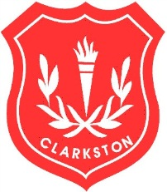
Our Christmas Fayre is nearly here (Saturday 3rd December) and Clarkston Primary PTA needs you to help us make it a success!
We would be grateful for any donations of the following:-

Any unopened bottles for the Bottle stall.
Children’s gifts (toddler age and above) for the Kids Lucky Dip.
Items for the Gift Tombola
(Can we please ask that all gifts are new or unused)

We would appreciate it if you can get donations to the school by Friday 25th November (to allow us to wrap them) although we can still take donations up to Friday 2nd December.

Donations of Home baking can be brought in on Friday 2nd December - no fresh cream please!

We also need an army of helpers on the day – if you can help please contact Karen Turner by leaving a message at the office, through our Facebook page or email Clarkstonprimarypta@outlook.com by Friday 25th November.

This year we are holding a competition to design our Christmas Fayre mascot. All entries must be submitted by Wednesday 23rd November. Each base will pick their entry and one winner will be announced on Monday 28th November when they will receive a prize and have their mascot used throughout the Fayre! Please see separate sheet for the entry form.

Thank you very much for all your support!

