The Bravest Rescue of the Great War
The Queen’s Pyjamas

St Athanasius Primary School
Friday 7th June 2019
7pm

You are cordially invited to an evening of remembrance to commemorate
The centenary of the end of the Great War, honouring the bravery and courage of all who sacrificed their lives for King and Country.

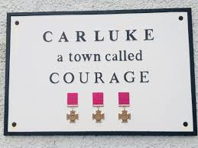

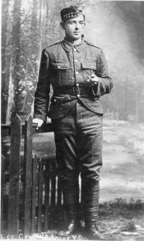

In Memory of Willie Angus VC

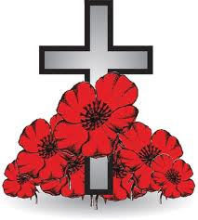
Lest we forget
November 2018 was the Year of Young People and the 100th anniversary of the end of the ‘Great War’. To commemorate this important part of our history. CLD youth work staff, teaching staff and young people from Coltness, Calderhead, St Aidan’s and Clyde Valley High Schools have established a production team who will produce a drama/documentary film based on the true story of William Angus, a Victoria Cross Medal recipient from Carluke.
On 12 June 1915 at Givenchy-lès-la-Bassée, France, Lance-Corporal Angus voluntarily left his trench to rescue a wounded officer, fellow Carluke man Lieutenant James Martin, who was lying within a few yards of the enemy's position and had been injured by a mine. To do this he had to travel through 64 metres in no-man's land under heavy bomb and rifle fire, and received about 40 wounds, some of them being very serious, including the loss of his left eye. His commanding officer said there had been no braver deed in the history of the British Army.
After the rescue he was taken to a military hospital in Boulogne-sur-Mer, where he learned of his award of the Victoria Cross. After 2 months in hospital he returned to London where he was given the Victoria Cross by King George V at Buckingham Palace on 30 August 1915. When the King commented on his 40 injuries, Willie Angus was said to have answered "Aye, Sir, but only 13 were serious."
The film will raise awareness of the impact of WW1 within schools, with young people and local communities.

