
Our Ref:
Your Ref:
Contact:
Tel: 01698 274920
www.northlanarkshire.gov.uk
Date

Head Teacher
John McGilp

Learning & Leisure Services
Coltness High School
Mossland Drive
Wishaw
ML2 8LY

Dear Parent/Carer
Easter School 2018
On the first week of the Easter Holidays beginning April the Monday 1st / Tuesday 2rd and Wednesday 3rd Coltness High School would like to invite your son/daughter to participate in this year’s Easter School. This opportunity will allow your son/daughter to gain the assistance they may need to achieve the grade they want from certain subject areas.
The Easter School will provide:
- Tuition from experienced subject teachers.
- Assistance for pupils in gaining a quality pass in their exam
- An awareness of the key concepts and topics required to pass their examination.
- Advice on study skills and exam techniques relating to key areas of the curriculum.

The Easter School also guarantees students:
- A place where they can work without interruption.
- Access to teachers who can help students with any difficulties which they may have.
- Access to technology, books and other resources.

Coltness High School hopes this year’s Easter school will help your son/daughter to build their confidence, raise their aspirations and boost morale across the board.

The School Day:
9:00am till 12:30pm
Pupils will be expected to attend all day and will also be expected to remain within the school grounds during interval.
School Uniform is not required
What will it cost?
Nothing!!
A snack will be provided during interval.
The Easter School will provide a unique opportunity for your son/daughter to prepare for National 4/5 and also the new higher examinations. Please complete both sides and return to Mr McDonald in the Technical Department no later than Friday 15th March.

Yours sincerely

J McGilp

Head Teacher
Please return both sides to Mr McDonald in the Technical Department by Friday 15th March
I would like my son/daughter________________________________ Class _______to attend the Easter School on
Monday 1st / Tuesday 2rd and Wednesday 3rd April 2018.
Parent/Carer Signature: …………………………….

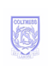

Coltness High School

Easter School 2018:- S4, S5, S6
Name……………………………………………………Class…………………………………
Please identify the subject/s your son/daughter would like to study using the table provided. This will allow us to gain information on which subjects and level they are sitting.

School Days: - Monday 1st / Tuesday 2rd and Wednesday 3rd:- 09:00am – 12:30Pm
Choose 4 subjects for each day, however you can study a subject more than once on the same day, As study classes will be ‘walk in’ apart from Maths due to numbers.

Mon 1st Subjects | Level | Tues 2nd Subjects | Level | Wed 3rd Subjects | Level

Please complete the table and return to Mr McDonald in the Technical Department no later than Friday 15th March.
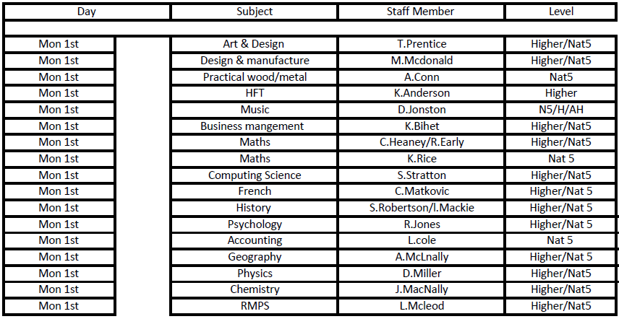
Choice of subject that are available and on which days.
