
COMMUNITIES & EDUCATION DIRECTORATE
Executive Director: Andrew McLelland
Cunninghame House, Irvine KA12 8EE
Tel: 01294 310000 www.north-ayrshire.gov.uk

Woodlands Primary School
Woodlands Avenue
Irvine
KA12 0PU
Tel: 01294 279532

Woodlands
Primary & EYC

December
2025
Newsletter

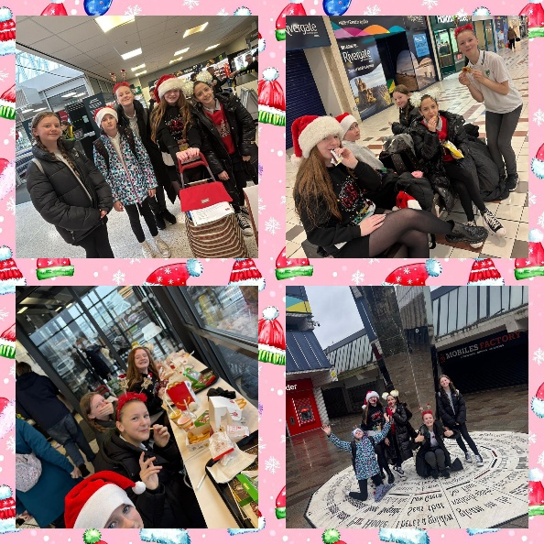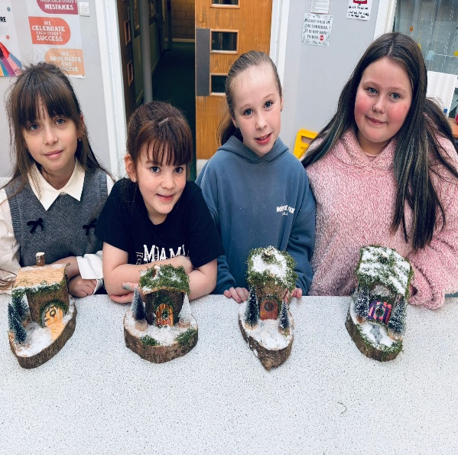

Dear Parents/Carers,
December Newsletter - A Festive Welcome!
As we step into the final month of the year, we want to take a moment to express our deepest gratitude for your continued support and involvement. Whether it’s attending events, helping with activities, or encouraging your children, your contributions have made a huge difference and are truly appreciated by all of us.
December is always a magical time in school, and we’re excited to share it with you. From Christmas parties to nativity performances, the month will be filled with opportunities to celebrate the season together. These moments not only bring joy but also create special memories for our children.
We are looking forward to welcoming everyone to our Christmas Market on Wednesday, 3rd December. Our Primary 7 pupils have done a fantastic job throughout their enterprise IDL, and their hard work will culminate in the products they’ve created and the sales skills they’ll showcase at the market.
Throughout Fridays in December, pupils are welcome to come to school wearing something festive. This could be a Christmas jumper, accessories, or any seasonal touch. It’s a fun way to celebrate the season together while keeping the focus on learning.
As the weather continues to cool, we kindly ask that all children come to school wearing a jacket each day. Outdoor play is an important part of our routine, and having a warm layer ensures that every child is comfortable and able to participate fully.
If your child does not have a jacket, we have many free jackets available. Please send a quick message to the office, and we will place one in your child’s bag discreetly.
We look forward to ending the term on a high note and sharing the holiday spirit with you all. Wishing everyone a very merry and bright December!
In Partnership,
Gordon Wilson

Head Teacher

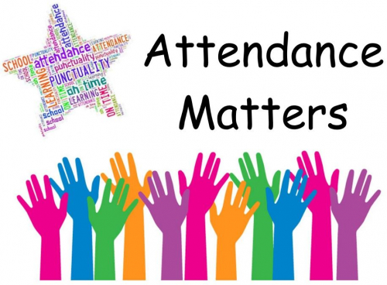
Attendance
Regular school attendance helps ensure:
- Children don’t miss important teaching, group work, or social/learning opportunities, building a strong foundation for future learning and success.
- Pupils stay connected to their peers and teachers, which supports social development, confidence, and wellbeing.
- Early detection and support for any difficulties — academic or personal, because staff can notice changes sooner when pupils are regularly present.
- Better long-term prospects: regular attendance helps build confidence and consistency, qualities valued by employers and in further education.


Nativity

Join us on Wednesday, 10th December, for the P1-P2 Nativity performance at 9:45am or 1:45pm! Our youngest pupils will have been working hard to bring the story of the Nativity to life with charming costumes, heartfelt songs, and lots of holiday spirit. It’s a wonderful way to celebrate the season together and support our little stars. We look forward to seeing you there. Letters with ticket information have already been sent to families last week.

Learning Conversations - November 2025

Our Learning Conversations Night was a great success, and we were delighted to see so many families attend. The support stalls were also very well received, offering valuable information and guidance for parents and carers. Thank you for taking the time to come along, we truly appreciate the chance to speak with you about your children, celebrate their achievements, and discuss their next steps in learning. Your involvement makes a real difference, and we value our partnership with you.

Committees


Our school committees are now up and running, and it has been amazing to hear how enthusiastic our pupils are about improving different aspects of school life. From the Playground Committee to the Sports Committee and many more, the ideas being shared are thoughtful, creative, and full of enthusiasm. Pupils are excited to take on leadership roles and make a real difference in their school community. It’s wonderful to see them working together, using their voices, and showing such pride in contributing to positive change across the school.

Skills Based Curriculum

We are excited to share updates on the implementation of our new skills-based curriculum at Woodlands. This approach focuses on developing the skills pupils need for learning, life, and work, ensuring they are prepared for future opportunities. It has been fantastic to work closely with our staff to design a curriculum that offers both depth and breadth across all areas of learning.
A huge amount of thought and effort has gone into setting up this curriculum, from planning learning experiences to ensuring progression and challenge at every stage. The dedication of our staff in working collaboratively to shape this approach has been truly inspiring. Their commitment is already making a real difference in the classroom as lessons are purposeful and focused on building meaningful skills alongside knowledge.
The impact on pupils’ learning experiences is already evident and this approach is not only supporting achievement now but will have a lasting impact on attainment and personal growth.
We are proud of the hard work that has gone into this curriculum and are excited to continue seeing our pupils flourish as a result.

Supporting and Challenging our Learners
You will have seen the letter sent out about improvements to our approach to supporting pupils through our staged intervention (STINT) system. If you were unable to attend Learning Conversations, the paperwork for your child will be sent to you this week for comment and signature. Sharing pupils’ targets with you is very important, as it allows us to work together to achieve the best outcomes for each individual learner.
Our PSAs and Target Support teachers have been busy with training and are now delivering timely interventions in literacy, numeracy, and Health & Wellbeing. This represents a significant shift in how we support pupils, and it has been wonderful to walk around the school and witness pupils’ “eureka” moments during these sessions. Pupils are growing in skill and confidence, and we are already seeing a positive impact on attainment.
We are thrilled with how these changes are helping each child make progress and look forward to continuing this exciting journey together.
Christmas at Woodlands

Christmas Market – December 3rd at 3:15 – 4:30pm
Our P7 pupils have been working very hard on their enterprise project, the Mistletoe Market. We warmly invite everyone to come along to the Woodlands Christmas Market on Wednesday 3rd December.
Christmas Lunch - Thursday 11th December
We will be having our annual Christmas Lunch on Thursday 11th December. Children are welcome to wear something festive or ‘Christmassy’ on the day.
Please remember that the menu is available on iPayImpact. If your child would like to join in for the Christmas lunch, you can pre-order their meal through iPayImpact.
Christmas Cinema Day – Tuesday 16th December
On Tuesday 16th December, the whole school will be going to the cinema in Ayr. This is a wonderful opportunity for all pupils to come together and enjoy a fun outing. You should have already received a letter with full details about the trip.
P3-P7 Christmas Concert - Wednesday 17th December
Our P3 to P7 pupils have been working hard to showcase their expressive arts skills and are excited to share their performances with you. Families are invited to come along and support them on Wednesday 17th December, with two options to attend: 9:45am or 1:30pm.
Performances will take place on:
- Wednesday 17th December at 9:45am
- Wednesday 17th December at 1:30pm
Each show is expected to last around 1 hour and 15 minutes. It promises to be a wonderful celebration of the pupils’ creativity, and we hope many families will come along to enjoy and cheer on their hard work.

Christmas Parties
Our Christmas parties will take place during the last two weeks of term. The schedule for each year group is as follows:
- All P1 children: Thursday 18th December (morning)
- All P2 children: Thursday 18th December (morning)
- All P3 children: Friday 12th December (afternoon)
- All P4 children: Tuesday 9th December (morning)
- All P5 children: Tuesday 9th December (afternoon)
- All P6 children: Thursday 18th December (afternoon)
- All P7 children: Thursday 11th December (afternoon)
Children may come to school dressed for their party, or if they prefer, they can be picked up at lunchtime by an adult to get changed for their afternoon party. If you wish to collect your child at lunchtime, please contact the school by phone or message to let us know.
Christmas Holidays

School closes on Friday 19th December at 2:30pm and reopens on Monday 5th January 2026 at 9am.

Diary Dates:
Please see diary dates from till the end of December. In the meantime please get in touch if there is anything you wish to discuss.

Thank you for your continued support.

In partnership,

Mr Wilson

Head Teacher

Woodlands Primary School and EYC
DIARY DATES

December 2025

Wednesday 3rd Dec | Woodlands Christmas Market 3:15pm.
Tuesday 9th Dec | P4 and P5 Christmas Parties
Wednesday 10th Dec | P1-P2 Nativity Performance
Thursday 11th Dec | P7 Christmas Party
Thursday 11th Dec | Christmas Lunch
Friday 12th Dec | P3 Christmas Party
Tuesday 16th Dec | Whole School Cinema Day (Ayr Cinema)
Wednesday 17th Dec | P3-P7 Christmas Concert
Thursday 18th Dec | P1, P2 and P6 Christmas Parties
Friday 19th Dec | Last day of school for the Christmas Break – 2:30pm finish
Monday 5th Jan | Pupils and Staff return to school

