**Communities and Education Directorate**

**Winton Primary School and EYC**

**Improvement Plan 2021-2022**





**Vision, Values and Aims**

*Our Vision*

At Winton Primary and Early Years Class, our vision is to work together to give our children the tools they need to successfully meet the challenges of the future and to contribute effectively to society.

*Our Values*

Respect for ourselves and others

Aspiration to be the best we can be

Equity of opportunity for all

Confidence in our ability

Excellence in all that we achieve

*Our Aims*

We endeavour:

* to create a nurturing, learning community where children feel safe and confident
* to create an environment where everyone is respected and understands their responsibilities
* to create opportunities for all learners to develop skills and qualities for life
* to create ambitious individuals who have the confidence to achieve in an ever changing world

**The North Ayrshire Annual Improvement Plan**

The North Ayrshire Education annual improvement plan sets out our priorities for the year ahead in pursuit of the joint aims of achieving excellence and equity for our learners. It takes account of the feedback from consultation with our stakeholders across the Council and community and ensures the delivery of the locally agreed priorities of the Council Plan and the nationally agreed priorities of the National Improvement Framework. In the delivery of this plan, we will work in close partnership across the Council and communities of North Ayrshire and as part of the South West Educational Improvement Collaborative (SWEIC).

The COVID-19 pandemic has presented us with a fresh set of challenges and this plan reflects this new evolving context. Therefore, this is a plan like no other previously devised. However, as well as the context, it draws on the rigorous self-evaluation undertaken in establishments and across the service of the progress towards the previous year’s plan. The process of arriving at the service level priorities and strategic actions included engagement of Head Teachers and the service leadership team in evaluation and planning sessions. At school level, this exercise was repeated with pupils, staff, parents/carers and key partners.

**Council Priorities:**

The Council strategic priorities for 2019-24 are detailed below:

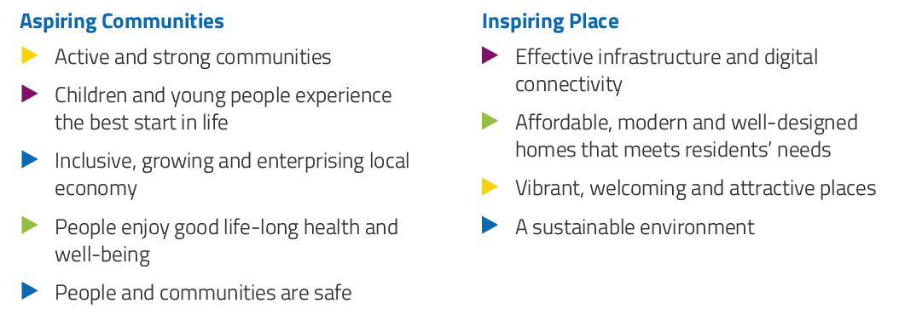

**National Improvement Framework:**

The National Improvement Framework for Education is designed to help us deliver the twin aims of excellence and equity; galvanising efforts and aligning our collective improvement activities across all partners in the education system to address our key priorities. These priorities remain as:

* Improvement in attainment, particularly in literacy and numeracy
* Closing the attainment gap between the most and least disadvantaged children
* Improvement in children and young people’s health and wellbeing
* Improvement in employability skills and sustained, positive school-leaver destinations for all young people

Alignment to Local and National Plans

This plan is aligned to local and national plans as follows:

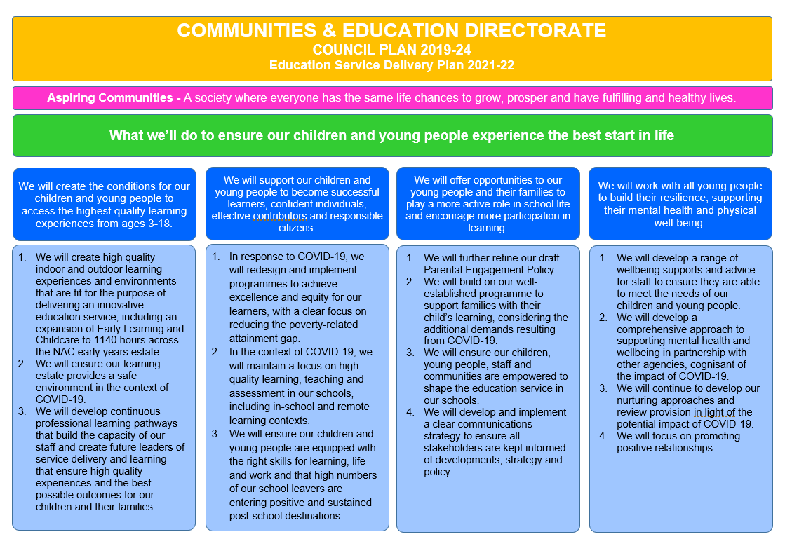

**Strategic Plan 2021-22: Winton Primary School and EYC**

|  |  |  |  |  |
| --- | --- | --- | --- | --- |
| **School Priorities** | *Create a safe environment for staff, pupils and their families in response to Covid-19 regulations and restrictions.* | *Ensure the positive HWB of our pupils, develop our nurturing approaches and promote positive relationships. Pupil Voice will be promoted throughout the life of the school, reflecting their positive wellbeing and confidence.* | *Maintain focus on high quality learning, teaching and assessment, with a clear focus on reducing the poverty-related attainment gap.* | *Ensure children are equipped with the right skills for learning, life and work in order to prepare them for the challenges of the future.* |
| **High Level Objectives** | We will ensure staff feel safe and secure about a post lockdown return to school.  We will ensure time and space is provided to actively promote staff health and wellbeing.  To further develop targeted approaches that support children and staff mental health and wellbeing through the application of Nurture as a whole establishment approach (as well as targeted) promoting reconnection. | We will review our in-house HWB programme pathways and make appropriate adjustments to better reflect NA strategy /programme of study and the current context.  We will establish a Nurture Base within the school to support inclusion  Re-establish the process that allow pupil voice to be heard in school, e.g. pupil focus groups, committees  Re-establish RRS Action Plan for Silver and maintain rights focus across the school.  Use HWB teacher to target individual children who require support to achieve positive HWB, to raise their self-esteem and confidence in learning. | Teachers will be supported to be reflective in the practice of teaching and assessing writing in order to impact positively in raising attainment (PM writing and PLA intervention)  Implement reading benchmarking across the school and use this to inform teacher’s assessment processes.  Develop the outdoor learning environment and experiences for the Early Years children.  Review the provision of phonological awareness and mark-making within the EYC in order to raise attainment. | Re-introduce the cluster technology planners through piloting the use of these in P4 and P7.  Re-establish links with local businesses, partnerships and STEM ambassadors in order to educate children about the world of work. |

**Strategic Plan 2021-22: Winton Primary School and EYC**

Here is an overview of how we intend to use our **Pupil Equity Funding** to support improvement:

**Detailed Action Plan 2021-22: Winton Primary School and EYC**

|  |  |  |  |  |  |  |  |
| --- | --- | --- | --- | --- | --- | --- | --- |
| **Establishment Strategic Priority:** | | Create a safe and supportive environment for staff, pupils and their families in response to Covid-19 regulations and restrictions | | | | | **Linked to Directorate Priority: 1** |
| **High Level Objectives** | **HGIOS 4**  **HGIOELC**  **NIF** | **Supported through PEF?**  **Y/N** | **How will we achieve this?** | **Timescale / Assigned to:** | **Pupil Outcomes**  *What will change for our learners?* | **Measurement**  *How will we measure impact?* | |
| We will ensure staff feel safe and secure in school  We will ensure time and space is provided to actively promote staff health and wellbeing.  To further develop targeted approaches that support children and staff’s mental health and wellbeing through the application of nurture as a Whole Establishment approach promoting reconnection.  To continue to promote ‘community’ across the Winton learning community and to support parents to feel included and supported. | QI 2.1-  2.4  QI 2.7  QI 3.1  NIF 1  QI 2.1-  2.4  QI 2.7  QI 3.1  NIF 1  QI 1.4  2.1  3.1  NIF 1/2  NIF 1 + 3  QI 2.5  3.1 | N  N | Develop, build and share school COVID plans, arrangements and expectations with staff and pupils in line with Scot Govt. guidance and direction from the local authority.    Maintain good public health behaviours in line with recovery planning and Scot Govt’s “FACTS” to reduce the incidence of the virus.  Use corporate signage advice and public health messages to regularly revise procedures with all members of the community.  Collegiate/INSET calendar will show staff wellbeing activities are undertaken and that Covid plans and procedures are shared and discussed.  Ensure there are clear channels of communication so that all staff are fully informed of policies, procedures and arrangements during, and post Covid 19 phasing.  Staff will be encouraged to look at the NAC Nurturing North Ayrshire’s Recovery CLPL programme modules as appropriate.  Identify additional evidence based resources/programmes/ activities to use to promote staff wellbeing in a nurturing environment.  Staff collegiate time to reinforce our staff community and share concerns  Staff encouraged to undertake refresher in North Ayrshire Council CLPL in Nurturing North Ayrshire’s Recovery Modules 1, 3, 7  Staff to undertake modules 2, 4, 5, 6 of Nurturing North Ayrshire’s recovery as required and in response to emerging staff and pupil needs  Use of Compassionate and Connected classroom resource  Continue to deliver the Winton online whole school assembly to provide our whole learning community with reconnection as the focus.  Re-establish our 3 school rules and our ‘Values’ through exemplification and celebration at assembly  Upload special assemblies to the whole school GLOW group to enable families to share in the celebration.  Pupils will contribute to the ideas/planning of assemblies. | *Ongoing*  *HT* | *Staff will feel safer and confident in their return to school when following and adhering to policy and guidance. Children in turn feel safe and secure and are able to learn.*  *Policies and procedures issued to staff are discussed and agreed at virtual collegiate meetings. Minutes show clear and consistent messages are being provided.*  *Staff will feel psychologically safer and confident in their return to school when focussing on:*   * *Impact of COVID 19 on Mental Health and Wellbeing* * *Recognising the importance of our own mental health* * *Setting up safe spaces/practices*   *Staff will feel confident about spotting the signs of changed behaviours associated with the COVID crisis in pupils and colleagues and signposting them to help.*  *Positive relationships feature highly in our response to pupils*  *Learning and Teaching promotes resilience and safeguarding of pupils*  *Pupils feel safe*  *There is mutual respect based on shared values and expectations*  *There is improvement in CYP’s health and wellbeing*  *This CLPL will support staff to:*   * *Establish readiness for learning* * *Manage stress and promote resilience* * *Recognise and celebrate success* * *Be attuned and understand behaviours affected by trauma* * *Use emotion coaching and de -escalation techniques*   *All members of the learning community will feel valued and included.*  *Their opinions will be heard and pupil voice celebrated.*  *Parents will be able to access our community from home and share in the celebration with their children.* | *Regular discussions held to review procedures*  *Observations on adherence to COVID arrangements*  *Minutes of collegiate meetings show that time is set aside for discussion of policies and procedures to alleviate any staff concerns*  *Email correspondence*  *Collegiate/INSET programme shows that a range of staff wellbeing activities and opportunities are being provided.*  *Minutes and notes from staff meetings highlight additional actions taken in response to staff needs*  *Analysis of staff/pupil/parent needs through discussion/questionnaires/ASN planning ensure supports are responsive to and supportive of our community’s needs.*  *Pupil Focus Group minutes will reveal the extent to which we are supporting the HWB of our pupils.*    *Evaluative statement drawn from professional feedback sessions built into the programme of CLPL to establish the staff capacity to help pupils and families through this continued testing time.*  *Feedback from focus groups: pupils, staff and parents will influence future events.* | |

|  |  |  |  |  |  |  |  |
| --- | --- | --- | --- | --- | --- | --- | --- |
| **Establishment Strategic Priority:** | | **\*** Ensure the positive HWB of our pupils, develop our nurturing approaches and promote positive relationships. Pupil Voice will be promoted throughout the life of the school, reflecting their positive wellbeing and confidence. | | | | | **Linked to Directorate Priority: 3 + 4** |
| **High Level Objectives** | **HGIOS 4**  **HGIOELC**  **NIF** | **Supported through PEF?**  **Y/N** | **How will we achieve this?** | **Timescale / Assigned to:** | **Pupil Outcomes**  *What will change for our learners?* | **Measurement**  *How will we measure impact?* | |
| We will review our in-house HWB programme pathways and make appropriate adjustments to better reflect NA HWB strategy and the current context.  We will establish a nurture base within the school to support inclusion  Re-establish the processes that allow pupil voice to be heard in school, e.g. pupil focus groups, committees  Re-establish RRS Action Plan for Silver and maintain rights focus across the school.  Use Covid Recovery HWB teacher to target individual children who require support to achieve positive HWB, to raise their self-esteem and confidence in learning. | NIF 5  QI 2.1-  2.4  3.1  NIF 5  QI 2.4  2.6  3.1  3.2  NIF 5  QI 1.2  1.3  3.1  NIF 1 + 5  QI 2.1  2.2  3.1  NIF 4 + 6  QI 3.1  3.2  2.4 | N  Y  Y | Staff will work collegiately as a whole school and in stage groups to create specific pathways and align our HWB programme to the NA strategy and current context   1. *Audit existing planners and how they are used* 2. *Assign elements of the NA HWB strategy to the various stages (3 collegiate nights)* 3. *Audit resources and required to implement the programme – purchase and arrange as appropriate* 4. *Feedback on planning – quality assure at this stage* 5. *Implement across the school* 6. *Whole school review of use of plans and evaluate in order to move forward*   Presentation to staff about the Nurture Class  Audit resources and gap-fill  Identify children  Seek parental permission and complete paperwork  Regular meetings with Nurture staff  Review planning  Pupil focus groups planned in annual calendar, addressing various topics  -Writing  -Reading  -HWB  -Numeracy and Maths  -DYW  An assembly setting the scene for Pupil Focus groups and how to take part effectively  Audit Pupil Voice in school  Communicate with parents to let them know  Collate responses, evaluate and share with pupils, staff and parents and make necessary changes  Create display ‘You said… We did’ so pupils can see their contributions are valued – children to lead the display  Audit current RRS practices  Audit staff knowledge and perceptions  Collegiate for staff  Identify a lead member of staff  Assembly for whole school  Form RRS Committee  Adapt Silver Action Plan  Implement appropriately and embed rights into the curriculum so that it underpins everything we do  Identify children for interventions across P1-7 based on SHANARRI assessments  Assess need  Identify targets  HWB teacher working in collaboration with CTs to support children to meet set targets | Jan-Jun 2022  CTs – working parties  Sept 2021 Nurture Teacher + Pract., HT;  Ongoing  Oct Assembly, thereafter monthly grps  HT  DHT  DHT | *Pupils will report that they are happy, secure and confident in their own HWB.*  *Staff will feel more confident in delivering the HWB curriculum and therefore learners will benefit from this in their achievement in HWB*  *Children will be more able to return to P1 classroom, ready to learn and achieve.*  *Pupils will feel engaged, included and valued and in turn, will be able to influence planning in the wider school context and thus their learning. They will be part of a collaborative process where they will feel empowered to make decisions.*  *Children will know and understand their rights and know how to keep themselves safe and make their voices heard.*  *Positive staff and pupil relationships.*  *Children will be better able to achieve their academic targets in class and learn if their HWB is positive.* | *Pupil focus group results*  *Staff pre and post questionnaires will show that they are more confident in delivering the Health and Wellbeing curriculum.*  *Annual overview*  *Curriculum pathway*  *Weekly plans*  *Lesson observations*  *Boxall profiles*  *On-going observations*  *Parental questionnaires*  *Teacher meeting minutes*  *Nurture and P1 Planning*  *Minutes of meetings*  *Action Plans*  *You said... We did display*  *Audit of current practices*  *Minutes of collegiate meeting(s)*  *Communication with parents*  *Committee minutes*  *Action Plan and evaluations of this*  *Curriculum plans*  *Class Charters*  *SHANARRI Wellbeing Assessments*  *(pre/mid/ post)*  *Pupil views/comments collected*  *HWB teacher plans and evaluations of sessions*  *Attainment figures*  *PASS Surveys*  *Boxall Profiles as appropriate*  *Staged Intervention Plans* | |

|  |  |  |  |  |  |  |  |
| --- | --- | --- | --- | --- | --- | --- | --- |
| **Establishment Strategic Priority:** | | Maintain focus on high quality learning, teaching and assessment, with a clear focus on reducing the poverty-related attainment gap | | | | | **Linked to Directorate Priority: 2** |
| **High Level Objectives** | **HGIOS 4**  **HGIOELC**  **NIF** | **Supported through PEF?**  **Y/N** | **How will we achieve this?** | **Timescale / Assigned to:** | **Pupil Outcomes**  *What will change for our learners?* | **Measurement**  *How will we measure impact?* | |
| Teachers will be supported to be reflective in the practice of teaching and assessing writing in order to impact positively in raising attainment (PM writing and PLA intervention)  Implement reading benchmarking across the school and use this to inform teacher’s planning for learning and their assessment processes.  Develop the outdoor learning environment and experiences for the Early Years children.  Review the provision of phonological awareness and mark-making within the EYC in order to raise attainment. | NIF 1 + 4  QI 2.2  2.3  1.1  1.3  3.2  NIF 4 + 6  QI 2.3  3.2  NIF 5  NIF 4 + 5 | Y  Y  N  N | Audit current writing practice and planning – what does a lesson look like and which resources are used; which genres taught?  Pupil feedback sought re: writing lessons  Intervention Class (PLA) feedback at Collegiate meetings – other CTs pilot methodology and feedback at next meeting – adapt practices as necessary  Pilot new resource (PM writing) at all stages  DHT team-teach in key stages in order to raise attainment  Teachers feedback and discuss pilot collegiately  Pupil focus groups  All staff trained in using the Literacy Assessment Kit (2x collegiate sessions by Scholastic 1.5 hr x2)  Each child benchmarked across the school by Pupil Support Teachers/DHT  Each child aligned to correct book banding level  Pupil Support teachers and DHT work with CTs to ensure pupils are supported at their level.  Teachers use the principles of the assessment kit in order to assess pupils’ reading.  Audit current outdoor environment;  Identify from previous milestones data /current observations areas for development;  Gather children’s views about the outdoor environment;  Purchase necessary resources;  Undertake necessary construction/decorative works;  Plan how the outdoors will be utilised to benefit the children and raise their attainment and wellbeing;  Consult children again;  Evaluate children’s experiences and changes in how the outdoor learning environment is being used  CLPL for staff  Audit current practices in phonological awareness  Identify training needs and provide training as appropriate  Audit indoor and outdoor environments in relation to mark-making provision  Phonological awareness activities embedded within the playroom/outdoors  Mark-making activities embedded within the playroom/outdoors  Communications Champion will lead staff in the developments  Regular evaluations | CTs  Aug-Dec  CTs  PSST  DHT  Training Aug;  Sept benchmarking  SEYP  EYPs  Audit Sept  SEYP  EYPs  Comm. Champion | *Pupils will enjoy writing and be motivated in writing lessons*  *Pupil attainment in writing will increase*  *There will be a systematic, consistent approach of the teaching or writing*  *Pupil attainment in reading will rise as they are accessing appropriate texts.*  *Teachers will be more confident in the assessment of pupil reading and will be in a better position to support learners, from a position of improved knowledge, leading to improved pupil experiences and outcomes in relation to attainment.*  *Children will be more engaged in their learning*  *Children’s literacy and numeracy skills will increase*  *Children will be more engaged in their learning and their attainment and achievement in literacy will increase.* | *Teacher confidence surveys – pre and post*  *Teacher planning*  *Pupil focus group comments*  *Writing Attainment Figures*  *Teacher confidence surveys – pre and post training*  *Reading Attainment Figures*  *Pupil focus groups*  *Benchmarking paperwork*  *Observations of reading lessons*  *Audits*  *Pupil views,*  *Floorbooks*  *Photographs,*  *Milestones data*  *Professional dialogue*  *PLPs*  *Audits*  *CLPL evaluations*  *Photographs*  *Planning*  *Milestones data*  *Professional dialogue* | |

|  |  |  |  |  |  |  |  |
| --- | --- | --- | --- | --- | --- | --- | --- |
| **Establishment Strategic Priority:** | | Ensure children are equipped with the right skills for learning, life and work in order to prepare them for the challenges of the future. | | | | | **Linked to Directorate Priority: 2** |
| **High Level Objectives** | **HGIOS 4**  **HGIOELC**  **NIF** | **Supported through PEF?**  **Y/N** | **How will we achieve this?** | **Timescale / Assigned to:** | **Pupil Outcomes**  *What will change for our learners?* | **Measurement**  *How will we measure impact?* | |
| Re-introduce the cluster technology planners through piloting the use of these in P4 and P7.  Re-establish links with local businesses, partnerships and STEM ambassadors in order to educate children about the world of work. | NIF 5  QI 3.3  NIF 3 + 5  QI 3.3  2.7 | N  N | Support teachers to implement the technology lessons  Back-fill pupil skills and resources as appropriate  Evaluate the use of the planners and their effectiveness  Teacher feedback  Seek pupil views  Appoint STEM Co-ordinator  Seek pupil views  STEM co-ordinator contact local businesses, partnerships and STEM ambassadors  Links set up  Welcome visitors in (virtually if necessary) to educate pupils on STEM in real life contexts.  World of Work week held in school where a variety of jobs are show-cased. | Ongoing throughout the year  CTs  March 2022  STEM co-ordinator  CTs | *Pupils will become more IT literate*  *Pupils will gain important skills for the world of work*  *Pupils will have a greater knowledge of the skills required for a variety of jobs.*  *Pupil aspirations will increase*  *Pupils will have a greater knowledge of jobs in the local area*  *Improved numeracy skills as a result of focusing on STEM* | *Teacher plans and evaluations*  *Pupil Feedback*  *Pre and post pupil questionnaires about the world of work*  *Photographs*  *Pupil evaluations of World of Work Week*  *Teacher plans and evaluations*  *Attainment figures for numercy*  *Assessment against the benchmarks* | |