

North Ayrshire Council: Communities and Education Directorate



Whiting Bay Primary School
Handbook
2026



Contents

Head Teacher Introduction | 3
Community Directorate (Education Services) | 4
- Directorate Aims and Priorities
- Rights Respecting Schools
Section 1: School Information | 5
- School Vision, Values, Aims
- School Contact Details
- School Staff
- School Calendar
Section 2: School Procedures | 9
- School Security
- Positive Relationships
- Playground Supervision
- Absence from School Premises at Breaks
- School Dress Code
- Dress Code for PE
- Personal Belongings
- Mobile Phones
- Information in Emergencies
- School Trips Off-island
- Listening and Learning
Section 3: Footwear, Clothing, Free School Meals and Transport | 14
- Footwear and Clothing Grants
- School Meals
- Free School Meals
- School Transport Policy
Section 4: School Registration, Enrolment and Attendance | 16
- Registration and Enrolment
- Attendance at School
- Structure of Classes
- Transfer to Secondary School
Section 5: Curriculum for Excellence | 19
- Curriculum for Excellence
- The Capacities
- Extra-curricular Activities
- Assessment and Reporting
Section 6: School Improvement | 23
- Standards & Quality Report/Improvement Plan
Section 7: Support for your Child | 24
- Additional Support for Learning
- Dispute Resolution Procedures
- Further Support
- Equalities
- Equality Act 2010
- Child Protection
- Inclusion
- Staged Intervention
- GIRFEC
- Psychological Services
- Data Protection
- Medical and Health Care
Section 8: Parental Involvement | 31
- Parent Council
- Home School Links
- Reports to Parents
- Homework
- School Committees
Section 9: Pupil Data Collection and Protection Policies | 35
Appendix 1: Important Contacts | 37

Head Teacher Introduction

Dear Parent/Carer

On behalf of all staff, parents and pupils, it is my great pleasure to welcome you to our school.

We work hard to create a safe, nurturing, happy and creative learning environment for all our pupils, encouraging every child to achieve their full potential and have high standards and expectations for all.

We believe that learning is life-long and aim to develop the skills required for learning, life and work in our rapidly changing world. We educate the whole child and everyone feels valued, respected and listened to. Our curriculum supports this through a broad general education for all; to develop successful learners, confident individuals, responsible citizens and effective contributors.

The home/school partnership plays an important role. Your home environment provides a wealth of learning opportunities to support your child’s development. This will be encouraged by teachers, who will provide opportunities for home learning.

You are encouraged to become involved in the life of the school. We have an active Parent Council who would be delighted to welcome you to join them. Parents are encouraged to participate in school life by, for example, assisting with activities or accompanying classes on school trips.

We look forward to having you as part of our school family, as a positive and successful partnership which will strengthen throughout your child’s school career.

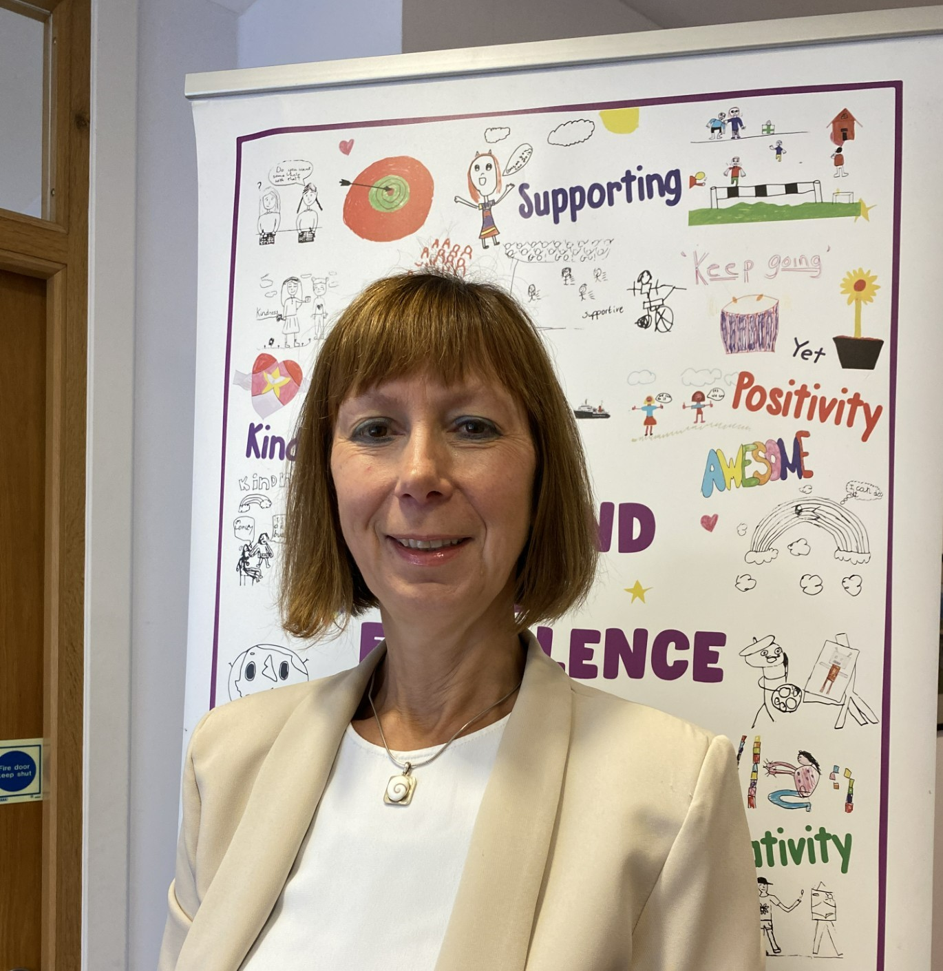Please feel free to contact us for any further information.

Yours sincerely
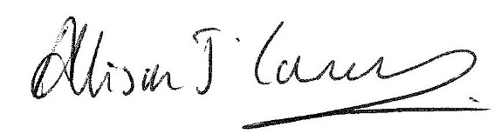
Allison Conner
Head Teacher

North Ayrshire Council

Education and Youth Employment Directorate

What we want to achieve

Our Overall Aim

Ensuring people have the right skills for learning, life and work.

Our Priorities

- We are reducing inequalities and delivering improved outcomes for children and young people.

- High quality learning and teaching is taking place in our establishments.

- Self – evaluation and performance improvement are embedded throughout our schools and central support teams.

- Levels of attainment and achievement are improving for all learners.

- High numbers of our young people are entering positive and sustained post-school destinations.
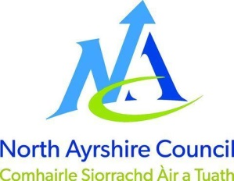

Rights Respecting Schools

The United Nations created the Convention on the Rights of the Child detailing 42 rights, which all children are entitled to. Our work through Rights Respecting School Award (RRSA) teaches children about these rights, which are embedded throughout our school handbook and policies.

Whiting Bay Primary is now a Rights Respecting School and we currently have our Silver Award.



SECTION 1: SCHOOL INFORMATION
Article 29 (goals of education)
Education must develop every child’s personality, talents and abilities to the full. It must encourage the child’s respect for human rights, as well as respect for their parents, their own and other cultures, and the environment.

Whiting Bay Primary School Vision, Values & Aims
Vision
To be an Island of Excellence
Values

Aims
The school recognises the importance of the partnership between parents and teachers in achieving its aims, which are:-

Successful Learners

- We will try to help our pupils to learn to be prepared for the ever changing world.

- We aim to make our learning fun and to the point.

Confident Individuals

- Our pupils will be able to pass on knowledge to others.

- We aim to motivate children to do their best.

Responsible Citizens

- We will try to prepare our pupils to be ready to be able to do any jobs in the future.

- We will give our pupils chances to connect with the community.

Effective Contributors

- We will give our pupils chances to develop relationships.

- We will help our pupils understand their role in keeping everyone safe at Whiting Bay Primary School.

Contact Details

SCHOOL NAME | Whiting Bay Primary School
ADDRESS | Whiting Bay  Isle of Arran  KA27 8PX
TEL | 01770 700260
EMAIL | Whitingbay@ea.n-ayrshire.sch.uk
WEBSITE | Our School | Whiting Bay Primary School
SCHOOL APP | ParentsPortal and EduSpot
CAPACITY | 75
PRESENT ROLL | 52
STAGES COVERED | P1 – P7
DENOMINATIONAL STATUS | Non-Denominational
SINGLE SEX/CO-EDUCATIONAL | Co-Educational
PREDICTED ROLL 2026 | P1  7 | P2  3 | P3  4 | P4  5 | P5  6 | P6  9 | P7  9

Staff

HEAD TEACHER | Mrs Allison Conner
DEPUTE HEAD TEACHER | Mrs Claire McNally
TEACHING STAFF | Mrs Kirsten Picken (Principal Teacher)  Mrs Lynsey Greig-Coles (Principal Teacher)  Mrs Fiona Kerr  Mrs Aldona Kabala  Mrs Pamela Gaw  Ms Sophie Taylor  Ms Jodie Sutton  Ms Katie Heron
PUPIL SUPPORT ASSISTANTS | Mrs Shonagh Pringle  Mrs Donna Murchie
EDUCATION BUSINESS ASSISTANT | Ms Lyndsey Thomson
HOME SCHOOL INCLUSION WORKER | Mrs Camilla McGregor
ACTIVE SCHOOLS CO-ORDINATOR | Mr Ross Dobson
JANITOR | Mrs Jean Dillion
CATERING ASSISTANTS | Ms Lisa Boyd

School Hours

OPEN | 9:00 am
INTERVAL | 10:30 am – 10:45 am
LUNCH | 12:15 pm – 1:00 pm
CLOSE | 3:00 pm

School Calendar 2026~27

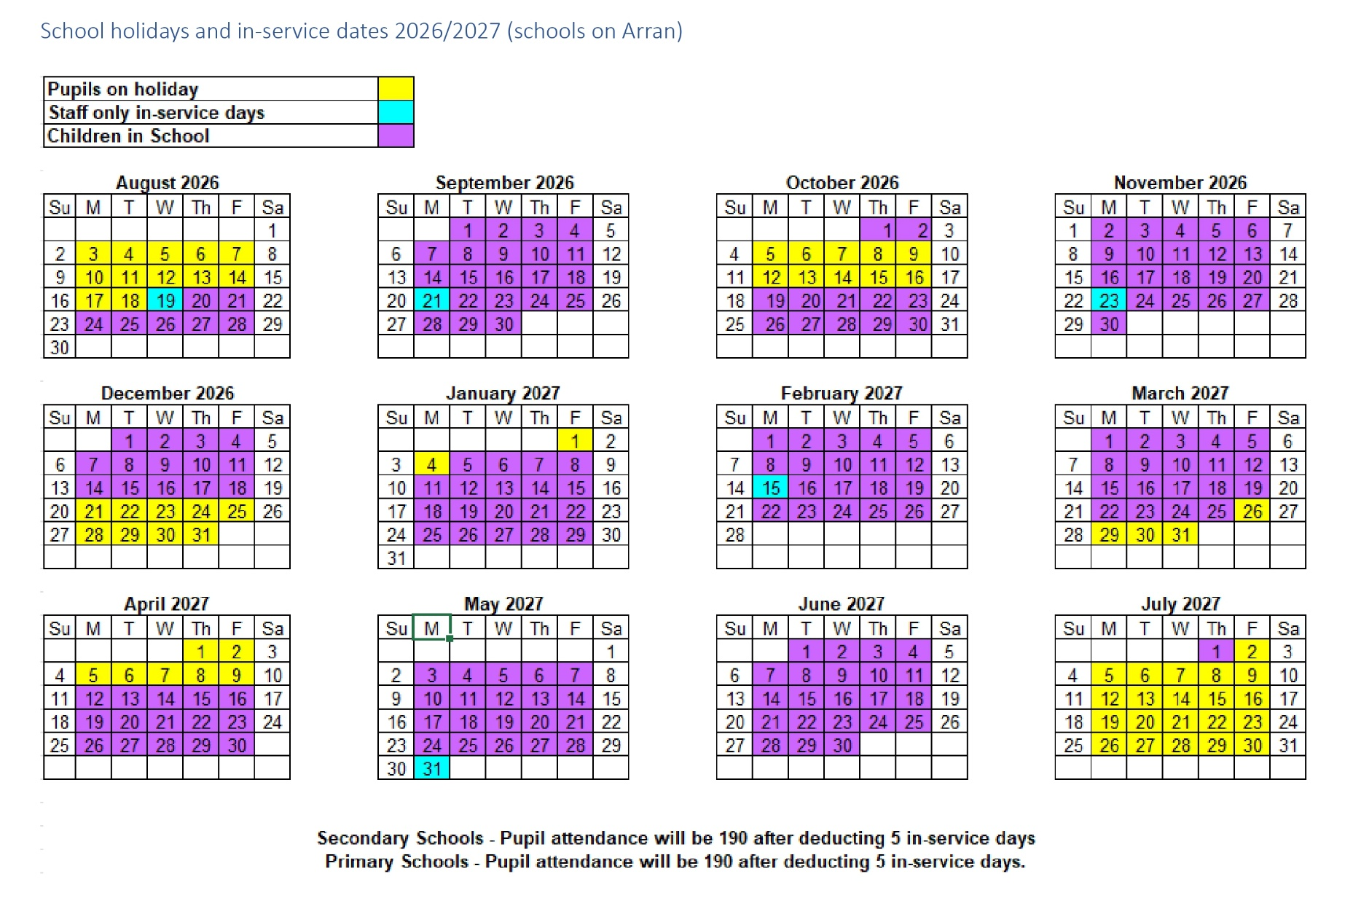

SECTION 2: SCHOOL PROCEDURES

School Security

North Ayrshire Council has introduced procedures to ensure the safety and security of children and staff when attending or working in a school. A number of security measures are used including the use of a visitors’ book, badges and escorts while visitors are within the school building. Anyone, parent/carer or visitor at a school for any reason, will be asked to report to the school office. School staff will then make any necessary arrangements in connection with the visit to the school.

It is the policy of Whiting Bay Primary that any member of staff will approach a visitor and ask for verification of identity. This measure ensures that children work in a safe and protected environment. We appreciate your support in carrying out all of the above measures.

Positive Relationships
Article 23
We support all children to be included in the school day.

Whiting Bay Primary School is committed to developing a nurturing approach and promoting positive relationships. Like every community, our school is built on the relationships within it, across it and its connections with others. Every member of staff is responsible for establishing and maintaining positive relationships with each other, with parents and with partners and most importantly with the young people in their care.

Our expectation of behaviour for children and young people are high. Some children may require additional support in relation to their behaviour and the school will work positively with the young person and the parents, and other partner, as appropriate, to ensure positive outcomes are achieved.

North Ayrshire Council is committed to the principles of restorative practices. This is a solution-focused approach to managing behaviour and resolving difficulties and which promotes healthy relationships that enable better behaviour and better learning.

Whiting Bay Primary School has a code of conduct to ensure the safety and well-being of all and parents are asked to support the school fully in the matter.

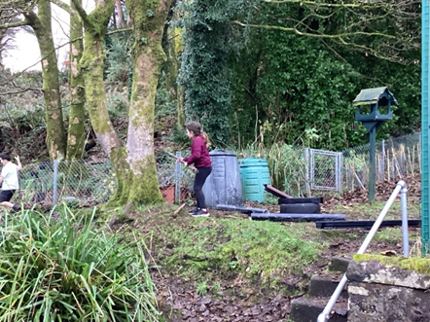

Playground Supervision
Article 3
The best interests of the child must be a top priority in all decisions and actions that affect children.

The Council meets the terms of the legal requirement that pupils be supervised in the playground by at least one adult during the interval or lunchtime if there are fifty or more pupils at the school. Our policy reflects that of NAC in terms of the Schools (Safety and Supervision of Pupils) (Scotland) Regulations 1990.

An adult presence is provided in the playground at break times. Pupils who travel by contracted school transport and arrive at school more than ten minutes before the start of the school day have accommodation allocated to them within the school during inclement weather.

Absence from School Premises at Breaks

Schools have a duty to look after the welfare of their pupils. This means that the staff should take the same care of pupils as a sensible parent would take, and includes taking reasonable care of pupils’ safety during intervals and lunchtimes.

It is the policy of North Ayrshire Council that pupils should not leave school grounds at intervals. Primary pupils should only leave school grounds at lunchtimes when they are going home for lunch with their parents’ agreement. Parents should put this request in writing to the Head Teacher. Pupils will leave and return through the main entrance door of the school.

Parents should encourage their children to follow these rules in the interests of safety.

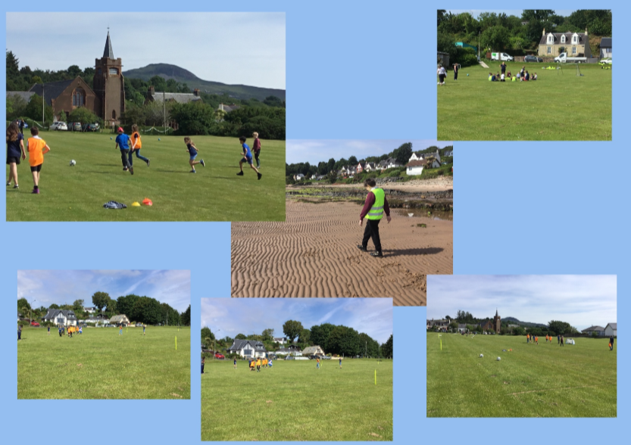
Scotland Day – Football at Whiting Bay Playing Field

School Dress Code

It is the policy of North Ayrshire Council to support the introduction of a reasonable and flexible dress code in schools in its area. The Council encourages each school to adopt its own code, after consultation with parents and pupils.

The Council believes that establishing a school dress code has many benefits. These include improvements in safety, security, positive behaviour and community spirit and a decrease in bullying and in expense for parents.

The Council will support schools in encouraging and helping pupils to conform to the chosen dress code. Some types of clothing will not be allowed at school in any circumstances, for reasons of safety, decency or wellbeing. Wearing of jewellery is not encouraged.

Types of clothing which will not be allowed include clothes which:

- Are a health or safety risk
- May damage the school building
- May provoke other pupils
- Are offensive or indecent
- Encourage the use of alcohol or tobacco

Our Dress Code is as follows:

- Burgundy school sweatshirt
- Black or grey trousers/
Shorts/skirt/pinafore

- White school polo shirt
- Burgundy & white summer dress
- Brown or black shoes

Dress Code for PE

For health & safety reasons all children must wear suitable clothing for PE.

We also adhere to health & safety guidelines and pupils must remove any item which may cause danger e.g. metal buckles, watches, earrings, jewellery etc. These items are the responsibility of the pupils. Long hair should be tied back.

Newly pierced ears may be covered at home during the initial healing process: approximately six weeks. After this time earrings must be removed for PE/swimming lessons. Please note that staff are not permitted to remove or tape over earrings.

Our PE Dress Code is as follows:

- Gym shoes or “indoor” trainers

Badged school uniform can be ordered online from https://whitingbayps.imagescotland.com/shop

Personal Belongings

All items of clothing should be clearly labelled with the child’s name in case of loss. It is appreciated that parents and pupils are distressed over the occasional loss of clothing and/or personal belongings. Parents are asked to assist in this area by ensuring that valuable items of clothing or personal belongings are not brought to school.

Parents should note that the Local Authority does not carry insurance to cover the loss of such items

Mobile Phones/Smart Watches

Safeguarding our pupils and staff is of paramount importance as children learn how to keep safe and act responsibly and respectfully online. We have strict guidance and policy on the use of mobile phones and smart watches in our schools. Most smart watches have the same functionality as mobile phones and can be set to record/ photograph and film.

While the benefits of mobile phones and smart watch devices are recognised, they can also be a serious distraction to work and on occasion, impact significantly on individual pupil and staff wellbeing. Mobile devices and/or smart watches, which have the functionality to film, photograph or record are not permitted within school. This is to ensure the privacy, security and wellbeing of everyone is maintained. Parents are kindly requested to ensure such devices remain at home. If it is absolutely necessary for a pupil to have smart watch/mobile phone with them in school, the following procedure is to be adhered to:

- At the beginning of the school day, pupils should store mobile devices in their own bags.

Any pupil using their devices during the school will have the device removed and parents will be contacted to collect the device at the end of the school day. Inappropriate use of text messages and/or photographs/recordings (video and audio) whilst in school may be treated as a breach of the school’s code of conduct or a serious incident, which could be referred to the police.

Information in Emergencies

We make every effort to maintain a full education service but on some occasions circumstances arise which lead to disruption. Schools may be affected by, for example, severe weather, temporary interruption of transport, power failures or difficulties of fuel supply, in such cases, we shall do all we can to let you know about the details of closure or re-opening. We will keep you in touch by using letters, emails, texts, NAC website, notices in local shops and the Village Hall, announcements in the press and West FM.

Should you have doubts about deteriorating conditions during the day, it may be advisable to contact the school. Parents should ensure that the school is aware of the emergency arrangements made for their child and have responsibility to update us with contact numbers.

School Trips Off-Island

For off-island trips, a Risk Assessment will take place beforehand regarding forecasted weather conditions on the trip day, affecting travel on the ferry. Should the predicted weather be unfavourable the trip may be cancelled in advance, with as much notice as possible.

Should CalMac issue an Amber alert in advance or on the morning pre-travel, then we will not go ahead with the trip in case the ferry is subsequently cancelled and the group is stuck on the mainland.

Listening and Learning

It is the policy of NAC to try to encourage feedback on the education service from parents and pupils. This is part of our overall commitment to giving the best possible service and to working in partnership.

We are, therefore, very interested in feedback of all kinds, whether it is suggestions compliments or complaints. If you wish to register a comment of any type about the school you can do this by writing, telephoning or making an appointment to see someone. All feedback is welcome and helps us keep in touch.

If, in particular, you have a complaint about the school please let us know. It is better that these things are shared openly and resolved fairly, rather than being allowed to damage the home/school relationship there will be not negative consequences arising from making a complaint and we will deal with the issue as confidentially as possible. If we have made a mistake we will apologise quickly and clearly and try to put things right.

There are some things which you should take note of in relation to make a complaint:

- The Council has a Two Stage Policy when dealing with complaints from parents.

- It is helpful if complaints are made initially to the Head Teacher. This makes sure that the school knows what is going on and has an opportunity to respond and resolve the issue.

- We will try to respond as quickly as possible, but often issues are complex and need time to investigate. It is, therefore, helpful if you can give some details of the issue and ask for an early appointment to discuss it.

- If you are not satisfied with our response, then you still have the right to request that your complaint is raised as a Stage 2 Complaint. Should you wish to request this you should contact Education and Youth Employment at Cunninghame House, Irvine, KA12 8EE (01294 324400).

- If, after receiving our final decision on your complaint, you remain dissatisfied with our decision or the way we have handled your complaint, you can ask the SPSO to consider it. We’ll tell you how to do this when we send you our final decision.

- You should also note that you have the right to raise unresolved concerns with your local councillor or MSP/MP.

- Parent Councils have an important role in developing links between the school and the wider parent body and can often be helpful in helping to deal with issues of general concern. Parents are, however, advised that individual more personal complaints are not appropriate to be raised via Parent Councils due to the need for appropriate confidentiality.

SECTION 3: EDUCATIONAL GRANTS: FOOTWEAR, CLOTHING, FREE SCHOOL MEALS AND TRANSPORT

Footwear and Clothing Grants
Parents receiving Universal Credit will normally be entitled to grants for footwear and clothing for their children. Universal Credit claimants’ monthly income must not exceed £660.00, however, some parents earning more than this may still be eligible.

Parents who receive Income Support, Income based Job Seeker’s Allowance, any income related element of Employment and Support Allowance, Support under part V1 of the Immigration and Asylum Act 1999, Child Tax Credit only (with income under £17,005), both Working Tax Credit and Child Tax Credit (with an income up to £7,920) may also still be entitled to grants for footwear and clothing for their children.

Parents who may be unsure whether they can apply should contact the Council Contact Centre on 01294 310000 or the Council’s Welfare Reform Team on 0300 99 4606 for further advice. Information and application forms may be obtained from schools.

Free School Meals
Children of parents receiving Universal Credit (claimants’ monthly income must not exceed £660.00), Income Support, Income based Job Seeker’s Allowance, any income related element of Employment and Support Allowance, Support under part V1 of the Immigration and Asylum Act 1999, both Working Tax Credit and Child Tax Credit (with an income up to £7,920) are entitled to a free midday meal and free milk. Parents and Carers should contact 01294 310000 for further information.

Please Note: All pupils in Primary 1 to 5 are entitled to a free school meal, which includes milk.

Other than Primary 1 to Primary 5 pupils, only those children whose parents receive job seeker's allowance or income support will be entitled to free milk. Milk may however be available for purchase in the school during the lunch period.

Further information can be found on the Grants and Allowances webpage.

Pupils are supplied with a menu in advance, and we encourage you to discuss this with your child before school and pre-order their lunch options on the iPay site.

You are welcome to provide your child with a packed lunch if you prefer and we encourage pupils to make healthy choices and eat a balanced diet. We request that pupils do not bring in cans or bottles of fizzy or isotonic juice to drink and that take-away food is not provided as a packed lunch.

Parents of children who require a special diet should provide a medical note from their doctor.

Children who prefer to eat a packed lunch may do so in the dining hall.
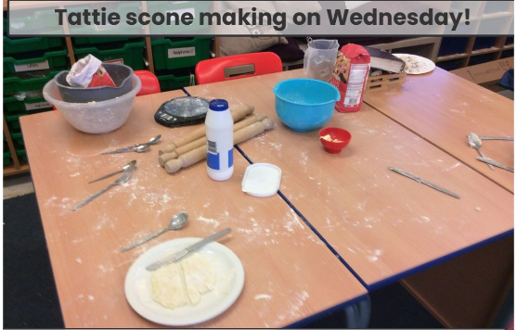
P1-P3

School Transport Policy
North Ayrshire Council has a policy of providing free transport to all pupils who live more than two miles walking distance from their catchment primary school or three or more miles from their catchment secondary school using the shortest suitable walking route. In addition, free transport may also be provided for whole or part of the journey between a pupil’s main address and school (or other educational establishment) when the criteria outlined in section 4 of the School Transport Policy is met.

Applications for mainstream transport are made by parents and carers using North Ayrshire Council’s Transport Hub transport system. Applications may be submitted throughout the year and should be made as soon as confirmation of a place at a catchment establishment has been received. Please note free school transport will not be provided following a successful placing request. If you believe your child may require transport for another reason, please review the entitlement criteria in the School Transport Policy under Section 4 before discussing this with the school.

If places are available and no additional costs is incurred by the local authority, it may be possible to apply for privilege seat in transport provided by the authority, please liaise with North Ayrshire Transport Hub for further information (transporthub@north-ayrshire.gov.uk / 01294 541613). Where free transport is provided it may be necessary for pupils to walk a short distance to the vehicle pick-up point. Walking distance in total, including the distance from home to the pick-up point and from the drop-off point to the school in any one direction, will not exceed the Council's limits (see above section). It is the parents’ responsibility to ensure that their child arrives at the pick-up point on time. It is also the parents’ responsibility to ensure that their child behaves in a safe and acceptable manner while boarding, travelling in and leaving the vehicle. Misbehaviour can result in children losing the right to free transport.

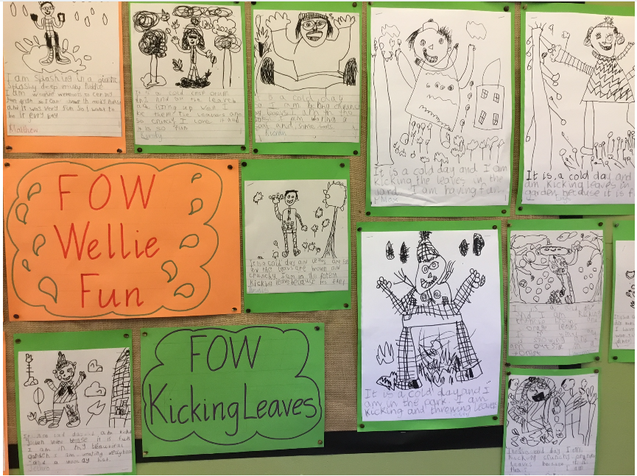

P1-P3

SECTION 4: SCHOOL REGISTRATION, ENROLMENT AND ATTENDANCE
Article 28
Every child has the right to an education. Primary education must be free and available to every child.

Registration and Enrolment

The date for registration of school beginners is advertised in the local press and is normally in January each year. Pupils will be registered in the school for their catchment area.

Parents are provided with information about the school and procedures for making placing requests, if required. Arrangements for meetings with parents and induction days for pupils will be notified during the spring or summer terms.

Parents of pupils who have moved to the area or who wish their child to transfer to the school should contact the school office for information about appropriate procedures and to arrange a visit to the school.

Parents are welcome to contact the Head Teacher at any time by visiting or telephoning the school.

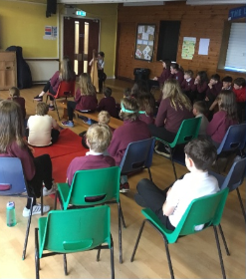

Friday Assembly with music by a pupil

Early Years Registration

Information on registering for our Early Years class can be found on North Ayrshire Council website: Early learning and childcare enrolment (north-ayrshire.gov.uk)

Please contact the school office if you have any queries.

Attendance at School/Lateness

It is the responsibility of parents of children of school age to educate their child; most do this by ensuing that their child attends school regularly.

Attendance is recorded twice a day, morning and afternoon. Absence from school is recorded in the school register as authorised, unauthorised or temporarily excluded.

Parents are asked to inform the school by email, letter or telephone if their child is likely to be absent for some time, and to give the child a note on his or her return to school, confirming the reason for absence. If there is no explanation from a child’s parents, the absence will be regarded as unauthorised.

Every effort should be made to avoid family holidays during term time as this both disrupts the child’s education and reduces learning time. Parents should inform the school by letter, before going on holiday, of the dates. Such absence will be authorised only where certain and very specific family circumstances exist. The majority of family holidays taken during term time will be categorised as unauthorised absence.

Parents may request that their children be permitted to be absent from school to make an extended visit to relatives. Only written requests detailing the destination, the duration and the provision that will be made for their continuing education will be granted. Such extended absences will be recorded separately from the normal attendance and absence information.

The School Inclusion Officer investigates unexplained absence, and the Authority has the power to write to, interview or prosecute parents, or refer pupils to the Reporter to the Children’s Panel if necessary.

Structure of Classes

Primary schools educate pupils at seven broad year stages, Primary 1 to Primary 7. A year stage is defined as a group of pupils entering primary education at a common date. Schools are staffed based on the total number of pupils; however, the number of pupils at each year stage will vary. This means that Head Teachers are required to organise classes to make best use of available staff, resources and space to the benefit of all children in the school.

Pupils may, therefore, be taught in a single stage class or a composite class where two or more year stages are grouped together. This may also change as pupils move from one year to the next.

National guidelines on the curriculum indicate that pupils should progress through learning experiences tailored to their own needs and abilities. This means that pupils in all classes follow programmes designed to help them progress at their own level. This applies to all pupils regardless of whether or not they are in a composite or single year stage class.

The national agreement on class sizes states that the maximum number of pupils in a class is 30 in P1-3 and 33 in P4-7. In a composite class, the maximum number is 25.

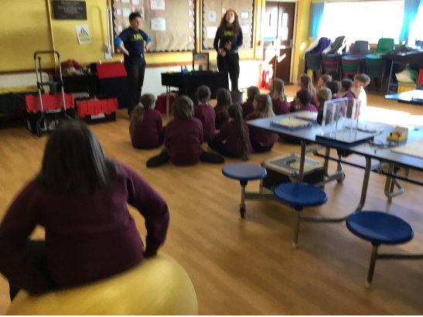

Generation Science Workshop

Transfer to Secondary School

Pupils are normally transferred between the ages of eleven and a half and twelve and a half, so that they will have the opportunity to complete at least four years of secondary education.

Parents will be informed of the arrangements no later than January of the year preceding the date of transfer at the start of the new session.

Whiting Bay Primary School is an associated primary school of:

Arran High School
Lamlash
Isle of Arran
KA27 8ND
Tel: 600341

During their time in P7, pupils are taken to the High School as part of the induction programme. Teachers from local primary schools and their secondary colleagues have worked together to create a Pupil Profile of Achievement, which will be completed in P7 and passed onto the High School.

Teachers from both schools liaise to ensure a smooth transition which focuses on progression for pupils.

Parents will be informed of the details of the visits when appropriate.



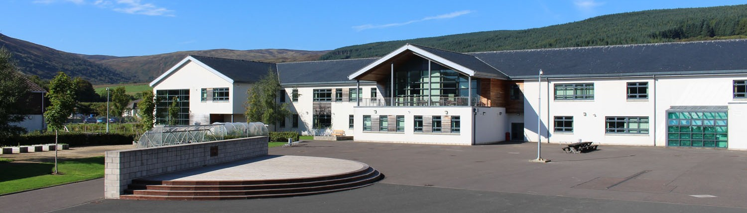

SECTION 5: CURRICULUM FOR EXCELLENCE
Article 29 (goals of education)
Education must develop every child’s personality, talents and abilities to the full. It must encourage the child’s respect for human rights, as well as respect for their parents, their own and other cultures, and the environment.

Curriculum for Excellence is the national curriculum for Scottish schools for learners from age 3 to 18. It aims to raise standards; prepare our children for a future they do not yet know and equip them for the jobs of tomorrow in a fast-changing world.

Curriculum for Excellence enables professionals to teach subjects creatively, to work together across the school and with other schools, to share best practice and explore learning together. Glow, Scotland’s unique, world-leading, online network supports learners, teachers, and families in this.
Teachers and practitioners will share information to plan a child’s “learning journey” from 3-18, ensuring children continue to work at their own pace whilst providing challenge upon which they can thrive.

Curriculum for Excellence balances the importance of knowledge and skills. Every child is entitled to a broad and deep general education where every single teacher and practitioner will be responsible for literacy and numeracy – the language and number skills that unlock other subjects and are vital to everyday life. There is emphasis too on health and wellbeing – to ensure that the school is a place where children feel safe and secure.

Curriculum for Excellence develops skills for learning, life and work to help young people go on to further study, secure work and navigate life. It brings real life into the classroom, making learning relevant and helps young people apply lessons to their life beyond the classroom. It links knowledge in one subject area to another helping children understand the world and make connections. It develops skills so that children can think for themselves, make sound judgements, challenge, enquire and find solutions.

Children’s progress is assessed using a broad range of approaches to ensure children achieve their potential. Ultimately, Curriculum for Excellence aims to improve our children’s life chances, to nurture successful learners, confident individuals, effective contributors, and responsible citizens, building on Scotland’s reputation for great education.

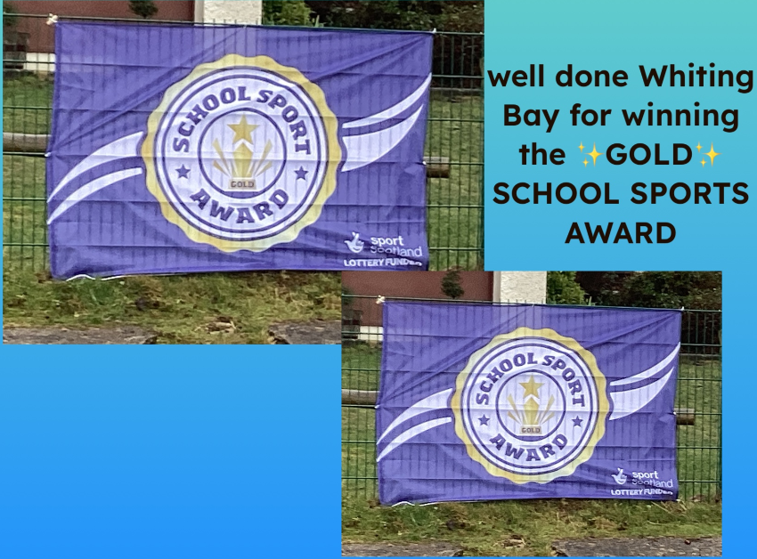

Curriculum for Excellence: The Capacities

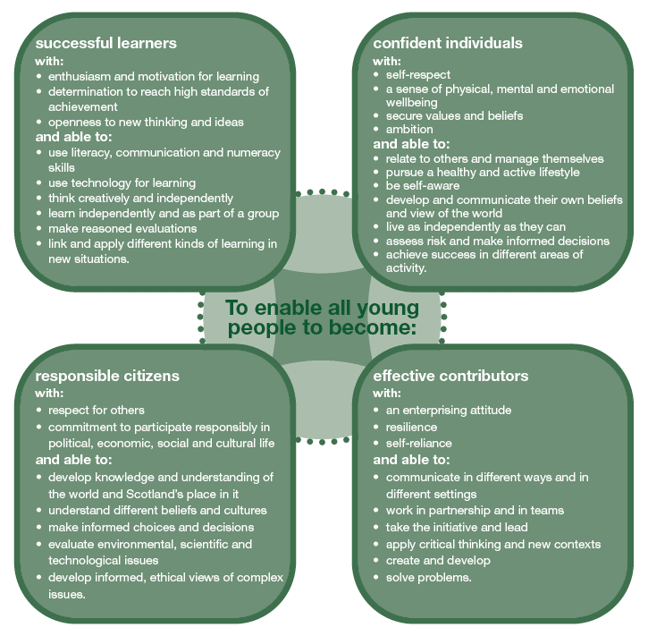

Further information about Curriculum for Excellence and the Experiences and Outcomes can be found on the Curriculum for Excellence website.

www.educationscotland.gov.uk/thecurriculum/whatiscurriculumforexcellence

Extra-Curricular Activities
Article 31 (leisure, play and culture)
Every child has the right to relax, play and take part in a wide range of cultural and artistic activities.

Our children have access to a wide range of after school activities.

Isle of Arran Music School
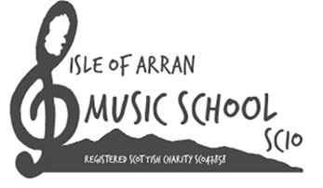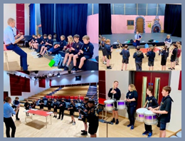

The Isle of Arran Music school gives children from Primary 5 upwards the opportunity to receive free tuition in Chanter (progressing to Bagpipes), Clarsach and Drums.

Arran Youth Foundations
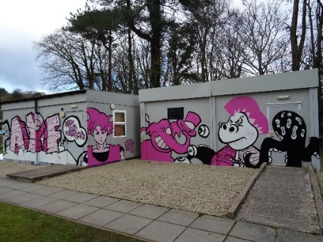

Arran Youth Foundations, although predominantly aimed at High School children, have opened their doors to welcome our Primary 7s to a youth club afternoon.
This gives the children opportunity to meet Primary 7s from the other schools that they will begin High School with.
The AYF offer invaluable support to the youngsters and offer a wide variety of activities.

After School Sports Club

This club is very popular, and again is open to the upper school. It is run by our local Active Sports Coordinator, offering a wide range of sporting activities for the children to participate in.

Arran Junior Sailing Club
This club runs during the Summer term and offers children to chance to experience learning all aspects of sailing.


Messy Church

This club is open to all local primary children and offers an afternoon of crafts, song and food.

Assessing Children’s Progress in the Broad General Education (BGE) Early Years – end of S3

Assessment is a central part of everyday learning and teaching for children and young people. Evidence of progress is gathered on an ongoing and informal basis through asking questions, observing children working together and making formative comments on their work. Children may also assess their own work or that of their classmates; this is called self and peer assessment. Some assessment is more formal such as projects, investigations and standardised assessments.

The assessment of children’s progress throughout the BGE (Early – S3) is based on teachers’ views: their professional judgement. Teachers draw on their professional knowledge and understanding of the child; on the benchmarks for literacy and numeracy, which provide clear information about what children and young people should be able to do and demonstrate by the end of a Curriculum for Excellence Level; and on a wide range of assessment information.

Teachers of P1 P4, P7 and S3 are asked at the end of every school year whether children have achieved the relevant Curriculum for Excellence level for their stage in reading, writing, talking and listening (literacy), and their ability to understand and work with numbers (numeracy). Most children are expected to have achieved the early level by the end of P1, first level by the end of P4, second level by the end of P7 and third or fourth level by the end of S3.

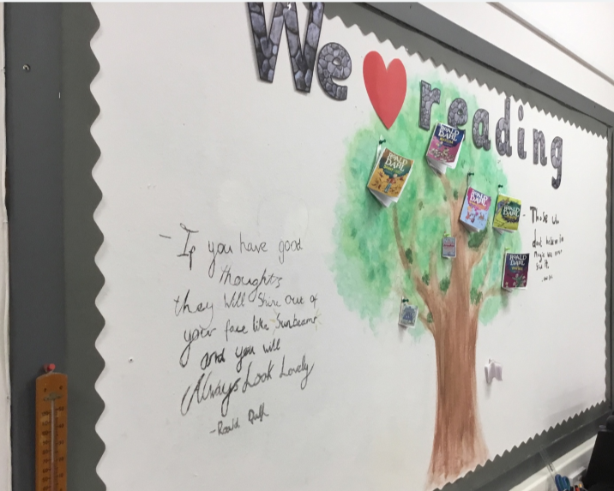
Our library
The Government has also introduced new national standardised assessments, which cover some aspects of reading, writing and working with numbers. These assessments are completed online and are automatically marked by the online system giving teachers immediate feedback to help plan next steps and support children’s progress.

Teachers remain best placed to know how the children in their class are progressing. Their professional judgement will continue to be the most important way of assessing your child’s progress at school.

As a parent, you continue to have a key role in helping your child to learn. Your child’s teacher will keep you informed about how your child is progressing. Please contact us if you have any concerns about their learning, assessment or for more information on how you can support your child’s learning at home.

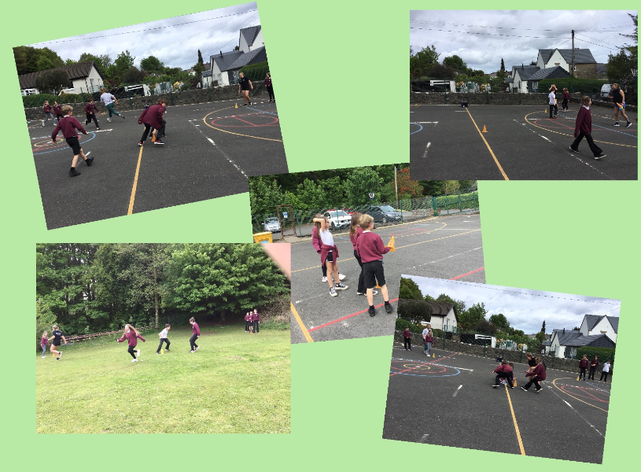

Commonwealth Games Running Workshop
SECTION 6: SCHOOL IMPROVEMENT

Standards & Quality Report/Improvement Plan

Schools in North Ayrshire follow a Quality Improvement process designed to highlight strengths and identify areas for improvement. The process is based on the school’s self-evaluation process with Heads of Service and Senior Managers involved in at least three formal validation visits each session.

This validation process involves talking to pupils, staff and parents about learning and improvements made by the school. This results in actions for improvement for the school to take forward in their planning process.

In addition, themed reviews are undertaken from time to time e.g. to look and report on the quality of the Broad General Education (3-18) and Senior Phase Education within secondary schools. This process is based upon standards and expectations contained within the following National Standards documentation:

- National Improvement Framework
- How Good is Our School? 4
- How Good is Our Early Learning and Childcare?

A Standards and Quality Report and School Improvement plan are produced on an annual basis by every school and centre. Staff, parents/carers, young people and school partners will play an active role in the development of these key school documents.

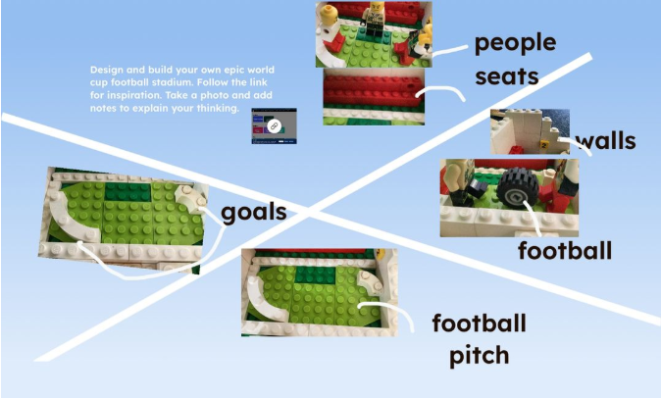
World Cup Stadium Stem Challenge

SECTION 7: SUPPORT FOR YOUR CHILD

Equalities

In line with North Ayrshire Council policy, educational provision is open to all pupils, regardless of sex, age, religion, race, disability or any other potential barrier and all reasonable measures will be taken to ensure that the curriculum is available to every child. Schools also have a duty to promote equality and to eliminate racist and other discriminatory behaviours.

Equality Act 2010

The Equality Act 2010 has been drawn up to tackle inequality and prevent discrimination against people on the basis of protected characteristics. It brings together several existing laws and aims to make understanding the law simpler and also introduces a new single public sector equality duty, which requires public bodies to actively advance equality.

The duties set out in Chapter 1 of Part 6 of the Equality Act apply to all schools. These provisions protect pupils at the school and in the case of admissions, those applying or wishing to apply for admission. Former pupils are also protected from discrimination or harassment.

Guidance on the Act and its requirements for schools in relation to the provision of education can be accessed via the Scottish Government website.

Child Protection

Education Services has a fundamental duty to contribute to the care and safety of all children and young people in North Ayrshire. In fulfilling this duty, the service must engage in close partnership with parents/carers and relevant agencies, primarily the Health and Social Care Partnership and where appropriate the Scottish Children’s Reporter’s Administration. The Service will work in partnership with a number of levels within the establishment or school within the cluster or local area and through Integrated Children’s Services and Community Health Partnership.

The Standard Circular entitled, “Protecting and Safeguarding North Ayrshire’s Children” provides guidance for policy and practice within all educational establishments. The Council is one of the key partners in the North Ayrshire Child Protection Committee, a multi-agency group which takes the lead role in ensuring that our children and young people are cared for, protected from harm, and grow up in a safe environment.

Each school has a named Child Protection Co-ordinator who is the main point of contact for school staff and for external agencies seeking contact with the school on child protection matters. There is an extensive staff-training programme available to staff and, in addition, at the beginning of each school session all staff receive an update on child protection policies, safeguarding and procedures.

Inclusion

North Ayrshire Council is committed to supporting the well-being and educational progress of all learners including those with additional support needs. Including learners requires all staff to demonstrate commitment, innovation, and flexibility in order to ensure that all children and young people have access to quality learning opportunities and experiences. Our Inclusion Strategy states that:

An inclusive approach to education supports an ethos of achievement and high expectation, recognises difference, respects these differences, and sees differences between learners as opportunities for learning.

An inclusive approach to education promotes tolerance and a positive understanding of diversity.
An inclusive approach to education alleviates the barriers to learning, supports the achievement of all and has positive relationships at its heart.

The presumption of mainstream as outlined in Standards in Scotland’s Schools (2000) sets out that children will be educated in a mainstream setting unless exceptional circumstances apply. North Ayrshire has a duty to ensure clear assessment outline the additional needs of a child or young person which may require support in an alternative provision.

Where this is the case, North Ayrshire has a clear process that supports the Team Around the Child (TAC) to make a recommendation for consideration of alternative provision. This is outlined in the Standard Circular E19 and requires establishment staff to work with parents and carers to ensure all supports have been put in place for a child or young person in their mainstream context before submitting clear evidence before requesting alternative provision. North Ayrshire council staff will then make a recommendation based on the evaluation of this evidence, a review of the needs of the young person and the current peer group in each setting.

The Education (Disability Strategies and Pupils’ Educational Records) (Scotland) Act, October 2002, requires local education authorities to prepare and implement accessibility strategies to improve, over time, access to education for young people with disabilities. Access covers:
- The physical building and grounds
- The curriculum (both formal and informal)
- Information on any educational planning that might affect the child or young person’s education.

The Education (Additional Support for Learning) (Scotland) (2009) Act sets out certain duties on local education authorities and confers certain rights on children and their parents. These duties include the need to:
- Identify, assess, and address the need for additional support for any child/young person failing to benefit from school education, for whatever reason.
- Seek and take account of the views of the child/young person on issues relating to their education.
- Engage in helpful partnership working with parents/carers and staff from other agencies.

Additional Support for Learning

Any child who needs more or different support to what is normally provided in schools or early years is said to have ‘additional support needs’. This includes children who may need extra help with their education as a result of issues arising from social and emotional difficulties, bullying, physical disability, having English as an additional language, a sensory impairment or communication difficulty.

The Additional Support for Learning Act

The Education (Additional Support for Learning) (Scotland) Act 2004 came into force in November 2005. In June 2009, the Act was amended. These amendments form the Education (Additional Support for Learning) (Scotland) Act 2009 and came into force on November 2010.

Main provisions of the Act
- The Act provides the legal framework underpinning the system for supporting children and young people in their education, and their families.
- This framework is based on the idea of additional support needs. This broad and inclusive term applies to children or young people who, for whatever reason, require additional support, long or short term, in order to help them make the most of their school education and to be included fully in their learning.
- The 2009 Act automatically deems that all looked after children and young people have additional support needs unless the education authority determine that they do not require additional support in order to benefit from school education.
- In addition, education authorities must consider whether each looked after child or young person for whose school education they are responsible requires a co-ordinated support plan.

Duties under the ‘Additional Support for Learning’ legislation
North Ayrshire must assess any pupil with additional support needs and provide any support necessary for them to benefit fully from their education. All the evidence says that it is best to intervene early to prevent difficulties developing and taking root. For example, by making sure reading is well taught and that all pupils gets encouragement and support at home we can hopefully reduce the likelihood of the young person encountering literacy difficulties later on.

Whatever the type of challenge that arises, it is important to detect it early, develop a shared understanding of what is needed (the establishment may request extra specialised help to do this) and take action to help to pupil achieve. Whenever we start this process for any child or young person, we will always explain to them and to their parents or carers our concerns and what we will do to help.

The establishment can get support from a range of visiting professionals including educational psychologists. Each establishment has a link educational psychologist and staff can ask for informal advice on supporting learners. If more detailed individual help is required, they will talk to you about formally involving the educational psychologist. The educational psychologist can only be involved in consultation, collaborative assessment, and planning interventions for your child with your agreement.

Staged Intervention

A young person’s need for support is addressed through a cycle of identification, assessment, planning, support and review. This process is called Staged Intervention.

In North Ayrshire we organise support under the following headings:
- Enhanced Universal Support
- Stage 1
- Stage 2

Universal support is a fundamental element of the service provided by all educational establishments. There may be times when a child or young person needs some additional support to help them achieve their full potential and this is where the stages of support need to be identified and explained.

Enhanced Universal

Some supports are considered as Enhanced Universal, reflecting that they are provided within universal services but are planned and delivered with enhancement to day-to-day practice.
Within Enhanced Universal a young person may require a higher level of support due to concerns surrounding their wellbeing or learning, or a combination of both.

The needs of the child or young person are met within their classroom or playroom with some adjustment to their environment, curriculum, and/or approaches to learning and teaching. Some aspects of work may be planned individually or as part of a group however this will be recorded as part of playroom or classroom planning. Class teachers and keyworkers will monitor and record progress.

Stage 1
This stage applies to children and young people whose support needs cannot be met through Enhanced Universal services. They require additional support available within their own establishment which may include Support for Learning and/or targeted pastoral support.

Stage 2
This stage signifies that the needs of the young person are significant and/or exceptional and are not being fully met through Enhanced Universal or Stage 1 supports and services. The young person requires more specialist and/or intensive support.

At both Stage 1 and 2, a Team Around the Child discussion will review the learner’s strengths and needs, agreeing appropriate interventions and supports. The learner and their parent/carer must be fully involved in this process and the young person’s targets and progress will be recorded using the North Ayrshire Staged Intervention planning format.

Where a child or young person has additional support needs, extra planning is required when they move to a new class, new school or when they are moving on from secondary school. How far ahead this transition planning needs to start depends on the young person’s individual needs, but for most children and young people with Additional Support Needs transition planning should start at least one year before the date of the planned move.

Further advice and guidance around supporting needs can be found on the ENQUIRE website.

Getting it Right for Every Child–Ensuring their Wellbeing

The Children and Young People (Scotland) Act 2014 puts children and young people at the heart of planning and services and ensures their rights are respected across the public sector. It seeks to improve the way services work to support children, young people and families.
• The Act ensures that all children and young people from birth to 18 years old have access to a Named Person

- The Act puts in place a single planning process to support those children who require it
- The Act places a definition of wellbeing in legislation
- The Act places duties on public bodies to co-ordinate the planning, design and delivery of services for children and young people with a focus on improving wellbeing outcomes, and report collectively on how they are improving those outcomes

Taking a ‘Getting it Right for Every Child’ approach to supporting every child is a priority within our school and we aim to assist every child in our school to reach their potential. The wellbeing of children and young people is at the heart of ‘Getting it Right for Every Child’. The approach uses eight areas to describe wellbeing in which children and young people need to progress in order to do well now and in the future.

The Eight Indicators of Wellbeing (SHANARRI)

Safe | Healthy | Achieving | Nurtured
Active | Respected | Responsible | Included

Why we have to get it right for every child

Education and Youth Employment must safeguard, support and promote the wellbeing of all children and young people and address need at the earliest opportunity. These functions are the responsibility of schools and establishments and those who work in them and with them. All who work in Education and Youth Employment have a responsibility to ensure the wellbeing of North Ayrshire’s children and young people.
For more information on ‘Getting it Right for Every Child’ in North Ayrshire go to www.girfecna/.co.uk

Psychological Services

The Educational Psychology Service in North Ayrshire is part of, and contributes to, the strategic objectives of Education and Youth Employment by improving outcomes for children and young people. Educational Psychologists work together with parents, teachers and other professionals to help children and young people make the most of their lives, within educational settings and the wider community. Educational Psychologists are involved in working with individuals where there is specific need, but also have a significant role in offering training, support and consultation to education establishments aimed at enhancing outcomes for all children.

Your child’s school has a system of staged intervention for identifying, assessing, monitoring and reviewing the ongoing progress of all children and young people. As part of this wider system, each school and authority early years centre has a link educational psychologist.

When concerns arise about a particular pupil, the school takes action to address these concerns. This may be a one-off, or may lead to longer term involvement. Through this process the educational psychologist can, if required, contribute to the ongoing assessment and support for your child. The educational psychologist will be involved while there is a specific role for them within the collaborative assessment process.

Find out more: http://www.northayr-edpsychs.co.uk

Data Protection

Personal data is required to be collected by North Ayrshire Council in order to deliver education services. It is necessary to collect personal data regarding pupils, parents, carers and other individuals to enable us to carry out our duties under the Education (Scotland) Act 1980 and the Education (Scotland) Act 2016.

The Data Protection Act 2018 sets out the legal basis for processing data. You can refer to our privacy notice for details of the different basis under which we may process individuals’ data.

https://www.north-ayrshire.gov.uk/Documents/EducationalServices/eye-privacy-policy.pdf

We may also share or receive an individual’s personal data with the following:

- Scottish Government & Education Scotland
- Private Nurseries
- Strathclyde Passenger Transport
- Scottish Children’s Reporter Administration
- Social Work Services
- Scottish Public Services Ombudsman

Where we are required, we will also make disclosures required by law and may also share information with other bodies responsible for detecting/preventing fraud or auditing/administering public funds. Individuals have legal rights under the data protection legislation including the right of access. Further details can be found in the Council’s Privacy Policy at:

https://www.north-ayrshire.gov.uk/privacy-policy.aspx

Medical & Healthcare

Medical examinations are carried out at various times during a child’s primary school years. Parents are given notice of these and encouraged to attend. Vision and hearing tests and dental examinations, which parents need not attend, are also carried out and parents informed of any recommended action or treatment. All examinations are carried out by Ayrshire and Arran Health Board staff.

If a pupil takes ill or has an accident at school, which requires that the child be sent home or for treatment, First Aid will be provided and parents/carers contacted immediately. (In the event of a serious illness or accident, a member of staff will accompany the child to a doctor or hospital and parents/carers will be notified immediately.)

For this reason it is important that the school has contact details for parents/carers and an additional contact person in case parents/carers cannot be reached. It is also important that the school is kept fully informed and updated with regards to any medical condition.

It is the parent’s responsibility to notify the school and keep medical information updated as required.

Children will not be send home unaccompanied.

Dispute Resolution Procedures

If you feel that things are not being done properly to support your child then the Council has a range of ways to work with you to resolve any issues. You can ask at any time for a copy of the booklet called ‘Resolving Disagreements’. This booklet will give you ways to make sure your concerns are listened to and addressed.

Further Support

The following organisations are able to provide advice, further information and support to parents of children and young people with Additional Support Needs.

1. Enquire: Scottish Advice and Information Service for Additional Support for Learning

Website: http://enquire.org.uk/
Helpline: 0345 123 2303
Email: info@enquire.org.uk

2. Scottish Independent Advocacy Alliance

Website: http://www.siaa.org.uk
Telephone: 0131 260 5380
Email: enquiry@siaa.org.uk

3. Scottish Child Law Centre

Website: http://www.sclc.org.uk
Telephone: 0131 667 6333
Email: enquiries@sclc.org.uk

SECTION 8: PARENTAL INVOLVEMENT

Parental Engagement and Involvement

NAC Parental Involvement Strategy

All schools have clear systems in place for communicating with everyone in the parent forum. Communications with parents are clear, jargon-free, specific and easily accessible. A variety of methods and approaches are used by schools to communicate with the parent forum including face to face, traditional communication methods and digital media for example, Twitter, Facebook. Considerations will always be given when communicating with parents who have literacy, language and communication challenges.

Schools ensure that parents know who to contact when they wish to discuss their child’s learning or wellbeing and will seek to provide a private space for such discussions and make sure parents are given adequate time and support. Consideration will be given to family circumstances.

Parents are welcome to contact the school at any time to arrange an appointment to discuss any matter with the class teacher, Depute Head, Head Teacher or Head of Centre. New families are welcome to contact the school and request a suitable visiting time at any point throughout the session.

Parents are given opportunities to understand the way learning and teaching takes place in the classroom. This may be in the form of class visits to take part in the learning experience alongside their child or attending events which share the learning. Frequent invitations are issued to parents to participate in school activities such as open days, class assemblies, workshops and to assist with outings and visits, sports and concerts. There will be a series of early meetings for the parents of Primary 1 pupils and parents are kept informed of events with a range of newsletters, website updates, texts, invitations and social media sites.

A variety of methods will be used to ensure information about your child’s progress is shared. Schools are encouraged to provide parents/carers with information on their children’s progress at regular intervals throughout the year through a range of activities. There is an expectation that part of this will be in a written format.

Reporting Examples:

Individual Learners
- Written reports/tracking reports
- Learning conversations with pupil/teacher/parent/carer
- Pupil reflections on their learning in logs
- Parent/ carer consultation / parents’ meetings involving parent/teacher/pupil, as appropriate.
- Home/school diaries
- Profiling activities
- Learning walls and displays.

Groups of learners
- Assemblies
- Open day events
- School concerts/shows
- Social media
- Curriculum workshops led by children, young people and staff
- Parent Council meetings
- School/class newsletters

Parent Council

All parent/carers are automatically members of the Parent Forum at their child’s school and will be entitled to have a say in what happens at the school.

As a member of the Parent Forum parents will have a say in selecting the Parent Council (the representative body) to work on behalf of all the parents at the school.

The Head Teacher is the professional adviser to the Parent Council and has the right to attend and speak at Parent Council or Parent Forum meetings.

The objectives of the Parent Council are:

- To work in partnership with staff to create a welcoming school, which is inclusive for all parents
- To promote partnership between the school, its pupils and all its parents
- To develop and engage in activities which support the education and welfare of the pupils
- To identify and represent the views of parents on the education provided by the school and other matters affecting the education and welfare of pupils
- To be involved in the recruitment process for appointing the Head Teacher and Depute Head Teacher of the school

The Parent Council meets at least once a term.

Current Office Bearers are:

Chairperson: Mrs Kirsty West
Secretary: Ms Joanna McCallum
Treasurer: Miss Sheila Barr

For more information on the Parental Involvement Act or to find out about parents as partners in their children’s learning, please contact the school or North Ayrshire Council Educational Services or visit the Parent zone website on www.parentzonescotland.gov.uk



Parentzone Scotland is a unique website for parents and carers in Scotland, from early years to beyond school. The website provides up-to-date information about learning in Scotland and practical advice and ideas to support children’s learning at home in literacy, numeracy, health & wellbeing and science.

Information is also available on Parentzone Scotland regarding additional support needs and how parents can get involved in their child’s school and education. Furthermore, the website has details about schools, including performance data for school leavers from S4-S6 and links to the national, Local Authority and school level data on the achievement of Curriculum for Excellence levels.

Parentzone Scotland can be accessed at https://edcuation.gov.scot/parentzone.

Home School Links

Parents are invited, informally or by letter, at least twice a year to visit the school in order to view their children’s work and discuss progress with the teacher and members of the Senior Leadership Team.

Parents are welcome to contact the school at any time to arrange an appointment to discuss any matter with the class teacher, Depute Head Teacher or Head Teacher. New families are welcome to contact the school and request a suitable visiting time at any point throughout the session.

Frequent invitations are issued to parents to participate in school activities such as open day, class assemblies, and curricular workshops and to assist with outing sad n visits, sports and concerts. We have early meetings for the parents of P1 pupils and keep parents informed of events with a range of newsletters, website updates, texts and invitations. We are also using Seesaw to share aspects of your child’s life in school.

Reports to Parents

Parents’ meetings with teachers are held in school twice a year, usually in November and March. Written reports are made to parents annually in June and will contain information regarding their child’s attainment. A copy of this report is kept on file in school for the purpose of transfer of information between teachers in the school and into the secondary sector.

Homework

Parents have a very important role in helping their children to get the best out of school and it is important that they take an active interest in their child’s progress at school. This can be done by:

- Encouraging hard work and high standards at all times
- Stressing the importance and relevance of what is learned at school
- Supporting the school’s policy on homework and discipline

The type of homework will vary depending on the age and ability of individual pupils. Reading commonly forms part of the homework set and will be specified by the teacher on a reading marker. Parents are encouraged not only to read with their child but also to discuss the story and pictures.

In the early and middle stages oral reading should be practised regularly at home whereas in the upper primary, where children are competent in the mechanics of reading, a greater emphasis may be placed on silent reading and comprehension. Reading for enjoyment should be encouraged at all stages. Whiting Bay Primary participates in the Accelerated Reading™ programme and enjoys a wide range of books to be shared in our library.

Spelling is also an important part of homework from P3 onwards (although some children may be asked to practise even earlier). Maths homework will be given to consolidate understanding and proficiency at all stages of the school.

From time to time pupils are given assignments and personal projects, which may involve research, investigation, preparing a speech, leaning a poem or a similar activity.

We really appreciate the involvement of parents and are very grateful to those parents who so faithfully sign reading markers and jotters to confirm that they have overseen each piece of work and for leaving comments on their child’s Seesaw posts.

School Committees

Article 12 (respect for the views of the child)
Every child has the right to express their views, feelings and wishes in all matters affecting them, and to have their views considered and taken seriously.

Presently, the following committees take place at Whiting Bay Primary School:

- Eco Schools
- Pupil Voice
- Rights Respecting Schools Group

Membership of these committees can include pupil representatives from all year groups, staff and parents.



P6/7 Learning about budgeting
SECTION 9: PUPIL DATA COLLECTION AND PROTECTION POLICIES

The Scottish Government and its partners collect and use information about pupils through the Pupil Census to help to improve education across Scotland. This note explains why we need this information, how we use it and what we do to protect the information supplied to us.

Why do we need your data?

In order to make the best decisions about how to improve our education service, Scottish Government, education authorities and other partners such as SQA and Careers Scotland need accurate, up-to-date data about our pupils. We are keen to help all our pupils do well in all aspects of school life and achieve better examination results.

Accurate and up-to-date data allows us to:

- Plan and deliver better policies for the benefit of all pupils
- Plan and deliver better policies for the benefit of specific groups of pupils
- Better understand some of the factors that influence pupil attainment and achievement
- Plan and implement targeted approaches to reducing the poverty-related attainment gap
- Share good practice
- Conduct teacher workforce planning
- Target resources better
- Enhance the quality of research to improve the lives of young people in Scotland
- Provide a window on society, the economy and on the work and performance of government by:
  - Publishing statistical publications and additional table about school education
  - Providing school level information

Data Policy

Information about pupils’ education is collected in partnership between the Scottish Government and Local Authorities through the ScotXed programme which aims to help schools and Local Authorities by supporting efficient collection, processing and dissemination of statistical information. The Scottish Government then provides analysis of the data to support research, planning, management and monitoring of education services as well as to produce National Statistics publications.

Education data within Scottish Government is managed effectively by secure systems and is exploited as a valuable corporate resource subject to confidentiality restraints. As part of its data policy, Scottish Government will not publish or make publicly available any information that allows individual pupils to be identified, nor will data be used by Scottish Government to take any actions in respect of individuals. Data is held securely and no information on individual pupils can or would be made publicly available by Scottish Government.

The individual data collected by Scottish Government is used for statistical and research purposes only.

Your Data Protection Rights

Any sharing or linkage of data will be done under the strict control of Scottish Government, and will be consistent with their data policy and the National Data Linkage Guiding Principles. Decisions on the sharing or linkage of data will be taken in consultation with relevant colleagues and individuals within and outwith Scottish Government as part of a Data Access Panel. At all times the rights of the individual (children or adults) under the GDPR and other relevant legislation will be ensured.

Further information can be found on:

https://www2.gov.scot/topics/statistics/scotxed/schooleducaiton/ESPrivacyNotices

Concerns

If you have any concerns about the ScotXed data collections you can email the Data Protection & Information Assets Team on dpa@gov.scot or the Head of Education Analytical Services, Mick Wilson, at mick.wilsong@gov.scot or by writing to Education Analytical Services, Area 2A-North, Victoria Quay, Leith, EH6 6QQ.

Alternative versions of this page are available on request from the ScotXed support Office, in other languages, audio tape, Braille and large print.

Alternatively, complaints may be raised with the Information Commissioners Office at casework@ico.org.uk

Appendix 1

Important Contacts

Head of Service

Andrew McClelland

North Ayrshire Council
Cunninghame House
Irvine
KA12 8EE

01294 324413

