After all the excitement of Christmas, we are back in school and ready to get working hard in Term 3 of Primary 1. Rudolph, our Elf is away back to the North Pole to live with Santa for the year but will be keeping an eye on us for next year! The boys and girls all did a super job during their Nativity performances and enjoyed their Christmas Party at the end of Term 2. We hope you liked our Selfie Calendars! This term we will be very busy using all the skills we have learned so far in Primary 1 and hopefully adding some more!

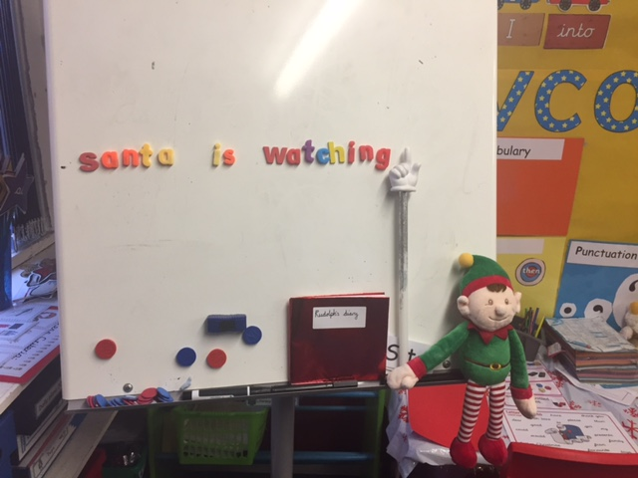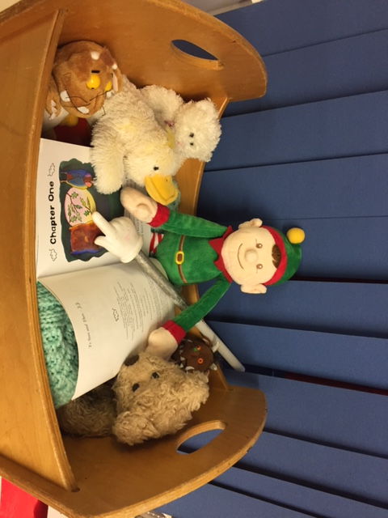

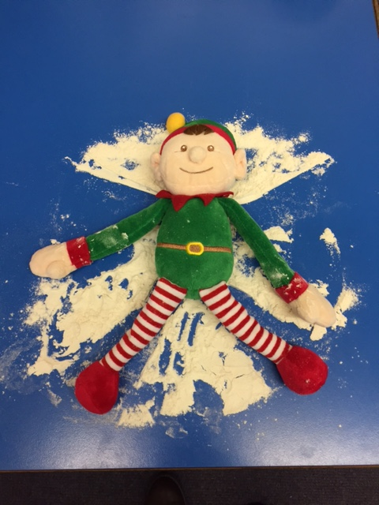

In January we will be learning about Scotland – amongst other activities! We will also learn a Scottish poem as part of our whole school Burns competition. We will then spend a couple of weeks learning all about Chinese New Year. There will be lots of arts and crafts activities linked to this topic – we can’t wait! Our main topic in Term 3 will then begin and is titled ‘Katie Morag’. This is a ‘Storyline’ topic, where all the areas of the curriculum (literacy, numeracy, art, music, drama etc) will be linked to the topic. We will learn about island life, Scottish cultures and writing letters.

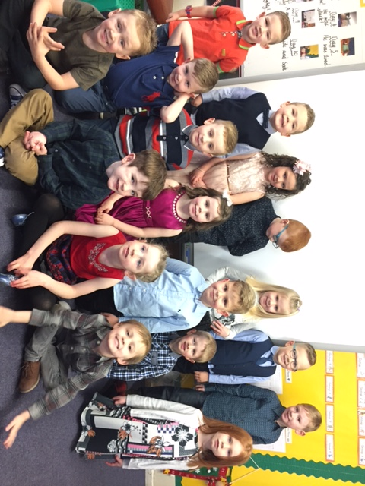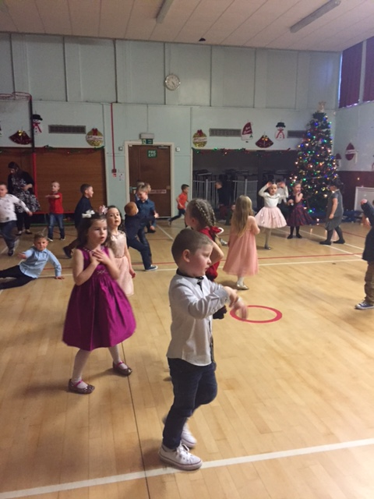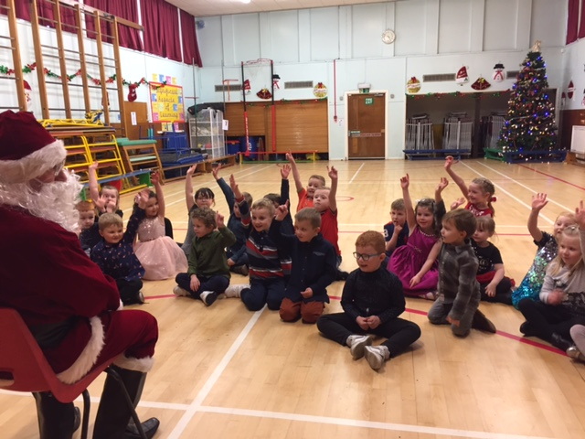

In numeracy, we will be continuing to improve our number skills in a variety of ways. We will be working on counting forwards and backwards within 30 and lots of us will be able to recognise numbers up to 20 (and maybe even 30!) by Easter. At the beginning of the term we will be learning our left and right to give basic directions. We will also be learning about symmetry and 3D shapes. Please continue to talk about aspects of maths you see at home and when you are out and about – this will help our children see numbers/shapes/patterns in a variety of contexts.

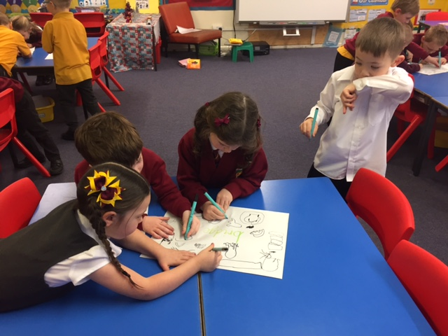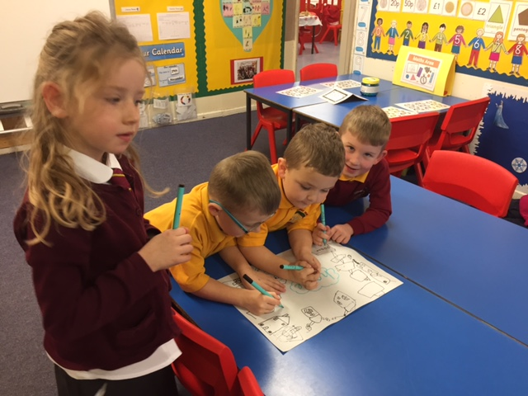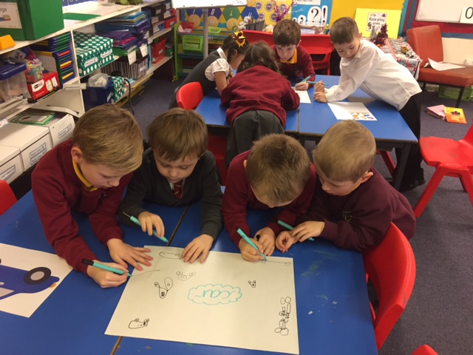

This term we will continue our Stay and Play sessions. The dates for these will be Friday 27th January, Friday 24th February and Friday 31st March. We also hope to have other activities for parents and family members to join in with throughout the term. We will keep you posted of these on our weekly homework sheet. Thank you for your continued support, I look forward to a busy term ahead!

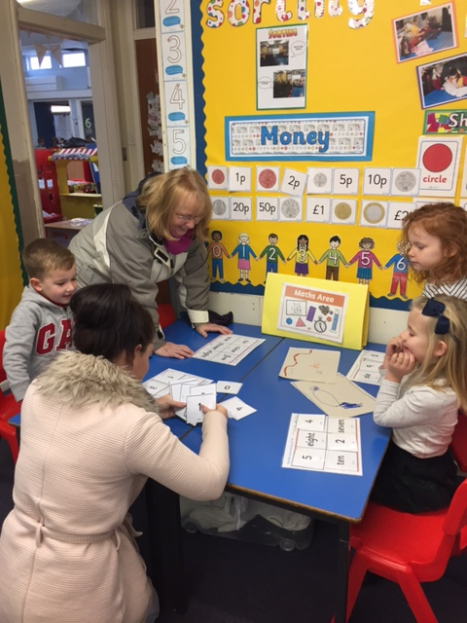

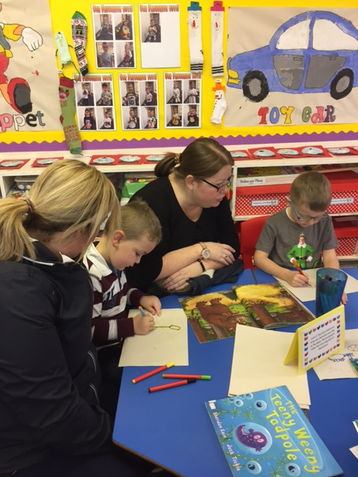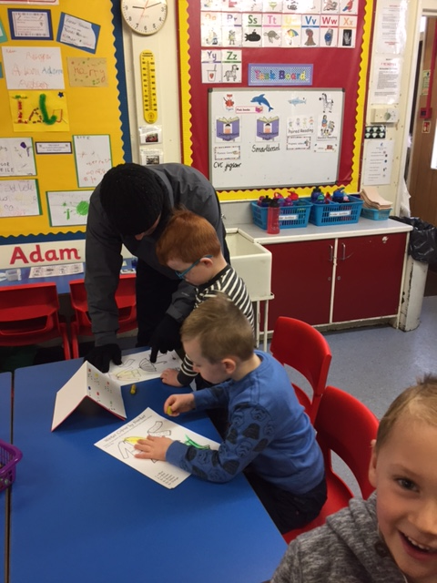

Thanks, Mrs McFarlane.