Primary 1 are doing a great job settling into school life! Our soft start in the morning is working very well, giving the children the opportunity to ease themselves into our busy school day. During this time we have been choosing activities such as building with construction materials, improving our fine motor skills at finger gym, ‘writing’ stories, putting on puppet shows, investigating bugs with magnifying glasses and lots of other fun learning activities. We are working hard to remember to self-register ourselves and organise our book bags, snacks and water bottles. There is a lot to remember!
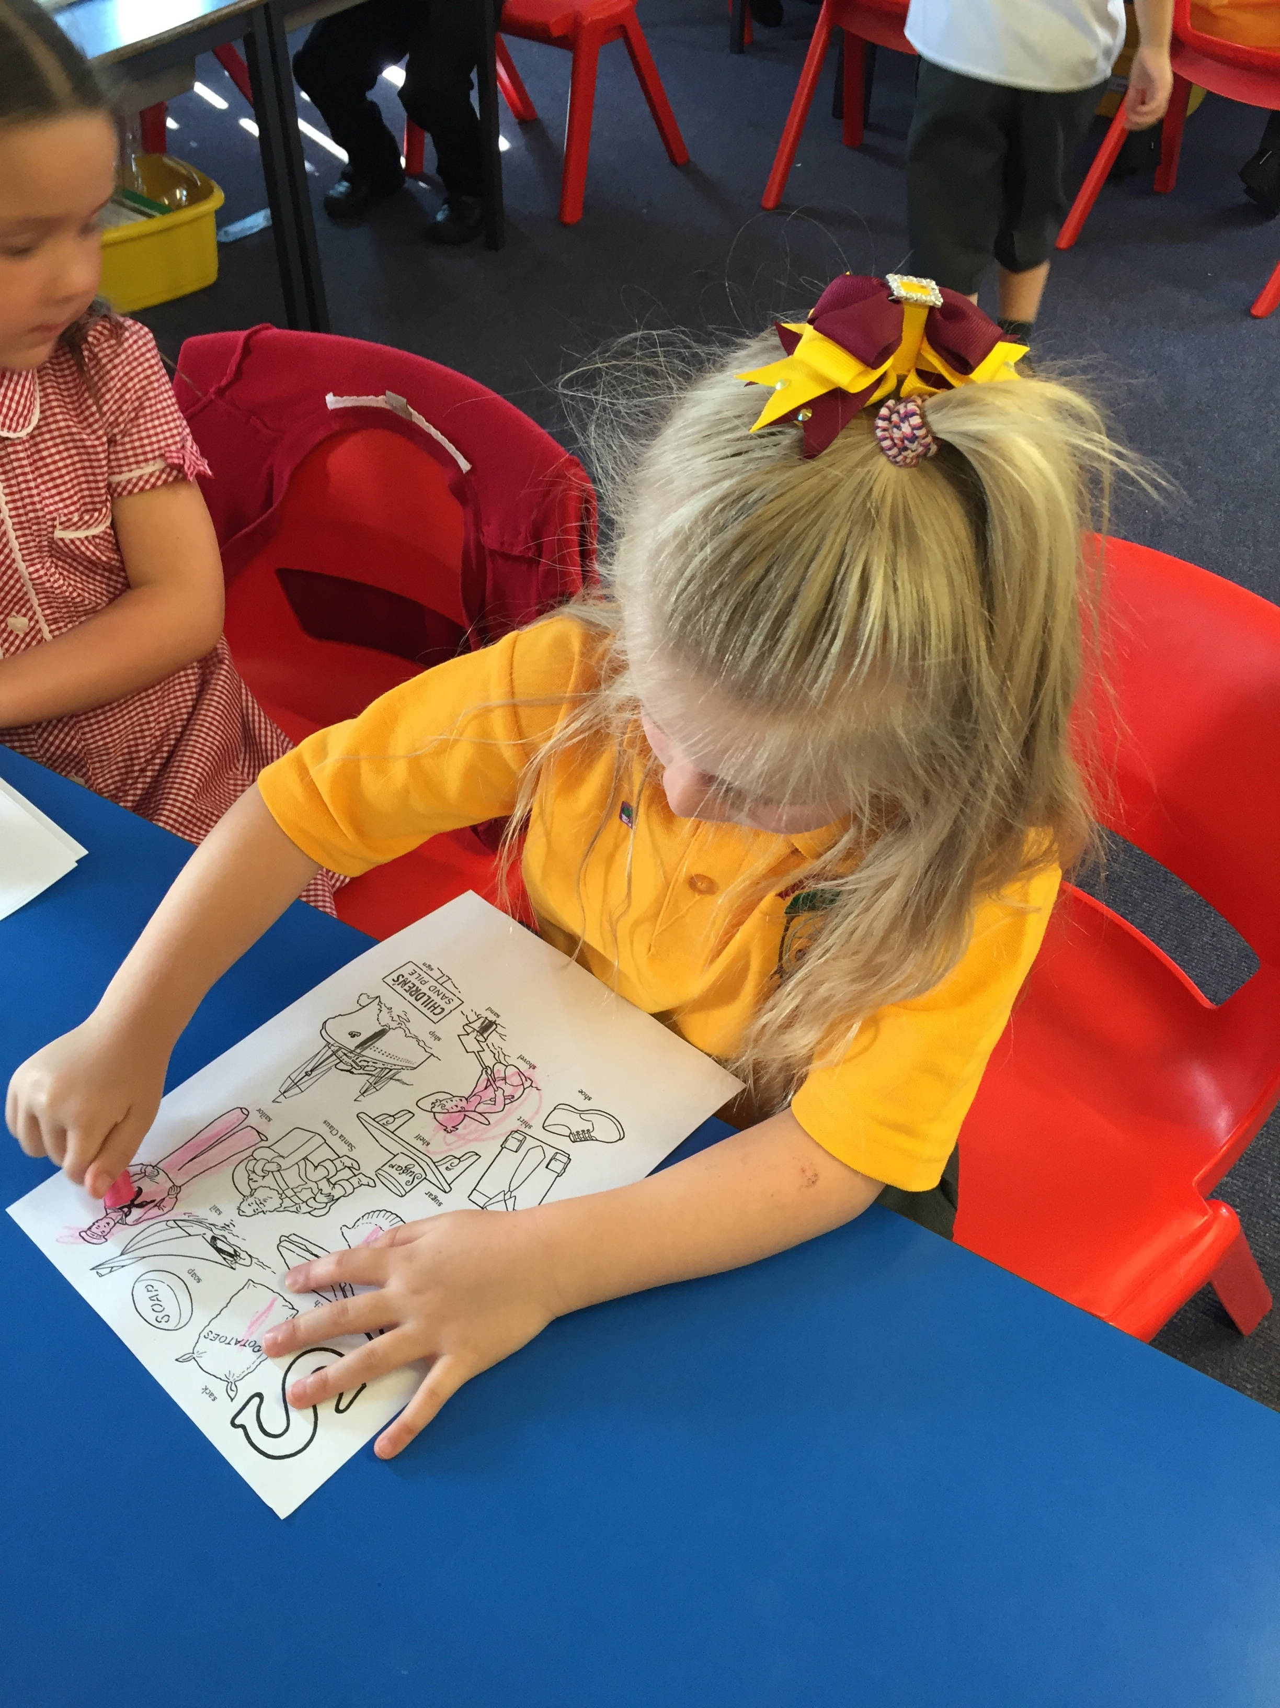
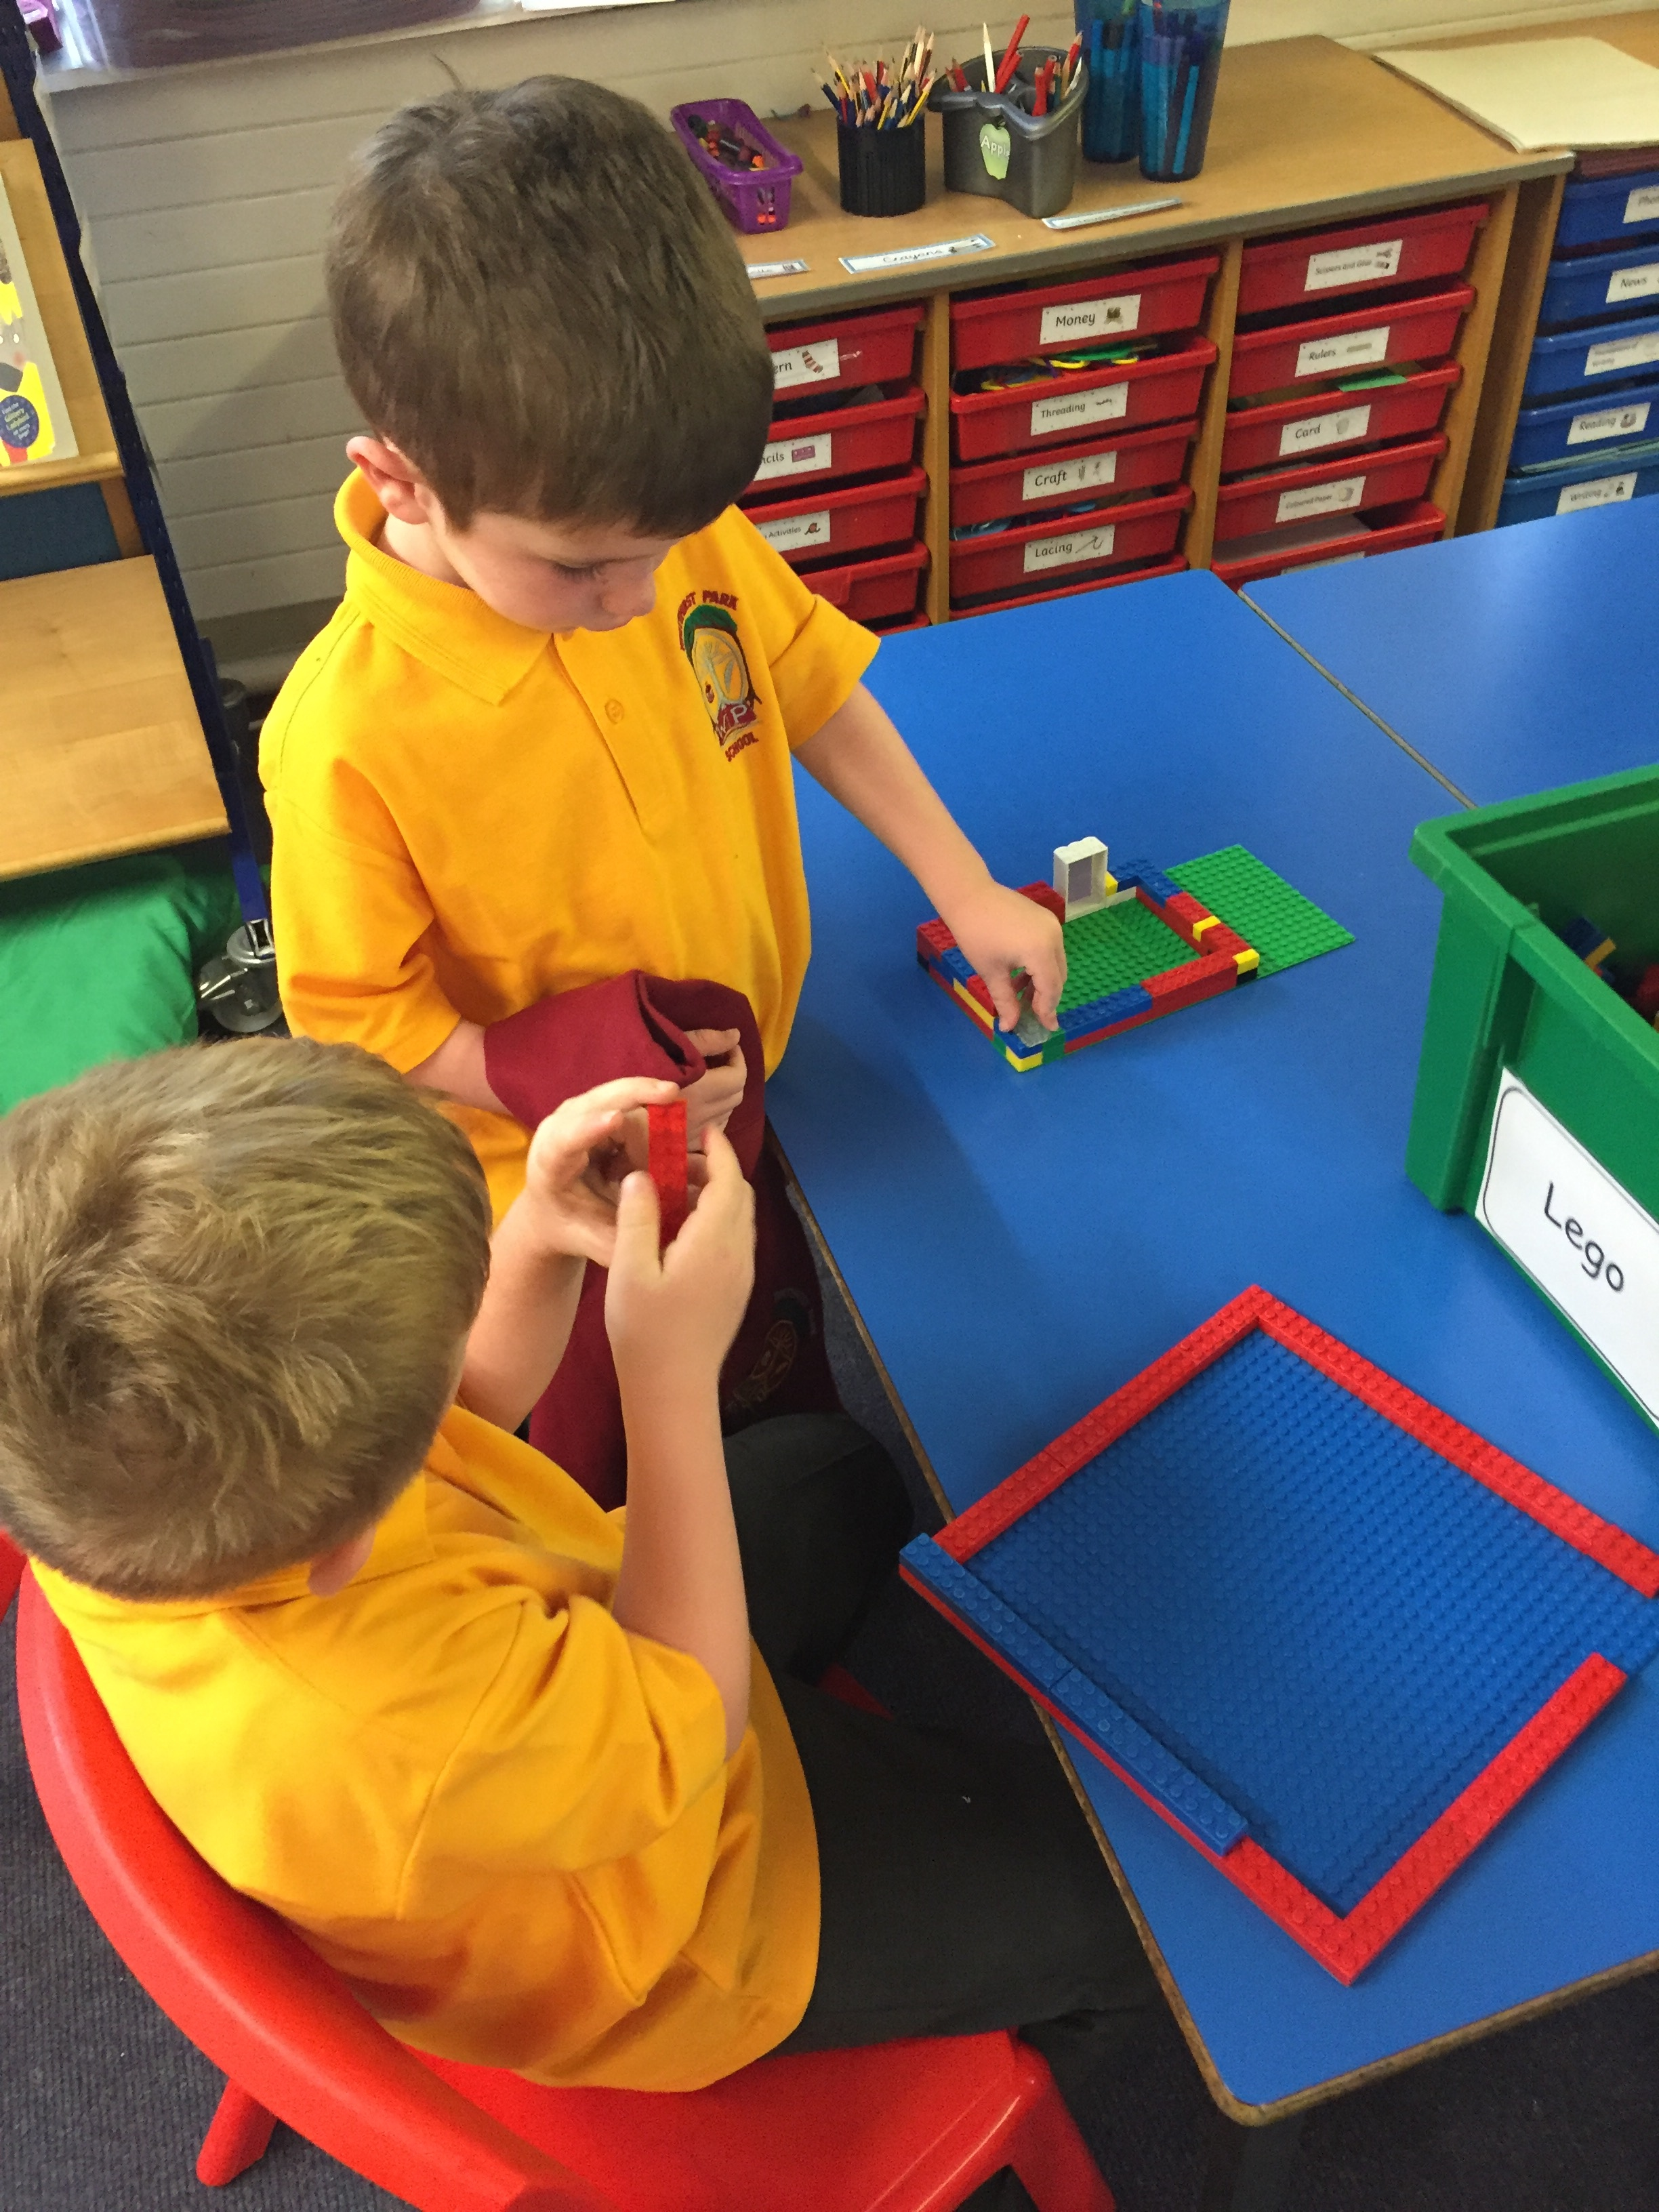
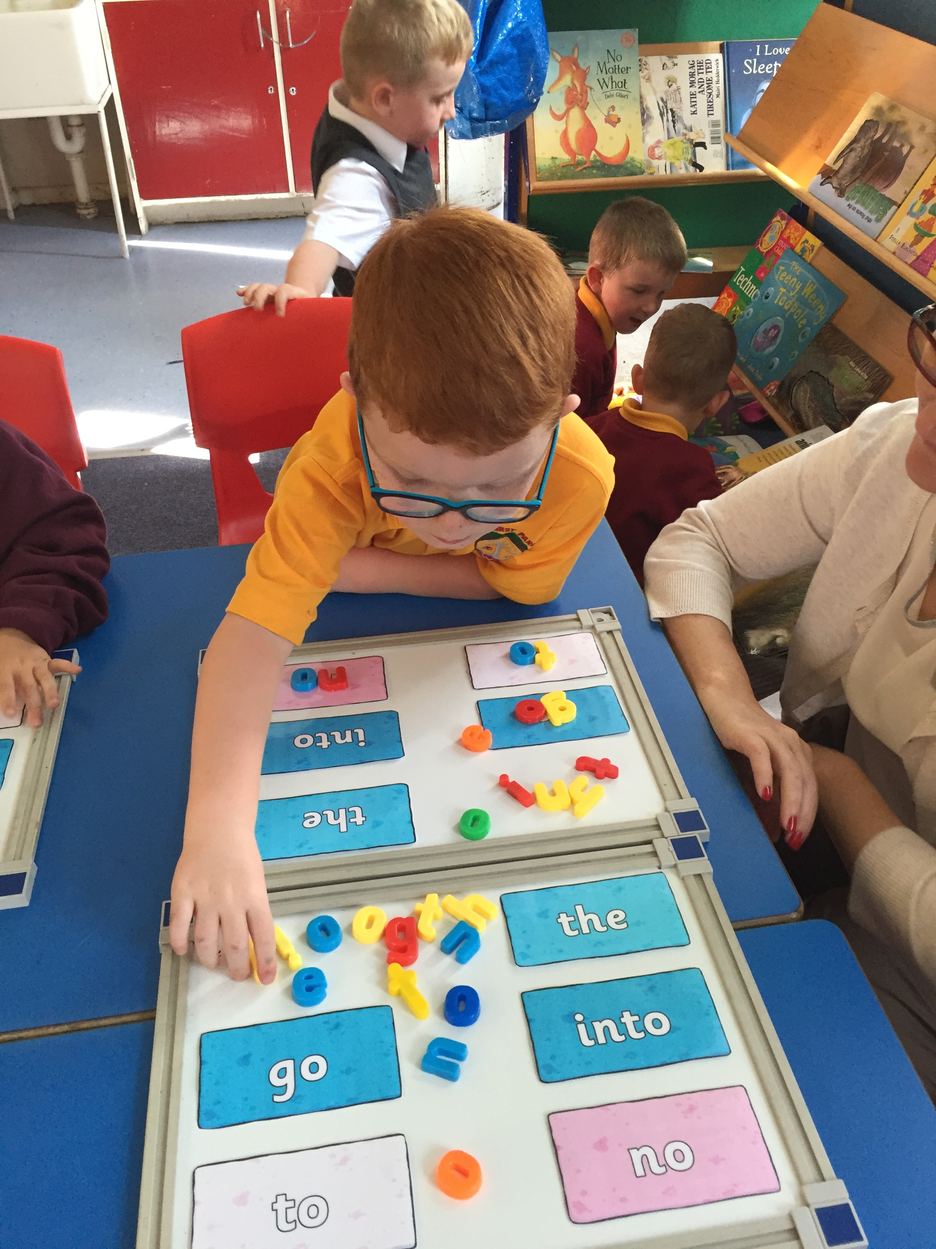

Our topic this term will be My School. We will work together to decide what we want to learn and record our thoughts and findings. We have already come up with some super questions of things we would like to find out! Our Religious and Moral Education topic will be babies. We look forward to finding out how to care for a new baby.
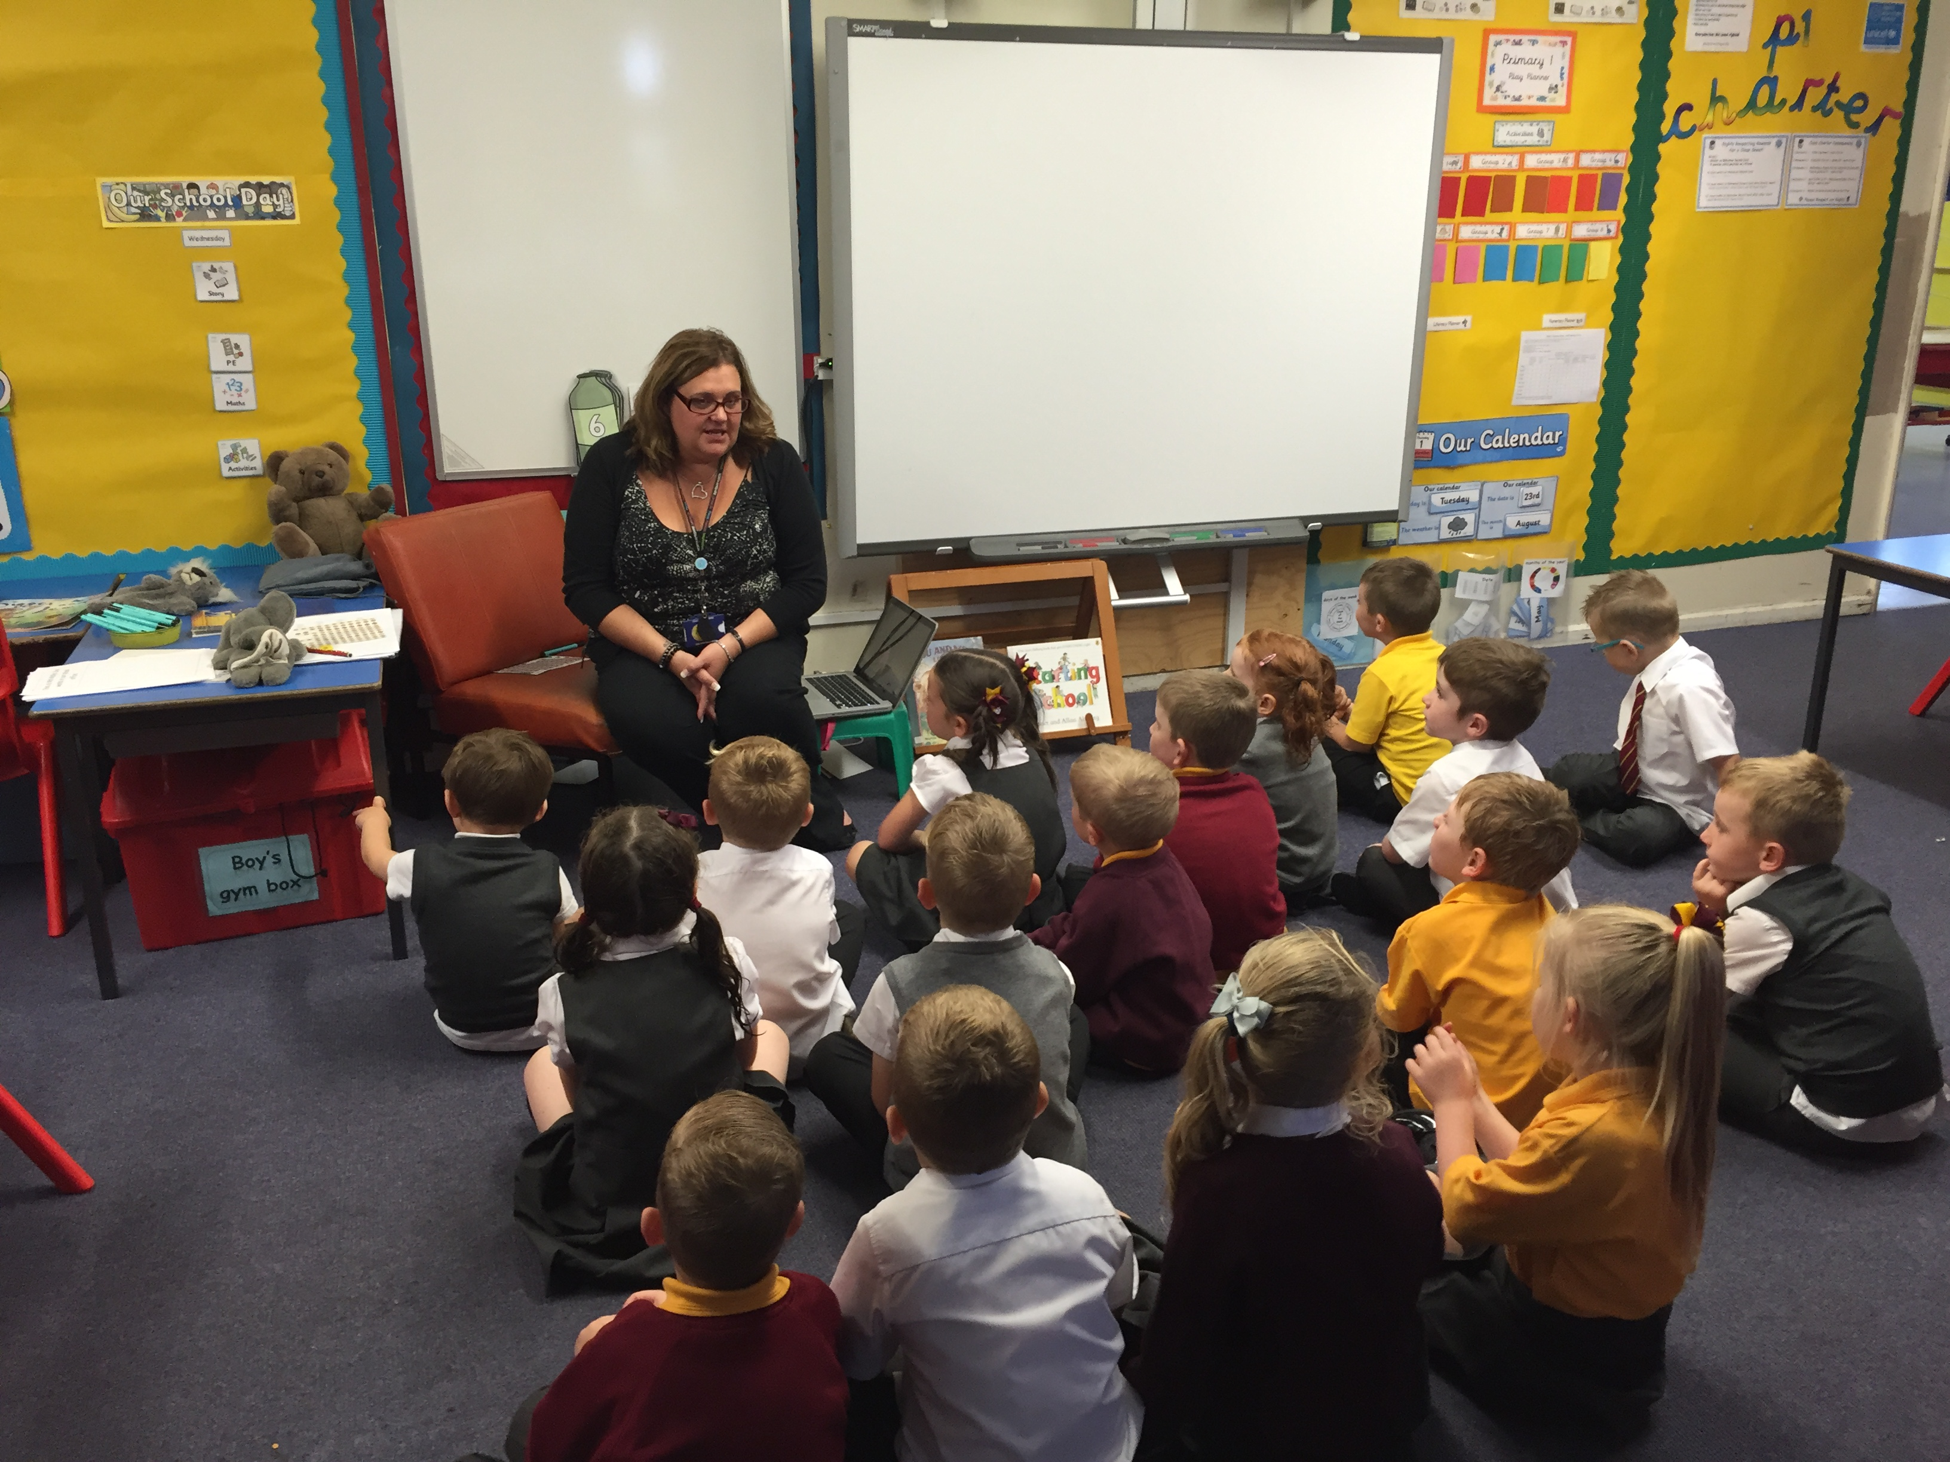
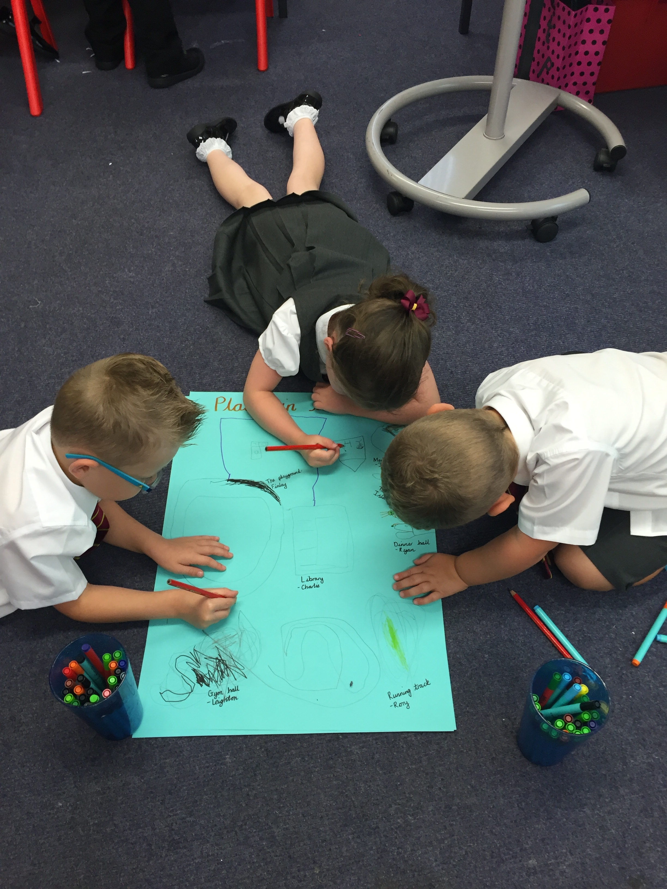
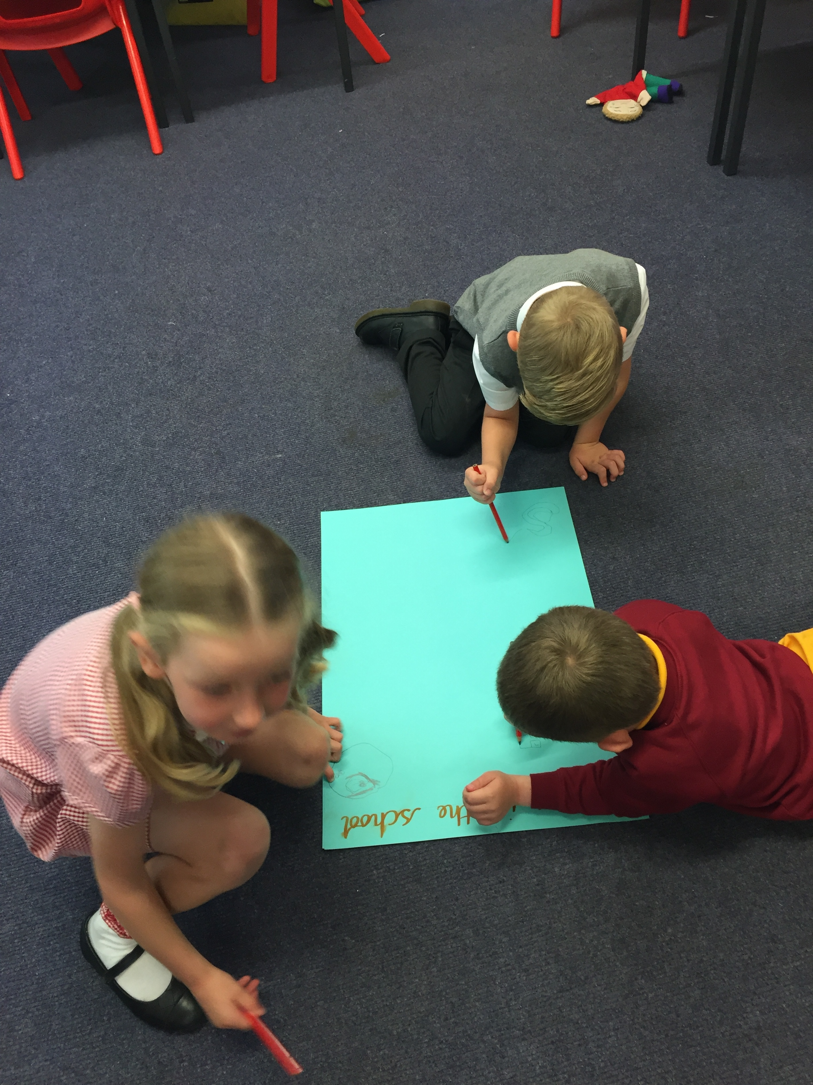

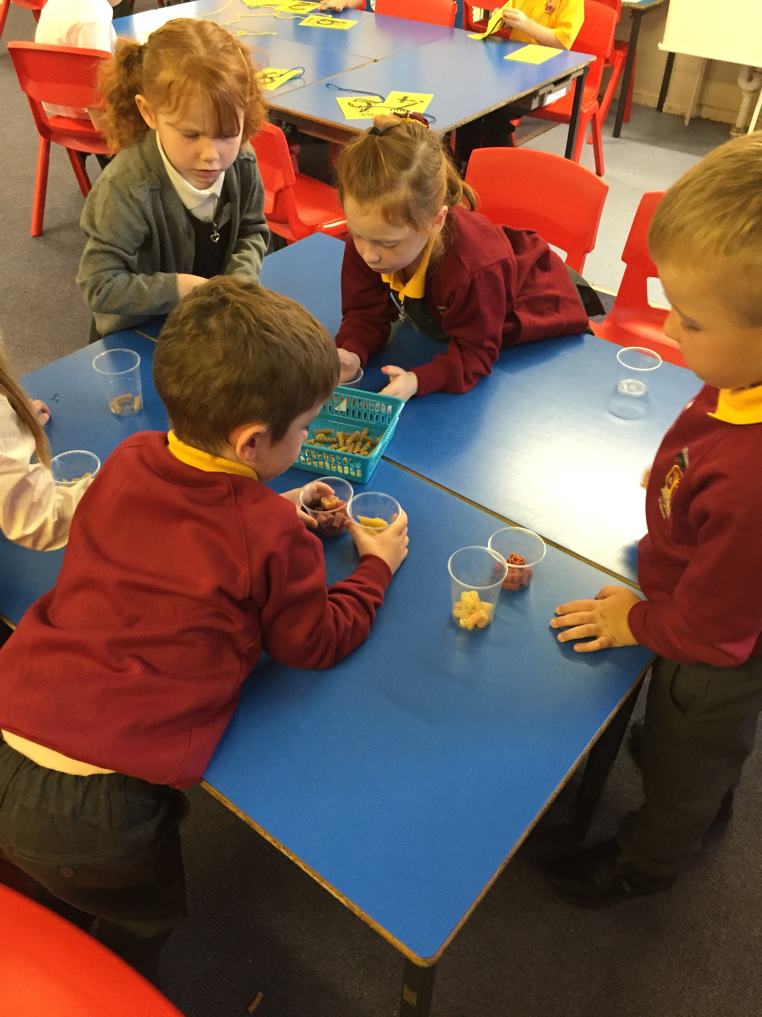
Our Literacy and Numeracy skills are developing well. We are learning our sounds and numeracy skills alongside Primary 1b and then undertaking activities together, across both classrooms. In numeracy we will be sorting, exploring pattern, learning to form our numbers correctly and learning to order numbers.
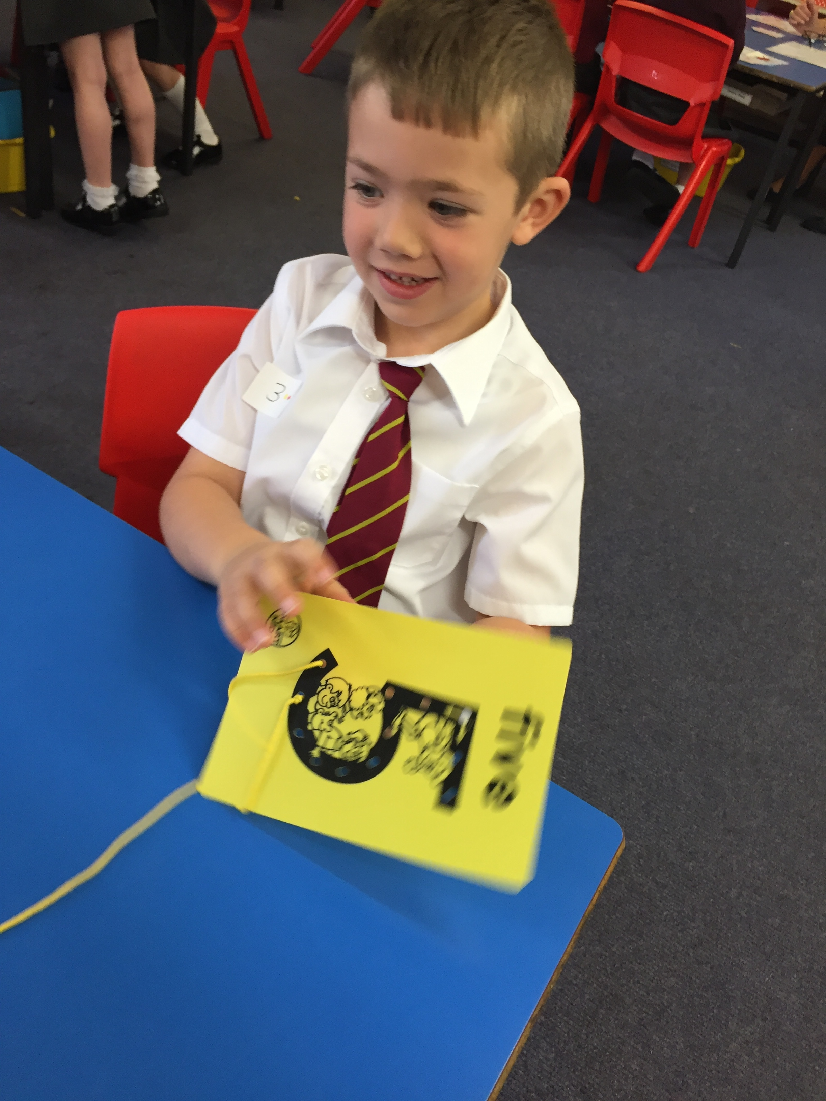
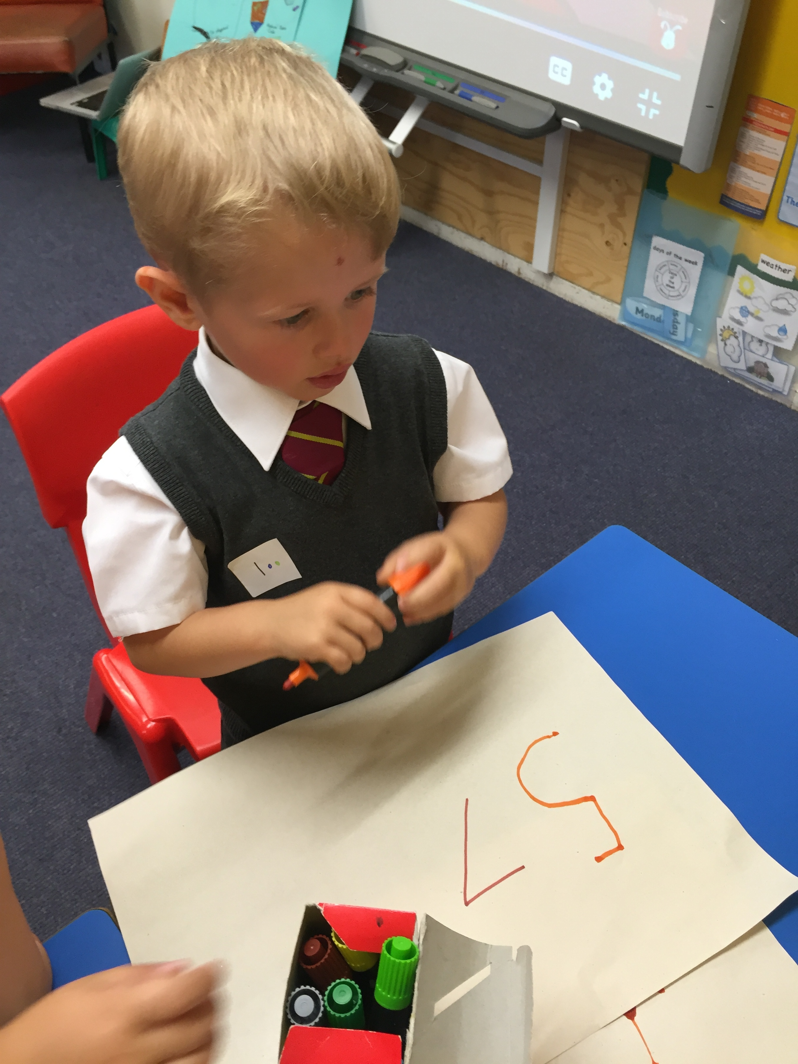

In Literacy, we will be learning around 3 new ‘sounds’ per week and will begin to put these together to make words. We will also be learning how to form letters using cursive script.

Our gym days will be Mondays and Wednesdays this year. Mrs McFarlane will take the class to gym on a Monday and Mrs Williams will take the class on a Wednesday. We will be taking part in small developmental games and then starting some gymnastics work. In Health and Wellbeing, we will be getting to know each other and learning how to build friendships. We will also learn to use ‘Turtle’ to help us deal with feelings.
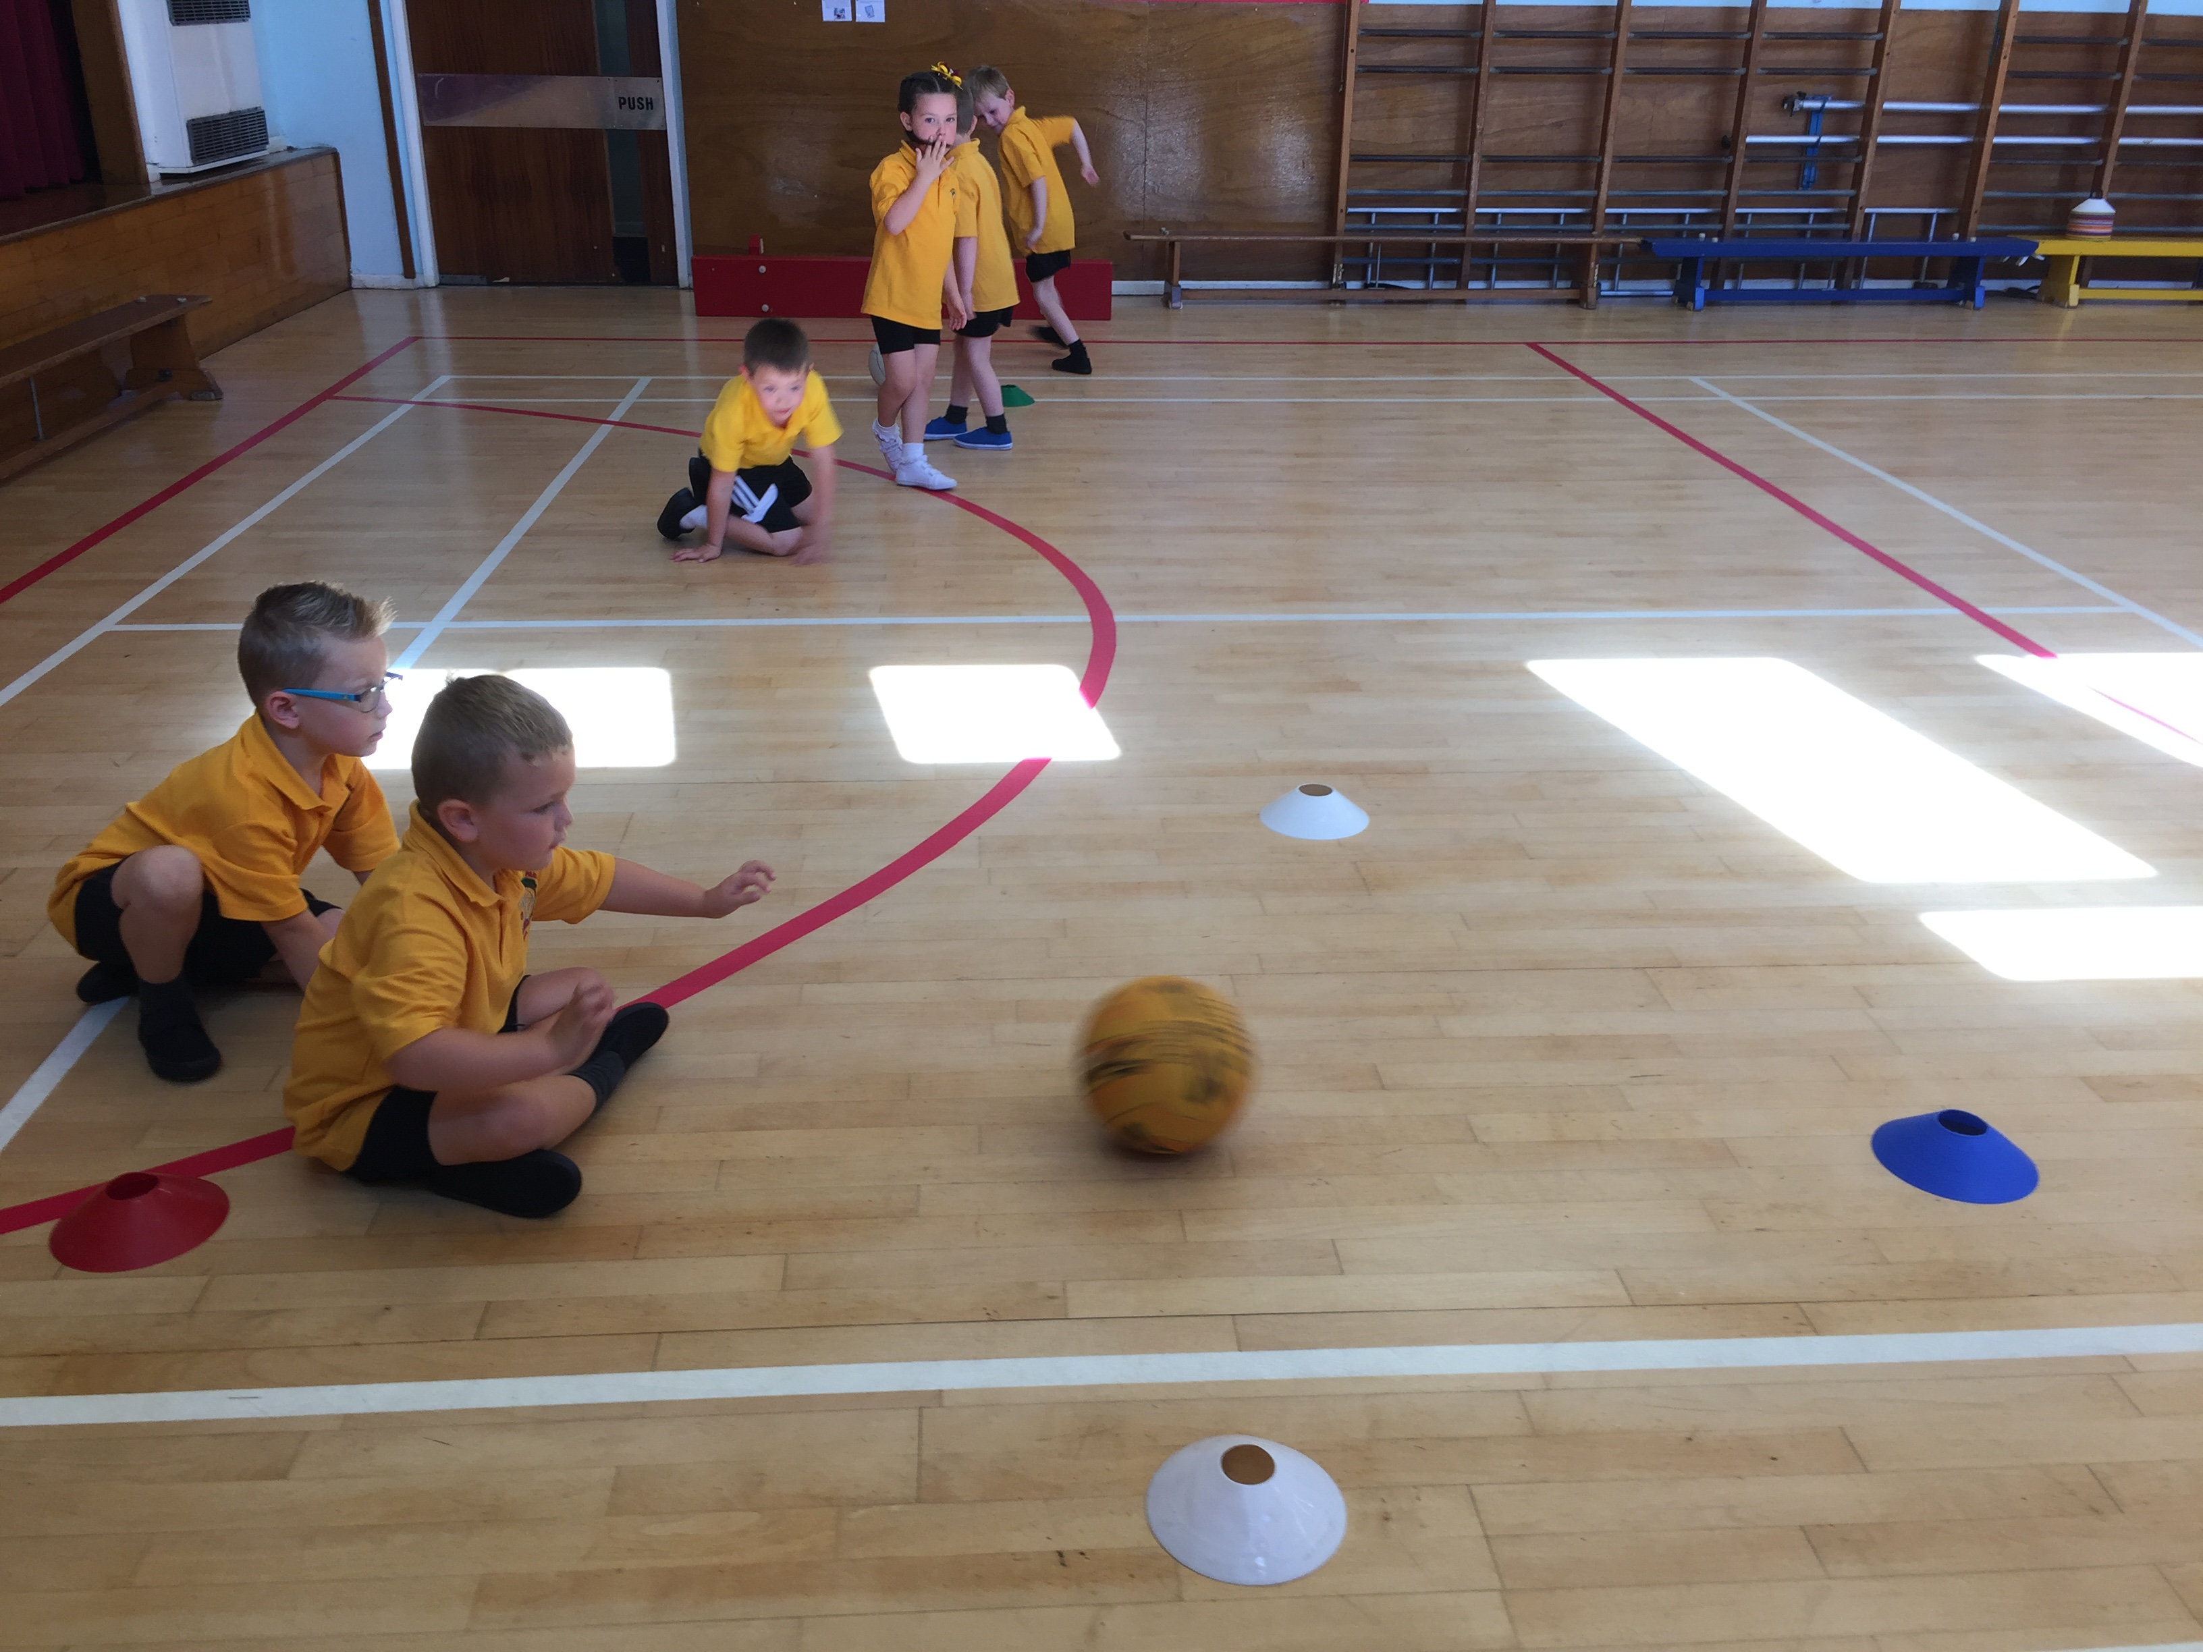
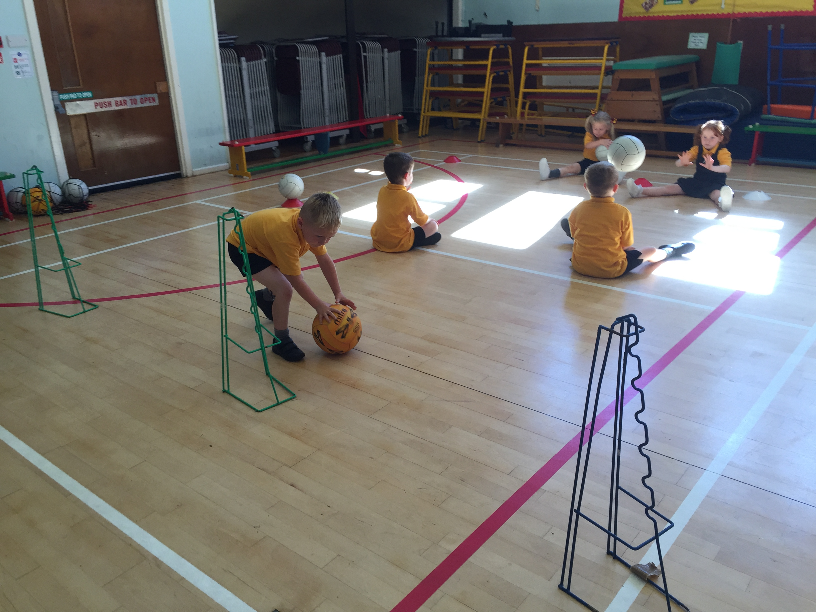
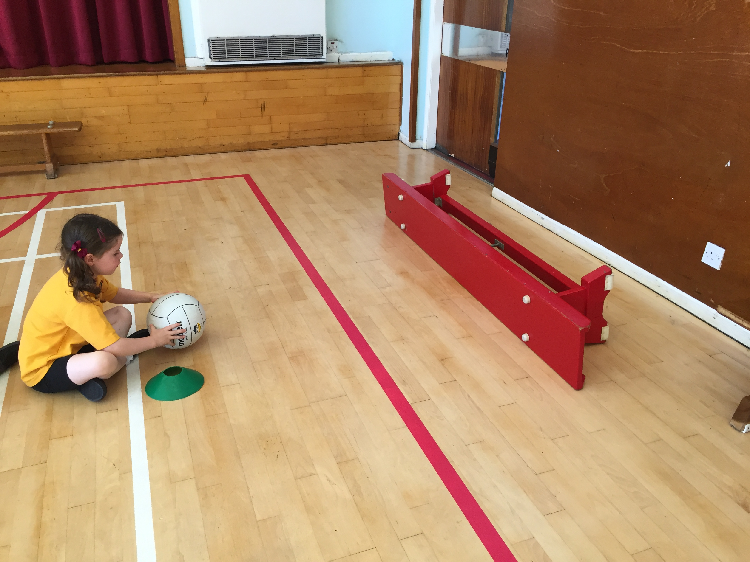

We are all enjoying getting to know each other and are looking forward to learning lots of new things together!

