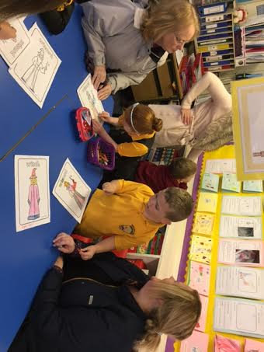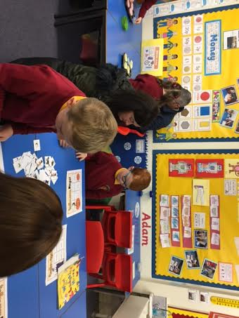Primary 1 are off to a flying start! We have had a super first term and are now fully settled into school life! We are very much enjoying our Soft Start in the morning and are taking part in a variety of activities such as writing, role play, numeracy games, finger gym, pencil control activities, building and constructing, craft projects and story telling. We are fortunate to have some parent helpers who assist the children during this time with art and craft activities. If you would like to help out for a short while in the mornings, please let Mrs McFarlane or Mrs Munro know. Homework on a weekly basis is working well, if there are any issues (e.g. a really busy week!) just let your child’s teacher know. It would be helpful if book bags could still be brought to school each day to allow us to issue any letters and other paperwork as and when required.

*Primary 1 Stay and play October 2016*

Our topic this term will be Toys. We will be investigating how toys work and linking this with our Science work of pushing and pulling. Our Religious and Moral Education topic will be Christmas. We will be exploring the Christmas story and learning about some Christmas traditions. We will also be very busy practising for our Primary 1 Nativity! Look out for letters coming out soon!

Our Literacy and Numeracy skills are developing well. We have now covered all of our Phase 2 sounds and words and will spend Term 2 revising these. We will be working more on blending sounds to read words, and segmenting words to learn how to write and spell them. We have worked very hard on writing our names using cursive script and this term will begin to practise our surnames too. We have started our letter formation using cursive script and although this is quite tricky, we are doing so well! This term we will continue to learn how to form lots of new letters and will do this in lots of ways – making them in shaving foam, writing them on chalkboards and whiteboards, drawing them in sand and using a pencil to write them in our jotters. This term in numeracy we will be learning about money using coins and counting 1ps and 2ps. We will extend our counting skills up to 30 and learn how to make amounts to 10 in different ways.

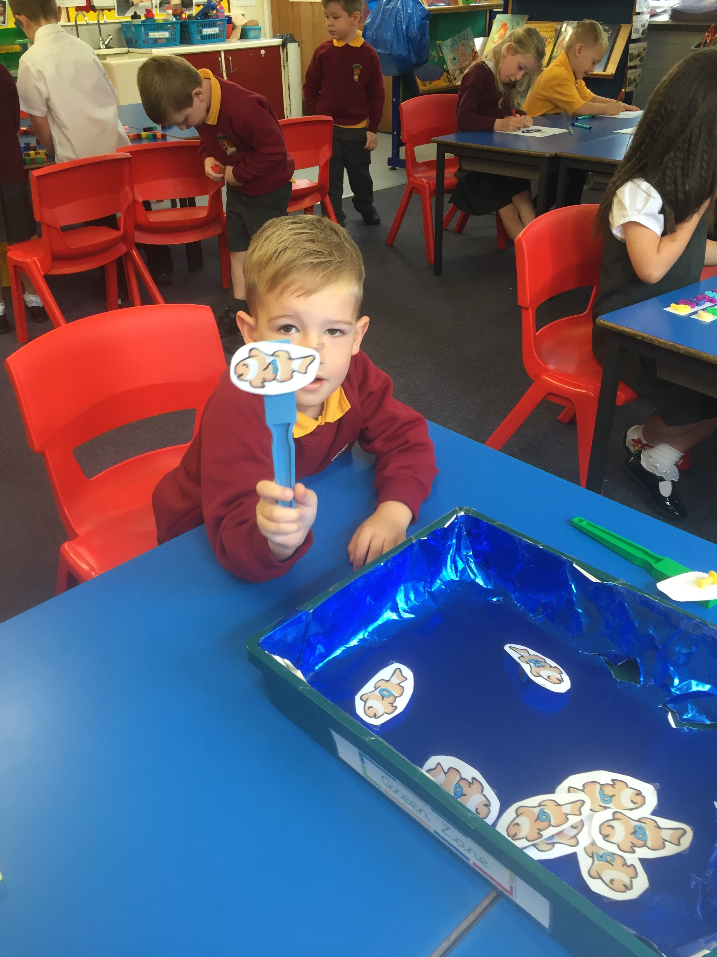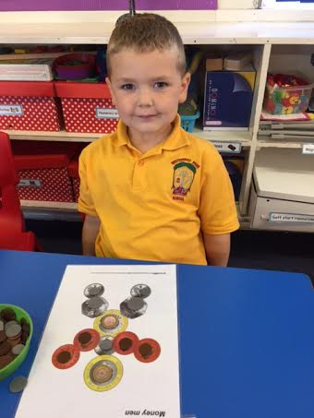

Our gym days will continue to be Mondays and Wednesdays (and an extra slot on a Thursday afternoon), though Nativity rehearsals, this may change slightly in the coming weeks. We are getting quicker at getting changed before and after gym, giving us lots more time to hone in skills in the gym hall! This term we will be working on target games such as hockey and basketball and towards Christmas, we will start to learn some group dances to allow us to perform these at our Christmas Party.

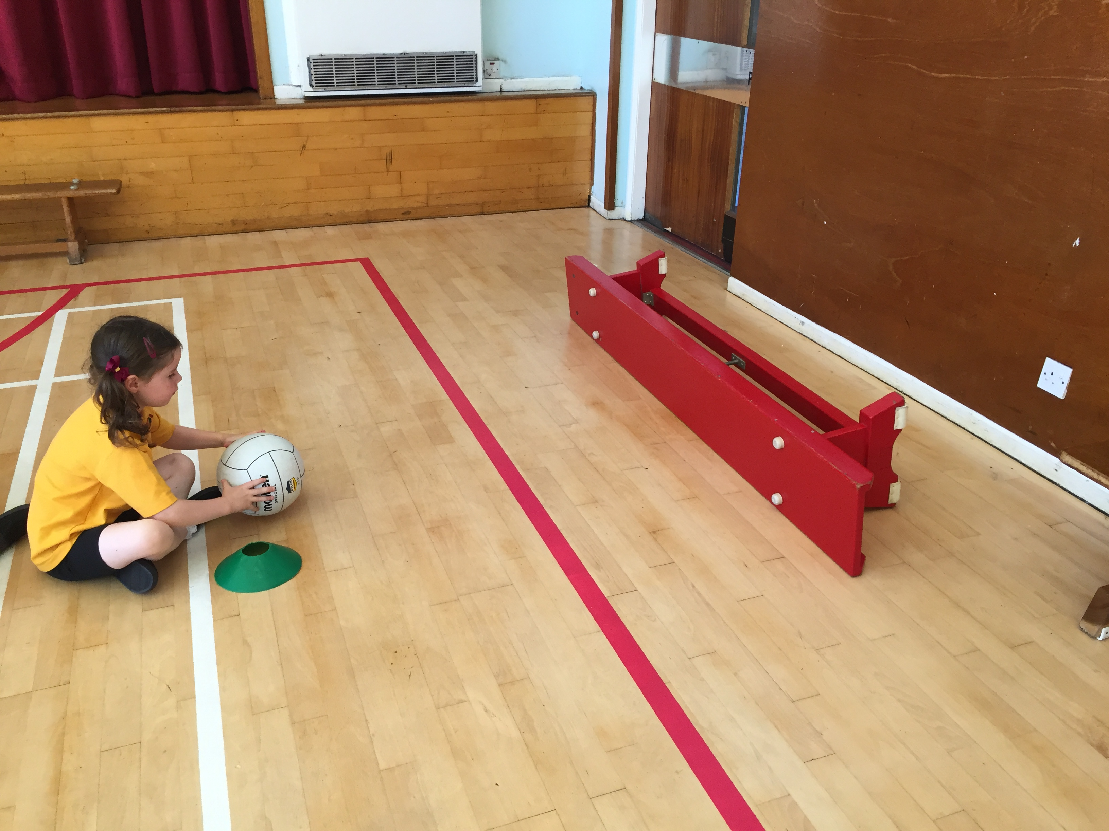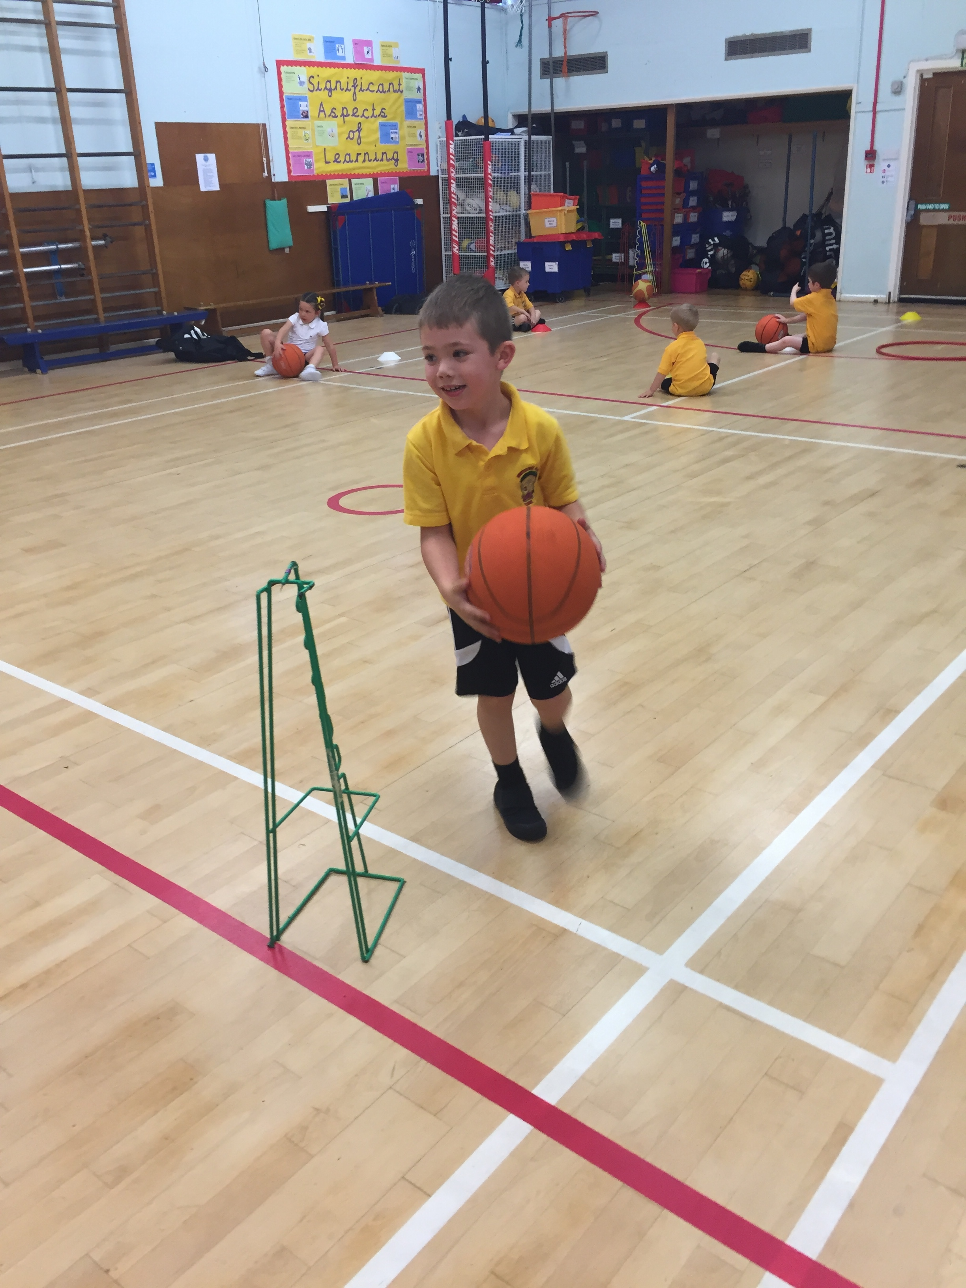

We have a very busy term coming up and will keep you informed of all the dates for your diary through school newsletters and notes on the homework sheets.