

Education Service
West Kilbride Primary School
and Early Years Class
Improvement Plan
2025-2026


Vision, Values and Aims
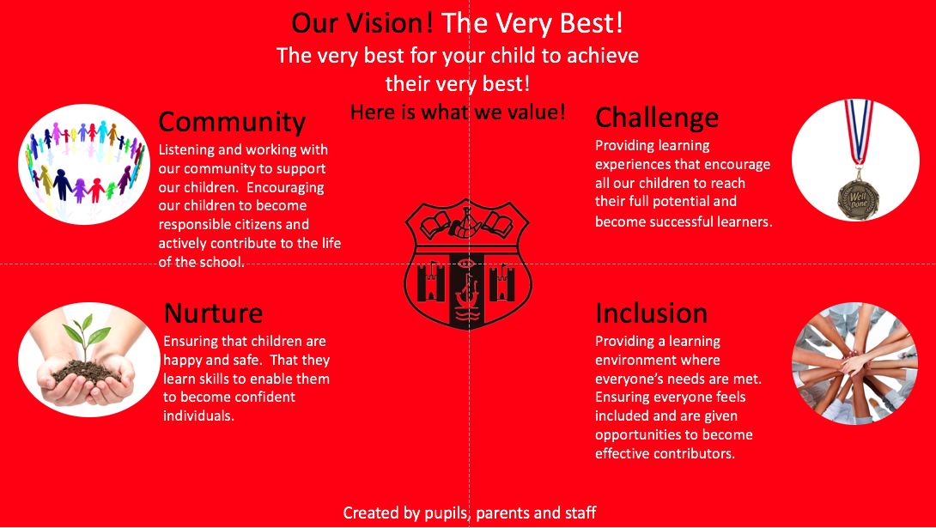

EDUCATION SERVICE: IMPROVEMENT PLAN SUMMARY 2023/4 – 2025/6

The Education Service Improvement Plan is aligned to the 5 priorities of the National Improvement Framework. Individual establishments should create their own plan under these 5 priorities, based on rigorous self-evaluation and analysis of performance evidence. Stakeholders should be fully engaged in the development of the plan. In the diagram below, the orange boxes show the thematic areas under each priority which the service intends to focus on in the year ahead.
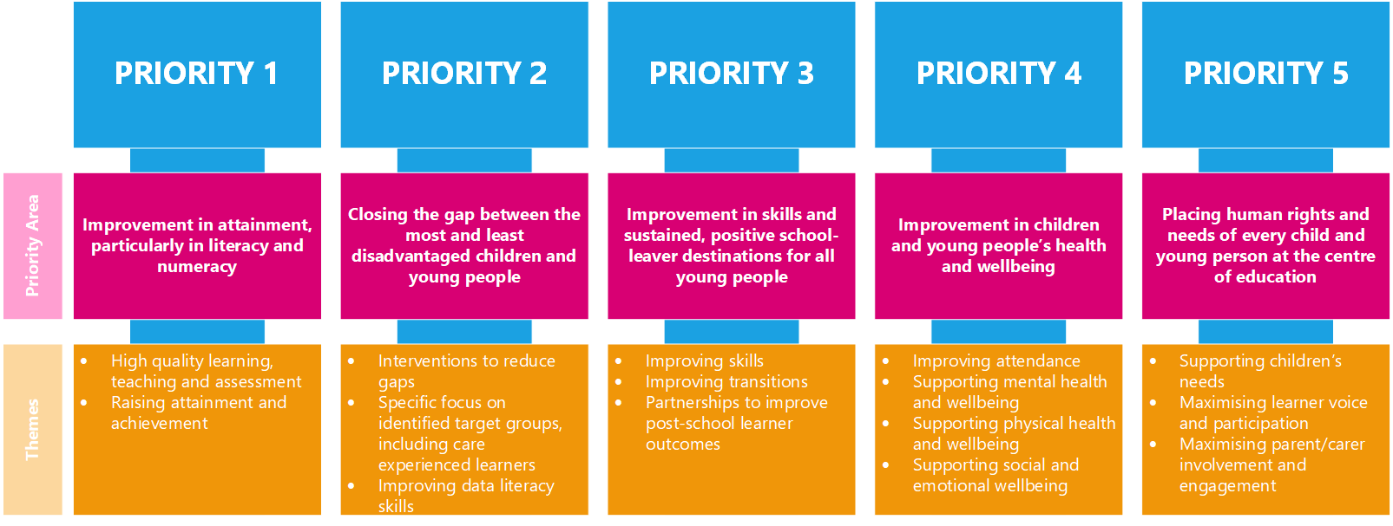

PRIORITY 1
Strategic Objective:
What do you we want to specifically achieve across your school/department/EY centre?
To empower all learners with the knowledge and skills to engage fully in the digital world of the 21st century through the direct teaching of Technologies outcomes and to ensure pupils are fully engaged with the wider curriculum, facilitated by the use of digital technologies.

Select the KEY drivers for this improvement priority
Education Service Priority  Please select the relevant service priorities | NIF Drivers of Improvement  Please select up to three NIF drivers | How Good Is Our School 4  Please select up to three quality indicators for this priority | Quality Improvement Framework for ELC settings  Please select up to three quality indicators for this priority
1. Improvement in attainment, particularly literacy and numeracy  3. Improvement in skills and sustained, positive school-leaver destinations | 2. Teaching and practitioner professionalism  4. Curriculum and assessment  5. School & ELC improvement | 2.3 Learning, teaching and assessment  2.2 Curriculum  3.2 Raising attainment and achievement | 3.3 Learning, teaching and assessment  1.2 Staff skills, knowledge, values and deployment  Curriculum
Rationale for Change
What did our analysis of data tell us? What self-evaluation information supports this change? Provide details of the gaps or barriers you wish to address. State clearly if this is related to PEF spend.
Lesson observations demonstrated limited use of digital technologies to facilitate learning across the curriculum. This was supported by feedback from our Local Authority Establishment Review, which stated, “Use of digital technologies is at an early stage of development” and suggested that the use of digital technologies could be further integrated into classroom practice. Informal professional dialogue with all staff groups (Class Teachers, EYC staff and PSA staffing) suggested a lack of professional confidence and competency in using a wide range of digital strategies to enhance learning and for Class Teachers, barriers to fully teaching Technology outcomes relating to ICT due to professional competency and a resource deficit.

PRIORITY 1: Action Plan
Pupil Outcomes | Implementation Plan | Timescales/  Responsibility | Measurement of Impact | Analysis & Evaluation of Progress | Cost  (PEF)
Specifically, what will change for our learners? | How will we achieve this?  What do we plan to do? | What are our timescales? Who will lead? | How will we know the change is an improvement? Can you quantify this?  What data will be collated and analysed to demonstrate progress? Consider baseline data. | How do we know that the experiences & outcomes for learners have improved? What does the data tell us which demonstrates impact? | Please enter the cost to the nearest £
Learners will benefit from enhanced use of digital technologies to support learning and teaching across all areas of the curriculum. | St All staff will become familiar with the new 2-18 NAC digital strategy, implementing this in our EYC and P1-7 classes.  All staff will participate in Microsoft Educator and Microsoft 21st Century Learning Design training to be able to use a range of digital technologies confidently across the curriculum.  Most teaching staff will attend ‘Using AI’ training at the PLA.  PSA staff will attend ‘Digital Accessibility’ training at the PLA.  Staff will integrate digital technologies into children’s play and learning experiences, both outside and indoors and recognise and celebrate where this is happening.  P6 pupils will take part in a digital learning project with our Trio schools to facilitate learning within an IDL context using digital platforms.  PP Pupils will have access to the Sumdog learning platform to enhance digital access to Literacy and Numeracy resources and act as a tool to support engagement. | June 2026  DHT  June 2026  HT  September 2025  PLA/HT  February 2026  PLA/HT  Ongoing  HT  April 2026  HT  August 2025  DHT | Staff will complete a baseline skills audit followed by a post-intervention audit to identify gaps and demonstrate progress.  Post-training exit passes will demonstrate increased staff confidence and competency.  Post-training exit passes will demonstrate increased staff confidence and competency.  Post-training exit passes will demonstrate increased staff confidence and competency.  Forward planners will evidence increased inclusion of digital technologies to support learning across the curriculum. Pupil and staff surveys will demonstrate increased use of ICT within learning and teaching.  Post-project feedback will evidence high levels of pupil engagement, supported by the use of digital technology. Completed projects will also evidence completed aim.  Sumdog usage will be tracked and pupil voice sought to determine engagement levels.
Learners will benefit from staff who are confident and competent in delivering learning outcomes directly related to technologies. | Key teaching staff will participate in Sphero Bolt and Vex 123 training, supported by access to these resources to enable practical implementation of skills mastered.  A Digital Skills Cluster In-service day will also support upskilling on a range of apps and hardware.  Staff will explore using ‘Purple Mash’ as a teaching resource, allowing for the delivery of progressive, coherent and engaging lessons with a technologies focus.  Resources will be purchased to support the delivery of Technologies outcomes. | June 2026  DHT  November 2025  Cluster HTs  June 2026  HT  June 2026  DHT | Post-training exit passes will demonstrate increased staff confidence and competency.  Post-training exit passes will demonstrate increased staff confidence and competency.  Forward planners will evidence use of Purple Mash programme of work from EYC through to P7.  Resource inventory. |  | Training Costs  £140  Purple Mash Subscription  £1100  Resources  £3500

PRIORITY 2
Strategic Objective:
What do you we want to specifically achieve across your school/department/EY centre?
Pupils will be actively engaged in their learning processes, including in individual target-setting and within assessment practices, leading to increased engagement and more motivated learners.

Select the KEY drivers for this improvement priority
Education Service Priority  Please select the relevant service priorities | NIF Drivers of Improvement  Please select up to three NIF drivers | How Good Is Our School 4  Please select up to three quality indicators for this priority | Quality Improvement Framework for ELC settings  Please select up to three quality indicators for this priority
5. Placing human rights and needs of every child and young person at the centre of education  1. Improvement in attainment, particularly literacy and numeracy | 4. Curriculum and assessment  5. School & ELC improvement  Choose an item. | 1.2 Leadership of Learning  3.2 Raising attainment and achievement  Choose an item. | 3.3 Learning, teaching and assessment  1.2 Staff skills, knowledge, values and deployment  4.3 Children's progress
Rationale for Change
What did our analysis of data tell us? What self-evaluation information supports this change? Provide details of the gaps or barriers you wish to address. State clearly if this is related to PEF spend.
Lesson observations evidenced a lack of pupil participation in assessment processes- whilst there was some use of peer or self-assessment, this was marginal. There also continues to be a lack of effective use of AIfL strategies within learning and teaching. Whilst some pupils are involved in target-setting across the school, again this is not consistent. Feedback from our Local Authority Establishment Review also suggested increased planning for high quality assessment activities during the planning process to evidence application of learning, with pupil voice being more evident in planning and target setting across all aspects of learning achievement.
Within our EYC, planning will need to be adapted to align with changes to our Local Authority format, ensuring a consistent approach is taken to planning, assessment and tracking. Changes to observation recording, including the use of digital technologies, could free up staff to produce more high- quality observations.

PRIORITY 2: Action Plan
Pupil Outcomes | Implementation Plan | Timescales/  Responsibility | Measurement of Impact | Analysis & Evaluation of Progress | Cost  (PEF)
Specifically, what will change for our learners? | How will we achieve this?  What do we plan to do? | What are our timescales? Who will lead? | How will we know the change is an improvement? Can you quantify this?  What data will be collated and analysed to demonstrate progress? Consider baseline data. | How do we know that the experiences & outcomes for learners have improved? What does the data tell us which demonstrates impact? | Please enter the cost to the nearest £
Pupils will benefit from the use of high quality assessment practices. | Staff will use a variety of formative and summative assessment practices, with increased use of AIfL strategies, supported by CLPL input.  Pupils will engage in increased peer and self-assessment, supported by robust, co-created success criteria.  Staff and pupils will use Seesaw as a tool for formative assessment, with pupils independently capturing work for assessment across EYC to P7.  Staff will engage in CLPL to develop their competency in using Seesaw as a tool to track, record and assess learning.  Within the EYC, staff will trial a new model for recording observations, supported by the use of Seesaw to reduce bureaucracy and support planning. | Ongoing  HT  Ongoing  HT  Ongoing  HT  January  HT  Ongoing  HT | Lesson observations and ongoing dialogue with pupils will evidence increased use of AIfL strategies.  Lesson observations and jotter audits will evidence increased use of peer and self-assessment.  Seesaw learning journals will record pupil work.  Post-training exit passes will demonstrate increased staff confidence and competency.  Observation information will be focussed and concise. Staff feedback will share positive views on new approach. |  | Seesaw Subscription  £2616
Pupil voice will be increased with pupils using digital tools to set personal learning goals. | A consistent tool and model will be implemented to ensure pupils are setting individual learning goals and evaluating these regularly across the school and EYC, at an age and stage appropriate level. | Ongoing  HT | Pupil targets will demonstrate individual goals and progress towards these.
EYC pupils will benefit from consistent and streamlined approaches to planning in line with Local Authority guidance, which will support EYC staff to focus more on high quality interactions and observations. | Supported by the NAC central team, who will meet with EYC staff fortnightly, the EYC team will trial a new approach to planning using the new NAC planning documents. | Ongoing  HT/ Rachel Reid | New planning documents will be in use.

PRIORITY 3
Strategic Objective:
What do you we want to specifically achieve across your school/department/EY centre?
We will develop skills progressions to support play and skills based learning to ensure meta-skills are explicit and progressively taught across all areas of the curriculum, including further utilising the outdoors.

Select the KEY drivers for this improvement priority
Education Service Priority  Please select the relevant service priorities | NIF Drivers of Improvement  Please select up to three NIF drivers | How Good Is Our School 4  Please select up to three quality indicators for this priority | Quality Improvement Framework for ELC settings  Please select up to three quality indicators for this priority
3. Improvement in skills and sustained, positive school-leaver destinations  4. Improvement in children and young people's health and wellbeing | 4. Curriculum and assessment  2. Teaching and practitioner professionalism  5. School & ELC improvement | 3.3 Increasing creativity and employability  3.2 Raising attainment and achievement  2.2 Curriculum | 3.1 Play and learning  Curriculum  4.3 Children's progress
Rationale for Change
What did our analysis of data tell us? What self-evaluation information supports this change? Provide details of the gaps or barriers you wish to address. State clearly if this is related to PEF spend.
Last year, we incorporated Play pedagogy within P1 and 2 and created opportunities for enquiry-based learning within P3-7. This was well received by both staff and pupils with the ‘How Good is our Play Pedagogy’ post-assessment tool showing that we have made improvements in nearly all areas, in particular in having a vision of play as part of education, having a balance of learner directed play, guided play and direct instruction and engagement in risky play. The natural next step in this journey is the incorporation of a meta-skills framework to support pupils to be able to identify and track the skills they are learning both through play experiences and learning and teaching opportunities. Staff have shown a keenness to work towards this as an area for improvement.

PRIORITY 3: Action Plan
Pupil Outcomes | Implementation Plan | Timescales/  Responsibility | Measurement of Impact | Analysis & Evaluation of Progress | Cost  (PEF)
Specifically, what will change for our learners? | How will we achieve this?  What do we plan to do? | What are our timescales? Who will lead? | How will we know the change is an improvement? Can you quantify this?  What data will be collated and analysed to demonstrate progress? Consider baseline data. | How do we know that the experiences & outcomes for learners have improved? What does the data tell us which demonstrates impact? | Please enter the cost to the nearest £
Staff will be confident in planning play/enquiry-based learning opportunities which support the development of Meta-skills, enabling pupils to benefit from high quality learning environments. | Staff will be introduced to the Meta-skills Progression Framework to support them to identify what meta-skills look like in practice for each level of CfE.  Staff will develop play/enquiry based learning experiences with an identified skills focus during open area rotations.  Staff will incorporate the language of Meta-skills into lesson starters and plenaries to encourage pupils to identify skills being developed and evaluate their own progress towards this. | September 2025  HT  Ongoing  DHT  October 2025 onwards  Class Teachers | Staff will use the ‘Embedding Skills’ audit tool to self-evaluate practice in relation to meta skills in both August 2025 and May 2026 to demonstrate progress.  Open area planners will demonstrate a skills focus for each area.  Lesson observations will evidence clear links to meta-skills.
Pupils will be confident in using the language of Meta-skills to support them to plan and evaluate their own progress and achievement. | Pupils will be introduced to Meta-skills via the Meta Skills Land resources including the introduction of Meta Skills Land Characters within class lessons and at assembly times.  Pupils within P3-7 will self-evaluate their individual progress towards Meta-skills development through the termly use of the Learner Self-evaluation toolkit. This will begin in Term 3 once pupils are familiar with meta-skills language.  Pupils within P3-7 will set termly targets based upon areas identified for development during self-reflection. This will begin in Term 3 once pupils are familiar with meta-skills language. | October 2025 onwards  Class Teachers/ DHTs  Term 3 and 4  Class Teachers  Term 3 and 4  Class Teachers | Dialogue with pupils will demonstrate that they are familiar with the Meta Land characters. Pupils will be able to explain the traits of each of the characters.  Completed self-evaluation wheels will demonstrate progress within skills development in most pupils within P4-7.  Termly pupil targets will be recorded from term 3 onwards to evidence individual progress.
Open area and outdoor learning environments will be further enhanced to support pupils to access meaningful skills-based learning experiences. | An outdoor learning development plan has been created which will see the creation of a raised pond area, bug hotels, an outdoor workshop and an outdoor classroom with seating area to support pupils to develop and use transferable skills outdoors.  The Infant and P7 open areas will be further resourced to support a play/enquiry-based learning model including the purchase of a reading zone and role play area. | June 2026  HT  October 2025  HT | Pupil surveys will demonstrate increased time spend engaging in outdoor learning activities. School will be awarded the Level 4 RHS Gardening Award.  Pupil surveys will evidence pupil use of and views on new resources. |  | Outdoor development  £20,000  Open area development  £5000

PRIORITY 4
Strategic Objective:
What do you we want to specifically achieve across your school/department/EY centre?
Pupils will benefit from more accessible and inclusive learning environments which will promote inclusion and engagement for all learners.
Select the KEY drivers for this improvement priority
Education Service Priority  Please select the relevant service priorities | NIF Drivers of Improvement  Please select up to three NIF drivers | How Good Is Our School 4  Please select up to three quality indicators for this priority | Quality Improvement Framework for ELC settings  Please select up to three quality indicators for this priority
3. Improvement in skills and sustained, positive school-leaver destinations  4. Improvement in children and young people's health and wellbeing | 4. Curriculum and assessment  2. Teaching and practitioner professionalism  5. School & ELC improvement | 2.4 Personalised support  3.1 Ensuring wellbeing, equality and inclusion  Choose an item. | 3.1 Play and learning  Curriculum  4.3 Children's progress
Rationale for Change
What did our analysis of data tell us? What self-evaluation information supports this change? Provide details of the gaps or barriers you wish to address. State clearly if this is related to PEF spend.
Class teachers currently audit their own learning environments termly using a checklist; recommendations from our Local Authority Establishment Review suggest that this should now be monitored by SLT to ensure areas a clutter free, organised and promote independence in learning. Enhanced use of environment checklists and Circle framework audits would ensure learning environments are inclusive and promote a more active approach to learning, taking cognisance of all learning styles. This would reduce low and medium-level distress behaviours which were identified as a root cause in disrupting learning within our Promoting Positive Behaviours Staff Survey.

Analysis of Insight data in the secondary and ACEL data in the primary continues to show that there is a significant attainment gap between those with an ASN and those who do not have an ASN. Analysis of results, AAA data in secondary and pupil feedback shows that there is still work to do on meeting the learning needs of all learners. Staff feedback shows that not all staff feel confident in supporting learners with additional support needs. Pupils need to feel supported with their learning and staff need to upskill their knowledge about specific needs and confidently support learners of different levels within their classrooms. Feedback from staff and PSAs shows that there is also a need to develop a more cohesive approach to CLPL across Pupil Support, Astra and SSR. This alongside the introduction of targeted support teachers in Primary Schools presents us with opportunities to work together to support these new staff. Work is also required to ensure that there is a consistent approach to creating inclusive classroom environments across the school and the cluster which will support transitions. It has been agreed that this will form cluster work next session.

PRIORITY 4: Action Plan (Cluster Priority)
Pupil Outcomes | Implementation Plan | Timescales/  Responsibility | Measurement of Impact | Analysis & Evaluation of Progress | Cost  (PEF)
Specifically, what will change for our learners? | How will we achieve this?  What do we plan to do? | What are our timescales? Who will lead? | How will we know the change is an improvement? Can you quantify this?  What data will be collated and analysed to demonstrate progress? Consider baseline data. | How do we know that the experiences & outcomes for learners have improved? What does the data tell us which demonstrates impact? | Please enter the cost to the nearest £
The development of a cross cluster strategy will meet the needs of all learners, particularly those with an additional support need. | Use of the Circle Resource across the cluster to develop practice around creating an inclusive learning environment. | Ongoing  Cluster Primary HTs | Pupil feedback will show that pupils have access to inclusive classrooms. Staff will feel more confident in their ability to create inclusive classrooms to meet the needs of all learners.  Staff will use Circle Resource audit tool to evaluate practice and identify next steps.
Pupils will benefit from the development of inclusive learning environments in line with Circle Resource. | A test of change will trial new adapted learning environments, featuring soft furnishings, alternative learning spaces and adaptive seating. | October 2025 | Post-intervention pupil surveys will show satisfaction in new classroom design.  PASS data in trial classes will increase by 2%.  Environment checklists will be completed termly by SLT alongside lesson observations to identify areas for development in each classroom. |  | Adapted Classroom environments  £6000
Pupils will benefit from staff who are well trained in meeting a range of ASN needs and in delivering bespoke strategies to improve attainment. | Key staff will engage in training designed to support pupils with Additional Support Needs. Training will include SCERTS Transactional Supports, Kitbag and Little Interventions for Little People. | February 2026  PLA/HT | Post-training exit passes will demonstrate increased staff confidence and competency.

This should only be completed for aspects of your PEF spend not included within your Improvement Plan priorities.
PEF contact - HT or DHT with responsibility for the plan: |  |  | Gemma Carson
Carry forward: | £20142.78 | Total Allocation: | £49,000 | Total: | £69,142.78  Proposed spend- £58,632
PEF Action Plan
Poverty Related Gap | Pupil Outcomes | Implementation Plan | Timescales/  Responsibility | Detail of Spend | Measures of Impact | Analysis & Evaluation of Progress
Provide details of the gap or barrier you wish to address. | Specifically, what will change for our learners? | What do we plan to do to achieve this outcome? | What are our timescales?  Who will lead? | Record cost & provide concise detail of what this entails. | How will we know the change is an improvement? Can you quantify this? What data will be collated and analysed to demonstrate progress? Consider baseline data. | What does the data tell us? How well is evidence from self-evaluation analysed to improve pupil outcomes? How is the spend contributing to narrowing our attainment gap?
Many of our pupils within SIMD 1 and 2 are limited by West Kilbride’s geographical location and as such, learning experiences or trip out-with the village are limited. | Learners will be supported to access a wide range of learning opportunities out-with the local area including festivals, sporting events and learning experiences. | Buses will be paid for by the school for events where it is felt that cost will be a barrier to attendance. Additionally, where there is a family cost to some excursions, school will pay for those families who are not able to. | August 2025- June 2026 | £2000 | Almost all pupils will be able to experience an out of school learning experience across 2024-2025.
Many disadvantaged pupils are still identified as being off-track with their attainment. | Pupils will be supported using a variety of intervention programmes. | Two part-time Pupil Support Assistants will support with delivery of intervention programmes to ensure they are consistent and comprehensive. | August 2025- June 2026 | £16276 | Improved individual pupil data. Improved overall school attainment data.
Many disadvantaged pupils are still off track in Reading. | A sideways progression framework with a tailored Reading programme designed to support intervention work will support all pupils to make steady and consistent progress at an individual level. | Purchase additional reading scheme to support sideways progression pathway for P4-7 learners who are not on track within Reading. | December 2025 | £2000 | Individual progress in pupils off track in Reading will be evidenced by SWRT results. Most pupils using differentiated scheme of work will make progress at an individual level.

