

Communities and Education Directorate
West Kilbride Early Years Class
Improvement Plan
2024-2025
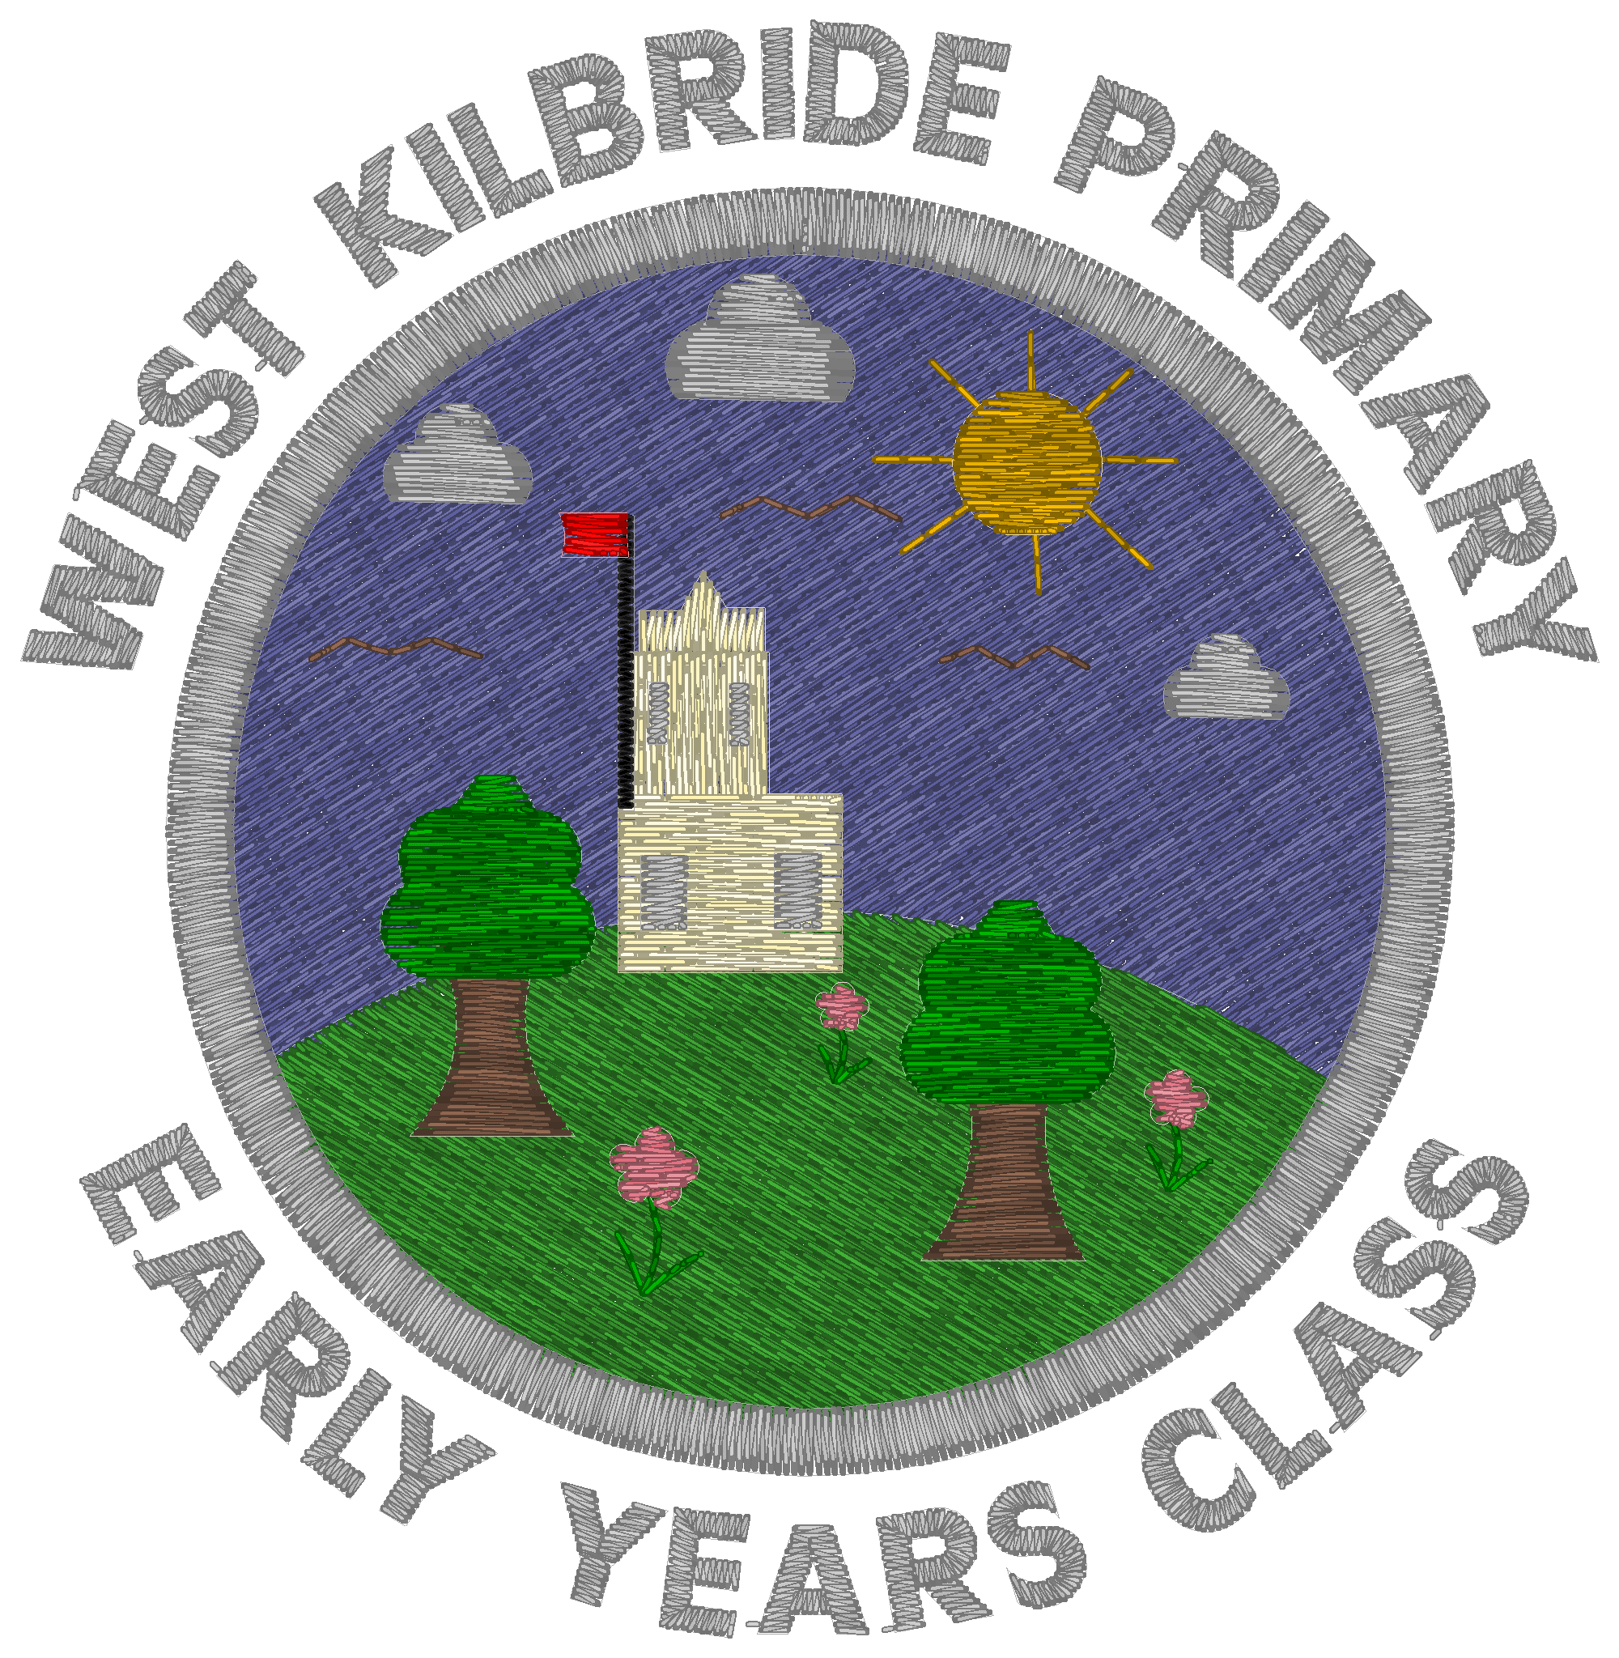

Vision, Values and Aims

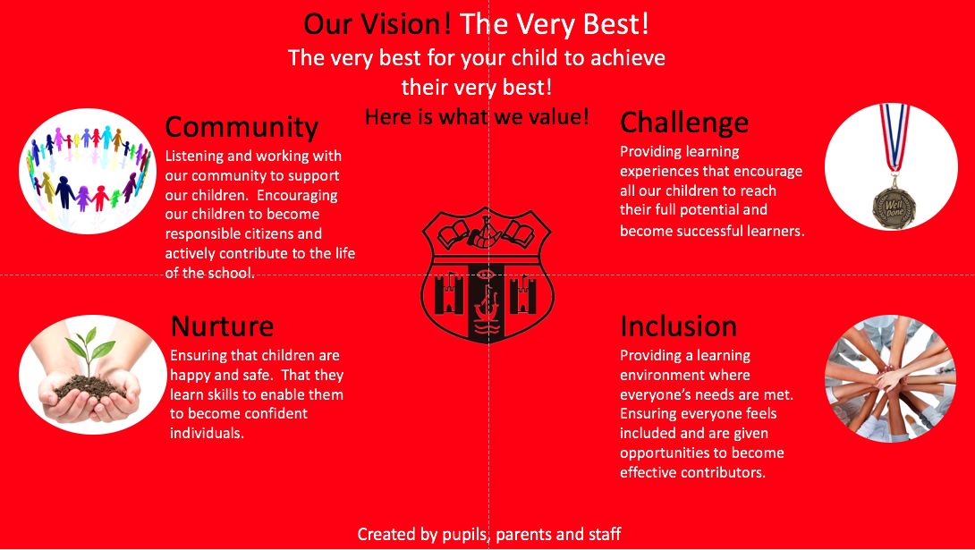

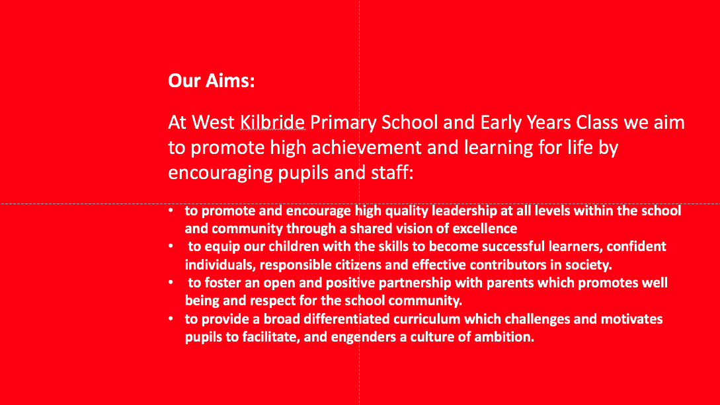

EDUCATION SERVICE: IMPROVEMENT PLAN SUMMARY 2023/4 – 2025/6

The Education Service Improvement Plan is aligned to the 5 priorities of the National Improvement Framework. Individual establishments should create their own plan under these 5 priorities, based on rigorous self-evaluation and analysis of performance evidence. Stakeholders should be fully engaged in the development of the plan. In the diagram below, the orange boxes show the thematic areas under each priority which the service intends to focus on in the year ahead.
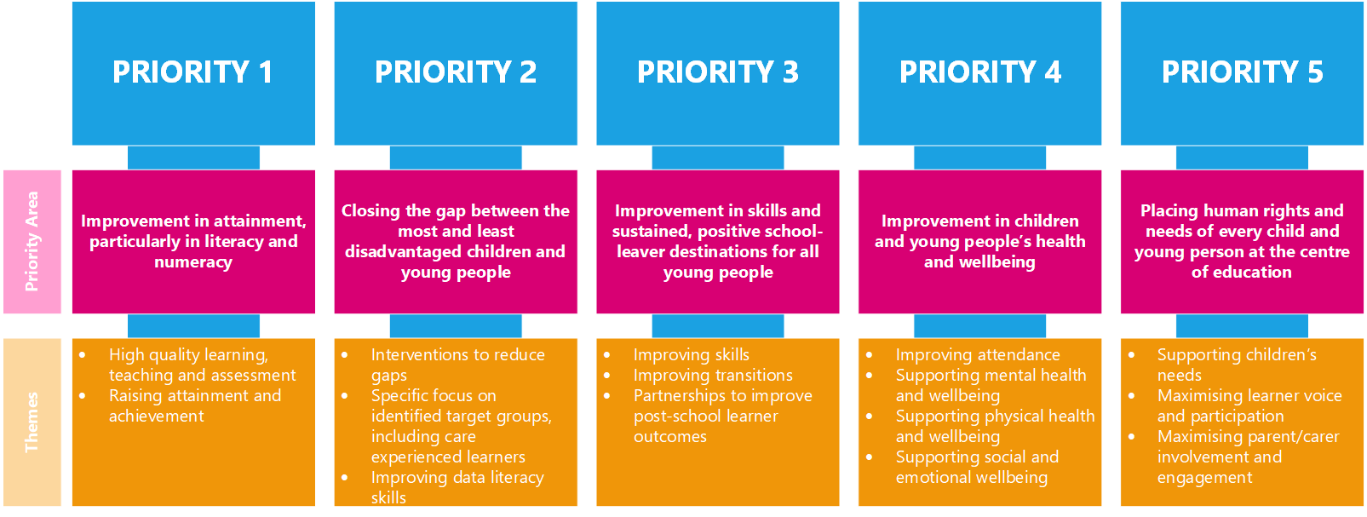

PRIORITY 1 To maintain attainment in Literacy and Numeracy with the EYC.
Strategic Objective:
To maintain attainment and achievement within Literacy and Numeracy through more robust setting of PLP targets linked directly to EY Milestones and personalised supports offered through Staged Intervention processes, supported by a programme of robust quality assurance and moderation.

Highlight your KEY drivers for this improvement priority
Service Priorities  - Improvement in attainment, particularly in literacy and numeracy  - Closing the attainment gap between the most and least disadvantaged children and young people  - Improvement in skills & sustained, positive school-leaver destinations for all young people.  - Improvement in children & young people’s health & wellbeing  - Placing human rights & needs of every child & young person at the centre of education | HGIOS□ & HGIOS ELC  Language specific to HIGIOELC is in green
 | 1.1 Self-evaluation for self-improvement  1.2 Leadership for learning  1.3 Leadership of change  1.4 Leadership & management of staff  (practitioners)  1.5 Management of resources to promote equity |  | 2.1 Safeguarding & Child Protection  2.2 Curriculum  2.3 Learning, teaching & assessment  2.4 Personalised Support  2.5 Family Learning  2.6 Transitions  2.7 Partnerships |  | 3.1 Ensuring wellbeing equality and inclusion  3.2 Raising attainment & achievement  (Securing children’s progress)  3.3 Increasing creativity and employability  (Developing creativity and skills for life and learning)
NIF Drivers of Improvement  - School & ELC Leadership  - Teaching & Practitioner Professionalism  - Parent/carer involvement & engagement  - Curriculum & Assessment  - School & ELC Improvement  - Performance Information | Care Standards - Care Inspectorate Quality Indicators  Applicable within all early years settings
 | - Nurturing care and support  - Children are safe and protected  - Play and learning  - Family engagement  - Effective transitions | 2.1 Quality of the session for care, play and learning  2.2 Children’s experience high quality facilities |  | 3.1 Quality assurance and improvement are led well  3.2 Leadership of play and learning  3.3 Leadership and management of staff and resources |  | 4.1 Staff skills, knowledge and values  4.2 Staff recruitment  4.3 Staff deployment
Rationale for Change
Milestone data from the 2023-2024 academic session showed low attainment levels for our pre-school cohort, with attainment challenges across Literacy and Numeracy. 43% of pupils within our pre-school cohort did not attain expected levels for Literacy during the 2023-2024 academic session. 36% of pupils within our pre-school cohort did not attain expected levels for Numeracy during the 2023-2024 academic session.

PRIORITY 1: Action Plan
Pupil Outcomes | Implementation Plan | Timescales/  Responsibility | Measurement of Impact | Analysis & Evaluation of Progress | Cost  (PEF)
Specifically, what will change for our learners? | How will we achieve this?  What do we plan to do? | What are our timescales? Who will lead? | How will we know the change is an improvement? Can you quantify this?  What data will be collated and analysed to demonstrate progress? Consider baseline data. | How do we know that the experiences & outcomes for learners have improved? What does the data tell us which demonstrates impact? | Please enter the cost to the nearest £
Earlier intervention for pupils not on track will support them to make greater progress towards achievement of EY milestones. | - Termly tracking meetings will identify pupils who are not on track and investigate support that require to be in place both within the playroom and through external agency partnerships. | HT  Termly October 2024 | - Termly tracking meeting data will evidence robust professional dialogue around supporting attainment. | Termly tracking meetings and PLP moderation have identified targeted areas for pupil development to ensure they have a greater chance of achieving milestones.
PLP targets will be specifically linked to milestones to fill gaps in learning experiences. | - Staff will use agreed NAC PLP format, ensuring that targets are related to areas identified as ‘off track’ or requiring development for individual pupils. | EYC Staff  September 2024 | - Completed PLP documents.  - Quality assurance procedures will evidence SMART PLP targets which support learners to attain.  - PLPs will be recorded on NAC recommended format. | All staff now using NAC PLP format, and ensuring targets are clearly linked to areas for development identified during termly tracking meetings. Termly moderation of PLP targets supports this.
Staff will have a clear understanding as to what is required to demonstrate clear achievement of milestones. Robust assessment processes will support accurate recording of attainment. | - Staff will engage in moderation activities supported by colleagues from NAC central team to ensure they are fully confident in their professional judgement in relation to completed milestone data. | HT/ EYC staff/ NAC Central team  January 2024 | - Moderation activities will demonstrate accurate assessment by a competent staff team, alongside any skills gaps.  - Exit passes will demonstrate staff confidence and competency. | Two staff attended two moderation sessions with Rachel Reid, EYC Co-ordinator. They discussed moderation based on the Es and Os through use of observations, linked with the milestones that are now embedded in the tracker. Together the staff have now transferred data for a child over from milestone tracker to the new NAC tracking document. Staff feedback suggested the sessions were, “useful in answering queries and providing an opportunity for professional dialogue”.
Pupils with identified Additional Support Needs will be supported to attain through targeted STINT interventions. | - Staff will create personalised STINT targets for pupils identified through NAC Staged Intervention processes to support pupils to reach their own potential. | EYC Staff  September 2024 | - Completed STINT paperwork with demonstrate personalised supports put in place to support learners. | Two pupils benefit from Enhanced Universal support within the EYC, one pupil has been identified as requiring Level 1 support and two pupils benefit from Level 2 STINT support. All STINT paperwork has been quality assured by DHT/ASN Co-ordinator.
A well-trained staff team will support improved attainment. | - Staff will access training via Gateway alongside bespoke training packages specifically for WKEYC including Embedding Numeracy and Maths Across the Environment and Embedding Literacy Through Storytelling. | EYC staff/ HT/NAC Central Team  June 2024 | - Pre- and post- training questionnaires for staff.  - Lesson observations will demonstrate a range of high quality learning experiences.  - Environment observations will highlight numeracy and literacy rich learning environments. | All staff attended ‘Embedding Numeracy and Maths Across the Environment’ training on 06/02/2025. All four staff rated themselves as a ‘5’ in a scale of 1-5 in terms of confidence to deliver Numeracy and Maths outcomes using the environment as a vehicle for delivery following the training. Staff were enthused following this training and feedback shared that they, “loved it”.  All staff were scheduled to attend ‘Embedding Literacy Through Storytelling’ training on 13/03/2025 but unfortunately, this was cancelled.  Literacy and Numeracy environmental audits have been completed to identify areas for development.

PRIORITY 2 To further incorporate outdoor learning within and across the school day.
Strategic Objective: To support pupils to more fully access the breadth of the curriculum with the outdoor environment. Children access 80% of their EYC day outdoors.
Highlight your KEY drivers for this improvement priority
Service Priorities  - Improvement in attainment, particularly in literacy and numeracy  - Closing the attainment gap between the most and least disadvantaged children and young people  - Improvement in skills & sustained, positive school-leaver destinations for all young people.  - Improvement in children & young people’s health & wellbeing  - Placing human rights & needs of every child & young person at the centre of education | HGIOS□ & HGIOS ELC  Language specific to HIGIOELC is in green
 | 1.1 Self-evaluation for self-improvement  1.2 Leadership for learning  1.3 Leadership of change  1.4 Leadership & management of staff  (practitioners)  1.5 Management of resources to promote equity |  | 2.1 Safeguarding & Child Protection  2.2 Curriculum  2.3 Learning, teaching & assessment  2.4 Personalised Support  2.5 Family Learning  2.6 Transitions  2.7 Partnerships |  | 3.1 Ensuring wellbeing, equality and inclusion  3.2 Raising attainment & achievement  (Securing children’s progress)  3.3 Increasing creativity and employability  (Developing creativity and skills for life and learning)
NIF Drivers of Improvement  - School & ELC Leadership  - Teaching & Practitioner Professionalism  - Parent/carer involvement & engagement  - Curriculum & Assessment  - School & ELC Improvement  - Performance Information | Care Standards - Care Inspectorate Quality Indicators  Applicable within all early years settings
 | - Nurturing care and support  - 1.2 Children are safe and protected  - Play and learning  - Family engagement  - Effective transitions | 2.1 Quality of the session for care, play and learning  2.2 Children’s experience high quality facilities |  | 3.1 Quality assurance and improvement are led well  3.2 Leadership of play and learning  3.3 Leadership and management of staff and resources |  | 4.1 Staff skills, knowledge and values  4.2 Staff recruitment  4.3 Staff deployment
Rationale for Change
Our outdoor learning environment was significantly developed last year to ensure breadth of curriculum delivery outdoors. However, further work should be undertaken to increase staff skillset and the amount of time spent by our young people outdoors.

PRIORITY 2: Action Plan
Pupil Outcomes | Implementation Plan | Timescales/  Responsibility | Measurement of Impact | Analysis & Evaluation of Progress | Cost  (PEF)
Specifically, what will change for our learners? | How will we achieve this?  What do we plan to do? | What are our timescales? Who will lead? | How will we know the change is an improvement? Can you quantify this?  What data will be collated and analysed to demonstrate progress? Consider baseline data. | How do we know that the experiences & outcomes for learners have improved? What does the data tell us which demonstrates impact? | Please enter the cost to the nearest £
Children will spend increasing amounts of time in EYC within the outdoor learning environment. | - Staff will investigate how snack provision and drinking water access can be delivered outdoors.  - A robust process will be put in place to support children (particularly non-verbal/pre-verbal children) to signal that they would like to access the outdoor space.  - Staff will engage in Love Outdoor Learning training which focusses on tailored curricular delivery outdoors.  - Staff will also participate in further training delivered by NAC aligned specifically to the EYC ‘Outdoor Learning’ accesses through Gateway. | EYC Staff  February 2025  EYC Staff  October 2024  HT/EYC Staff  August 2024  January 2025 | Quality assurance observations will highlight changes to and strengths of snack provision.  All children will move freely to access outdoor spaces. This will be evidenced during learning walks, planning documents and lesson observations.  Pre- and post- training questionnaires will demonstrate improvements in staff confidence and competence.  Pre- and post- training questionnaires will demonstrate improvements in staff confidence and competence. | Observations of snack and lunch routines in Term 1 highlighted areas for improvement, particularly around self-service, hand hygiene and the need for available drinking water across learning environments. This was mirrored in Care Inspectorate feedback. Term 2 observations demonstrated significant improvements in all areas identified. Drinking water and snack are now available in both internal and external learning environments.  A new system supports all children to access the outdoor play environment by moving their photograph from the indoor container to the outdoor container. All pupils are able to manage this, although a few require verbal prompts to do so.  All EYC staff engaged in ‘Love Outdoor Learning’ training on 23/09/24. Pre-training, the majority of staff rated themselves as a ‘3’ in a scale of 1-5 in terms of confidence to deliver general outdoor learning. Post-training questionnaires show this rising to a confidence rating of a ‘4’ for most staff. Three times as many staff rated themselves as a ‘5’ post-training in relation to being able to create activities designed in response to the spaces they are working in outside and making the best use of the materials, objects and resources they find there.  All staff have now accessed NAC ‘Outdoor Learning’ training. Respondents rated their confidence in delivering outdoor learning provision before engaging with NAC's 'Outdoor Learning' twilight training session as 2.67 out of 5. Post-training, the same staff rated their confidence as having improved to 4.33 out of 5.
Children will benefit from high quality learning and teaching resources within the outdoor environment. | - HT will complete Outdoor Environment audit to identify resource gaps and resource accordingly, including on building upon capacity for Loose Parts Play. | HT  January 2025 | Completed audit paperwork. | Completed audit identified a need for water and snack provision outside, which has now been implemented. There was also a need for a pupil-led risk assessment to support a daily safety check of the outdoor environment. This was completed in November 2024. Staff also identified a need for a Fire Pit to enhance the learning environment. This has now been purchased. Staff are working towards the safe usage of this.

PRIORITY 3 To refresh whole school approach to developing positive relationships, ensuring the school is safe, nurturing and respectful.
Strategic Objective:
Nurture Principles applied consistently by all staff to enable pupils feel safe, valued and respected.
To support pupils who regularly experience distress behaviours to manage strong emotions through co- and self-regulation.
Highlight your KEY drivers for this improvement priority
Service Priorities  - Improvement in attainment, particularly in literacy and numeracy  - Closing the attainment gap between the most and least disadvantaged children and young people  - Improvement in skills & sustained, positive school-leaver destinations for all young people.  - Improvement in children & young people’s health & wellbeing  - Placing human rights & needs of every child & young person at the centre of education | HGIOS□ & HGIOS ELC  Language specific to HIGIOELC is in green
 | 1.1 Self-evaluation for self-improvement  1.2 Leadership for learning  1.3 Leadership of change  1.4 Leadership & management of staff  (practitioners)  1.5 Management of resources to promote equity |  | 2.1 Safeguarding & Child Protection  2.2 Curriculum  2.3 Learning, teaching & assessment  2.4 Personalised Support  2.5 Family Learning  2.6 Transitions  2.7 Partnerships |  | 3.1 Ensuring wellbeing, equality and inclusion  3.2 Raising attainment & achievement  (Securing children’s progress)  3.3 Increasing creativity and employability  (Developing creativity and skills for life and learning)
NIF Drivers of Improvement  - School & ELC Leadership  - Teaching & Practitioner Professionalism  - Parent/carer involvement & engagement  - Curriculum & Assessment  - School & ELC Improvement  - Performance Information | Care Standards - Care Inspectorate Quality Indicators  Applicable within all early years settings
 | - Nurturing care and support  - 1.2 Children are safe and protected  - Play and learning  - Family engagement  - Effective transitions | 2.1 Quality of the session for care, play and learning  2.2 Children’s experience high quality facilities |  | 3.1 Quality assurance and improvement are led well  3.2 Leadership of play and learning  3.3 Leadership and management of staff and resources |  | 4.1 Staff skills, knowledge and values  4.2 Staff recruitment  4.3 Staff deployment
Rationale for Change
Data showed us that staff knowledge of Nurture Principles was inconsistent, with some staff having had a wealth of training and others having had very little. We have a high component of children with ASN requirements within this year’s EYC cohort who require tailored support to co- or self-regulate. Consistent use of bespoke strategies would support this. 29% of pupils did not meet HWB milestone attainment last year.

PRIORITY 3: Action Plan
Pupil Outcomes | Implementation Plan | Timescales/  Responsibility | Measurement of Impact | Analysis & Evaluation of Progress | Cost  (PEF)
Specifically, what will change for our learners? | How will we achieve this?  What do we plan to do? | What are our timescales? Who will lead? | How will we know the change is an improvement? Can you quantify this?  What data will be collated and analysed to demonstrate progress? Consider baseline data. | How do we know that the experiences & outcomes for learners have improved? What does the data tell us which demonstrates impact? | Please enter the cost to the nearest £
Pupils will be effectively supported to co-/self-regulate when displaying distress behaviours. Pupils will feel safe within their learning environment. There will be commonality in language between EYC and school provisions. | - Introduction of ‘Zones of Regulation’ programme to support pupils to express their emotions in a healthy and positive way.  - Positive Behaviour Support Plans used consistently in supporting dysregulated young people, with all stakeholders consulted. | Training October 2024  HT/Ed Psych  Resources implementation November 2024  November 2024  SEYP/HT | - Staff training database  - Comparison of year-on- time allocation of pupils receiving internal enhanced provision.  - PBSP audit as per Quality Assurance calendar. | All staff engaged in ‘Zones of Regulation’ training with Educational Psychology on 23/09/24. Post-training, 75% of staff said the training fully met their training needs, rating it 5/5. The remaining 25% rated it as 4/5. Staff commented that the training, “gave a great insight into the framework, why it is important and how we can use it to teach not only ourselves but students to identify, recognise, understand and regulate their emotions”.  A Zones of Regulation focussed check-in tool is now in use for all children.
Pupils will feel well supported by knowledgeable staff team. | - Delivery of all whole school nurture modules to improve upon staff knowledge of Nurture Principles.  - Creation of refreshed Promoting Positive Relationships policy to ensure shared understanding of approaches used, in consultation with parents, pupils and staff. | June 2025  HT  June 2025  HT/DHT | - Staff training database  - Completed policy document | All staff have engaged with Whole School Nurture modules, delivered by HT and this training is now complete.  All EYC parents have been surveyed in relation to our relationships within the EYC. One parent responded and reported that they ‘strongly agree’ that behaviour within West Kilbride EYC is good. The same parent also responded ‘strongly agree’ when asked if they felt behaviour was well managed within West Kilbride EYC. Policy document now complete and available for stakeholders.

