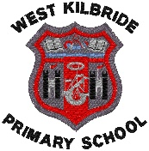
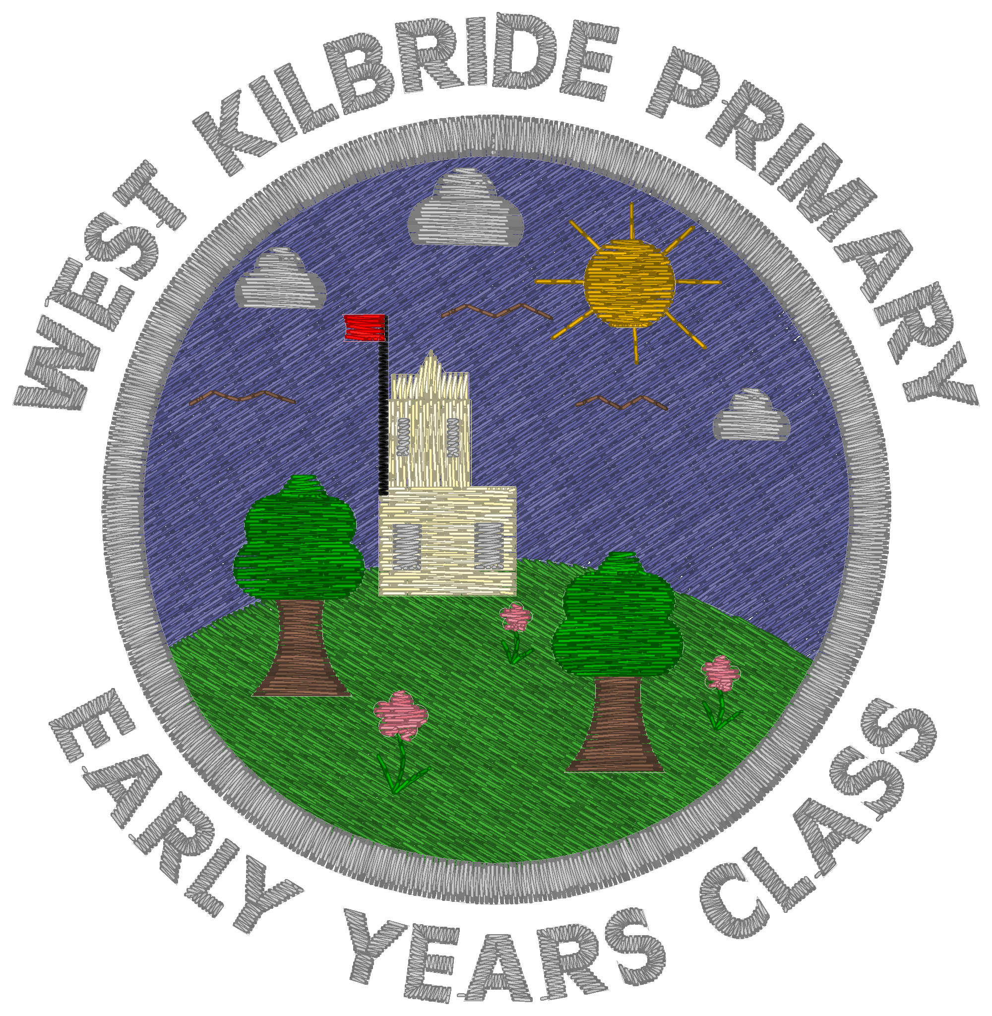
West Kilbride Primary school
Parent Council AGM- Monday 3rd November 2025
Head Teacher Report- Mrs Carson

- Staffing
I am delighted to share that Mrs Lewis will be returning to work on a phased basis as of this week. She will resume her normal Mon-Thurs working hours, week beginning 24th November. Mrs Diamond will continue to support the class on Mrs Lewis’ non-working days to maintain consistency.

Sadly, Mrs Samantha Moore has left us for a permanent post within Largs Primary- she will be greatly missed and we are very sad to see her go. We have appointed Miss Emily Pentleton to fill this post and hope she will start with us over the next few weeks.

Mrs Judith Boyle was successful in gaining our 4hr PSA post, which became available due to a reduction in Mrs Hazel Montgomery’s hours. We have also recruited Mrs Alice Zolobajluk to our 15hr PEF funded PSA post and she has started with us today.

Miss Shelby Galloway will leave us at Christmas to begin her maternity leave and so Miss Todd has already begun working with the class on a part-time basis. We are liaising with NAC as to the plans to fill the other two days in this class.

- Maintenance
As you know, securing maintenance work has been an ongoing challenge. However, we are delighted with recent progress. The October holidays saw a plethora of work being carried out in the school. We had identified a number of unsafe trees within our embankment area, and with the support of our colleagues in Streetscene, these have now been removed.
Miss Armstrong’s classroom has had ongoing issues with dampness due to a leak from the toilets. Although the leak was remedied some time ago, the work to re-plaster and decorate the classroom was paused until the area had dried out. Re-plastering work was carried out during the October work with re-painting being carried out over the November long weekend.
Our fire exit door within the staff prep room had rot and water damage- this has also been replaced.
We have also renewed our efforts to paint and refresh our classrooms and took advantage of the let submitted for the Halloween Disco and the P3 school trip to begin renovation works in the two P3 classrooms. One classroom is complete and the other will need some more time to finish it off. We will send further requests for painting support to parents/carers as we move through the term, with a particular push to finish off the P3 space and another to paint both P7 classes and their open area space whilst they are in Arran in April. If this is something you can help with, please let our office team know.
- PVG registration
We are experiencing ongoing challenges with the new PVG registration requirements. Firstly, there is some lack of clarity as to who exactly requires PVG registration under the new guidelines and as a Head Teacher collective, we are awaiting clarity from NAC as to best practice.
As a school, we are in a secure place given that we have always erred on the side of caution and requested PVG checks for our core parental volunteers such as parent helper who help with reading sessions and our Gardening Team etc. At the time of securing these, NAC were funding all applications. However, with the increased applications, this fund has now been exhausted and schools are required to pay for our PVG applications independently. This is putting some strain on our budget at present.
We feel we are in a relatively secure position with our current PVG registered volunteers in order to fulfil requirements for upcoming events such as out panto and nativity outings, but of course this depends on those PVG registered parents/carers being available to support the events on the day. We need to tread a delicate balance of securing enough volunteers to support our larger events but not too many that we would struggle with the financial outlay. We would like to thank all of the parents/carers who have volunteered to register so far- without you, our larger school events and school outings couldn’t go ahead so thank you!
- Learning Conversations
A few parents have raised queries with regards to the changes to learning conversations. Some of the queries relate to the changed timings of our learning conversations. All Class Teachers’ working hours are guided by a Working Time Agreement, individual to each school but governed by a set of regional and national requirements. At the end of each academic year, the WTA is negotiated and agreed between School Leaders and Class Teachers to ensure working time directives are met and teachers are not working beyond their allocated weekly hours. This guidance was revised and re-issued to Head Teachers by NAC in March 2025. Although the guidance remains largely unchanged, the rules are much more rigid in how they are being implemented and we are now unable to vote to override these as a collective. For example, we previously voted as a staff team to override the 5hr/week working limit and host one late parents evening, usually from 3.30-8.30pm, with the prep time being allocated in the weeks running up to it. Now the guidance stipulates that the longest learning conversation stint can be is 2.5hrs with 2.5hrs prep time in one week, meaning they have to be spread over two weeks. The school let guidance also prohibits us opening beyond 6pm, hence the changes to the event timings. As a staff team, we are not in favour of these changes but as with all other schools in NAC, we are unable to remedy this.

We also must now add equal prep time as meeting time to our WTA. So, if we allocate two 5hr meetings over the year, we need to allocate 10hrs prep time from our WTA, therefore 20hrs in total, in addition to 30hrs for reports. Previously, we negotiated as a team and only allocated prep time for one block, as the team had already written reports and felt that this was adequate preparation for Learning Conversations, but this is no longer allowed. Hence the reason we chose to move to one learning conversation, one Learning Showcase, one Link and Learn and increased use of Seesaw for reporting. All pupils who get targeted support from our TS teachers will have an additional Learning Conversation in May. As a staff team, we felt with this in place, and the written reports at the end of May, that this would be a better model making more efficient use of our WTA hours, but we are happy to re-look at this for next academic year if parents feel strongly that they would like two. Cluster schools are mainly having two, but no learning showcases or Link and Learn sessions, which our parents asked for more of last year following the Burns Supper. Broader than the cluster, some schools have chosen to move to once per year and an optional meeting for pupils requiring additional support, similar to our model.

Additionally, should we choose to remain with one Learning Conversation, we can look at the timings of this within the calendar year. We felt November gave staff an opportunity to get to know pupils in advance of the meeting and identify any potential challenges, whilst giving parents/carers/staff enough time in the school year to address issues with our young people to have an impact on their learning.

I will aim to survey parents on this in March to gather wider views in advance of our new WTA negotiations but please be mindful that with an additional Learning Conversation added, we will of course have to choose to remove something.

- Respectful Communications
Since we have returned to school following the October break, my staff team have had a few interactions with parents/carers which have not been respectful, with use of raised voices and abusive and expletive language. We would like to remind our school community that we are all on the same team, working hard to get it right for all of our children. Whilst we appreciate that, at times, emotions can run high, it is important to communicate this in a calm and respectful way. Moving forward, I have instructed my staff team to curtail conversations which make them feel them feel offended, afraid, threatened or abused and I will manage these incidents in line with NAC’s Managing Unacceptable Contact Policy, of which I have provided a copy to the Parent Council.

- Sporting Success
We are delighted with our recent sporting achievements- our school Boys football team were undefeated in their cluster football matches last week and following our treble success last year, we are now very much the team to beat. Similarly, we had great success at the Cross Country event on Saturday 25th October with seven podium places and five team medals. A very big thank you goes to our volunteer coaches and parents who support with these events!

- P6 Digital Learning Project
P6 had a great time on Tuesday meeting virtually with their peers from Beith and Whitehirst Primary Schools. Over the course of four weeks, pupils will meet up on Teams and will use OneNote to collaboratively create an online project, presenting it in real life alongside their partnership school peers at the end of the project. This great piece of work will be a big step in securing our Digital Schools Award.

- Rights Respecting Schools- Journey to Gold
You may remember, we were successful in becoming re-accredited for our Silver RRS Award earlier in the year. We are now on our Journey to Gold which, to be successful, requires all hands on deck. The RRS Committee would like to thank the Parent Council for their support with including the UNCRC articles in their social media posts to raise awareness of children’s rights. This will greatly support us on our Journey to Gold.

