
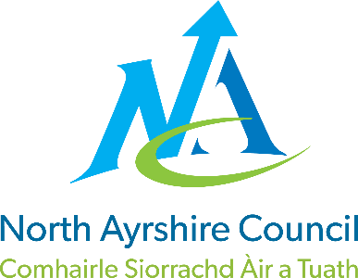

St Palladius Primary

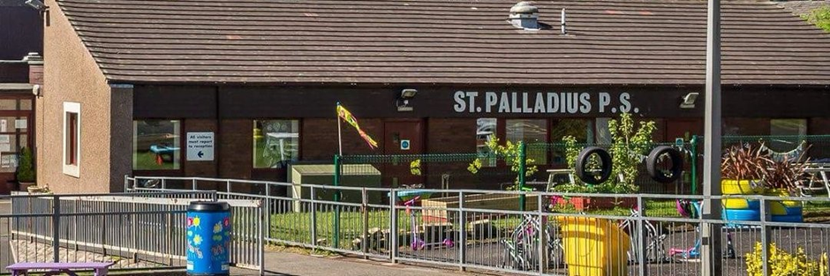

STANDARDS AND QUALITY REPORT
June 2025
This report will inform you of the school’s progress and achievements in the last session and let you know about our plans for 2024-2025.
I hope that you find it helpful and informative.
Patricia Bhela

Acting Head Teacher

OUR SCHOOL
St Palladius Primary is a denomination primary school in Dalry, North Ayrshire. Our current role is 80 pupils across 4 classes: P1/2, P3/4, P5/6, P6/7.

Our pupils and families are supported by our dedicated school staff. Our staffing consists of our Headteacher, Principal Teacher, 3 full time teachers and 3 part time class teachers, 1 part time Pupil Support teacher, 2 full time Pupil Support Assistants, a trainee Pupil Support Assistant and our janitor. We also have 2 part-time Education Business Assistants and 3 catering/cleaning staff.

Our P1 pupils mostly come from Dalry Early Years Centre and Playtime Early Years, both located within the town. Almost all our pupils go on to attend St Matthew’s Academy where they continue to experience high quality learning and teaching and opportunities for wider achievement.

At St Palladius, we pride ourselves on the excellent relationships we have with our children and families as well as strong links with the wider community of Dalry, our Parish and the Garnock Valley. St Palladius is a welcoming, nurturing, and inclusive environment where diversity is celebrated. Our staff provide high quality learning and teaching experiences, designed to meet the needs of all our learners.We value positivity, teamwork, courage, integrity and resilience. We aim to give our pupils the skills and knowledge needed to become lifelong learners and the decision makers of the future.

OUR VISION, VALUES AND AIMS
Our Vision
We have a nurturing and inclusive ethos at St. Palladius which ensures all children are safe and happy. By working together and across the community, children are engaged in activities which allow them to reach their full potential and give them the skills needed for life, learning and work.
Our Values: Compassion Ambition Respect Equity
At St. Palladius we aim to:
- Be caring towards others and the world around us; treating everyone with kindness and helping people in need.
- Work hard in all that we do, setting ourselves high expectations, believing that we can succeed and showing a determination to achieve.
- Be honest and trustworthy. Valuing the rights of others and treating all members of our school community with dignity and respect.
- Ensure that the needs of the individual are met, providing appropriate opportunities and support to enable all learners to reach their full potential.
At St. Palladius we CARE!

ATTAINMENT & ACHIEVEMENT
Throughout the year we gather lots of information on how our children are progressing in their learning. To monitor their progress, we watch children working through tasks, listen to what they say, ask important questions, set challenges and use some standardised assessments. Staff meet regularly to discuss, examine and track the progress made by pupils.

North Ayrshire Council also asks us to summarise our children’s achievement in reading, writing, listening and talking as well as numeracy and maths. They ask us to look particularly at children who have reached the end of the Early, First and Second Levels: P1, P4 and P7. We are proud of how well our learners are progressing.

Achievement and Attainment
- Our attainment levels were good in the year 2024-25.
- Most P1 pupils achieved Early Level in Listening and Talking. The majority of P1 pupils achieved Early Level in Numeracy.
- Most P4 pupils achieved 1st Level in Listening and Talking, Reading and Writing. All achieved 1st Level in Numeracy.
- Most P7 Pupils achieved Second Level in Listening and Talking. The majority of P7 pupils achieved 2nd Level in Reading, Writing and Numeracy.
- All pupils who have not achieved a level or who have been identified as ‘not yet on track’, received additional targeted support.
- We had a 94.2% overall attendance rate (at start of June). This is a higher overall attendance than last session.

WIDER ACHIEVEMENT
Some highlights and successes from this year are:

Pupil Leadership
- Young STEM Leaders – after a very successful year last year, our STEM leaders have consolidated their learning by attending NAC STEM Leaders activities. They have also supported STEM learning across the school.
- Young Leaders of Learning have visited another school to meet with their YLL and shared best practise. They have shown visitors around our school, talking about our strengths, plans and next steps. They have observed in classrooms and given pupils feedback about their learning. They have surveyed children about their learning, identified areas for improvement and have addressed these.
- Our Sports Leaders completed their training with Active Schools and have planned Sports Day and lunchtime clubs. We are hoping to achieve Gold Sports Award before the Summer holidays. We have increased the amount of children participating in our sports events.
- In addition to the formal leadership roles in school, pupils have organised other lunchtime clubs, including dance, Lego Spike, Kapla and Chess.
- All children are also in Leadership groups, which meet regularly.
- Sparkle Wall – this is used to highlight our children’s achievements outwith school. They are shared via our social media and celebrated in Assembly every week.
- Some children participated in Active Schools’ North Ayrshire Small Schools Virtual Competition. Our children regularly received certificates for achievements.
Awards
- RSPB Wild Challenge Award P1/2
- Sonappa Gold award
- Pope Francis Faith Award
- Reading Schools Award
- Big Schools Bird Watch
- School for Nature (David Attenborough)
- Laudato Si School

Partnerships
- Library – To develop a love of reading and building curiosity of the world, our children have been visiting the Library. Visits enable further exploration of learning which they are doing in class. We would like to further build on these experiences next year.
- We continue to have a strong partnership with Dalry Boundary Trust. The school has supported local events and the Trust has supported the school with funding for outings and activities, including the whole school panto and P7’s residential trip to Inverclyde. Without their financial support, we would not have been able to fund these events. Being visible in our community has fostered a sense of pride.
- St Palladius Parish – As well as attending Mass at St Palladius Church, we have had mass in the school, with the parishioners invited. We plan to make this a regular occurrence, fostering a closer relationship with our parishioners. Fr Stephen is a regular visitor in the school and is getting to know our children and they are getting to know him. St Vincent de Paul group have supported some of our families financially.
- World of Work Week - We welcomed people from many walks of life to our school to talk to our children about their jobs: what they do and how they came to be in their jobs. This has helped our children to learn about the different jobs in our community and the paths which can lead to these jobs.
- Community Gardens – We have a planter in the town which our Gardening Club maintain. This has raised our profile in the community and further fosters a sense of pride in our school.
- Local businesses - Through these partnerships, our children have learnt new skills, found out about their local area and further developed their creativity and leadership skills.

HOW SUCCESSFUL HAVE WE BEEN IN IMPROVING OUR ESTABLISHMENT?
Our capacity for improvement is good, given our approach and commitment to self-evaluation for improvement.
Priority 1
To develop as a community of faith and learning within our schools and across the Deanery. UNCRC articles: 8, 12, 13, 14.
- Through training, staff are more aware of The Catholic Charter and what this entails in the daily life of St Palladius Primary.
- We have been successful at achieving our Pope Francis Faith Award and completing Laudato Si.
- We have had mass in school and parishioners were invited.
- Fr Stephen is a regular visitor in school, getting to know our children.
Priority 2
To increase and enhance pupil participation within and across our schools. UNCRC articles 12, 13, 15, 17, 28, 29
- Young Leaders of Learning underwent training and have put this training into pracise both in school, across the classes, and at other schools.
- Young Leaders of Learning have observed children in class and have given them feedback about their pupil participation. This was very positive in each class.
- The self-evaluation Participation Mapping Tool, observation and The Leuven Scale assessment in each class led to teachers identifying areas to improve. These were then actioned and an increase in pupil participation was seen.
- Pupil voice and pupil’s self-evaluation identified areas they felt they were strong and areas to improve relating to pupil participation. These have been actioned by teachers.
- All children are in a leadership group. All children have participated in a range of events linked to their leadership group.
Priority 3
To raise attainment in literacy through high quality learning, teaching and assessment approaches. UNCRC articles 2, 28, 29
- We have introduced a new phonics and spelling programme. Phonics is the relationship between sounds (phonemes) and the letters (graphemes) that make these sounds which lead to children being able to read. In turn, this helps them to write words.
- We are already seeing improvements in phonics and spelling across the school.
- Targeted support has been provided for children to improve reading. This has been successful.
- Staff training for reading and spelling strategies to improve teaching and learning and therefore attainment.
- We have revamped the library to make it an engaging and welcoming place to be. Children use it regularly and books are borrowed and returned. Pupil Librarians ensure the library is tidy.
- A parent and child morning reading club was started. Due to low up-take, we have reviewed this support for next year.
- Reading Schools Award is submitted. We achieved Bronze Award.

QUALITY INDICATORS
Provide your evaluation & brief summary statement for each of the 4 core QIs
QI 1.3 Leadership of Change | Evaluation | 4 Good
All teaching staff, including support staff, are involved in leadership groups across the school. As a result they have engaged with and/or delivered professional learning.

Staff are focused on the School Improvement Plan priorities for the school year and have led positive changes across the classes and the school.

We have worked hard to develop the children’s leadership skills and this has been successful. We have established Leadership groups which all children are involved in. In addition, we have Sports and Digital Leaders, Young Leaders of Learning and House Captains and Vice Captains. These all gather Pupil Voice about aspects of school they would like to change and changes have been implemented as a result of these discussions.
QI 2.3 Learning, Teaching & Assessment | Evaluation | 4 Good
Through professional development work this session, staff have increased capacity for providing high quality learning and teaching. Pupils have regular feedback sessions with teaching staff, enabling them to set targets and evidence their successes.
Staff use a range of assessment methods to gather accurate data and evidence to support their professional judgement. Effective tracking of learners ensures that any barriers to learning are identified and supports put in place.
Observations by the Young Leaders of Learning led to feedback to the children about their engagement and learning – this was overwhelmingly positive.
QI 3.1 Ensuring Wellbeing, Equality & Inclusion | Evaluation | 4 Good
We have a strong, supportive school community and we pride ourselves in knowing our children and families very well. All staff are invested in the wellbeing, equality and inclusion of all children in St Palladius. We have robust safeguarding processes in place.
All staff are trained and this is updated termly. External agencies are used for expertise where needed for our children and families. Across the school, we use Zones of Regulation to help children manage their emotions and to enable them to support each other in times of need. 94% of children said that they felt the school was welcoming and everyone belonged.
QI 3.2 Raising Attainment & Achievement | Evaluation | - Good
Pupils are making good progress across the school. Regular planning and robust tracking meetings mean that we are able to ensure each child is getting the support and challenge which they need in order to make progress. Pupils who do not meet the national expectations have a plan and almost all are making good progress with their individual targets.
We celebrate our children’s achievements outside of school through our Sparkle Wall. We celebrate children’s achievements and when they uphold our school Values through Headteacher Awards.

PUPIL EQUITY FUNDING
This session, we used most our PEF to employ a Classroom Assistant to support our most vulnerable learners. This involved:
- Supporting children in their learning
- 1-1 support in class
- a morning reading club
We also used PEF to purchase Outdoor Loose Parts Play equipment for the whole school to use. This has helped their problem-solving and co-operative learning skills.
We used PEF to purchase resources to help reading comprehension across the school. This was identified as an area which needed support. Staff underwent some training in ways to teach reading to further improve the children’s skills.
We have bought new books for the library based on the children’s interests.

Impact for pupils

Targeted support has been provided for identified children. As a result, they are engaged in their learning and making progress. There has been a marked improvement in the children’s resilience and levels of engagement, the children are more ready and able to learn. They are not giving up and instead are demonstrating willingness to persevere. Identified children with more complex needs are more able to access the curriculum and activities with the support given to them.

IMPROVEMENT PLAN PRIORITIES 2025-2026
Priority 1
- To improve phonetical awareness across the school.
- To improve writing across the school.
Priority 2
- To raise attainment in Numeracy across the school
Priority 3
- To develop our health and well-being programmes to positively impact on pupils’ mental health and well-being and resilience.

