Roald Dahl Day activities 2021 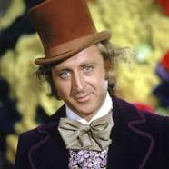

Unscramble the following letter to make names of characters in a Roald Dahl book. The book that the character is in is in brackets.

Character
Haiercl Tubkce
(Charlie and the chocolate factory)

Unta Kpisre
(James and the giant peach)

Rm Omwodrwo
(Matilda)

Rsm Vislre
(Esio Trot)

Het Dgrna Hhgi Twhci
(The Witches)

Nejnferi Noyhe
(Matilda)

Rm Iwtt
(The Twits)

Ercub Tebotgrort
(Matilda)

Asjme Yehnr Rtotetr
(James and the giant peach)

Sauugust Olgpo
(Charlie and the chocolate factory)

Yndan
(Danny Champion of the world)

Retlaw Gisgob
(Fantastic Mr Fox)

How many Roald Dahl characters can you name in 2 minutes?
