St Matthew’s Academy Helpsheets 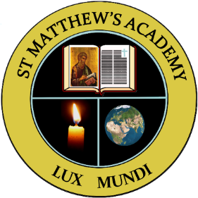
Issues Online
What is it?
This website
- provides access to hundreds of articles on contemporary issues, through a fully searchable online database
- allows users to log-in from anywhere, at any time
- presents full-colour e-book versions of all the latest titles in the Issues series
- encourages further research through unique multimedia archive
How do I access the website?
Can access directly from the school’s Glow Home Page (this is the simplest way)
Or Log on to www.independence.co.uk/issues-online.htm
User name – sma
Password – 6092
How do I find information on my topic?
Type your topic into the search box and a list of articles should appear.
Click on the article you’d like to read and you are taken to it.
Useful facts and statistics are also given for each topic.
You may have access to an ebook on your chosen topic. Simply click on the ebooks library tab at the top and you’ll be shown all the ebooks available. Click on any that are of interest and that should allow you to read the book electronically.
March 2020

