ST MARK’S PS
IS BACK!
Health and Wellbeing is one of the most important aspects of our school life. In order to encourage and promote an active lifestyle for our school community for the last couple of years, we introduced FIT FRIDAYS. Every Friday, the children will participate in active learning throughout the day (eg PE, outdoor spelling, active maths lessons, limited screen time, etc). They should come to school with their school top but comfortable bottoms (joggers, leggings, shorts, etc) and footwear.
WHOLE SCHOOL FIT FRIDAY – WHEELIE DAY FRIDAY 13th OCTOBER
In addition, on the last Friday of the month there will be a whole school activity for the children to take part in. We will send out details of this before the event. Pupils can wear their own comfortable clothes for these events.
We will start next with wheelie day on Friday the 13th October. The children will be encouraged to bring their bicycle, scooter, skateboard, roller skates, or whatever else with wheels into school. The only condition is that they must also have a helmet to wear to ensure there are no bumps to the head!
During the school day, your child’s class will have the chance to scoot around the school.
As there will be so many bikes etc. brought to school, please take your child’s ‘wheels’ to their classroom door where they will stored until it is their turn to scoot round the school.
Thanks once again for your ongoing support.
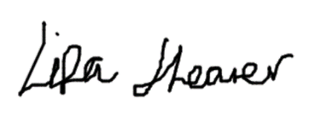
Lisa Shearer
Principal Teacher

