Rights Respecting Schools
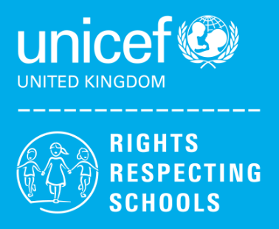
The Rights Respecting School Award (RSSA) is run by UNICEF UK and is based on the principles of the UNCRC – The UN Convention on the rights of the Child.
“The Rights Respecting Schools Award puts children’s rights at the heart of schools in the UK.”
https://www.unicef.org.uk/rights-respecting-schools/the-rrsa/about-the-rrsa/
Click on the image to find out more information from UNICEF.
What are ‘Children’s Rights’?
Every child is entitled to specific human rights. There are 54 articles which explain all the rights children hold legally across the world.
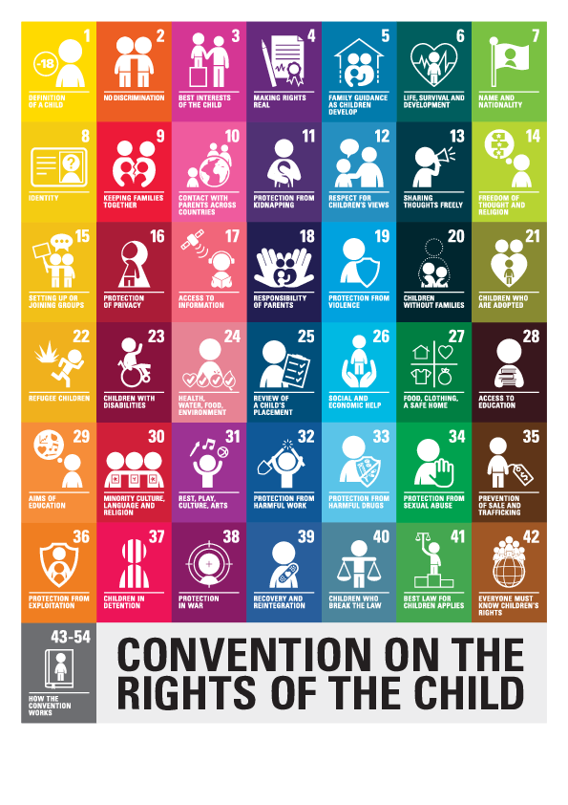
“Article 1 (definition of the child): Everyone under the age of 18 has the rights in the Convention.”
What is a Rights Respecting School?
The initiative encourages schools to not only learn about children’s rights but also to encourage respect in all relationships. The St. Mark’s community models rights and respect in all relationships: between adults and between pupils. Together young people and the school community learn about children’s rights, putting them into practice every day.
The RRSA encompasses all that we do as a school to allow our children flourish into kind and respectful lifelong learners who advocate the rights of every child everywhere and make a positive contribution to society.
Be Ready Be Safe Be Respectful

Why do we want to be a Rights Respecting School?

- Positive Relationships – Through striving to achieve the award pupils, staff and the school community develop relationships of mutual respect and everyone’s opinion has equal value.
- Happy Children – Children develop their self-esteem and wellbeing through promoting the values identified in the UNCRC.
- Active Participants in School – Through embedding the UNCRC, children are involved in the decision making progress and are part of the decisions made about their learning and wellbeing.
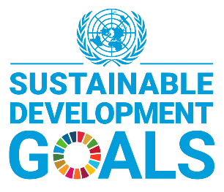
- Promote Global Citizenship – Children will learn about issues affecting children around the world and are able to raise awareness at home and in their community. They will discover ways they can help others get the rights with which they are entitled and bring about change. We promote the use of the Sustainable Development Goals
in learning so that children can contribute to a better future for all.

https://www.un.org/sustainabledevelopment/climate-action-superheroes/
(Click image for more information)

What is happening at St. Mark’s Primary?
At St. Mark’s Primary, we are working towards achieving the Silver: Rights Aware of the Rights Respecting School Award. It recognises the work that duty-bearers (such as teachers, staff, parents and the local government who are accountable for ensuring that children experience their rights) do to ensure that all children can access their rights as defined in the UNCRC.
Term 1
We are evaluating our Silver: Rights Aware of the Rights Respecting School Award Action Plan.
Article 12 (respect the views of the child)
Every child has the right to express their views, feelings and wishes in all matters affecting them, and have to have their views considered and taken seriously.

We will be gathering views of pupils, staff and parents/carers through questionnaires. We will use these to inform our next steps on our Silver Award Accreditation journey.
Learner Participation is very important at St. Mark’s. We are currently restarting our Global Goals and Rights Respecting Steering Group – Our Children’s Champions. Our Pupil Council will also work alongside our group to represent children’s voices.
Our Children’s Champions and Pupil Council will be elected and be representatives for their class and peers.
They will meet regularly to address issues that have been raised by pupils whilst also helping influence and drive change throughout the school and community.
In addition, the pupils will have opportunities to organise events, support younger pupils and present assemblies and showcases to inform our school community about the UNCRC and Global Goals.
Mrs. Griffin, Mrs Logue and Miss Thompson are leading our Rights Respecting School work, however, all pupils and staff are involved in the process and contribute to the decisions and actions taken.
Mrs Griffin will lead out first Rights Respecting Schools Assembly this session, for pupils and staff, on Monday 9th of October.

Class Charters
Our Class Charters are visual documents that establishes an agreed set of rights-based principles upon which relationships can be based and which provide a language for shared values. Creating charters support positive learning environments for children and young people in the classroom and across the whole school. Our charters helps make the UNCRC more prominent and relevant.
Each classroom has their own class charter with the rights they felt were most important to them displayed and referred to. We have also linked the rights to our school values to show they are a core part of our school community.

(photos to follow)
Relationships Expectations Achievement Love

One of our first Children’s Champions Challenges will be to support the school community creating our Playground Charter.

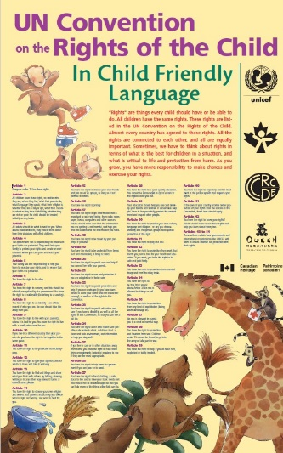
We are continuously working to promote the UNCRC in the school and hope to continue our work through further training for staff and pupils and implementing the rest of our action plan.

Please support us in our journey to becoming a Rights Respecting School.
Talk to your children about what they know and are learning about the UNCRC.
Ask how you can help and be part of our school community as we work together to achieve our Rights Respecting Award.
