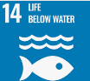
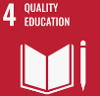
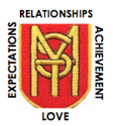
Primary 6 Home Learning Grid – September 2023
Relationships, Expectations, Achievement, Love

This term we have been exploring the Sustainable Development Goals. We hope that these activities will give you a greater insight into goal #14 – Life Below Water.

Writing  Create a fact-file for an ocean creature of your choice. You may use the template attached below to help structure your fact-file. | Writing  Much of our unwanted plastic ends up in the ocean. Can you create an information poster explaining the dangers of ocean pollution? | Reading  Read the case study attached below about the Great Barrier Reef. Then consider the accompanying statements. Are they fact, opinion or both? Give reasons for your answers. | Talking and Listening  Watch the short video about our oceans found at: https://youtu.be/epQHFPvqWHY  Consider these questions:  How do you feel about the ocean?  Did you learn anything new about the problems our oceans face?  How does this relate to your life? | Health and Wellbeing  Write a list of all of the single use plastic items you can find in your home. Consider and list alternatives that could be instead.
STEM  Design a machine that aims to tackle the plastic problem in the ocean. This could be by educating people about the problem; by preventing plastic from entering rivers and oceans or by removing the plastic waste that is already there. | Numeracy  Develop your recall of number processes by playing Hit The Button  https://www.topmarks.co.uk/maths-games/hit-the-button | s  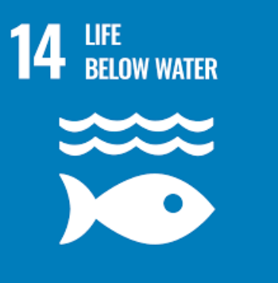  s | Numeracy  Look at the top 10 items collected from the ocean below. Calculate how many items would be collected if each item was reduced by 10,000 and 100,000. | Health and Wellbeing  Research one way that people are approaching the clean-up of the ocean? Write a paragraph describing their efforts.
STEM  You can learn more about Artificial Intelligence being used in oceans and about coding by visiting  https://code.org/oceans | ICT  Explore the website  https://earthcubs.com/global-goals/life-below-water/  There are a variety of games, activities and ideas linked to SDG 14. | Reading  Read Poseidon Patrol to learn more about the theme and issues surrounding Life Below Water  https://worldslargestlesson.globalgoals.org  /resource/poseidon-patrol/ | Velcro Poetry  We have been fortunate to have the fabulous poet Simon Lamb visit our school. Enjoy some of his poetry at  https://www.youtube  .com/watch?v=9OvlGgV-9kg | European Day of Languages  Celebrate this special event on Tuesday by visiting  https://learning-corner.learning.europa.eu/play-games_en

