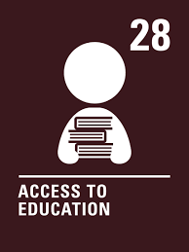
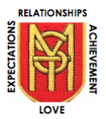
Primary 2 Home Learning Grid – September 2023
Relationships Expectations Achievement Love

Literacy  Reading  I can remember events in a story and talk about them.  I use my knowledge of phonics to sound out unfamiliar words.  Try to read with a grown up or on your own every day. This could be a book you have from school or your own.  Remember to use your phonic sound knowledge and the picture clues in the story to help you as you read.  When you have read a story, discuss with a grown up, or write down, your favourite part and why, favourite characters and why, what do you think might or could happen next?  Challenges –  - Can you retell the story to an adult in your own words?  - Make a word search with some of your reading words? Ask a grown up to help.  - Play hangman with your reading words  Listen to a Rachel Bright story on youtube:  https://www.youtube.com/results?search_query=rachel+bright+stories | Literacy  Phonics  I am learning to identify, form and write sounds/letters.  Can you write all of the letters in the alphabet in upper case:  ABCDEFGHIJKLMNOPQRSTUVWXYZ  Can you write all of the letters in the alphabet in lower case:  abcdefghijklmnopqrstuvwxyz  Challenge:  Can you match the upper case letters to the lowercase letters?  For example:  Aa/Bb/Cc/Dd/Ee/Ff and so on.  Writing  I can write a sentence using a capital letter and full stop.  Feelings Sentence  Write a sentence about how you are feeling. Think about the feelings in our zones of regulation and the ‘Colour Monster’ story  Remember:  Capital letters.  Finger spaces.  Full stops.  Here are some words to help you –  feeling  I  am  sad  happy  calm  angry  scared  loved  Challenge –  Can you practise writing your first and second name?  Can you practise writing the days of the week? | Numeracy  I can read, order, recite and write numbers to 10, 20 or up to 100.  Go on an Autumn walk and collect leaves, stick or conkers. Count how many you have found.  Pretend to be the teacher. Grab a collection of your teddies, action figures or dolls and teach them to count forward as high as you can.  Practise writing your numbers into your jotter forward and back within 20.  Find ordering games on Topmarks:  https://www.topmarks.co.uk/maths-games/5-7-years/ordering-and-sequencing  Watch number ordering videos on youtube:  https://www.youtube.com/watch?v=WHuuuh9GgP8  Maths  I can recognise, name, sort 2D shapes.  I can draw simple 2D shapes  Use the shapes we have been learning about in class to draw a home for your worry monster. Can you name and label the different shapes that you use?  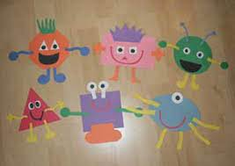  Challenge:  What 2D and 3D shapes can you spot around your house?  Can you draw or take pictures of items that are:  Circles  Squares  Triangles  Rectangles
HWB  I am learning to keep my body fit and healthy doing short repeated exercises.  Try to do some exercise each day. This could be cosmic kids yoga on youtube, searching for ‘the body coach’ on youtube, just dance or jogging around your garden.  Here are some good places to visit on youtube:  https://www.youtube.com/watch?v=L_A_HjHZxfI  https://www.youtube.com/watch?v=KAT5NiWHFIU  https://www.youtube.com/watch?v=Qjcw2Vov_5k  Or perhaps you could time yourself?  Get an adult to set a timer to 1 minute.  How many of the following movements can you complete in 1 minute?  -star jumps  -squats  -high knees  -high kicks  -toe touches | Art  I am learning to create artwork using Autumnal colours  We have been learning all about Autumn. Can you remember the colours that we see in Autumn. Go for a walk and look at the environment. Use your walk as inspiration to create your own Autumnal picture. Make sure that you use Autumn colours:  -red  -orange  -brown  -green  -purple  -grey  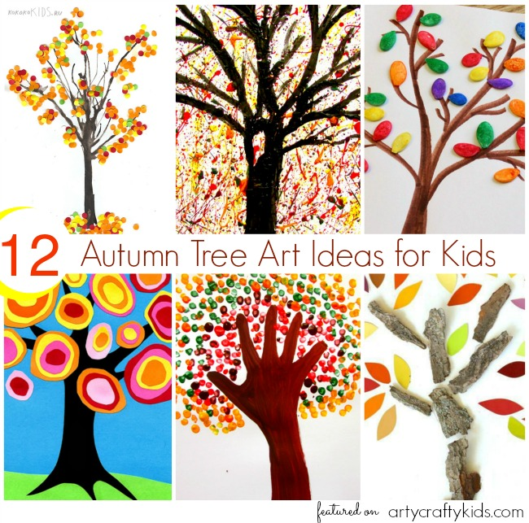  Music 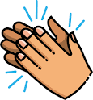  I can use my body to make music  Find your favourite song. Play the song and try to keep the beat using your hands:  -clap your hands to the beat  -tap your knees to the beat  -click your fingers to the beat  -stamp your feet to the beat  Challenge:  Can you make up a sequence of beats using all of the movements above and perform it to your family  Here is a video on youtube to help you:  https://www.youtube.com/watch?v=92gf8dAlhUw | Learning Across the Curriculum  Zones of Regulation  I can talk about my feelings with an adult/sibling. I can draw a picture of the zone that I am in.  Think about our ‘Colour Monster’ story. Think about which monster you most identify with each day and draw a picture of your feelings using the colour that matches your mood.  Red – Angry  Yellow - Happy  Blue - Sad  Green – Calm  Pink – Loved  Black - Scared  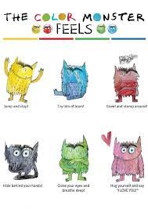  Technology  Can you build a colour monster out of recycled materials at home?  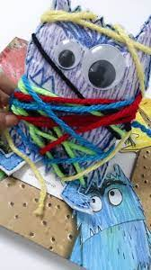

Maths strategies
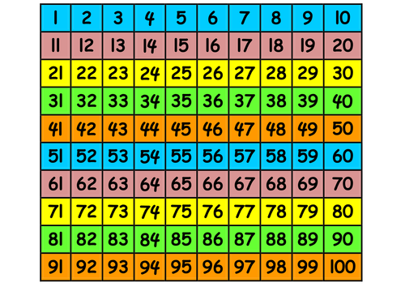
Use a number line or number square…

Use your fingers to count on and back
