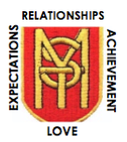
ST MARK’S PS
TERM
PARENT INFORMATION LETTER
WELCOME TO TERM 1 OF PRIMARY 6!
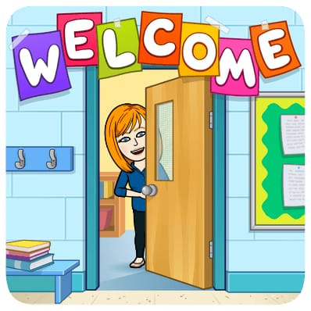
A very warm welcome to Primary 6 - what a quick first few weeks together it has been. We have many great things to look forward to in the coming weeks and months.

CLASS INFORMATION
We have PE on a Tuesday and Thursday. Every day we try to have at least 15 minutes of physical activity to keep our minds and bodies healthy. Please ensure your child comes to school with a filled water bottle, so that they can stay hydrated throughout the school day. On PE days pupils may come to school with trainers on and ready for PE- School on Top, Sports on the Bottom - all jewellery should be left at home and any long hair tied back off the face, please. Homework will be issued regularly across the term, our focus will be on reading skills.

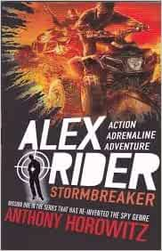
LITERACY
In reading, we will be revising SHORS strategies to help the children to understand what they have read. Our class novel is ‘Stormbreaker’ by Anthony Horowitz, the children are enjoying this book. We are exploring vocabulary, character and theme. We will be taking on the First Minister’s Reading Challenge, where we will be setting different reading goals. As a school, we are working towards gaining our Reading Schools Bronze Award.

In writing, we are working on tools and skills for writing and developing paragraph-writing skills when completing free writing tasks.

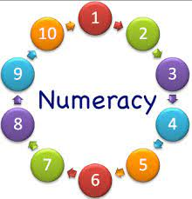
NUMERACY
In numeracy this term, we are developing our estimation, rounding and place value knowledge and skills, with larger numbers. We will be focusing on mental addition and subtraction strategies to help us solve different problems. We are aiming to improve tables recall this year – we are enjoying a number of activities and games! In class maths, we will be learning about the properties of 2D shape and symmetry.

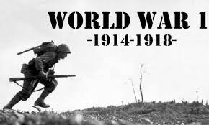
ACROSS THE CURRICULUM
Our class context for learning is the First World War. The children chose this topic. We will be learning about the road to war, military, rationing, technology that developed during WWI and what happened to children during the war.

There will also be a focus on Learning for Sustainability and Rights Respecting Schools.

Across the year, we will begin the silver level of the JASS award where we will work through four sections:
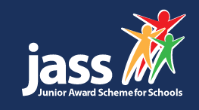
- My Interests: developing an interest or learning a new skill
- Get Active, Stay Active: taking part in sport and physical activity
- Me and My World: contributing to the local community
- Adventure: outdoor activity and learning, including team work and problem solving

This award is something that the children really enjoy and comes with many benefits. My Interests and Get Active, Stay Active are to be completed at home. Me and My World and Adventure will be completed in school.
Overall, we are shaping up to have a very busy term! Let me finish by saying that all I wish from your children is that they try their very best in all things and that we have a wonderful time together. Please keep in touch if you have any issues or questions regarding your children.

Kind Regards
Claire McKie

