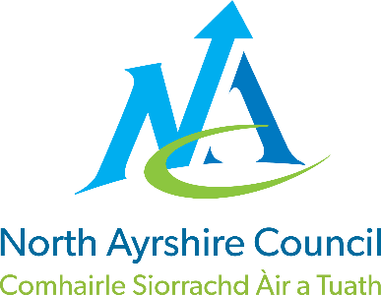

ST JOHN’S PRIMARY & EYC

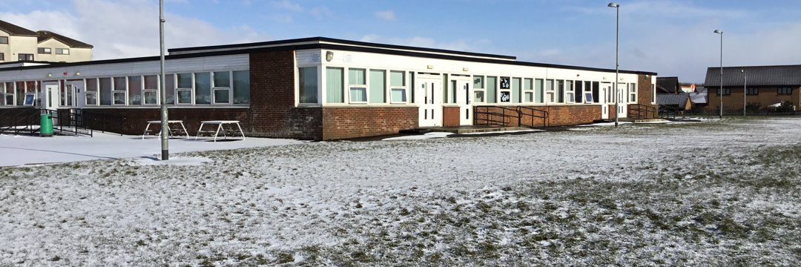
STANDARDS AND QUALITY REPORT
June 2026
This report will inform you of the school’s progress and achievements in the last session and let you know about our plans for 2026-2027.
I hope that you find it helpful and informative.
Joanne Boyle

Acting Head Teacher

OUR SCHOOL
OUR SCHOOL
St John’s Primary School is a Catholic school which serves the town of Stevenston and its surrounding areas.
The school roll during 2025 - 2026 was ninety two children in five classes with sixteen children in the nursery in morning and afternoon sessions. In our staff we had a Head Teacher, 2 Depute Head Teacher (1FT equivalent), Nurture Teacher, Targeted Support Teacher, five class teachers and a newly qualified teacher.

Our support staff comprised of one Janitor, one Education Business Assistant, two Pupil Support Assistants one Pupil Equity Funded Pupil Support Assistant who supports Play and a Dining Hall Supervisor.

In the Early Years class we had a Senior Early Years Practitioner, one Early Years Practitioner and two Early Years Assistants.
The school was well supported by our School Nurse, Eileen Murnie, Educational Psychologist, Kim Whitehead, Speech and Language Therapists, Childsmile, Counselling Services, our School Chaplain, Canon Martin Poland, Family Wellbeing Support Team and Active Schools Coordinator, Chris Hayes.

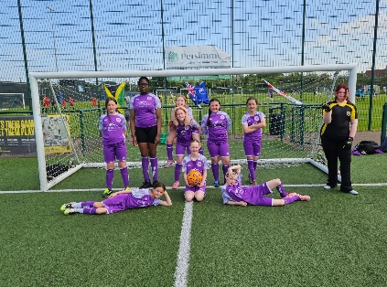
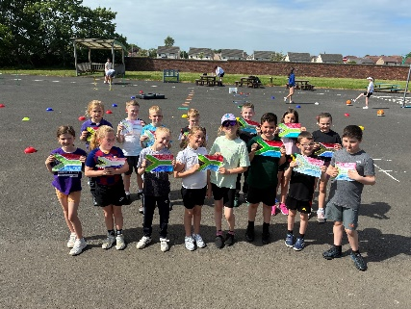

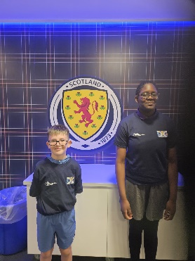

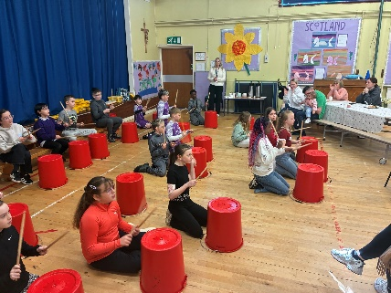
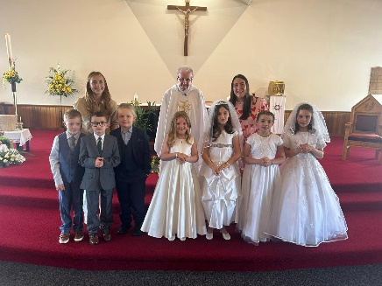

OUR VISION, VALUES AND AIMS
VISION, VALUES & AIMS
In December 2025 we consulted our school community and revised our Vision, Values and Aims.
OUR VISION
Our vision is of a safe and happy learning community where we inspire one another to greatness and open doors to new opportunities.
OUR VALUES
- INVOLVEMENT
- RESPECT
- FAITH
- TEAMWORK
- CREATIVITY
- COMMUNITY

OUR AIMS
- We will work together in partnership to develop mutual respect and trust, sharing the same goals, to develop skills for life
- We will provide a safe and welcoming community where everyone is treated as an individual and is supported to achieve
- We will work together as a whole school team to challenge and support excellence in learning and teaching
- We will work in partnership with the church community to develop the ethos of Catholic faith where all are valued and respected impacting on the spiritual and emotional growth of all
- We will provide a child centred curriculum which is relevant, challenging, progressive and incorporates personalisation and choice to meet the needs of all learners
- We will ensure that the social, emotional and mental wellbeing of everyone is at the heart of all we do by ‘Getting it Right for Every Child’
- Everyone will be treated respectfully and celebrated as individuals
- We will be reflective and evaluative in our practice to raise attainment and achievement for all.
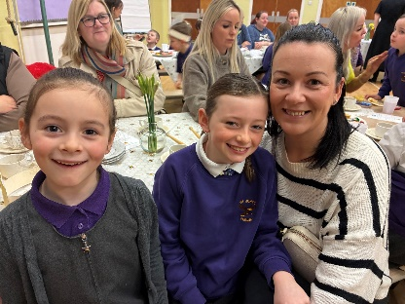
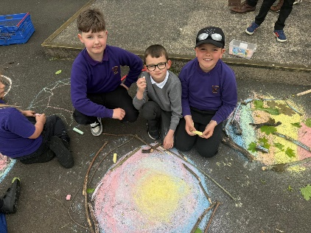
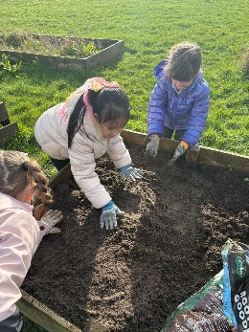

ATTAINMENT & ACHIEVEMENT
Attainment & Achievement
- Our children were successful in our school’s Burns Competition in Poetry
- All classes celebrated key events in the Liturgical Calendar e.g. All Saints Mass, Advent, Lent etc.
- JRSO led successful initiatives within the school
- Our football team participated in all games in the Champions League
- Our netball team took part in the St Matthew’s Academy Netball League
- Celebrated children’s successes and achievements weekly at assemblies and at the end of session celebrations
- Children celebrated the sacraments of Reconciliation and First Eucharist
- Primary 7 had a successful residential trip to Lockerbie Manor
- Liaised with all partner agencies to meet the needs of all pupils e.g. Canon Martin, Educational Psychologist, Facilities Management
- Pupil Voice is strong. All children are members of our Pupil Committees. Our children are the change makers in our school community and beyond.
- P6 completed the Active Schools Young Leaders Course
- Digital Leaders have shared their knowledge and expertise across the school
- Our children have shared their talents and skills through showcasing these at key assemblies e.g. Nativity, Christmas Concert and Daffodil Tea
- P1 data – most children achieved Early Level in Literacy and Numeracy
- P4 data – the majority children achieved First Level in Literacy and Numeracy
- P7 data – less than half achieved Second Level in Literacy and the majority achieved Second Level in Numeracy

WIDER ACHIEVEMENT
Wider Achievements
- P7 achieved their Pope Francis Faith Award. P6 started their journey
- Maintained the Digital Schools Award
- Developed opportunities for children to develop their leadership skills through implementing a robust buddying programme
- Achieved Bronze Myhappymind Award
- We worked throughout the session with Chris our Active Schools Coordinator to provide Leadership Training and Sporting opportunities for all pupils
- Maintained Silver Accreditation for Rights Respecting Schools. Empowering our children to become change makers and leaders within our community and beyond
- Maintained green flag status with Eco Schools Scotland
- Our Young Leaders of Learning were trained and visited a partner school to share their ideas about improving Numeracy within our school
- Four pupils presented in the Moderation showcase in Eglinton Park
- P6/7 participated in the North Ayrshire Athletics Competition
- Four children were Commonwealth Games Ambassadors and World Cup Ambassadors who planned and led activities for pupils
HOW SUCCESSFUL HAVE WE BEEN IN IMPROVING OUR ESTABLISHMENT?
PRIORITY 1 : To raise attainment in numeracy

- Teaching staff have engaged with the new North Ayrshire Mathematics Framework and associated planners, ensuring consistent implementation across stages. Targeted intervention groups have been established for pupils not yet meeting expected levels, supporting progress and addressing gaps in learning.
- Staff have collaborated with the local authority numeracy lead to access coaching, moderation opportunities, and professional learning, strengthening practitioner confidence and consistency of assessment. Pupil focus groups were conducted to gather learners’ views on numeracy, with particular emphasis on the use of manipulatives to support understanding.
- A whole-school self-evaluation of mathematics was undertaken by teaching and Early Years staff using Education Scotland’s draft mathematics self-evaluation toolkit, leading to the identification and implementation of key improvement actions. YLLs developed an audit tool and facilitated pupil focus groups to evaluate numeracy and mathematics provision within their own schools, aligned with HGIOURS.
- In addition, YLLs hosted reciprocal visits with two other schools, focusing on school improvement in numeracy and mathematics, including learning environments and the use of numeracy-rich displays. Family engagement was strengthened through a numeracy-focused curricular afternoon, Stay and Play sessions, and the provision of family maths challenges to support learning at home.

PRIORITY 2: To further develop our health and wellbeing programmes to positively impact on pupils’ mental health and wellbeing and resilience.
- Staff have participated in training on the myHappymind programme, supporting whole-school implementation of the resource. Parents and carers have attended information sessions and have begun engaging with the associated app, strengthening home–school links and reinforcing wellbeing strategies beyond the classroom.
- Pupils have been introduced to the resource through class-based learning, assemblies, and home activities, ensuring consistent messaging across school contexts. The programme was also embedded during Children’s Mental Health Week, further reinforcing its focus on emotional wellbeing and resilience.
- Staff have undertaken additional professional learning in We Were Expecting You and sensory circuits. As a result, sensory circuits have been introduced across the school to support regulation and readiness for learning. In addition, new quiet spaces have been developed to provide pupils with calm, supportive environments when required.
- The school has achieved Bronze Accreditation for myHappymind, recognising progress in embedding the programme across the school community.

PRIORITY 3: To develop a Sustainable learning setting and move towards meeting the goals outlined in Target 2030.

- A consistency guide for Outdoor Learning was developed alongside the introduction of “Grab and Go” outdoor learning bags to support staff in delivering high-quality learning experiences outdoors. Staff have developed a deeper understanding of the four Cs within the Learning for Sustainability (LfS) framework—Curriculum, Culture, Community, and Campus—following participation in cluster moderation events.
- Using LfS indicators, strengths and areas for development have been identified and used to inform ongoing improvement planning. Pupil voice was gathered to evaluate the impact of LfS, with Young Leaders of Learning presenting their findings at the moderation showcase, demonstrating increased pupil leadership and engagement.
- Staff confidence in planning and delivering high-quality Learning for Sustainability experiences has increased, supported by targeted outdoor learning professional development. Further staff training in outdoor learning has also been undertaken to strengthen practice across the school.
- Parental engagement was promoted through a Learning for Sustainability open afternoon, providing families with opportunities to experience outdoor learning approaches. Collaborative cluster events included pupils from St. Winning’s, St. John’s, and St. Anthony’s participating in a dedicated LfS day at Eglinton Country Park.
- In addition, the Depute Head Teacher completed a two-day Learning for Sustainability course to gain Outdoor Learning accreditation, enabling them to lead ongoing staff development in this area.
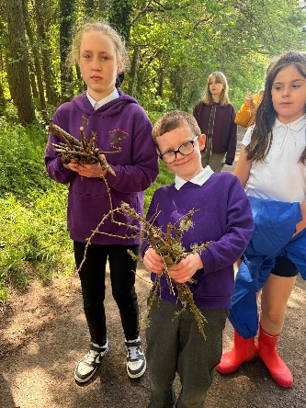
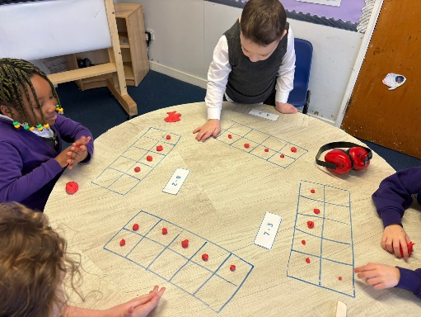
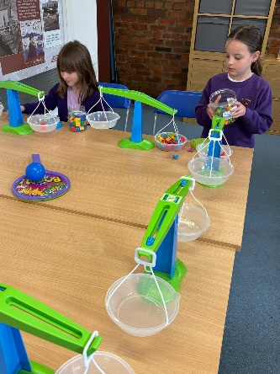

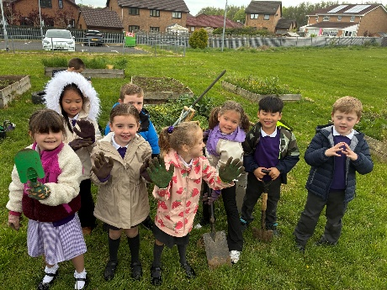
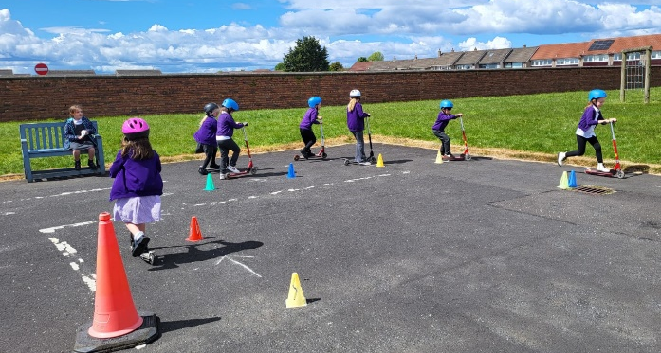

QUALITY INDICATORS
Provide your evaluation & brief summary statement for each of the 4 core QIs
QI 1.3 Leadership of Change | Evaluation: Very Good
At St John’s, we are committed to ensuring the highest possible standards and success for all children. All staff demonstrate a strong commitment to shared educational values and professional standards, which underpin our work across the school community.
Senior leaders provide effective and consistent leadership, enabling the school and wider community to develop, promote, and sustain an aspirational vision that drives continuous improvement. This vision is embedded in practice and supports ongoing school improvement.
All staff take responsibility for implementing change and actively promote equality, inclusion, and social justice across all aspects of school life. Robust strategies are in place to monitor and evaluate the impact of change on outcomes for children, ensuring that developments are evidence-informed and contribute meaningfully to the work of the school.
QI 2.3 Learning, Teaching & Assessment | Evaluation: Good
Our learning environment is built on positive, nurturing, and appropriately challenging relationships which support high-quality learning and positive outcomes for all learners. Staff foster a climate where children feel supported, respected, and motivated to achieve their best.
Children’s achievements, both in and out of school, are effectively recorded, recognised, and celebrated. Learners are supported to understand how their achievements contribute to the development of skills for life, learning, and work, promoting confidence, responsibility, and aspiration.
Assessment approaches are well matched to learners’ needs and are used effectively to support children in demonstrating their progress and next steps in learning. Tracking and monitoring systems are well understood by staff and used consistently to identify progress, inform professional judgement, and secure improved outcomes for all learners.
QI 3.1 Ensuring Wellbeing, Equality & Inclusion | Evaluation: Very Good
Within our school community there is a shared and well-established understanding of wellbeing and children’s rights across the whole school community. All stakeholders actively promote a safe, secure, and nurturing climate where children feel valued, respected, and supported to thrive.
Relationships across the school community are consistently positive and supportive, founded on mutual respect and a strong sense of belonging. This contributes to an inclusive ethos where all learners are encouraged to participate fully in the life of the school.
The school complies with and actively engages in statutory requirements and relevant codes of practice, ensuring that policy and practice reflect current expectations and promote high standards of care and support.
There is a strong commitment to inclusion and equality, which leads to improved outcomes for all learners. All children are encouraged to be involved in school life, with barriers to participation identified and addressed effectively. Staff strive to include and engage all pupils.

QI 3.2 Raising Attainment & Achievement | Evaluation: Good
Attainment in literacy and numeracy is a central focus within school improvement priorities and is leading to improvements in overall attainment. Robust approaches to tracking, monitoring, and targeted support are helping to secure positive outcomes for learners.
Overall, learners are successful, confident, and responsible individuals who contribute positively to the life of the school, the wider community, and as global citizens. They demonstrate a wide range of skills and attributes developed through high-quality learning experiences and participation in a broad range of activities.
Attendance levels continue to improve, reflecting strong engagement with learning. Exclusion rates remain low, with inclusive practice ensuring that all learners are supported effectively and are able to access education successfully.
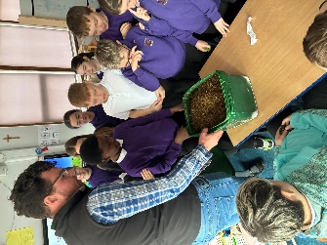
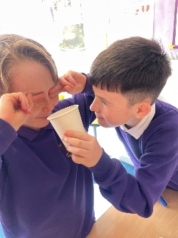
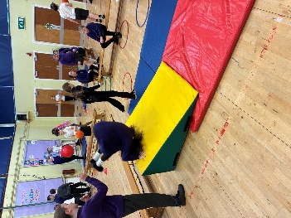
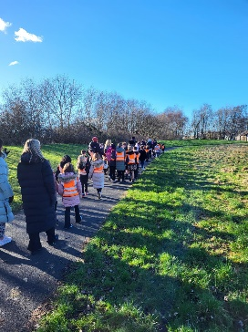
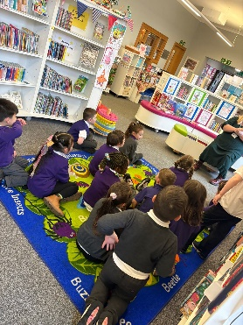

PUPIL EQUITY FUNDING
In St John’s we used our Pupil Equity Funding to support Play and outdoor learning within our school. We funded a Pupil Support Assistant to support Play Pedagogy and outdoor learning in P1-7.
To strengthen our whole-school approach to health and wellbeing, we purchased myHappymind to support the development of children's resilience, emotional literacy, self-regulation and positive mental wellbeing. The programme provides a consistent, evidence-informed framework that helps children understand how their brains work, recognise and manage their emotions, and develop positive relationships. This supports children's readiness to learn, confidence and engagement in learning, creating a positive environment where all learners can thrive.

IMPROVEMENT PLAN PRIORITIES 2026-2027
Priority 1
- Improvement in attainment in reading through the introduction of North Ayrshire Reads.
Priority 2
- Improvement in children’s mental health and wellbeing through embedding of the My Happy Mind strategies, New Authority approach and a focus on attendance.

Priority 3
- To embed Learning for Sustainability across the curriculum, strengthening outdoor learning, STEM and digital technologies and develop learners who are informed, responsible and active global citizens.

