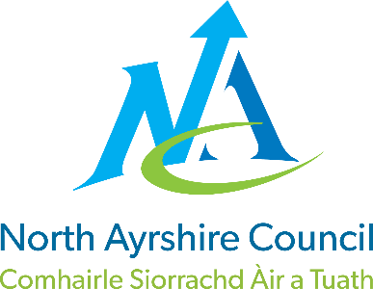 

**ST JOHN’S PRIMARY & EYC**

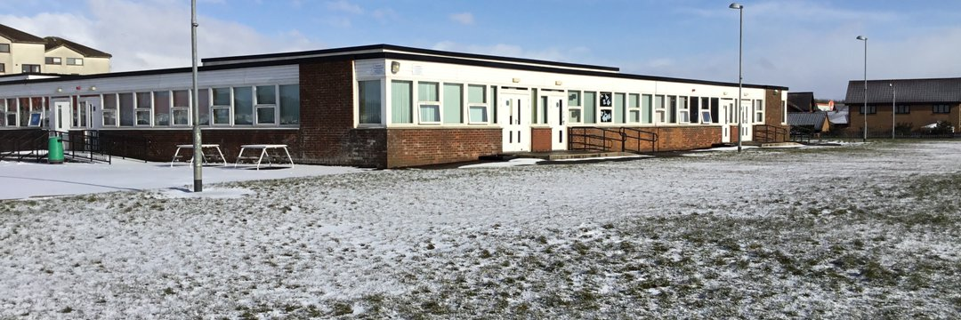

**STANDARDS AND QUALITY REPORT**

**June 2025**

This report will inform you of the school’s progress and achievements in the last session and let you know about our plans for 2025-2026.

I hope that you find it helpful and informative.

Karen McAllister

Head Teacher

|  |
| --- |
| **OUR SCHOOL** |
| **OUR SCHOOL**  St John’s Primary School is a Catholic school which serves the town of Stevenston and its surrounding areas.  The school roll during 2024 - 2025 was ninety four children in five classes with sixteen children in the nursery in morning and afternoon sessions. In our staff we had a Head Teacher, Depute Head Teacher, Nurture Teacher, Additional Support Needs Teacher, five class teachers and a newly qualified teacher.  Our support staff comprised of one Janitor, one Education Business Assistant, two Pupil Support Assistants one Pupil Equity Funded Pupil Support Assistant who supports Play and a Dining Hall Supervisor.  In the Early Years class we had a Senior Early Years Practitioner, a Lead Practitioner, one Early Years Practitioner and two Early Years Assistants.  The school was well supported by our School Nurse, Eileen Murnie, Educational Psychologist, Clara Davidson, Speech and Language Therapists, Childsmile, Counselling Services, our School Chaplain, Canon Martin Poland, Family Wellbeing Support Team and Active Schools Coordinator, Chris Hays.  C:\Users\JMcMahon1\Downloads\IMG_5853.PNG C:\Users\JMcMahon1\Downloads\IMG_5127.jpg C:\Users\JMcMahon1\Downloads\IMG_5835.jpg  C:\Users\JMcMahon1\Downloads\PHOTO-2025-05-17-12-52-18.jpg C:\Users\JMcMahon1\Downloads\IMG_5836.jpg |

|  |
| --- |
| **OUR VISION, VALUES AND AIMS** |
| **VISION, VALUES & AIMS**  In August 2023 we consulted our school community and revised our Vision, Values and Aims  **OUR VISION**  Our vision is of a safe and happy learning community where we inspire one another to greatness and open doors to new opportunities.  **OUR VALUES**   * INVOLVEMENT * RESPECT * FAITH * TEAMWORK * CREATIVITY * COMMUNITY   **OUR AIMS**   * We will work together in partnership to develop mutual respect and trust, sharing the same goals, to develop skills for life * We will provide a safe and welcoming community where everyone is treated as an individual and is supported to achieve * We will work together as a whole school team to challenge and support excellence in learning and teaching * We will work in partnership with the church community to develop the ethos of Catholic faith where all are valued and respected impacting on the spiritual and emotional growth of all * We will provide a child centred curriculum which is relevant, challenging, progressive and incorporates personalisation and choice to meet the needs of all learners * We will ensure that the social, emotional and mental wellbeing of everyone is at the heart of all we do by ‘Getting it Right for Every Child’ * Everyone will be treated respectfully and celebrated as individuals * We will be reflective and evaluative in our practice to raise attainment and achievement for all.   C:\Users\JMcMahon1\Downloads\IMG_5878.jpg C:\Users\JMcMahon1\Downloads\IMG_5871.JPG C:\Users\JMcMahon1\Downloads\IMG_5861.JPG C:\Users\JMcMahon1\Downloads\IMG_5854.JPG |

|  |
| --- |
| **ATTAINMENT & ACHIEVEMENT** |
| **Attainment & Achievement**   * Our children were successful in our school’s Burns Competition in Poetry * All classes celebrated key events in the Liturgical Calendar e.g. All Saints Mass, Advent, Lent etc. * JRSO led successful initiatives within the school * Our football team participated in all games in the Champions League * Celebrated children’s successes and achievements weekly at assemblies and at the end of session celebrations * Children celebrated the sacraments of Reconciliation, Confirmation and First Eucharist * Primary 7 had a successful residential trip to Lockerbie Manor * Liaised with all partner agencies to meet the needs of all pupils e.g. Canon Martin, Educational Psychologist, Facilities Management * Pupil Voice is strong. All children are members of our Pupil Committees. Our children are the change makers in our school community and beyond. * P6 completed the Move and Improve Active Schools Yound Leadership Course * P7 participated in a Wellbeing programme with our Educational Psychologist * P7 took part in the Sonappa Digital Music Programme * Digital Leaders have shared their knowledge and expertise across the school. * Our children have shared their talents and skills through showcasing these at key assemblies e.g. John Muir, Nativity, Christmas Concert and Daffodil Tea * P1 data – most children achieved Early Level in Literacy and Numeracy * P4 data – most children achieved Early Level in Literacy and Numeracy * P7 data – most children achieved Early Level in Literacy and Numeracy |

|  |
| --- |
| **WIDER ACHIEVEMENT** |
| **Wider Achievements**   * P7 achieved their Pope Francis Faith Award. P6 started their journey. * Maintained the Digital Schools Award * Developed opportunities for children to develop their leadership skills through implementing a robust buddying programme * P1/2 achieved the RSPB Silver Award * P2/3 achieved the Royal Horicultural Society Gardening Award * P4/5 achieved the John Muir Award * P5/6 achieved the Young STEM Leaders Award * P7 achieved the Sonappa Digital Music Award * P7 achieved the Cycle Friendly School Award for the school * The Fairachiever Fairtrade Award was maintained * Continuation of the Pope Francis Laudato Si initiative * We worked throughout the session with Chris our Active Schools Coordinator to provide Leadership Training and Sporting opportunities for all pupils * Maintained Silver Accreditation for Rights Respecting Schools from UNICEF UK. Empowering our children to become change makers and leaders within our community and beyond * Maintained green flag status with Eco Schools Scotland. * Our Young Leaders of Learning were trained and visited a partner school to share their ideas about school improvement * Some P6 pupils have been trained in iCycle |

|  |
| --- |
| **HOW SUCCESSFUL HAVE WE BEEN IN IMPROVING OUR ESTABLISHMENT?** |
| **PRIORITY 1 :**  **To develop as a community of faith and learning within our schools and across the Deanery**   * All teaching staff engaged in professional reading and worked collectively as a Deanery to gather views and recognise key features within our schools * Head Teachers from the Deanery attended the CHAPS Conference and cascaded good practice to the Cluster schools * All P7 pupils from the Cluster schools attended a Retreat at St Matthew’s Academy with the theme of ‘Pilgrims of Hope’ * Positive Relationships and Behaviour Policy was reviewed to align with the Gospel Values * Children from across the school were involved in Parish events e.g. Adeste Fideles with the Synod Group * P7 pupils were involved in a Stakeholder event to gather their views around the Inspection Processs   **PRIORITY 2:**  **To improve the quality of Learning, Teaching and Assessment across our school**   * Staff have participated in Listening and Talking Moderation Activities with St. Anthony’s and St. Winnings Primary Schools * Staff introduced new planning for assessment high quality assessments in interdisciplinary learning * Teaching staff engaged in professional learning with the Professional Learning Academy on Problem Solving strategies. This enhanced the learning opportunities for our children. New resources for teaching of numeracy and mathematics were purchased.   **PRIORITY 3:**  **To increase pupil participation within and across our school and early years class**   * All staff were trained in the Learner Participation Policy and now use the four arenas of participation as part of their planning * Four P6 pupils were trained with other children from the Cluster to be Young Leaders of Learning * The Young Leaders of Learning took part in visits to a partner school with a focus on school improvement * Each child experienced opportunities and developed their meta skills in class through Pupil Committees and working towards and achieving accredited awards.   **PRIORITY 4:**  **To raise attainment in Literacy in P1 and P2 by implementing Literacy power in an Hour –PLA intervention**   * The P1/2 teachers have attended fortnightly training focussing on phonics, word study, reading and writing in order to deliver the most up to date and research driven pedagogy * The P1/2 teachers have team taught throughout the session to deliver guided reading sessions to raise attainment in Literacy.   C:\Users\JMcMahon1\Downloads\IMG_5860.JPG **C:\Users\JMcMahon1\Downloads\IMG_5858.JPG** C:\Users\JMcMahon1\Downloads\IMG_5857.JPG **C:\Users\JMcMahon1\Downloads\IMG_5876.jpg C:\Users\JMcMahon1\Downloads\IMG_5875.JPG** |

|  |  |
| --- | --- |
| **QUALITY INDICATORS**  Provide your evaluation & brief summary statement for each of the 4 core QIs | |
| QI 1.3 Leadership of Change | Evaluation: Very Good |
| At St John’s we are committed to ensuring that we achieve the highest possible standards and success for all children. All staff show commitment to shared educational values and professional standards. Senior leaders provide strong leadership which has enabled our school and wider community to develop, promote and sustain an aspirational vision which underpins our continuous improvement.  All staff take responsibility for implementing change and promoting equality, inclusion and social justice. We have effective strategies in place to monitor and evaluate the impact of changes on outcomes for children and the work of our school. | |
| QI 2.3 Learning, Teaching & Assessment | Evaluation: Good |
| Our learning environment is built on positive, nurturing and appropriately challenging relationships which lead to high-quality learning outcomes. Children’s achievements in and out of school are recorded and recognised. Children understand how these achievements help them develop knowledge and skills for life, learning and work.  Assessment approaches are matched to the learning needs of children and are used to support them to demonstrate where they are in their learning.  Tracking and monitoring are well-understood and used effectively to secure improved outcomes for all children. | |
| QI 3.1 Ensuring Wellbeing, Equality & Inclusion | Evaluation: Very Good |
| Our whole school community has a shared understanding of wellbeing and children’s rights. All stakeholders promote a climate where children feel safe and secure. Relationships across the school community are very positive and supportive, founded on a climate of mutual respect.  We comply and actively engage with statutory requirements and codes of practice.  We ensure inclusion and equality leads to improved outcomes for all learners. All learners are included, engaged and involved in the life of the school. | |
| QI 3.2 Raising Attainment & Achievement | Evaluation: Good |
| Attainment levels in literacy and numeracy are a central feature of the school’s priorities for improvement and are raising attainment.  Overall, our learners are successful, confident, exercise responsibility and contribute to the life of the school, the wider community and as global citizens. They are personally and socially adept and have achieved a range of skills and attributes through a wide range of activities.  Attendance levels are high and improving. Exclusion rates are low and inclusion is successful for all. | |

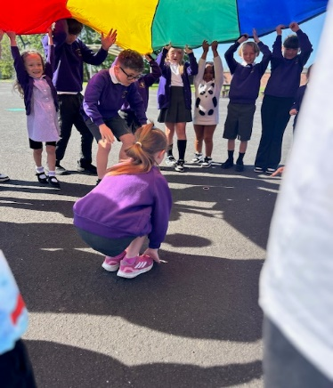 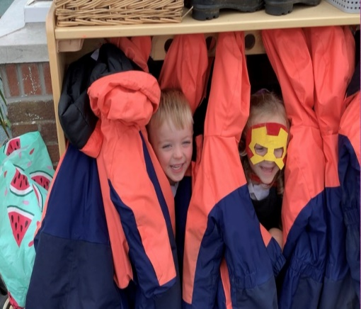 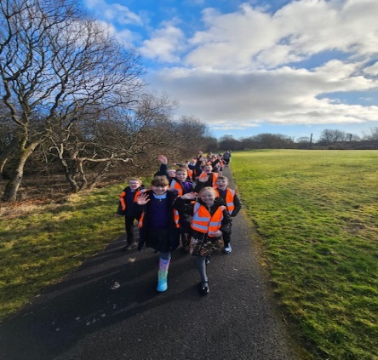

|  |
| --- |
| **PUPIL EQUITY FUNDING** |
| In St John’s we used our Pupil Equity Funding to support Play within our school. We funded a Pupil Support Assistant to support Play Pedagogy in P1-3 and help to extend this into P4-7.  We also identified a gap in resources in P4-7 in Numeracy and Maths and we purchased manipulatives for the children to use to enhance learning and teaching and deepen understanding of maths concepts. |

|  |
| --- |
| **IMPROVEMENT PLAN PRIORITIES 2025-2026** |
| **Priority 1**   * Improvement in attainment in numeracy and increase learner participation in numeracy leading to school improvement.   **Priority 2**   * Improvement in children’s mental health and wellbeing through introduction of the My Happy Mind resource.   **Priority 3**   * To develop Learning for Sustainability across the curriculum and develop learners who are informed, responsible and active global citizens.   **C:\Users\JMcMahon1\Downloads\IMG_5872.JPG C:\Users\JMcMahon1\Downloads\IMG_5855.JPG C:\Users\JMcMahon1\Downloads\IMG_5841.jpg C:\Users\JMcMahon1\Downloads\IMG_5839.jpg**  C:\Users\JMcMahon1\Downloads\IMG_5874.JPG C:\Users\JMcMahon1\Downloads\IMG_5837.jpg C:\Users\JMcMahon1\Downloads\IMG_1490.JPG C:\Users\JMcMahon1\Downloads\IMG_5834.jpg |