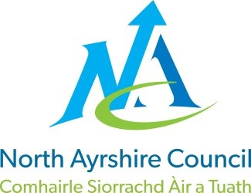
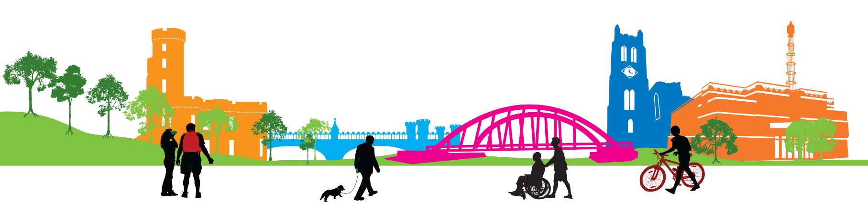


Communities and Education Directorate
St John’s EYC
Improvement Plan
2024-2025


EDUCATION SERVICE: IMPROVEMENT PLAN SUMMARY 2023/4 – 2025/6

The Education Service Improvement Plan is aligned to the 5 priorities of the National Improvement Framework. Individual establishments should create their own plan under these 5 priorities, based on rigorous self-evaluation and analysis of performance evidence. Stakeholders should be fully engaged in the development of the plan. In the diagram below, the orange boxes show the thematic areas under each priority which the service intends to focus on in the year ahead.

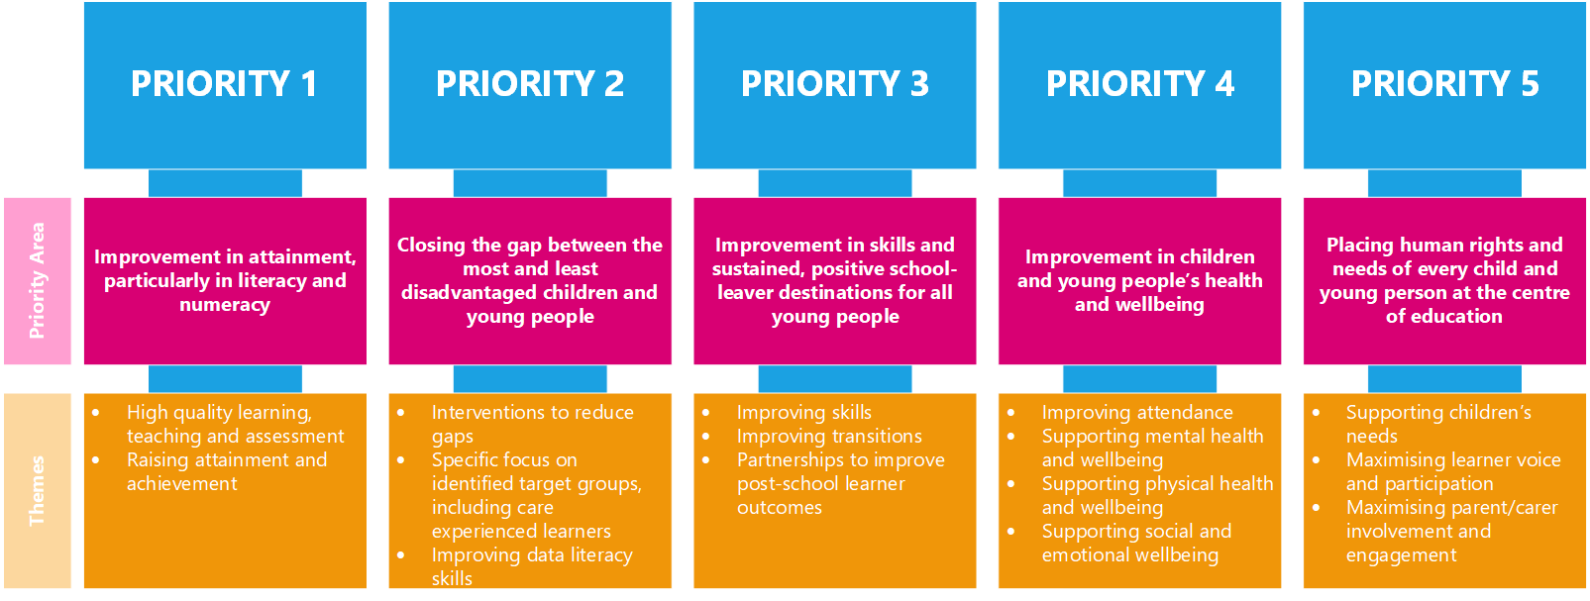

PRIORITY 2: Improvement in attainment in literacy and numeracy ( NAC Priority 1)

Strategic Objective:
To improve the quality of Learning, Teaching and Assessment across our school
UNCRC Articles 12, 13,17, 28 and 29
Highlight your KEY drivers for this improvement priority
Service Priorities  - Improvement in attainment, particularly in literacy and numeracy  - Closing the attainment gap between the most and least disadvantaged children and young people  - Improvement in skills & sustained, positive school-leaver destinations for all young people.  - Improvement in children & young people’s health & wellbeing  - Placing human rights & needs of every child & young person at the centre of education | HGIOS□ & HGIOS ELC  Language specific to HIGIOELC is in green
 | 1.1 Self-evaluation for self-improvement  1.2 Leadership for learning  1.3 Leadership of change  1.4 Leadership & management of staff  (practitioners)  1.5 Management of resources to promote equity |  | 2.1 Safeguarding & Child Protection  2.2 Curriculum  2.3 Learning, teaching & assessment  2.4 Personalised Support  2.5 Family Learning  2.6 Transitions  2.7 Partnerships |  | 3.1 Ensuring wellbeing equality and inclusion  3.2 Raising attainment & achievement  (Securing children’s progress)  3.3 Increasing creativity and employability  (Developing creativity and skills for life and learning)
NIF Drivers of Improvement  - School & ELC Leadership  - Teaching & Practitioner Professionalism  - Parent/carer involvement & engagement  - Curriculum & Assessment  - School & ELC Improvement  - Performance Information | Care Standards - Care Inspectorate Quality Indicators  Applicable within all early years settings
 | - Nurturing care and support  - 1.2 Children are safe and protected  - Play and learning  - Family engagement  - Effective transitions | 2.1 Quality of the session for care, play and learning  2.2 Children’s experience high quality facilities |  | 3.1 Quality assurance and improvement are led well  3.2 Leadership of play and learning  3.3 Leadership and management of staff and resources |  | 4.1 Staff skills, knowledge and values  4.2 Staff recruitment  4.3 Staff deployment
Rationale for Change
- Improve attainment in literacy, maths and numeracy, for all children – Milestones data, staff professional judgement, tracking data, assessment data
- Establish consistent whole school approaches/strategies for learning/teaching maths and numeracy, particularly through a play based pedagogy at early level – observation feedback and pupil sampling feedback, planning folders to ensure staff are planning assessment. ( See Assessment calendar)
- Improve practitioner confidence in identifying achievement of a level/achievements within – staff knowledge base and confidence based on senior manager visit, PRDs and minutes from Planning and Attainment meetings, moderation feedback and Education Scotland self-evaluation document and next steps identified by staff
- Data action plans

PRIORITY 2: To improve the quality of Learning, Teaching and Assessment across our school
Pupil Outcomes | Implementation Plan | Timescales/  Responsibility | Measurement of Impact | Analysis & Evaluation of Progress | Cost  (PEF)
Specifically, what will change for our learners? | How will we achieve this?  What do we plan to do? | What are our timescales? Who will lead? | How will we know the change is an improvement? Can you quantify this?  What data will be collated and analysed to demonstrate progress? Consider baseline data. | How do we know that the experiences & outcomes for learners have improved? What does the data tell us which demonstrates impact? | Please enter the cost to the nearest £
Play Pedagogy  - Ensuring a smooth transition in learning styles from nursery to P1 and P2  - Motivated and engaged learners with strong peer relationships  Children are more independent and leading their learning and are curious, creative and can solve problems | - Adapt and develop indoor and outdoor learning spaces/ environments  - Further develop responsive planning  - Staff working at early, first and second level develop their understanding of play pedagogy through focused professional learning and engage with NAC play pedagogy resources  - Engage in self-evaluation activities  - Further develop Stay and Play sessions through parent views and opinions | - August 2024- June 2025  - Termly Self Evaluations | - Staff Observations  - Floor books  - Milestone data  - self-evaluation using HGIOS and HGIOLC - features of highly effective play pedagogy  - Parental Questionnaires
Outdoor Learning  - Outdoor spaces will continue to enhance learning and wellbeing  - Increased enjoyment of learning and teaching in the outdoors  - All children will have the opportunity to participate in a range of creative outdoor learning experiences | - The EYC will make effective use of the outdoor learning environment  - Development of an Outdoor Learning Policy | - Identify a staff member to lead Outdoor Learning  - Develop a planning tool/ format for Outdoor Learning  - Develop, implement and evaluate an action plan to promote outdoor learning across the school | - Pre and post audits  - Peer observations  - Self-evaluation

PRIORITY 3 Placing human rights and needs of every child at the centre of education( NAC Priority 5)
Strategic Objective:
To increase pupil participation within and across our schools and early years classes.
UNCRC Articles 12, 13, 15, 17, 28, 29,
Highlight your KEY drivers for this improvement priority
Service Priorities  - Improvement in attainment, particularly in literacy and numeracy  - Closing the attainment gap between the most and least disadvantaged children and young people  - Improvement in skills & sustained, positive school-leaver destinations for all young people.  - Improvement in children & young people’s health & wellbeing  - Placing human rights & needs of every child & young person at the centre of education | HGIOS□ & HGIOS ELC  Language specific to HIGIOELC is in green
 | 1.1 Self-evaluation for self-improvement  1.2 Leadership for learning  1.3 Leadership of change  1.4 Leadership & management of staff  (practitioners)  1.5 Management of resources to promote equity |  | 2.1 Safeguarding & Child Protection  2.2 Curriculum  2.3 Learning, teaching & assessment  2.4 Personalised Support  2.5 Family Learning  2.6 Transitions  2.7 Partnerships |  | 3.1 Ensuring wellbeing, equality and inclusion  3.2 Raising attainment & achievement  (Securing children’s progress)  3.3 Increasing creativity and employability  (Developing creativity and skills for life and learning)
NIF Drivers of Improvement  - School & ELC Leadership  - Teaching & Practitioner Professionalism  - Parent/carer involvement & engagement  - Curriculum & Assessment  - School & ELC Improvement  - Performance Information | Care Standards - Care Inspectorate Quality Indicators  Applicable within all early years settings
 | - Nurturing care and support  - 1.2 Children are safe and protected  - Play and learning  - Family engagement  - Effective transitions | 2.1 Quality of the session for care, play and learning  2.2 Children’s experience high quality facilities |  | 3.1 Quality assurance and improvement are led well  3.2 Leadership of play and learning  3.3 Leadership and management of staff and resources |  | 4.1 Staff skills, knowledge and values  4.2 Staff recruitment  4.3 Staff deployment
Rationale for Change
- To create the right culture for meaningful learner participation in self-evaluation and school improvement activities thus impacting on pupil participation levels.
- To create opportunities for children to influence approaches taken to learning, teaching and assessment thus impacting on the curriculum on offer.
- To implement the Young Leaders of Learning programme, developed by Education Scotland, to give children and young people an increasing say in their education and their schools, building upon the UNCRC Rights of the Child and meta-skills.

School review/HMIe feedback/school context input as necessary (related feedback to learner participation and children as leaders of their learning).

PRIORITY 3: To increase pupil participation within and across our schools and early years classes
Pupil Outcomes | Implementation Plan | Timescales/  Responsibility | Measurement of Impact | Analysis & Evaluation of Progress | Cost  (PEF)
Specifically, what will change for our learners? | How will we achieve this?  What do we plan to do? | What are our timescales? Who will lead? | How will we know the change is an improvement? Can you quantify this?  What data will be collated and analysed to demonstrate progress? Consider baseline data. | How do we know that the experiences & outcomes for learners have improved? What does the data tell us which demonstrates impact? | Please enter the cost to the nearest £
All staff and children will work together to evaluate a range of aspects of school life including teaching and learning (QI 1.1)  All pupils participate in self-evaluation from HGIOURS: Theme 2, Our Learning and Teaching (page 12). Pupils will have the opportunity to ask questions, answer questions, provide feedback leading to positive change. | - Staff and children will self-evaluate their understanding using the Participation Mapping Tool  - 4 arenas of Pupil Participation to be completed by staff and each class.  - HGIOURS adapted for EY feedback collected from each class | - 23rd Sept In-service (staff)  - 23rd Sept In-service (staff)  - Week beginning 26th Sept (pupils)  - August to September | - Self-evaluation: Participation Mapping Tool (pre and post assessment completed by staff and pupils)  - 4 arenas of pupil participation used to identify key strengths and areas for development  - HGIOURS feedback collated from each class and high level messages shared, next steps developed and evaluated
Staff increased confidence in their understanding of North Ayrshire’s policy on Learner Participation ensuring greater consistency and opportunities for our children. This will empower children to participate and use their voice, make them feel valued and listened to, and see themselves as the change makers in our schools. | - Learner Participation policy staff focus & methods of participation (7 Golden Rules)  - Staff complete ‘Readiness checklist’ and develop a learner participation framework for implementation | - 23rd Sept In-service (staff)  - 23rd May In Service (staff) | - Written feedback from staff:  - staff identify the main aspects of the policy  - key take-away points  - potential impact identified from the policy  - challenges raised from the policy (CLPL required to support implementation in practice?)  - Pre and post readiness checklist and mapping tool completed, analysed and high level messages gathered and shared.  - Staff evaluate the impact of learner participation framework on school development
EY children will have increased understanding of the role of a Leader of Learning.  Four EY children will be selected and trained as Young Leaders of Learning (YLL). Children will become familiar with the language and processes of improvement and will contribute to evidence gathering and reporting.  Pupils will have opportunities to develop their meta-skills in relation to their leadership role.  Pupils will take lead roles in taking forward lead actions from the peer school visits.  YLL pupils will show an increase in understanding of importance of pupil participation as part of school development and will showcase their learning on a display board within the school and will share their YLL journey at a whole school assembly. | - Pupils will listen to story about YLL  - Each pair of schools will host. One sessions should be planned: half day in each nursery.  - Pupils will take part in self-evaluation using HGIOURS: Theme 2, to explore what is working well, areas for improvement and work together to devise a short action plan.  - Ideas for YLL visits: pupil focus groups:, tour of the EY, look at resources to play and learn with and the indoor and outdoor environment  - Children will meet will meet with the SMT to discuss how pupils will implement and evaluate their action plan to bring about school improvement. The vision for the implementation of the plan is to involve a wider pupil group. | - September to October 2024  - September to October (before October holidays) 2024  - TBC (visits to be completed in term 2)  - SMT meet with YLL pupils in term 2 after school visits to implement action plan and evaluate in terms 3 and 4. | - Children complete mascot sheet  - Create video of EY  - Organise video to send to Castlepark  - Children will take photographs of things they think are good/things they think the other nursery needs or they would like.  - YLL 4 will share their ideas with the rest of the children and the SMT  - Pupil voice gathered at the end of each YLL session by SMT  - Pupil voice collated and shared with paired EY (on agreed format)  - Evidence of feedback, action plan and implementation guide  - A variety of evidence gathered during visits  - Action plan and implementation plan, including evaluation.  - Display boards within school re: YLL journey  - Evidence of showcase to the whole school e.g. PPT slides or photographs
Children to continue experiencing a range of leadership opportunities in class and across the school. |  | - Ongoing throughout the year | - Accreditation certificates and reports  - Pupil showcasing learning

