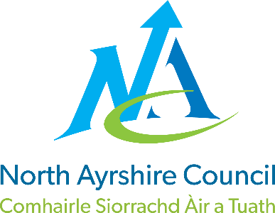

ST JOHN’S PRIMARY & EYC

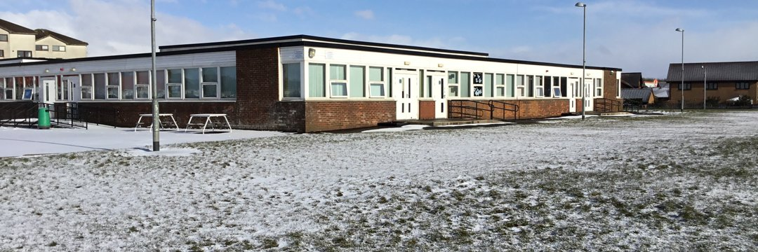
STANDARDS AND QUALITY REPORT
June 2024
This report will inform you of the school’s progress and achievements in the last session and let you know about our plans for 2024-2025.
I hope that you find it helpful and informative.

Karen McAllister

Head Teacher

OUR SCHOOL
OUR SCHOOL
St John’s Primary School is a Catholic school which serves the town of Stevenston and its surrounding areas.
The school roll during 2023 - 2024 was ninety eight children in five classes with sixteen children in the nursery in morning and afternoon sessions. In our staff we had a Head Teacher, Depute Head, Reading Recovery Teacher, Nurture Teacher, Recovery Teacher, five class teachers and a newly qualified teacher.

Our support staff comprised of one Janitor, one Education Business Assistant, five Classroom Assistants one of whom is a Nurture classroom assistant and a Dining Hall Supervisor.

Reading Recovery and Nurture are partly funded by the Pupil Equity Fund.
In the Early Years class we had a Senior Early Years Practitioner, a Lead Practitioner, two Early Years Practitioners and an Early Years Assistant.
The school was well supported by our School Nurse, Eileen Murnie, Educational Psychologist, Dr Kim Whitehead, Speech and Language Therapists, Childsmile, The Exchange Counselling Services, Aberlour, our School Chaplain, Canon Martin Poland, Family Wellbeing Team and Active Schools Coordinator, Chris Hays.

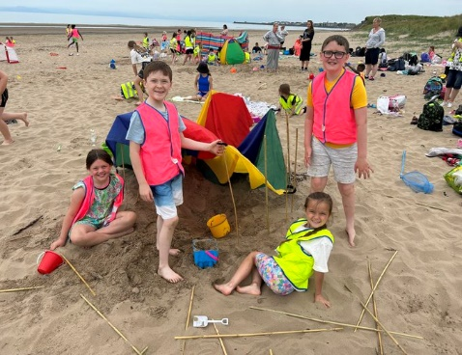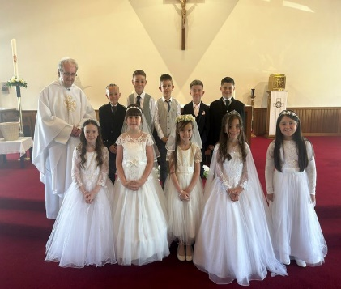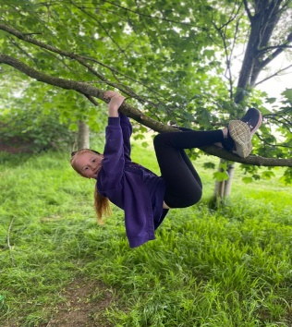
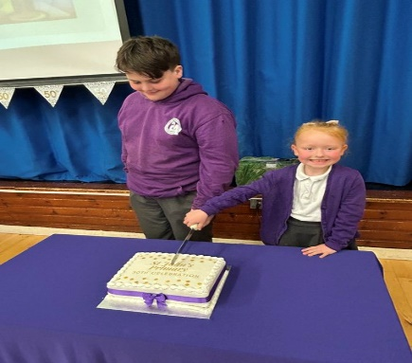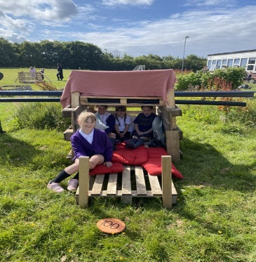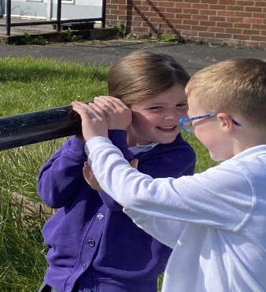

OUR VISION, VALUES AND AIMS
VISION, VALUES & AIMS
In August 2022 we consulted our school community and revised our Vision, Values and Aims
OUR VISION
Our vision is of a safe and happy learning community where we inspire one another to greatness and open doors to new opportunities.
OUR VALUES
- INVOLVEMENT
- RESPECT
- FAITH
- TEAMWORK
- CREATIVITY
- COMMUNITY

OUR AIMS
- We will work together in partnership to develop mutual respect and trust, sharing the same goals, to develop skills for life
- We will provide a safe and welcoming community where everyone is treated as an individual and is supported to achieve
- We will work together as a whole school team to challenge and support excellence in learning and teaching
- We will work in partnership with the church community to develop the ethos of Catholic faith where all are valued and respected impacting on the spiritual and emotional growth of all
- We will provide a child centred curriculum which is relevant, challenging, progressive and incorporates personalisation and choice to meet the needs of all learners
- We will ensure that the social, emotional and mental wellbeing of everyone is at the heart of all we do by ‘Getting it Right for Every Child’
- Everyone will be treated respectfully and celebrated as individuals
- We will be reflective and evaluative in our practice to raise attainment and achievement for all.

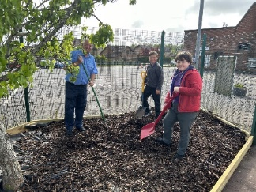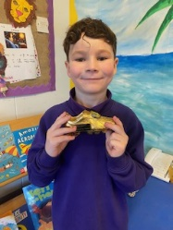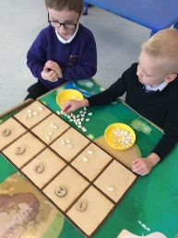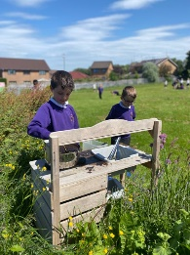

ATTAINMENT & ACHIEVEMENT
Attainment & Achievement
- Our children were successful in our school’s Burns Competition in Poetry
- All classes celebrated key events in the Liturgical Calendar e.g. All Saints Mass, Advent, Lent etc.
- Our school contributed to the North Ayrshire Youth Council Conference in March 2024
- Dance Team reached the finals of the NAC Dance Competition
- Netball Team reached the finals of the NAC Netball League
- Successful in securing funding from Youth PB for our Breakfast Club
- JRSO led successful initiatives within the school
- The school was represented at all North Ayrshire Cross Country events
- Our football team participated in all games in the Champions League
- Celebrated children’s successes and achievements weekly at assemblies and at the end of session celebrations
- Children celebrated the sacraments of Reconciliation, Confirmation and First Eucharist
- Primary 7 had a successful residential trip to Lockerbie Manor
- Liaised with all partner agencies to meet the needs of all pupils e.g. Canon Martin, Educational Psychologist, Facilities Management, Family Learning Team
- Pupil Voice is strong. All children are members of our Pupil Committees. Our children are the change makers in our school community and beyond.
- P6 completed the Move and Improve Active Schools Young Leadership Course
- P4-7 took part in the Sonappa Digital Music Programme
- Digital Leaders have shared their knowledge and expertise across the school.
- Our children have shared their talents and skills through showcasing these at key assemblies e.g. John Muir Assembly, School Shows, Nativity, Christmas Concert and Daffodil Tea

WIDER ACHIEVEMENT
Wider Achievements
- P7 achieved their Pope Francis Faith Award. P6 started their journey
- Maintained the Digital Schools Award
- Developed opportunities for children to develop their leadership skills through implementing a robust buddying programme
- RSPB Silver Award was maintained
- Fairachiever Fairtrade Award was achieved
- Continuation of the Pope Francis Laudato Si initiative
- P4 achieved the John Muir Award
- We worked throughout the session with Chris our Active Schools Coordinator to provide Leadership Training and Sporting opportunities for all pupils
- Received Silver Accreditation for Rights Respecting Schools from UNICEF UK. Empowering our children to become change makers and leaders within our community and beyond
- Maintained green flag status with Eco Schools Scotland

HOW SUCCESSFUL HAVE WE BEEN IN IMPROVING OUR ESTABLISHMENT?
Priority 1
To raise attainment in numeracy and mathematics through improved approaches across learning, teaching and assessment
· All teaching staff and classroom assistants have received numeracy training in Numeracy and Mathematics
· Staff have engaged with North Ayrshire’s Numeracy Strategy and have devised a Numeracy and Maths consistency guide
· Staff have participated in Numeracy Moderation Activities with St. Anthony’s and St. Winnings Primary Schools
· Time has been regularly allocated at collegiate sessions for sharing of good practice
· Digital learning permeates Numeracy and Mathematics
· Children have regular access to digital devices and tools
· We have continued to develop staff’s awareness of Dyscalculia through the NAC policy and CLPL sessions delivered by our Educational Psychologists

Priority 2
Improvement in children and young people’s health and wellbeing
· We have undertaken Education Scotland Self-evaluation of Recognising and Realising children’s rights and devised an implementation plan
· Continued with our Rights Respecting Committee
· Focus Articles are integral to weekly lessons
· Planned, implemented and evaluated Rights Focus Weeks in collaboration with our whole school community
· Further developed of our school community’s understanding of children’s rights
· We are preparing to host an accreditation visit at the end of April towards receiving our Silver Rights Respecting Schools Award
· Introduced the new ASN policy and procedures to staff
· Communicated new policy and procedure to parents/carers and children
· Introduced and implemented new Staged Intervention paperwork
· Early Years staff and SMT have visited other establishments to see play in action
· Staff working at early level are developing their understanding of play pedagogy through focused professional learning and have engaged with NAC play pedagogy resources
· Further developed Stay and Play sessions in P1 and P2/3
· Introduced a new document to track our children’s successes and achievements

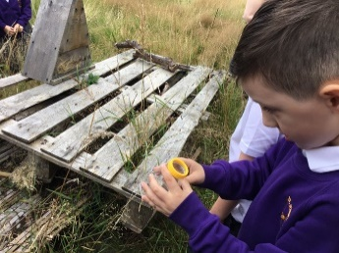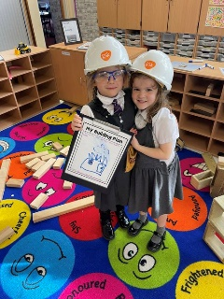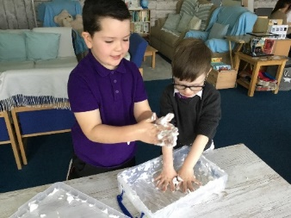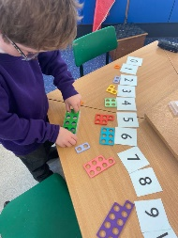

QUALITY INDICATORS
Provide your evaluation & brief summary statement for each of the 4 core QIs
QI 1.3 Leadership of Change | Evaluation: Very Good
At St John’s we are committed to ensuring that we achieve the highest possible standards and success for all children. All staff show commitment to shared educational values and professional standards. Senior leaders provide strong leadership which has enabled our school and wider community to develop, promote and sustain an aspirational vision which underpins our continuous improvement.
All staff take responsibility for implementing change and promoting equality, inclusion and social justice. We have effective strategies in place to monitor and evaluate the impact of changes on outcomes for children and the work of our school.
QI 2.3 Learning, Teaching & Assessment | Evaluation: Good
Our learning environment is built on positive, nurturing and appropriately challenging relationships which lead to high-quality learning outcomes. Children’s achievements in and out of school are recorded and recognised. Children understand how these achievements help them develop knowledge and skills for life, learning and work.
Assessment approaches are matched to the learning needs of children and are used to support them to demonstrate where they are in their learning.
Tracking and monitoring are well-understood and used effectively to secure improved outcomes for all children.
QI 3.1 Ensuring Wellbeing, Equality & Inclusion | Evaluation: Very Good
Our whole school community has a shared understanding of wellbeing and children’s rights. All stakeholders promote a climate where children feel safe and secure. Relationships across the school community are very positive and supportive, founded on a climate of mutual respect.
We comply and actively engage with statutory requirements and codes of practice.
We ensure inclusion and equality leads to improved outcomes for all learners. All learners are included, engaged and involved in the life of the school.
QI 3.2 Raising Attainment & Achievement | Evaluation: Good
Attainment levels in literacy and numeracy are a central feature of the school’s priorities for improvement and are raising attainment.
Overall, our learners are successful, confident, exercise responsibility and contribute to the life of the school, the wider community and as global citizens. They are personally and socially adept and have achieved a range of skills and attributes through a wide range of activities.
Attendance levels are high and improving. Exclusion rates are low and inclusion is successful for all.

PUPIL EQUITY FUNDING
In St John’s we used our Pupil Equity Funding to support Nurture within our school. We part funded a Nurture teacher and Nurture Classroom Assistant. Six children engaged in the Core Nurture programme. The staff also delivered the LIAM intervention, Nurture Lego Bricks, Growth Mindset and friendship groups. Data was also collected in relation to the GIRFEC SHANARRI indicators and My World Triangle.

IMPROVEMENT PLAN PRIORITIES 2023-2024
Priority 1
- To develop as a community of faith and learning within our schools and across the Deanery.
Priority 2
- To increase pupil participation within and across our school and early years class.
Priority 3
- To improve the quality of learning, teaching and assessment across our school and early years class.
