
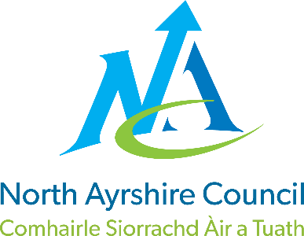
ST JOHN OGILVIE PRIMARY

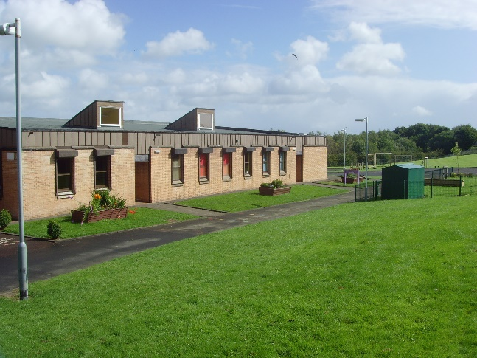

STANDARDS AND QUALITY REPORT
June 2025
This report will inform you of the school’s progress and achievements in the last session and let you know about our plans for 2025-2026.
I hope that you find it helpful and informative.

Pauline McCulloch

Pauline McCulloch, Head Teacher

OUR SCHOOL
St John Ogilvie Primary is a denominational, open plan school which opened in January 1984. We are part of the St Matthew’s Academy Cluster. Our wide catchment area includes Bourtreehill, Girdle Toll, Broomlands, Lawthorn, Montgomerie Park, Springside, Perceton and Dreghorn. The present school roll is 171 pupils.

We are proud of our relationships with children, parents / carers and families as well as our links with the local community. We hope that you find our school to be a positive, caring place where your child can reach their full potential.
We aspire to provide a happy, safe, challenging, motivational and supportive environment, wherein quality teaching and learning takes place, to ensure that everyone has the opportunity to flourish as an individual, work as part of a team and achieve their potential within a nurturing environment.

OUR VISION, VALUES AND AIMS
OUR VISION
To work together, help and support each other to be the best we can be
and reach our full potential.

OUR VALUES
Inclusion Equality Respect Honesty Trust
Responsibility Nurture

OUR AIMS
- To create a safe, healthy and welcoming school ensuring our children feel happy, valued and secure.
- To support pupils and families educationally, emotionally and socially.
- To provide a wide variety of opportunities through high quality learning and teaching experiences.
- To provide a sound Catholic education within a Christian environment.
- To encourage our children to be independent and take responsibility for their own learning.
- To equip our children with the knowledge and skills to make healthy choices now and in the future.

ATTAINMENT & ACHIEVEMENT
Our 2024 / 2025 Attainment Data:
ST JOHN OGILVIE PRIMARY SCHOOL 2024 – 2025 ATTAINMENT DATA: READING
CLASS | % Achieved  Early Level | % Achieved  First Level | % Achieved Second Level
P1 | 64.71% | - | -
P4 | - | 70.97% | -
P7 | - | - | 86.67%
Key Messages:
- ‘Tools for Reading’ at all stages has been identified as requiring a clear focus next session in order to raise attainment at all levels.
- Input from Professional Learning Academy (PLA) next session - Literacy Progression Framework and Supporting Dyslexic Learners. Pupils will have access to dyslexia friendly core readers and novels.
- Targeted Support Teacher will undertake quality guided reading with learners who are almost on track and Toe by Toe with targeted pupils.

ST JOHN OGILVIE PRIMARY SCHOOL 2024 – 2025 ATTAINMENT DATA: WRITING
CLASS | % Achieved  Early Level | % Achieved  First Level | % Achieved Second Level
P1 | 70.59% | - | -
P4 | - | 74.19% | -
P7 | - | - | 73.33%
Key Messages:
- ‘Tools for Writing’ at all stages has been identified as requiring a clear focus next session in order to raise attainment.
- North Ayrshire Literacy Progression Framework and Planners will be implemented next session.
- Input from PLA next session - Approaches to Writing.
- Targeted Support Teacher will be effectively timetabled next session to assist P1-P7 classes during weekly focused Writing Time.

ST JOHN OGILVIE PRIMARY SCHOOL 2024 – 2025 ATTAINMENT DATA:
TALKING & LISTENING
CLASS | % Achieved  Early Level | % Achieved  First Level | % Achieved Second Level
P1 | 73.53% | - | -
P4 | - | 96.71% | -
P7 | - | - | 83.33%
Key Messages:
- Focus on Oracy at all stages is helping to maintain a high standard of attainment throughout the school.
- We seek advice and support from other agencies and specialists as required regarding the development of communication skills.

ST JOHN OGILVIE PRIMARY SCHOOL 2024 – 2025 ATTAINMENT DATA: NUMERACY
CLASS | % Achieved  Early Level | % Achieved  First Level | % Achieved Second Level
P1 | 73.53% | - | -
P4 | - | 83.87% | -
P7 | - | - | 66.67%
Key Messages:
- Input from PLA next session - Using Manipulatives and Approaches to Numeracy.
- North Ayrshire Mathematics Framework and Planners will be implemented next session.
- Targeted Support Teacher will support individual pupils next session with basic numeracy skills.

Attendance
Our overall attendance rate for 2024/2025 was 89.83% which was slightly lower than the North Ayrshire average of 92.45%. This is mainly due to parents/carers taking their children on holiday during term time. This session, pupils will be involved in developing strategies to improve overall attendance.
Exclusions
Number of pupil exclusions continues to decrease. This is attributed to effective restorative and nurturing approaches throughout our school community.

WIDER ACHIEVEMENT
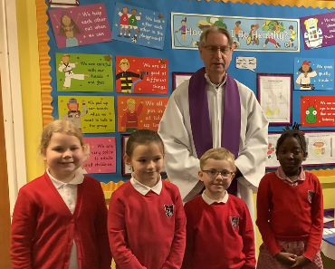
Sacraments
Congratulations to our children who celebrated the Sacrament of Reconciliation, Confirmation and First Holy Communion this year. Our school community will continue to support all children and their families on their journey of Faith and thank the parish of St John Ogilvie for their continued support.
Sporting Achievements
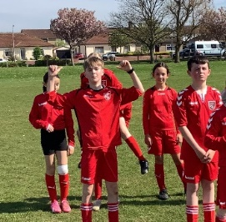
There has been a variety of sporting activities on offer to all stages during the year. These activities are planned for during and after the school day with staff, members of the community and visiting specialists supporting these.

Our P6 and P7 pupils enjoyed the Mixed Football Easter Cup Tournament 2025 organised by NA Active Schools. This was held at Kilwinning Sports Centre. All pupils thoroughly enjoyed this experience and were excellent ambassadors for our school.

Quiz Time
Our P6 team of 4 pupils represented our school very well at the Euro Quiz. Our P7 team of 4 pupils also enjoyed participating in Irvine Seagate Rotary Quiz. We are proud of our children for their positive attitude, personal and group research and behaviour at these events.
Leadership Opportunities
There have been many opportunities for our children to take on responsibility as leaders in our school community this year. All classes have a reading buddy in a different class which is a great learning experience for all children.

P6 successfully participated in the Young Leaders of Learning (YLL) Programme which involved visiting St Mark’s Primary and hosting their YLL in our school.
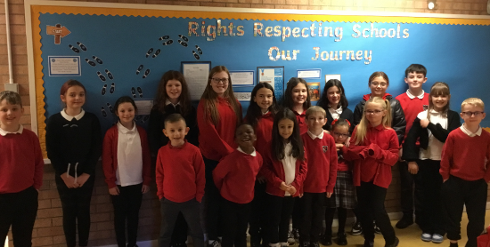
Our Rights Respecting Schools Committee meet regularly as we work towards our Silver Accreditation. The Committee look for opportunities to raise awareness of the rights of the child.

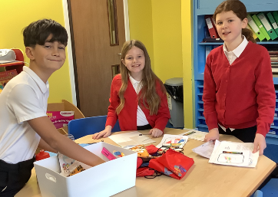
Our Junior Road Safety Officers attended a training event and organised various road safety initiatives in the school throughout the session which involved all classes.

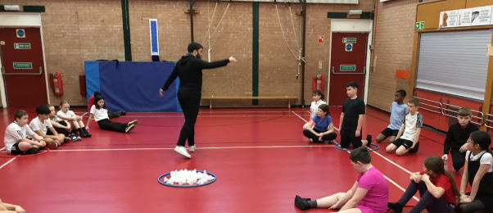
Christopher Hayes, Active Schools Co-ordinator trained our P6 pupils in Leadership skills. These skills were transferred to their buddying role with our Early Years children.

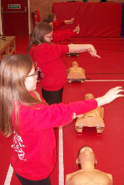
P7 buddies have provided care, friendship and support to P1 children throughout the year. P6 are now building up positive relationships with their Early Years buddies which will continue after the summer holiday.

P7 were trained in CPR techniques by Headstart. This is a critical skill that can save lives in emergency situations. Our pupils’ confidence and sense of responsibility were boosted after this session.

Partnerships
Brian Ross, Area Inclusion Worker organised and led an after school Family Fun Club for all children and their parents/carers. Families enjoyed taking part in a variety of family challenges designed to enhance their problem solving skills. Positive feedback given by all parents / carers who attended.


P7 pupils worked with Tim Dryer, STEM Co-ordinator and also Eglinton Park Rangers to create an information trail in Bourtreehill Park.

One of our P7 pupils was successful in designing a fantastic new logo for Irvine Judo Club. This will be put on the gable end wall at the Volunteer Rooms car park in Irvine for all to see and also on their merchandise. The school also won £500 which will be put towards outdoor resources for our pupils.

P4 pupils entered an RAF competition and won a free visit from the Royal Air Force Youth and STEM Team. All P4-P7 pupils participated in Robotics sessions.

We have developed a strong link with Irvine New Town Men’s Shed who kindly welcomed a small group of our pupils and helped them to build bird boxes.
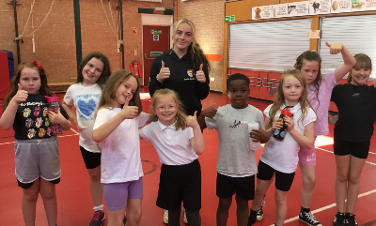
Through our Active Schools, we supported two students with their Leadership Courses. They provided after school clubs for various pupils which developed multi-sports and dance skills.

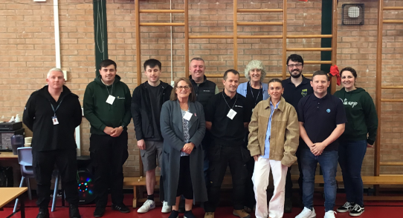
P6 and P7 pupils organised and led a successful World of Work Event Career Day which included lots of organisations from the local area.

HOW SUCCESSFUL HAVE WE BEEN IN IMPROVING OUR ESTABLISHMENT?
SCHOOL IMPROVEMENT PLAN PRIORITIES 2024/2025

PRIORITY 1
To raise attainment in Literacy and Numeracy
- We supported P1–P5 stages with an additional Class Teacher and Pupil Support Assistant during focused writing time which had a positive impact on progress and attainment. Depute Head Teacher supported P6-P7 stages.

- Play Based Learning effectively implemented at P1 and P2 stages. We have continuously developed our classrooms, open area and patio to support child led play pedagogy.

- Reading Buddies at all stages including early years has had a positive impact on progress and attainment in literacy.

PRIORITY 2
To increase participation of learners and engagement with families
- Young Leaders of Learning (YLL) successfully introduced at P6 stage with our YLL linking with YLL from St Mark’s Primary during the year.

- All classes involved in self-evaluation with a focus on the four arenas of learning:
- Decision Making Process.
- Opportunities for Personal Achievement.
- Learning, teaching and assessment.
- Connection with the Wider Community.

- We ensure that in each class, all pupils have a clear voice which is respected, listened to and suggestions acted upon. Staff and pupils work well together to evaluate what is working well and identify areas for development.

PRIORITY 3
To develop as a community of faith and learning within our school and across the Deanery
- We engaged in purposeful activities with a range of Church and Faith community partners.

PRIORITY 4
To raise attainment in literacy and numeracy in our Early Years
- Analysis of milestone data 2024/2025 highlighted the following:
- Attainment in Literacy, Numeracy and HWB is lower than North Ayrshire average.
- Girls out performing boys in all areas, including toileting.

QUALITY INDICATORS
Provide your evaluation and summary statements for each of the 4 core Qis
QI 1.3 Leadership of Change | Evaluation 4: Good
- We are committed to ensuring that we achieve the highest possible standard and success for all our pupils.
- All staff have consistently high expectations of all learners.
- We encourage pupil voice in all aspects of school life.
- All staff are clear on the school’s strengths and areas for development based on a range of evidence. This is used to create a clear rationale for future improvements.
- Our staff lead by example and are highly motivated to improving outcomes for all learners.
QI 2.3 Learning, Teaching & Assessment | Evaluation 4: Good
- Our school has a nurturing, Catholic ethos which supports a productive and secure learning environment in all classrooms where our children can thrive in their learning.
- Relationships are built on mutual respect and trust where all voices are heard. Pupil voice is stronger as we provide more opportunities for all pupils to get involved in school improvement.
- We support, encourage and celebrate wider achievements.
- Staff record, analyse and use assessment information to identify development needs in order to get it right for every learner.
QI 3.1 Ensuring Wellbeing, Equality & Inclusion | Evaluation 5: Very Good
- Relationships across our school community are positive and supportive, founded on a climate of mutual respect with a strong sense of community, shared values and high expectations.
- All staff are sensitive and responsive to the wellbeing of each individual child. Our children feel valued and listened to. We consider each child as an individual with his/her own needs and rights.
- A nurturing and inclusive ethos permeates all classroom environments. Calm Corners are used effectively. All staff utilise a restorative approach with children. Zones of Regulation used to encourage positive behaviour within an inclusive environment.
- We are utilising our outdoor spaces more effectively to promote positive relationships and wellbeing.
QI 3.2 Raising Attainment & Achievement | Evaluation 4: Good
- Majority of children attain appropriate levels. Attainment levels in literacy and numeracy are central features in the school’s priorities for improvement which is helping to raise attainment.
- Teachers are now more rigorous in using data, benchmarks and professional judgement effectively to identify achievement of a level, gaps in learning and what specific pupils need to focus on.
- Achievements are tracked and celebrated effectively through our assemblies, wall displays and effective use of social media platforms and regular newsletters.

The school’s overall capacity for improvement in relation to improving attainment, closing the attainment gap and improving children’s health and wellbeing is good.
PUPIL EQUITY FUNDING
Our Pupil Equity Fund (PEF) has been used in a variety of ways to improve outcomes for our learners, with a particular focus on supporting the wellbeing of children and raising attainment in literacy and numeracy.

- Pupil Support Assistants employed to contribute towards raising attainment and supporting the wellbeing of learners

This input was effective as we were able to offer the following:

- Targeted interventions for identified pupils to raise attainment.

- Supporting the wellbeing of specific pupils.

- Digital platforms to help raise attainment in literacy and numeracy

This input was effective as we were able to implement the following programmes:

- Sumdog to develop spelling and numeracy skills with P3 - P7 pupils.

- NESSY software to enhance spelling and reading at P3 - P7 stages for identified pupils.

IMPROVEMENT PLAN PRIORITIES 2025-2026
SCHOOL IMPROVEMENT PLAN PRIORITIES

2025/2026

PRIORITY 1 – To raise attainment in Literacy and Numeracy

- Implementation of North Ayrshire Literacy Progression Framework and Planners.
- Implementation of North Ayrshire Mathematics Framework and Planners.
- Focus on tools for reading and writing.
- Development of Play Based Learning at P1 and P2 stages.
- Input from Professional Learning Academy in reading, writing and numeracy.
- Targeted Support Teacher will support learners who are almost on track with guided reading and during writing time.

PRIORITY 2 – To improve the effectiveness of learner participation and engagement
with parents/carers and the wider community

The following strategies will enable our children to develop their leadership skills, critical thinking and communication skills:
- Engagement in wider life of the school and community
- Pupils will lead their learning
- Young leaders of learning (YLL)
- Young Stem Leader Programme (YSLP)

PRIORITY 3 – To develop digital technologies using the North Ayrshire Council 2-18
Digital Learning Strategy

- To equip all of our pupils with the skills needed to navigate the digital world responsibly and with confidence, fostering creative and critical thinking.

PRIORITY 4 – To deliver high quality teaching and learning experiences to all early
years’ children

- Enrich the quality of learning experiences for all early years’ children.
- Access to full time Equity and Excellence Lead Practitioner (EELP) will help to raise attainment and bridge the poverty related attainment gap for our most disadvantaged children. EELP will also provide targeted support for all children who require support/challenge.

