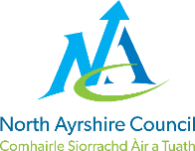
St. Bridget’s Primary
School, EYC and ESR Base

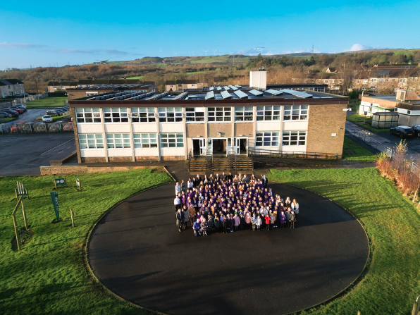

STANDARDS AND QUALITY REPORT
June 2023
This report will inform you of the school’s progress and achievements in the last session and let you know about our plans for 2023-2024.
I hope that you find it helpful and informative.
Dennis Hopkins
Head Teacher

Our School
St. Bridget’s Primary School is a denominational primary school situated in the town of Kilbirnie in North Ayrshire. The primary school roll as of June 2023 was 193. The Early Years Class (the Nursery) has capacity for 750 children in the morning and the same in the afternoon. We are also proud to incorporate an Educational Support Resource Base for pupils from all over North Ayrshire. It has a capacity of 12 pupils (full time equivalent).

The school operates a nine class structure and is led by a management team of the headteacher, the depute headteacher and one principal teacher.
The school staff community includes two clerical staff, a very supportive team of classroom assistants, a support for learning teacher and many others.
The pupil voice is very much encouraged in St. Bridget’s Primary and under the umbrella term SPEECH (Students Promoting Ethos, Equality, Citizenship and Harmony) we have a very active network of pupil-led committees, councils and groups.
Our Parent Council is an immensely supportive and active group. Their coordination of pupil activities, parental involvement and fundraising is exhaustive and contributes greatly to the strength of the St. Bridget’s community.
St. Bridget’s Primary School is very proud and appreciative of our close links with Father Mark Kelly and the whole community of St. Brigid’s R.C. Church. Father Mark is a regular visitor to the school to support our curriculum and to provide pastoral care as well as leading us in worship.
Our website is updated on a regular basis and this handbook can be downloaded from the site. Our X (Twitter) feed is a fabulous platform on which we share news of our busy school and EYC. Follow us @BridgetPrimary.
Please do not hesitate to contact the school at any time should you need any further information, advice or assistance.

Our Vision, Values and Aims
Our school vision is that children, staff and parents/carers work actively in partnership to enable all to realise their full potential. We all strive to be the best we can be.
Our core values are those of justice, courage, respect, compassion, responsibility and integrity. Our ‘Code of Conduct’ is based on three principles: Be Kind, Be Safe, and Be Responsible.
We aim:
• to form an effective and supportive partnership between pupils, parents/carers, school staff, other agencies and the community to support the development of each learner’s academic and social skills.

• to create a safe, secure, happy, exciting and hardworking atmosphere which supports the development of the whole learner, so that they are challenged, make good progress and achieve their full potential.

• to promote a positive attitude in our school community with an emphasis on self-respect, self-discipline, respect for others, good manners and confidentiality.

• to build upon the learners’ existing knowledge, skills and understanding to prepare them for each stage of their learning and life.

• to offer equality of opportunity for all within an inclusive environment.

• to offer a curriculum which gives all learners the opportunity to develop a variety of skills taking into account differing needs, interests and levels of development and attainment.

• to maintain a curriculum in which the teaching of skills and knowledge is planned, broad, balanced, relevant, exciting to learners and shows progression.

• to develop the thinking skills of all pupils, providing opportunities for independent learning within a supportive, fair and positive environment.

ATTAINMENT & ACHIEVEMENT
Attainment and Achievement
Every year we collect a wide variety of information on the teaching and learning within our school. To monitor the children’s attainment and achievement we use a range of processes and procedures such as standardised assessments, observations in the classrooms, teacher judgements, scrutinising the pupils’ work in discussion with the children themselves and much more. We meet as a whole school team and analyse our collection of data to plan targeted learning activities to ensure appropriate progress is being made.
North Ayrshire Council and The Scottish Government also ask us to summarise our children’s progress in Reading, Writing, Listening and Talking and Numeracy.
In the Early Years all preschool children achieved their expected milestones. In Primary 1, all children achieved their forecast levels in Literacy & Numeracy. In Primary 4 most children achieved first level in Literacy & almost all in Numeracy and in Primary 7 most children achieved second level across all four areas, Reading, Writing, Listening & Talking and Numeracy.
Children with additional needs have received extra support from Nurture staff, our ASN teacher, the Raising Attainment staff member and our team of classroom assistants.
Our successes are a direct result of our superb community partnerships and the high quality learning and teaching experiences taking place within our school, EYC and ESR Base.
Our attendance rate is higher than the North Ayrshire average and we have had no school exclusions for the tenth year in succession.

WIDER ACHIEVEMENT
In 2022/23 our high level features of success were:
- Every pupil in school and EYC was a member of a whole-school Council/Committee
- Every pupil given opportunity to attend an extra-curricular club
- School represented at all local sporting events and festivals
- JRSO training attended and pupils afforded roles of responsibility
- Gold Rights Respecting Schools Award
- Fairtrade Fair Achiever School
- All P7 pupils completed the Pope Frances Faith Award
- Holistic and nurturing approach to children’s learning
• Approachable and friendly pupils and staff
• Very well-maintained and spacious building
• Buddying - pupils supporting pupils P7-P1 and P6-EYC
• Pupils have numerous opportunities to adopt roles of responsibility
- All teaching staff has taken on an area(s) of responsibility
- Celebration of in-school and out-of-school successes
- EYC home learning journals very well utilised - 100% uptake
- healthy eating, especially at snack time
- Waste Warriors initiative (recognised by BBC) continued successfully
- Social Media presence - Twitter, YouTube and the school website. Parent Council utilise Facebook.
- School food bank project - supporting local community and school families every Tuesday
- Healthy Start Club every morning - has been attended by over half of our primary pupils
- School supported by three external counselors for individual and group work
- EYC Care Commission assessment was very positive
- Cluster working groups and communities
- Community links, e.g. Community WindPower, Tesco, GVAA, etc.
- Three pupils won their age (stage) competitions at the Garnock Valley Burns Competition
- School attendance data surpasses NAC and national averages
- 100% of pupils wear school uniform
- shoe, uniform and jacket banks created and accessed by many of our families
- Monday Meetings very well attended by family members
- All pupils attended Summer trips to the beach
- Almost all pupils attended a curricular field trip
- All P7s, bar two, attended the residential trip to the Arran Outdoor Education Centre
- Hallowe’en Pumpkin Patch and Winter Wonderland both attended by over 200 pupils and family members
- “Matilda”, the Nativity Show and the EYC/P1 “Percy the Park Keeper” performances very well attended
- The “Community of Kindness” event staged by our Justice and Peace Council vey well supported by local businesses and our families – over a four day period almost one hundred families visited to take food and/or gifts to help out at Christmas
- School staff involved in NAC groups and committees
- The school allotment goes from strength to strength – produce distributed to families and/or local initiatives at Café Solace and the Community Larder.

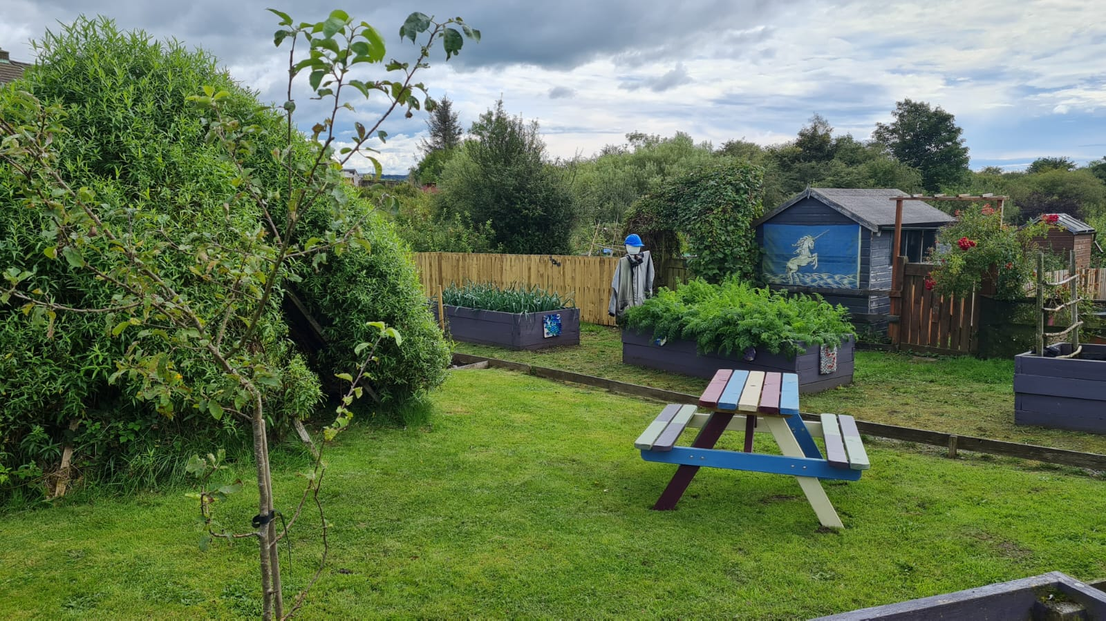

HOW SUCCESSFUL HAVE WE BEEN IN IMPROVING OUR ESTABLISHMENT?
Priority 1 - Deliver equitable provision and improved outcomes for all to raise attainment and achievement in Literacy.
We have made good progress in this priority, having met or bettered our expected levels across the EYC and school. We are still in the process of creating our programmes of study and pathways, otherwise we would have graded ourselves as a “Very Good” in this area.
Priority 2 - Deliver equitable provision and improved outcomes for all to raise attainment and achievement in Maths and Numeracy
Mirroring Priority 1 above, we have made good progress in this priority, having met or bettered our expected levels across the EYC and school. Again, we are still in the process of creating our programmes of study and pathways, otherwise we would have graded ourselves as a “Very Good”.
Priority 3 - Continue to encourage children and their families to be actively and creatively involved in the life of the school and in the learning at school and at home
We have done well in this priority with the reintroduction of numerous parents’/carers’ groups in our EYC. We have invited families in for many open events such as Celebration of Learning afternoons, transition activities, class-led themed assemblies and various schools shows and performances. This priority has again been identified as an area for development in session 23/24.
Priority 4 - To enhance learning and teaching through outdoor learning
Working in collaboration with a cluster school we formed a working party to include staff from our EYC, our ESR Base and from both primary schools. This group met regularly to look at policy and practice and also led two very informative sessions for the teaching staff of both schools. We will continue to prioritise outdoor learning with the addition of Play Pedagogy in session 23/24.

QUALITY INDICATORS
QI 1.3 Leadership of Change | Evaluation - Good
Our shared school vision, values and aims are reviewed annually with pupils, parents and staff. These are unique to our setting. Our improvement priorities are centred around what our children need to make progress in their learning across the curriculum. As a school we prioritise the Health and Wellbeing of the pupils as we believe in its all-encompassing importance. All staff members are committed to evaluating the impact of improvements to ensure positive outcomes for our learners.

QI 2.3 Learning, Teaching & Assessment | Evaluation - Good
Positive relationships underpin everything that we do. Pupils are positive about their school experience and engaged in their learning. The quality of learning and teaching is very good with learners experiencing a wide range of learning environments and approaches. Planning, tracking and monitoring are key features of our daily practice and are used to support, challenge and identify where intervention may be required. Prioritising the pathways and programmes of work this session once again should see evaluating as a “Very Good”

QI 3.1 Ensuring Wellbeing, Equality & Inclusion | Evaluation - Very Good
Relationships across our school are very positive and are highlighted by all visitors. We endeavour at all times to ensure all pupils and families feel well supported. We deploy our Nurture Staff to support the core group in the morning and a very wide variety of needs in the afternoon groups. The whole school community has a shared understanding of wellbeing and the rights of the child. Young people feel safe and cared for in school. Staff engage in regular professional dialogue around the rights, wellbeing and inclusion of all our young people. Children are knowledgeable about rights and inclusion.

QI 3.2 Raising Attainment & Achievement | Evaluation - Good
Almost all children across the school are achieving appropriate levels. We use appropriate tracking systems to ensure our pupils’ needs are being met and they are being constantly challenged to further their learning. Children’s personal achievements are recognised across the school. As highlighted during a recent school review, we need to look at the tracking over time of our students and also to further analyse particular groups of pupils as we look at our data sets for our current cohorts.

PUPIL EQUITY FUNDING
This year we have made good use of our Pupil Equity Funding (PEF) in order to reduce the poverty related attainment gap.
Highlights of our use of PEF in session 2022/23 and the impact are as follows:
In terms of staffing we utilised a portion of our Pupil Equity Fund to provide a full time classroom assistant in primary one. This level of support once again proved invaluable in providing our youngest students with the best possible start. The level of engagement and participation from the primary ones, and their readiness to learn, will once again dictate that we allocate PEF monies this session for the same purposes. 0.2 of a FTE teacher was also allocated to enable one of our staff members to be full time in class this session. Her class, the P5, has a very wide and varied level of need and the apportioning of the same teacher ensured a far more successful year both in terms of attainment but also in achievement and preparedness to learn. Once again we used PEF monies to part-fund our provision of Nurture this session. The Nurture teacher and practitioner supported our core group in the mornings, all of who ‘graduated’ back to class before the end of term. In a very wide and regularly reviewed (weekly) programme of supports in the afternoon, the Nurture staff worked with almost three quarters of our school roll. This targeted level of support ensured that the pupils’ wellbeing needs were being addressed, ensuring that we were providing the children with the best possible environments in which to learn.
We purchased software licences so as to provide enhanced and engaging activities for children to improve their Literacy and Numeracy skills (Education City, Times Tables Rockstars, Sumdog), both at school and at home. We also purchased licences to develop our home/school links (SeeSaw) and to further enhance our support for learning (Nessy). We purchased a number of iPads to ensure all children had access to technology to support and progress their learning. This resulted in children with EAL being able to access the curriculum with ease and children with literacy challenges using speech to text technology as well as spellchecking and a very fundamental level of motivation.
We used some of our PEF monies to provide subsidised/free transport for field trips throughout the year. We also provided extensive support for our primary sevens to access the residential trip to Arran. We know how enormous an impact these trips can benefit the health and wellbeing of our young people.
In 23/24 we intend to:
Continue to fund the same staffing as last session. We will also fund another full time teacher to enable us to have two classes at primary four. This stage of the school has a very high level of need across the largest number of pupils. The provision of an extra teacher will provide the essential support and enable the reallocation of other staff members across the school to support those most in need. Due to a reimbursed amount of PEF from last session (SALT project fell through) we shall employ an additional classroom assistant.
Further develop our environments inside and outside to provide opportunities for engaging learning activities through play and outdoor experiences.
We have set aside a portion of our PEF allocation to ensure support is available for out-of-school experiences and for the primary seven residential trip to Arran.

IMPROVEMENT PLAN PRIORITIES 2023-2024
Priority 1
To further develop our environments throughout the school to support and develop high quality teaching, learning and pedagogy of play. Enhance the use of space to promote learning both within the school and outdoors

Priority 2
Deliver equitable provision and improved outcomes for all to raise attainment and achievement in Literacy and Maths & Numeracy

Priority 3
Continue to encourage children and their families to be actively and creatively involved in the life of the school and in the learning at school and at home

