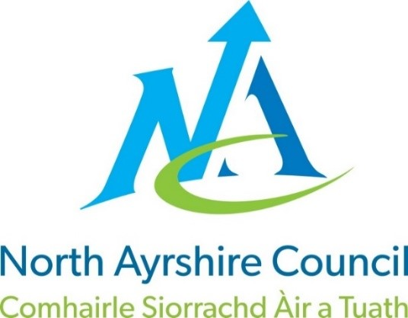



North Ayrshire Council: Communities and Education Directorate

St. Anthony’s Primary School

School Handbook

Session: 2025/2026

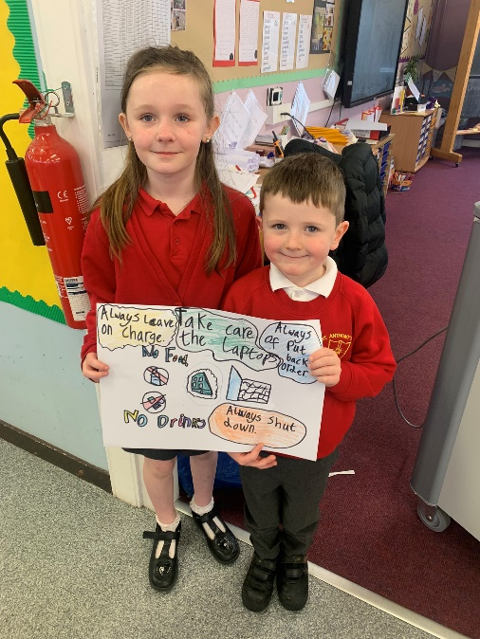

Working Together for Excellence. Page 1

Contents

Head Teacher Introduction | ……………………………………….….. | 4
Communities and Education Directorate | ………………………………………….. | 5
- Directorate Aims, Values and Priorities  Section 1: School Information | …………………………………………… | 6

- School Aims, Values, Ethos
- School Contact Details (Address, Telephone, Email, Fax)
- School Staff
- School Calendar/Holidays
Section 2: School Procedures 10

- School Security
- Positive Relationships
- Playground Supervision
- Absence from School Premises at Breaks
- School Dress Code
- Dress Code for PE
- Personal Belongings
- Mobile Phones
- Information in Emergencies
- Listening and Learning
Section 3: Footwear, Clothing, Free School Meals and Transport………………………….…..… 14

- Footwear and Clothing Grants
- Free School Meals
- School Transport Policy
Section 4: School Registration, Enrolment and Attendance 15

- Registration and Enrolment
- Attendance at School
- Structure of Classes
- Transfer to Secondary School
Section 5: Curriculum for Excellence ............................................................... 17

- Curriculum for Excellence
- The Capacities
- After-school Activities
- Assessment and Reporting
- Homework
- Pupil Councils
Section 6: School Improvement ............................................................... 21

- Standards & Qualities Report/Improvement Plan

Working Together for Excellence. Page 2



Section 7: Support for your child 22

- Additional Support for Learning
- Dispute Resolution Procedures
- Further Support
- Equalities
- Equality Act 2010
- Child Protection
- Inclusion
- GIRFEC
- Psychological Services
- Data Protection
- Medical and Health Care
Section 8: Parental Engagement and Involvement 30

- Parent Council
- Home School Links
- Reports to Parents
- Homework
- School Committees
Section 9: Pupil Data Collection and Protection Policies ………………………………….……….. 33
Appendix 1: Important Contacts

Working Together for Excellence. Page 3



Head Teacher Introduction

Dear Parents and Carers,

On behalf of the whole school community of St. Anthony’s Primary, I would like to extend a warm welcome to you and your child.

I hope you will feel welcome in the school and that your child will quickly feel that they belong to our school community. We are extremely proud of St. Anthony’s and the achievements of our whole school community. The pupils, staff and parents have worked in partnership to create a positive and stimulating teaching and learning environment where we strive to meet the intellectual, spiritual, physical, emotional and creative needs of every child in our care.

As a Catholic school, religion is taught not just as a subject, but as a way of life. This means our first duty is to treat others with love and respect. In this way, we hope our children will learn to work, respect and co-operate with all staff and each other.

This handbook is intended to provide general information for parents and carers and gives details of some aspects of life at St. Anthony’s Primary. Please do not hesitate to contact me if you wish to clarify any points mentioned in the handbook or discuss any issues relating to your child.

Yours sincerely

Jennifer Fleeting
Jennifer Fleeting
Head Teacher

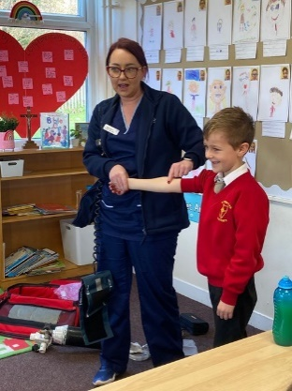
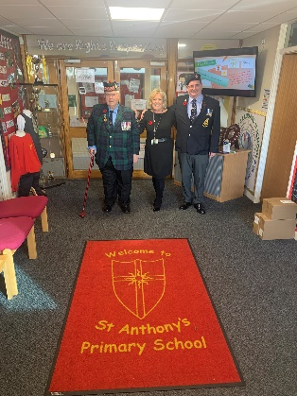

Working Together for Excellence. Page 4

Communities Directorate (Education Services) What we want to achieve

Our Overall Aim

Ensuring our children and young people experience the best start in life.

Our Priorities

  - We will create the conditions for our children and young people to access the highest quality learning experiences from ages 3-18.

  - We will support our children and young people to become successful learners, confident individuals, effective contributors and responsible citizens.

  - We will offer opportunities to our young people and their families to play a more active role in school life and encourage more participation in learning.

  - We will work with all young people to build their resilience, supporting their mental health and physical well-being.



Working Together for Excellence. Page 5

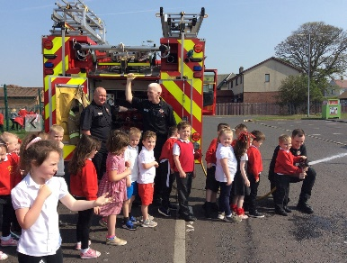

School Aims, Values, Ethos
Section 1: School Information

St. Anthony’s Primary School, Dykesmains Road,
Saltcoats, KA21 6DE, Telephone 01294 468559
E-mail stanthonys@ea.n-ayrshire.sch.uk Twitter @StAnthonysPS

School Motto Communitas praestantiam quaerens.
Working Together for Excellence.

School Vision

A community of learning where our young people are engaged in experiences that will give them the tools and skill set to participate in an ever-changing society.

School Aims

In St. Anthony’s Primary, we aim to:
- Provide a safe, secure, happy and health-promoting environment.
- Work closely with partnership agencies to present a broad general education that provides young people with the best possible learning opportunities and experiences.
- Raise attainment through continuous self-evaluation, bench marking and robust tracking procedures.
- Value the learning and achievements of all children.
- Promote respect and equality for all.
- Within our Catholic school, enable pupils to have an understanding and respect for different beliefs and cultures.

School Values

Following consultation with our whole school community, our School Values are:

Faith is not hoping God can, it is trusting He will

Included in all aspects of school life

Respect is how to treat everyone, not just those you want to impress

Teamwork makes the dream work

Working Together for Excellence. Page 6



School Staff
Mrs J Fleeting | - | Head Teacher
Mr A Burns | - | Depute Head Teacher (Acting)
Mrs A Mitchell / Miss M McCallum | - | Principal Teacher (Acting)
Mrs J McCrory | - | Primary 7 Class Teacher
Mr A Armstrong | - | Primary 6 Class Teacher
Miss E Dorrian | - | Primary 5/6 Class Teacher
Miss M McCallum | - | Primary 5 Class Teacher
Miss C McCulloch | - | Primary 4 Class Teacher
Mrs A Murphy | - | Primary 3/4 Class Teacher
Mrs P Spence / Mrs A Mitchell | - | Primary 2/3 Class Teacher
Mrs J Smith | - | Primary 2 Class Teacher
Mrs G Michelini | - | Primary 1M Class Teacher
Mrs A Grant |  | Primary 1G Class Teacher
Miss V Cruickshank | - | Targeted Support Teacher
Mrs J Kerr | - | Education Business Assistant
Mrs P McCallum | - | Education Business Assistant
Mrs K Robertson | - | Pupil Support Assistant
Miss S Young | - | Pupil Support Assistant
Mrs B Sohal | - | Pupil Support Assistant
Miss T Cassidy | - | Pupil Support Assistant
Miss C Galloway | - | Pupil Support Assistant
Mrs L McColl | - | Pupil Support Assistant
Miss A McColm | - | Pupil Support Assistant
Mrs M McCandless | - | Classroom Assistant
Mr K Weir | - | Janitor

Working Together for Excellence. Page 7



Visiting Staff

Mrs C Doig | - | Senior Manager
Canon Martin Poland | - | School Chaplain
Miss S Belshaw | - | School Counsellor
Mr C McDermott | - | Home School Inclusion Worker

Mrs A Montgomery | - | Music Specialist
Mrs J Walsingham | - | Music Specialist
Sr E Richardson | - | School Nurse

Miss K Whitehead | - | Educational Psychologist
Mrs S McClymont | - | Catering Manager
Mrs A Harper | - | Lunchtime Supervisor
Mrs M Gilmour | - | Area Cleaning Supervisor
Miss M Fitzsimmons | - | Cleaner
Miss M Sneddon | - | Cleaner

Working Together for Excellence. Page 8

School Holiday and In-Service Dates 2025/2026 (Mainland Schools)

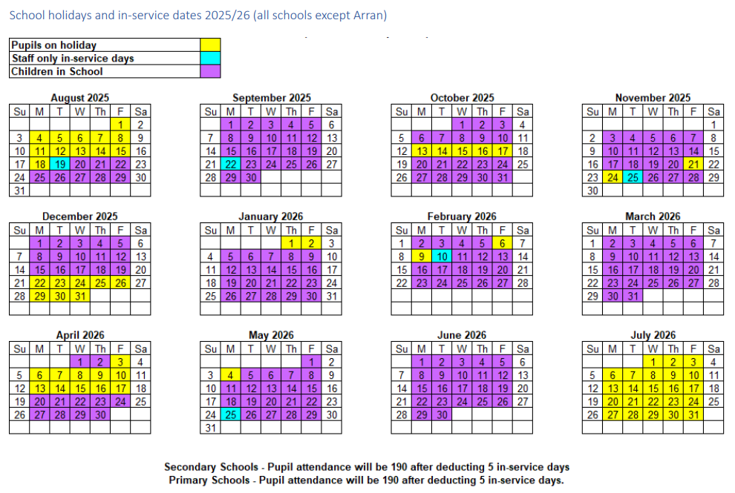

Working Together for Excellence Page 9



Section 2: School Procedures

School Security

North Ayrshire Council has introduced procedures to ensure the safety and security of children and staff when attending or working in a school. A number of security measures are used including the use of a visitors’ book, badges and escorts while visitors are within the school building. Any parent/carer or visitor at a school for any reason will be asked to report to the school office. The school staff will then make any necessary arrangements in connection with the visit to the school. It is the policy of the school that any member of staff will approach a visitor and ask for verification of identity. This measure ensures that children work in a safe and protected environment. We appreciate your support in carrying out all of the above measures.

Positive Relationships

The school is committed to developing a nurturing approach and promoting positive relationships. Like every community, our school is built on the relationships within it, across it and its connections with others. Every member of staff is responsible for establishing and maintaining positive relationships with each other, with parents and with partners and most importantly with the young people in their care.

Our expectations of behaviour for children and young people are high. Some children may require additional support in relation to their behaviour, and the school will work positively with the young person and the parents, and other partners, as appropriate, to ensure positive outcomes are achieved.

North Ayrshire Council is committed to the principles of restorative practices. This is a solution-focused approach to managing behaviour and resolving difficulties and which promotes healthy relationships that enable better behaviour and better learning.

The school has a code of conduct to ensure the safety and well-being of all and parents are asked to support the school fully in this matter.

Playground Supervision

The Council meets the terms of the legal requirement that pupils be supervised in the playground by at least one adult during the interval or lunchtime if there are fifty or more pupils at the school. Our policy reflects that of North Ayrshire Council in terms of the Schools (Safety and Supervision of Pupils) (Scotland) Regulations 1990.

An adult presence is provided in playgrounds at break times. Pupils who travel by contracted school transport and arrive at school more than ten minutes before the start of the school day have accommodation allocated to them within the school during inclement weather.

Working Together for Excellence. Page 10

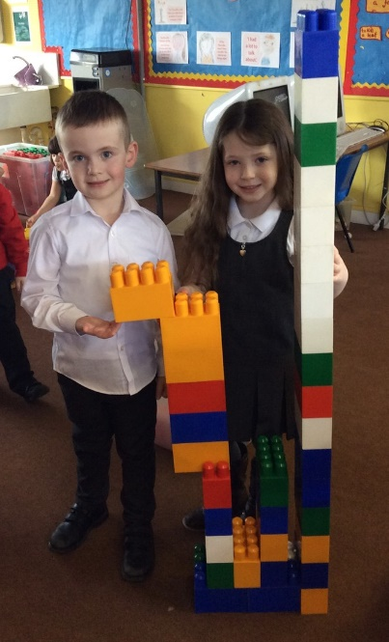

Absence from school premises at breaks

Schools have a duty to look after the welfare of their pupils. This means that the staff should take the same care of pupils as a sensible parent would take, and this includes taking reasonable care of pupils' safety during intervals and lunchtimes.

It is the policy of North Ayrshire Council that pupils should not leave the school grounds at intervals. Primary pupils should only leave school grounds at lunchtimes when they are going home for lunch with their parents' agreement. Parents should put this request in writing to the Head Teacher. Pupils will leave and return through main entrance door of the school.

Parents should encourage their children to follow these rules in the interests of safety.

School Dress Code

It is the policy of North Ayrshire Council to support the introduction of a reasonable and flexible dress code in schools in its area. The Council encourages each school to adopt its own code, after consultation with parents and pupils.
The Council believes that establishing a school dress code has many benefits. These include improvements in safety, security, positive behaviour and community spirit and a decrease in bullying and in expense for parents.
The Council will support schools in encouraging and helping pupils to conform to the chosen dress code. Some types of clothing will not be allowed at school in any circumstances, for reasons of safety, decency or wellbeing.
Types of clothing which will not be allowed include:
- Clothes which are a health or safety risk
- Clothes which may damage the school building
- Clothes which may provoke other pupils
- Clothes which are offensive or indecent
- Clothes which encourage the use of alcohol or tobacco

All items of clothing should be clearly labelled with the child's name in case of loss. It is appreciated that parents and pupils are distressed over the occasional loss of pupils' clothing and/or personal belongings. Parents are asked to assist in this area by ensuring that valuable items of clothing or personal belongings are not brought to school.

Our Uniform

At Saint Anthony’s Primary School, our uniform is red and grey. All children are encouraged to wear a white polo shirt or shirt, grey skirt or trouser and a jumper, sweatshirt or cardigan which preferably displays the school logo. N.B. black is not one of our school colours.

Working Together for Excellence. Page 11

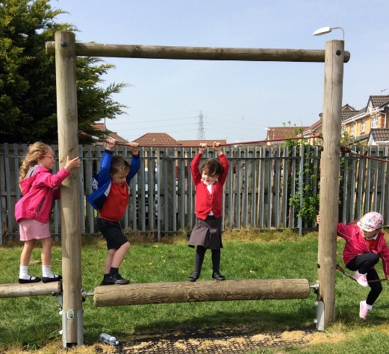

Personal Belongings

It is appreciated that parents and pupils may be distressed over the occasional loss of pupil’s clothing and/or personal belongings. Parents are asked to assist by ensuring that valuable items of clothing or personal belongings are NOT brought to school.
Parents should note that the authority does not carry insurance to cover the loss of such items.

Dress Code for PE

For health and safety reasons all children must wear suitable clothing for PE. This consists of black shorts and a white t-shirt with soft shoes for indoor activities.

We adhere strictly to health and safety guidelines and pupils must remove any item that may cause danger,
i.e. metal buckles, jewellery. These items are the responsibility of the pupil. Long hair should be tied back.

School Meals

Meals are served daily from the multi-choice cafeteria. The meals are planned to offer a healthy diet for the children. Please inform us if your child has any specific allergies. Parents of children who require a special diet can arrange this by contacting the school.

There are arrangements in place for children who would prefer to eat a packed lunch.

Mobile Phones

While the benefits of mobile phones are recognised, they can be a serious distraction to work. We actively encourage children to leave mobiles at home unless it is absolutely necessary. In these circumstances, children must switch off their phones during the school day and keep them in their school bag or place them within the class phone container. Those who do not adhere to this request will have their phone being stored at the school office. Inappropriate use of text messages and/or photographs/recordings (video and audio) whilst in school may be treated as a breach of the school’s code of conduct or a serious incident, which could be referred to the police.

Information in Emergencies

We make every effort to maintain a full educational service but on some occasions circumstances arise which lead to disruption. Schools may be affected by, for example, severe weather, and temporary interruption of transport, power failures or difficulties of fuel supply. In such cases, we shall do all we can to let you know about the details of closure or re-opening. We will keep you in touch by using letters, texts (where possible), NAC website, notices in local shops and community centres, announcements in the press and West FM. Should you have doubts about deteriorating conditions during the day, it may be advisable to contact the school. Parents should ensure that the school is aware of the emergency arrangements made for their child and have responsibility to update us with contact numbers.

Working Together for Excellence. Page 12

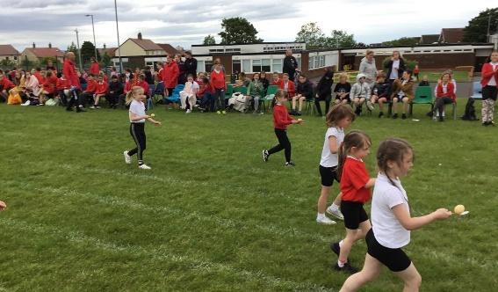

Listening and Learning

The North Ayrshire Council Education Service encourages feedback from parents and pupils and forms part of the Council’s overall commitment to providing the best possible service and to support partnership working.

We are therefore very interested in feedback of all kinds, whether it be compliments, suggestions or complaints. If you wish to raise a comment of any type about the school, you can do this in writing, by telephone or by making an appointment to see someone. All feedback is welcome and helps us keep in touch.

If, in particular, you have a complaint about the school, it is better that these things are shared openly so any damage to the home/school relationship can be minimised. There are no negative consequences arising from making a complaint and we will deal with the issue sensitively and confidentially if required. If we have made a mistake we will apologise and try to put things right.

There are some things which you should note in relation to making a complaint:

- The Council has a Two Stage procedure when handling complaints from parents and members of the public. More details on the two stages can be found in the Council’s complaint page here:

https://www.north-ayrshire.gov.uk/contact-us/complaints-and-feedback/make-a-complaint.aspx

- It is helpful if complaints are made initially to the school’s Head Teacher. This ensures the school is made aware of what is going on and has an opportunity to investigate and try to resolve the issue at Stage One first.

- We try to resolve all complaints as quickly as possible but if a complaint is complex more time may be needed to investigate. It is therefore helpful if you can provide full details of the issue at the outset and ask for an early appointment to discuss it.

- If you are not satisfied with a response you receive at Stage One, you can ask that your complaint is escalated to Stage Two. Should you wish to do this you should contact Education Services at Cunninghame House, Irvine, KA12 8EE or by telephone on (01294) 324400.

- If, after receiving the Stage Two final response letter you remain dissatisfied you can ask the Scottish Public Services Ombudsman to consider your complaint and we’ll tell you how to do this in the Stage Two response letter.

- Parent Councils have an important role in developing links between the school and the wider parent body and can often be helpful in dealing with issues of general concern. However, parents are advised that individual, personal complaints are not appropriate for raising via Parent Councils due to the possible need for confidentiality.

- Please note you can also raise concerns you may have with your local Councillor, MSP or MP but these will be handled under a different process to the Two Stage complaint process.

Working Together for Excellence. Page 13

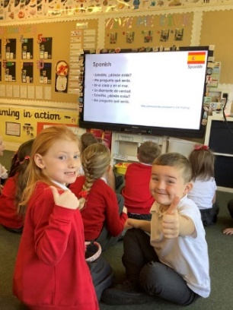

Section 3: Educational Grants: Footwear, Clothing, Free School Meals and Transport

Footwear and Clothing Grants
Parents receiving Universal Credit will normally be entitled to grants for footwear and clothing for their children. Universal Credit claimants’ monthly income must not exceed £660.00, however, some parents earning more than this may still be eligible.
Parents who receive Income Support, Income based Job Seeker’s Allowance, any income related element of Employment and Support Allowance, Support under part V1 of the Immigration and Asylum Act 1999, Child Tax Credit only (with income under £17,005), both Working Tax Credit and Child Tax Credit (with an income up to £7,920) may also still be entitled to grants for footwear and clothing for their children.
Parents who may be unsure whether they can apply should contact the Council Contact Centre on 01294 310000 or the Council’s Welfare Reform Team on 0300 99 4606 for further advice. Information and application forms may be obtained from schools.
Free School Meals
Children of parents receiving Universal Credit (claimants’ monthly income must not exceed £660.00), Income Support, Income based Job Seeker’s Allowance, any income related element of Employment and Support Allowance, Support under part V1 of the Immigration and Asylum Act 1999, both Working Tax Credit and Child Tax Credit (with an income up to £7,920) are entitled to a free midday meal and free milk. Parents and Carers should contact 01294 310000 for further information.
Please Note: All pupils in Primary 1 to 5 are entitled to a free school meal, which includes milk.
Other than Primary 1 to Primary 5 pupils, only those children whose parents receive job seeker's allowance or income support will be entitled to free milk. Milk may however be available for purchase in the school during the lunch period.
Further information can be found on the Grants and Allowances webpage.
Pupils are supplied with a menu in advance, and we encourage you to discuss this with your child before school and pre-order their lunch options on the iPay site.
You are welcome to provide your child with a packed lunch if you prefer and we encourage pupils to make healthy choices and eat a balanced diet. We request that pupils do not bring in cans or bottles of fizzy or isotonic juice to drink and that take-away food is not provided as a packed lunch.
School Transport
North Ayrshire Council has a policy of providing free transport to all pupils who live more than two miles walking distance from their catchment primary school or three or more miles from their catchment secondary school using the shortest suitable walking route. In addition, free transport may also be provided for whole or part of the journey between a pupil’s main address and school (or other educational establishment) when the criteria outlined in section 4 of the School Transport Policy is met.
Applications for mainstream transport are made by parents and carers using North Ayrshire Council’s Transport Hub transport system. Applications may be submitted throughout the year and should be made as soon as confirmation of a place at a catchment establishment has been received. Please note free school transport will not be provided following a successful placing request. If you believe your child may require transport for another reason, please review the entitlement criteria in the School Transport Policy under Section 4 before discussing this with the school.
If places are available and no additional costs is incurred by the local authority, it may be possible to apply for privilege seat in transport provided by the authority, please liaise with North Ayrshire Transport Hub for further information (transporthub@north-ayrshire.gov.uk / 01294 541613). Where free transport is provided it may be necessary for pupils to walk a short distance to the vehicle pick-up point. Walking distance in total, including the distance from home to the pick-up point and from the drop-off point to the school in any one direction, will not exceed the Council's limits (see above section). It is the parents’ responsibility to ensure that their child arrives at the pick-up point on time. It is also the parents’ responsibility to ensure that their child behaves in a safe and acceptable manner while boarding, travelling in and leaving the vehicle. Misbehaviour can result in children losing the right to free transport.

Working Together for Excellence. Page 14

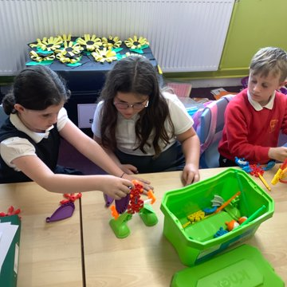

Section 4: School Registration, Enrolment and Attendance

Registration and Enrolment

The date for registration of school beginners is advertised in the local press and is normally in January each year. Pupils will be registered in the school for their catchment area.

Parents are provided with information about the school and procedures for making placing requests, if required. Arrangements for meetings with parents and induction days for pupils will be notified during the spring and summer terms.

Parents of pupils who have moved to the area or who wish their child to transfer to the school should contact the school office for information about appropriate procedures and to arrange a visit.

Parents are welcome to contact the Head Teacher at any time by visiting or telephoning the school.

Attendance at School/Lateness

It is the responsibility of parents of children of school age to educate their child(ren). Most do this by ensuring that their child(ren) attend(s) school regularly. Attendance is recorded twice a day, morning and afternoon. Absence from school is recorded as authorized, unauthorized or temporarily.

Parents are asked to inform the school by letter or telephone if their child is likely to be absent for some time, and to give the child a note on his or her return to school, confirming the reason for absence. If there is no explanation from a child’s parents, the absence will be regarded as unauthorised.

Every effort should be made to avoid family holidays during term time as this both disrupts the child’s education and reduces learning time. Parents should inform the school by letter, before going on holiday, of the dates. Such absence will be authorised only where certain and very specific family circumstances exist. The majority of family holidays taken during term time will be categorised as unauthorised absence.

Parents may request that their children be permitted to be absent from school to make an extended visit to relatives. Only written requests detailing the destination, the duration and the provision that will be made for their continuing education will be granted. Such extended absences will be recorded separately from the normal attendance and absence information.

The School Inclusion Worker investigates unexplained absence, and the authority has the power to write to, interview or prosecute parents, or refer pupils to the Reporter to the Children’s Panel, if necessary.

Working Together for Excellence. Page 15

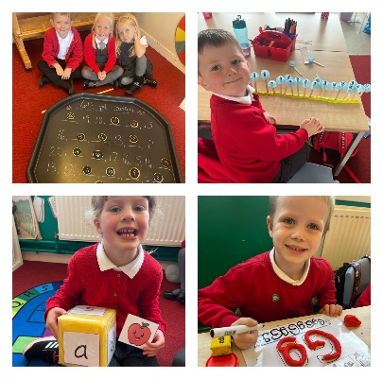


Structure of Classes

Primary schools educate pupils at seven broad year stages, Primary 1
to Primary 7. A year stage is defined as a group of pupils entering primary education at a common date. Schools are staffed based on the total number of pupils. However, the numbers of pupils at each year stage will vary. This means that Head Teachers are required to organise classes to make best use of available staff, resources and space to the benefit of all children in the school.

Pupils may, therefore, be taught in a single stage class or a composite class where two or more year stages are grouped together. This may also change as pupils move from one year to the next.

National guidelines on the curriculum indicate that pupils should progress through learning experiences tailored to their own needs and abilities. This means that pupils in all classes follow programmes designed to help them progress at their own level. This applies to all pupils regardless of whether or not they are in a composite or single year stage class.

The National agreement on class sizes states that the maximum number of pupils in a class is 25 in P1, 30 in P2 – P3, and 33 in P4 -7. In a composite class, the maximum number is 25.

Transfer to Secondary School
Pupils are normally transferred between the ages of eleven and a half and twelve and a half, so that they will have the opportunity to complete at least 4 years of secondary education. Parents will be informed of the arrangements no later than January of the year preceding the date of transfer at the start of the new session.

Saint Anthony’s Primary School is an associated primary school of:

Saint Matthew’s Academy Address: Jack’s Road, Saltcoats
KA21 5SH

Telephone No: 01294 606680

During their time in P7, pupils are taken to Saint Matthew’s Academy as part of the induction programme. Teachers from local primary schools and their secondary colleagues have worked together to create a Pupil Profile of Achievements which will be completed in Primary 7 and passed onto the secondary school. Teachers from both schools liaise to ensure a smooth transition which focuses on progression for pupils. Parents will be informed of the details of the visits when appropriate.

Working Together for Excellence. Page 16

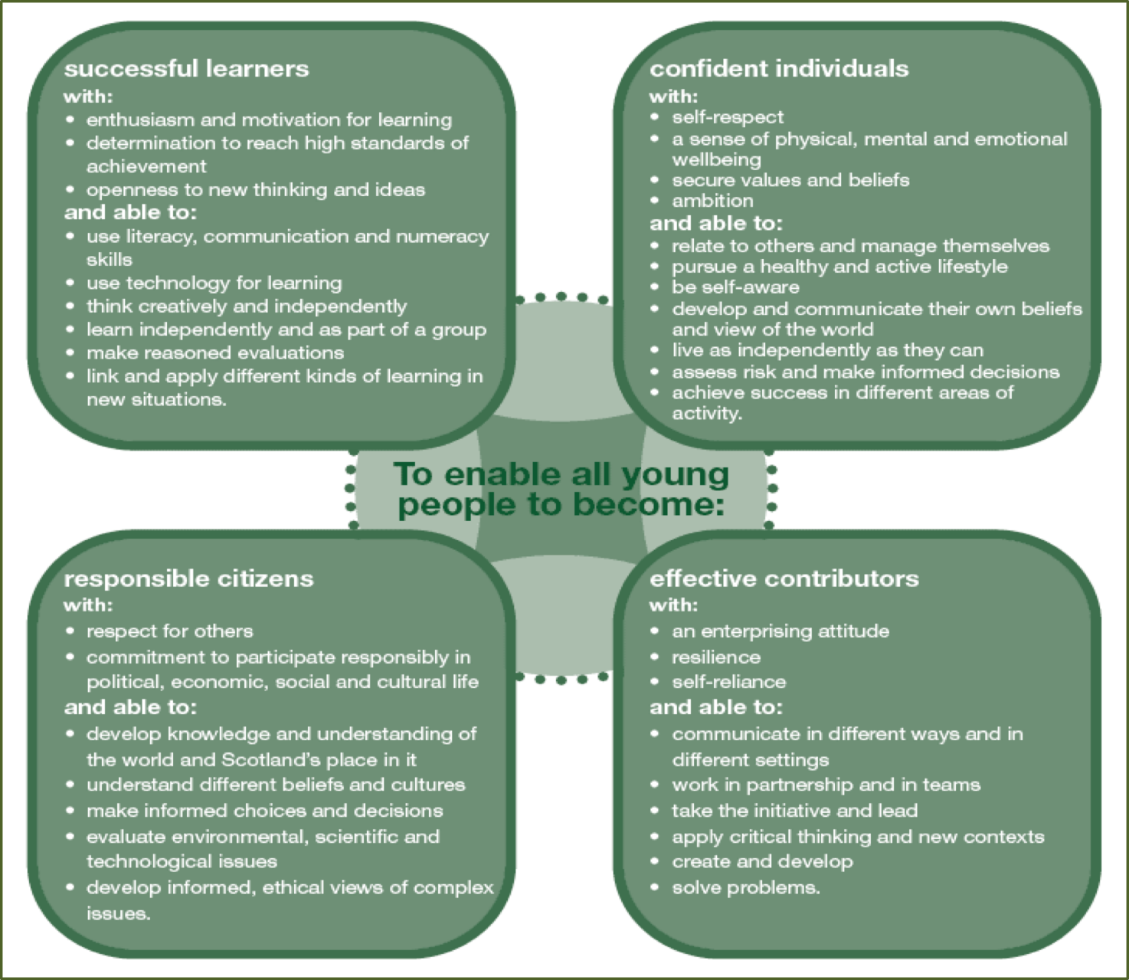
Section 5: Curriculum for Excellence

Curriculum for Excellence: The Capacities

Further Information about Curriculum for Excellence and the Experiences and Outcomes can be found on the Curriculum for Excellence website.

Working Together for Excellence. Page 17

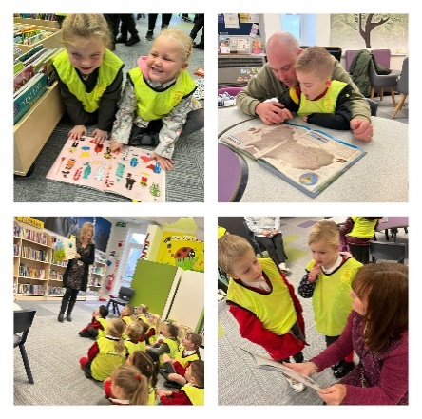


Curriculum for Excellence is the national curriculum for Scottish
schools for learners from age 3 to 18. It aims to raise standards, prepare our children for a future they do not yet know and equip them for the jobs of tomorrow in a fast-changing world.

Curriculum for Excellence enables professionals to teach subjects creatively, to work together across the school and with other schools, to share best practice and explore learning together. Glow, Scotland’s unique, world-leading, online network supports learners, teachers and families in this.

Teachers and practitioners will share information to plan a child’s “learning journey” from 3-18, ensuring children continue to work at their own pace whilst providing challenge upon which they can thrive.

Curriculum for Excellence balances the importance of knowledge and skills. Every child is entitled to a broad and deep general education where every single teacher and practitioner will be responsible for literacy and numeracy – the language and number skills that unlock other subjects and are vital to everyday life. There is emphasis too on health and wellbeing – to ensure that the school is a place where children feel safe and secure.

Curriculum for Excellence develops skills for learning, life and work to help young people go on to further study, secure work and navigate life. It brings real life into the classroom, making learning relevant and helps young people apply lessons to their life beyond the classroom. It links knowledge in one subject area to another helping children understand the world and make connections. It develops skills so that children can think for themselves, make sound judgements, challenge, enquire and find solutions.

Children’s progress is assessed using a broad range of approaches to ensure children achieve their potential. Ultimately, Curriculum for Excellence aims to improve our children’s life chances, to nurture successful learners, confident individuals, effective contributors, and responsible citizens, building on Scotland’s reputation for great education.

.

Working Together for Excellence. Page 18

After-school Activities

After-school activities are offered to pupils at various times throughout the year. Non-sporting activities such as cookery, coding, science, phonics, chess and various sports activities such as netball, football, athletics, basketball and hockey are accessible to various stages throughout the year. Saint Anthony’s actively participates in North Ayrshire Leisure’s Primary School Cross Country Programme. We enter local and national football tournaments and our netball team participates in the local league organised by our Active Schools Co-ordinator.

Assessing Children’s Progress in the Broad General Education (BGE) Early Years – end of S3

Assessment is a central part of everyday learning and teaching for children and young people. Evidence of progress is gathered on an ongoing and informal basis through asking questions, observing children working together and making formative comments on their work. Children may also assess their own work or that of their classmates; this is called self and peer assessment. Some assessment is more formal such as projects, investigations and standardised assessments.

The assessment of children’s progress throughout the BGE (Early Years – S3) is based on teachers’ professional judgement. Teachers draw on their professional knowledge and understanding of the child; on the benchmarks for literacy and numeracy, which provide clear information about what children and young people should be able to do and demonstrate by the end of a Curriculum for Excellence Level; and on a wide range of assessment information.

Teachers of P1, P4, P7 and S3 are asked at the end of every school year whether children have achieved the relevant Curriculum for Excellence level for their stage in reading, writing, talking and listening (literacy), and their ability to understand and work with numbers (numeracy). Most children are expected to have achieved the early level by the end of P1, first level by the end of P4, second level by the end of P7 and third or fourth level by the end of S3.

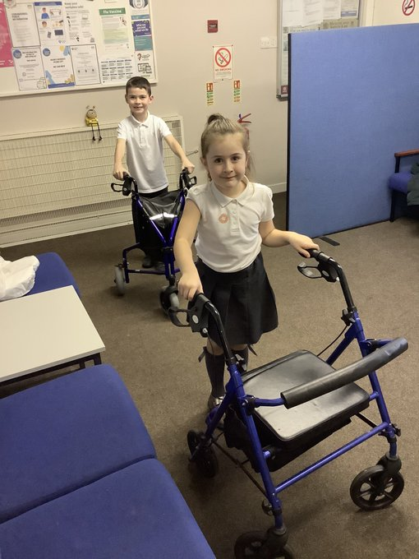
The government has also introduced new national standardised
assessments (SNSA) which cover some aspects of reading,
writing and working with numbers. These assessments are
completed online and are automatically marked by the online
system giving teachers immediate feedback to help plan next
steps and support children’s progress.

Teachers remain best placed to know how the children in their
class are progressing. Their professional judgement will
continue to be the most important way of assessing your child’s
progress at school.

Parents, families and carers have a key role in helping children to
learn.Your child’s teacher will keep you informed about their
progress. Please contact us if you have any concerns about their
learning, assessment or for more information on how you can
support your child’s learning at home.

Working Together for Excellence. Page 19

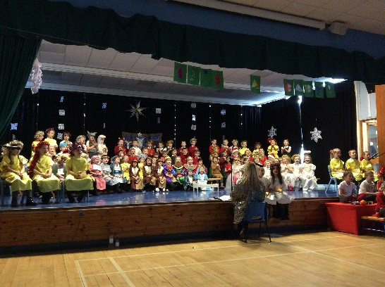

Homework

Parents have a very important role in helping their children to get the best out of school and it is important that they take an active interest in their child's progress at school. This can be done by:

- Encouraging hard work and high standards at all times
- Stressing the importance and relevance of what is learned at school
- Supporting the school's policy on homework and discipline

The type of homework will vary depending on the age and ability of individual pupils. Reading commonly forms part of the homework set and will be specified by the teacher. Learning to read can be challenging and the process is made easier if families read with their child and discuss the story and pictures in a way that encourages enjoyment and a love of books and stories.

In the early and middle stages oral reading should be practiced regularly at home whereas in the upper primary, where children are competent in the mechanics of reading, a greater emphasis may be placed on silent reading and comprehension. Reading for enjoyment should be encouraged at all stages. Spelling is also an important part of homework from P3 onwards (although some children may be asked to practice even earlier). Maths homework will be given to consolidate understanding and proficiency at all stages of the school. From time to time pupils are given assignments and personal projects which may involve research, investigation, preparing a speech, learning a poem or a similar activity. Homework is primarily set on Seesaw, an online platform, however paper copies are often provided and can be requested more frequently if this would benefit your child’s learning.

We really appreciate the involvement of parents, carers and families and are very grateful to those parents who so faithfully sign work to confirm that they have overseen each piece of work.

Pupil Councils

Every child’s voice is fundamental to the development of our school. One approach to ensuring every child experiences their right to have a say and is directly involved in leading our school is through our successful pupil councils. Each week, groups of children and staff from all stages meet to develop the following areas:

Rights Respecting Schools, Intergenerational, Digital Schools, Fairtrade, Eco, Sustainability, Health and Wellbeing, Outdoor Learning, Travel, Global Goals, RSPB, Mindfulness and Sports.

Working Together for Excellence. Page 20

Section 6: School Improvement Standards & Qualities Report/Improvement Plan
Schools in North Ayrshire follow a Quality Improvement process designed to highlight strengths and identify areas for improvement. The process is based on the school’s self-evaluation process with Heads of Service and Senior Managers involved in at least three formal validation visits each session.

This validation process involves talking to pupils, staff and parents about learning and improvements made by the school. This results in actions for improvement for the school to take forward in their planning process.

In addition, themed reviews are undertaken from time to time e.g. to look and report on the quality of the Broad General Education (3-18) and Senior phase Education within secondary schools. This process is based upon standards and expectations contained within the following National Standards documentation:

    - National Improvement Framework

    - How Good is Our School? 4

    - How Good is OUR School?

A Standards and Quality Report and School Improvement Plan are produced on an annual basis by every school and centre. Staff, Parents/ Carers, Young People and School Partners will play an active role in the development of these key school documents. Copies of these documents are available from the school office.


Working Together for Excellence. Page 21



Section 7: Support for your Child

Equalities

In line with North Ayrshire Council policy, educational provision is open to all pupils, regardless of sex, age, religion, race, disability or any other potential barrier and all reasonable measures will be taken to ensure that the curriculum is available to every child. Schools also have a duty to promote equality and to eliminate racist and other discriminatory behaviours.

Equality Act 2010

The Equality Act 2010 has been drawn up to tackle inequality and prevent discrimination against people on the basis of ‘protected characteristics’. It brings together several existing laws and aims to make understanding the law simpler and also introduces a new single public sector equality duty, which requires public bodies to actively advance equality.

The duties set out in Chapter 1 of Part 6 of the Equality Act apply to all schools. These provisions protect pupils at the school and in the case of admissions, those applying or wishing to apply for admission. Former pupils are also protected from discrimination or harassment.

Guidance on the Act and its requirements for schools in relation to the provision of education can be accessed via the Scottish Government website via here:

https://education.gov.scot/improvement/research/equality-act-2010/

Child Protection

Education Services has a fundamental duty to contribute to the care and safety of all children and young people in North Ayrshire. In fulfilling this duty, the service must engage in close partnership with parents/carers and relevant agencies, primarily the Health and Social Care Partnership and where appropriate the Scottish Children’s Reporter’s Administration. The Service will work in partnership with a number of levels within the establishment or school within the cluster or local area and through Integrated Children’s Services and Community Health Partnership.

The Standard Circular entitled, “Protecting and Safeguarding North Ayrshire’s Children” provides guidance for policy and practice within all educational establishments. The Council is one of the key partners in the North Ayrshire Child Protection Committee, a multi-agency group which takes the lead role in ensuring that our children and young people are cared for, protected from harm and grow up in a safe environment.

Each school has a named Child Protection Co-ordinator who is the main point of contact for school staff and for external agencies seeking contact with the school on child protection matters. There is an extensive staff-training programme available to staff and, in addition, at the beginning of each school session all staff receive an update on child protection policies, safeguarding and procedures.
Working Together for Excellence. Page 22

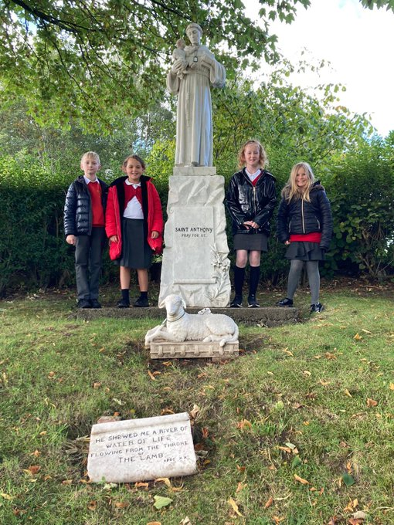

Inclusion
North Ayrshire Council is committed to supporting the well-being and educational progress of all learners including those with Additional support needs. Including learners requires all staff to demonstrate commitment, innovation and flexibility in order to ensure that all children and young people have access to quality learning opportunities and experiences. Our Inclusion Strategy states that:

- An inclusive approach to education supports an ethos of achievement and high expectation, recognises difference, respects these differences and sees differences between learners as opportunities for learning.
- An inclusive approach to education promotes tolerance and a positive understanding of diversity.
- An inclusive approach to education alleviates the barriers to learning, supports the achievement of all and has positive relationships at its heart.

The presumption of mainstream as outlined in the Standards in Scotland’s Schools (2000) sets out that children will be educated in a mainstream setting unless exceptional circumstances apply. North Ayrshire therefore has a duty to ensure that clear assessment outlines the additional support needs of a child or young person which may require support in an alternative provision. Where this is the case, North Ayrshire has a clear process that supports the Team around the Child to make a recommendation for consideration of alternative provision. This is outlined in the Standard Circular E19 and requires establishment staff to work with parents/carers to ensure all supports have been put in place to support a child or young person in their mainstream context before submitting clear evidence of what has been implemented and going on to request alternative provision. North Ayrshire Council staff will then make a recommendation based on the evaluation of this evidence and a review of the needs of the young person and the current peer group in each setting.

The Education (Disability Strategies and Pupils’ Educational Records) (Scotland) Act, October 2002, requires local education authorities to prepare and implement accessibility strategies to improve, over time, access to education for young people with disabilities. Access covers:
- The physical building and grounds
- The curriculum (both formal and informal)
- Information on any educational planning that might affect the child’s/young person’s education

The Education (Additional Support for Learning) (Scotland) (2009) Act sets out certain duties on local education authorities and confers certain rights on children and their parents. These duties include the need to:

- Identify, assess and address the need for additional support for any child or young person failing to benefit from school education, for whatever reason
- Seek and take account of the views of the child or young person on issues relating to their education
- Engage in helpful partnership working with parents/carers and staff from other agencies

Working Together for Excellence. Page 23

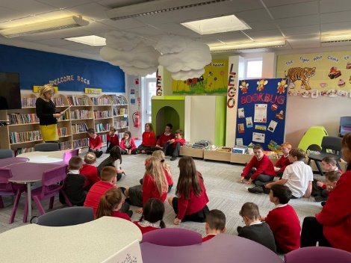

Additional Support for Learning

Any child who needs more or different support to what is normally provided in schools or pre- schools is said to have ‘additional support needs’. This includes children who may need extra help with their education as a result of issues arising from social and emotional difficulties, bullying, physical disability, having English as an additional language, a sensory impairment or communication difficulty.

The Additional Support for Learning Act

The Education (Additional Support for Learning) (Scotland) Act 2004 came into force in November 2005. In June 2009, the Act was amended. These amendments form the Education (Additional Support for Learning) (Scotland) Act 2009 and came into force on November 2010.

Main provisions of the Act

- The Act provides the legal framework underpinning the system for supporting children and young people in their school education, and their families.

- This framework is based on the idea of additional support needs. This broad and inclusive term applies to children or young people who, for whatever reason, require additional support, long or short term, in order to help them make the most of their school education and to be included fully in their learning.

- The 2009 Act automatically deems that all looked after children and young people have additional support needs unless the education authority determine that they do not require additional support in order to benefit from school education.

- In addition, education authorities must consider whether each looked after child or young person for whose school education they are responsible requires a co-ordinated support plan.

Duties under the ‘Additional Support for Learning’ legislation

North Ayrshire must assess any pupil with additional support needs and provide with any support necessary for them to benefit fully from their education. All the evidence says that it is best to intervene early to prevent any difficulties developing and taking root. For example, by making sure reading is very well taught and that all pupil gets encouragement and support at home we can hopefully reduce later difficulties.

Whatever the type of challenge that arises, it is important to detect it early, develop a shared understanding of what is needed (the school may request extra specialised help to do this) and take action to help to pupil achieve. Whenever we start this process for any child or young person, we will always explain to them and to their parents/carers what our concerns are and what we will do to help.

Working Together for Excellence. Page 24

The establishment can get support from a range of visiting professionals including educational psychologists. Each establishment has a link educational psychologist and staff can ask for informal advice on supporting learners. If more detailed individual help is required, they will talk to you about formally involving the educational psychologist. The educational psychologist can only be involved in consultation, collaborative assessment, and planning interventions for your child with your agreement.
Staged Intervention
A young person’s need for support is addressed through a cycle of identification, assessment, planning, support and review. This process is called Staged Intervention.
In North Ayrshire we organise support under the following headings:
• Enhanced Universal Support
• Stage 1
• Stage 2

Universal support is a fundamental element of the service provided by all educational establishments. There may be times when a child or young person needs some additional support to help them achieve their full potential and this is where the stages of support need to be identified and explained.

Enhanced Universal
Some supports are considered as Enhanced Universal, reflecting that they are provided within universal services but are planned and delivered with enhancement to day-to-day practice.
Within Enhanced Universal a young person may require a higher level of support due to concerns surrounding their wellbeing or learning, or a combination of both.
The needs of the child or young person are met within their classroom or playroom with some adjustment to their environment, curriculum, and/or approaches to learning and teaching. Some aspects of work may be planned individually or as part of a group however this will be recorded as part of playroom or classroom planning. Class teachers and keyworkers will monitor and record progress.
Stage 1
This stage applies to children and young people whose support needs cannot be met through Enhanced Universal services. They require additional support available within their own establishment which may include Support for Learning and/or targeted pastoral support.

Stage 2
This stage signifies that the needs of the young person are significant and/or exceptional and are not being fully met through Enhanced Universal or Stage 1 supports and services. The young person requires more specialist and/or intensive support.
At both Stage 1 and 2, a Team Around the Child discussion will review the learner’s strengths and needs, agreeing appropriate interventions and supports. The learner and their parent/carer must be fully involved in this process and the young person’s targets and progress will be recorded using the North Ayrshire Staged Intervention planning format.
Where a child or young person has additional support needs, extra planning is required when they move to a new class, new school or when they are moving on from secondary school. How far ahead this transition planning needs to start depends on the young person’s individual needs, but for most children and young people with Additional Support Needs transition planning should start at least one year before the date of the planned move.
Further advice and guidance around supporting needs can be found on the ENQUIRE website.



Working Together for Excellence. Page 25

Dispute Resolution Procedures

If you feel that things are not being done properly to support your child then the Council has a range of ways to work with you to resolve any issues. You can ask at any time for a copy of the booklet called ‘Resolving Disagreements’. This booklet will give you ways to make sure your concerns are listened to and addressed.

Further Support
The following organisations are able to provide advice, further information and support to parents of children and young people with ASN.

1.Enquire: Scottish Advice and Information Service for Additional Support for Learning
Website: http://enquire.org.uk/ Helpline: 0345 123 2303 Email: info@enquire.org.uk

2.Scottish Independent Advocacy Alliance Website: http://www.siaa.org.uk/ Telephone: 0131 260 5380
Email: enquiry@siaa.org.uk


3.Scottish Child Law Centre Website: http://www.sclc.org.uk/ Telephone: 0131 667 6333 Email: enquiries@sclc.org.uk

Working Together for Excellence. Page 26

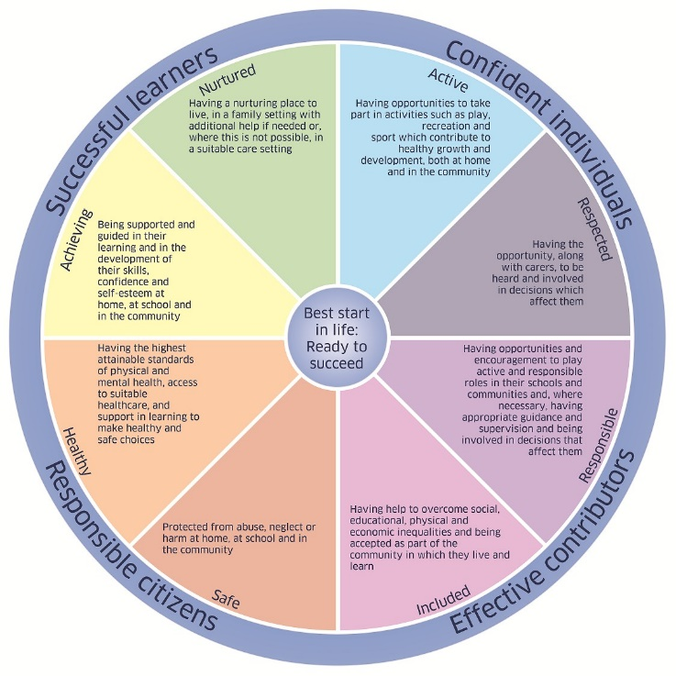

Getting It Right for Every Child – Ensuring their Wellbeing

The Children and Young People (Scotland) Act 2014 puts children and young people at the heart of planning and services and ensures their rights are respected across the public sector. It seeks to improve the way services work to support children, young people and families.

- The act ensures that all children and young people from birth to 18 years old have access to a Named Person.
- The act puts in place a single planning process to support those children who require it.
- The act places a definition of wellbeing in legislation.
- The act places duties on public bodies to coordinate the planning, design and delivery of services for children and young people with a focus on improving wellbeing outcomes, and report collectively on how they are improving those outcomes.

Taking a ‘Getting it Right for Every Child’ approach to supporting every child is a priority within our school and we aim to assist every child in our school to reach their potential. The wellbeing of children and young people is at the heart of Getting it right for every child. The approach uses eight areas to describe wellbeing in which children and young people need to progress in order to do well now and in the future.

The eight indicators of wellbeing (SHANARRI)

Safe, Healthy, Achieving, Nurtured, Active, Respected, Responsible, Included

Why we have to get it right for every child

Education and Youth Employment must safeguard, support and promote the wellbeing of all children and young people and address need at the earliest opportunity. These functions are the responsibility of schools and establishments and those who work in them and with them. All who work in Education and Youth Employment and in partnership with Education and Youth Employment have a responsibility to ensure the wellbeing of North Ayrshire’s children and young people.

For more information on Getting it Right for every Child in North Ayrshire go to www.girfecna.co.uk

Working Together for Excellence. Page 27

Psychological Services

The Educational Psychology Service in North Ayrshire is part of and contributes to the aims of Education Services by improving outcomes for children and young people. Educational Psychologists work together with teachers, parents and other professionals to help children and young people achieve their full potential, within educational settings and the wider community. Educational Psychologists are involved in working with individuals, but also have a significant role in offering training, support and consultation to increase capacity in education establishments on a wide range of issues. They are also involved in supporting research to evaluate how effective approaches to support children and young people are.

Your child’s school/ Early Years Centre already has a system of staged intervention for identifying, assessing, monitoring and reviewing the ongoing progress of all children and young people. As part of this wider system of support, each school and authority early years centre has a link educational psychologist.

When concerns arise about a particular child or young person the establishment will take action to address these concerns. If the concerns continue, school/ early years may have an informal discussion with the educational psychologist and ask about general advice.

If needed, a formal consultation meeting with parents/carers involving the educational psychologist can then be arranged. This will be discussed with you beforehand. This may be a one off or may lead to longer term involvement. Through this process the educational psychologist can, if required, contribute to the ongoing assessment and support for your child including providing support to the family. The educational psychologist will be involved while there is a specific role for them and will use a strengths based, solution oriented approach which takes into account the wider context of the child, family and community.

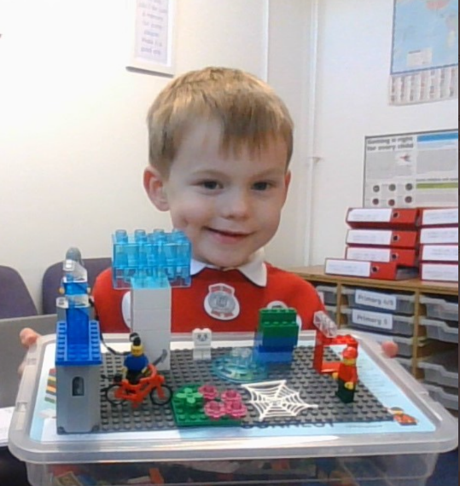
Find out more at: http://www.northayr-edpsychs.co.uk/

Working Together for Excellence. Page 28

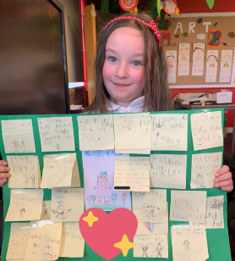

Data Protection

Personal data is required to be collected by North Ayrshire Council in order to deliver education services. It is necessary to collect personal data regarding pupils, parents, carers and other individuals to enable us to carry out our duties under the Education (Scotland) Act 1980 and the Education (Scotland) Act 2016.

The Data Protection Act 2018 sets out the legal basis for processing data. You can refer to our privacy notice for details of the different basis under which we may process individuals’ data.
https://www.north-ayrshire.gov.uk/Documents/EducationalServices/eye-privacy-policy.pdf

We may also share or receive an individual’s personal data with the following:
  - Scottish Government & Education Scotland
  - Private Nurseries
  - Strathclyde Passenger Transport
  - Scottish Children’s Reporter Administration
  - Social Work Services
  - Scottish Public Services Ombudsman

Where we are required we will also make disclosures required by law and may also share information with other bodies responsible for detecting/preventing fraud or auditing/administering public finds. Individuals have legal rights under the data protection legislation including the right of access. Further details can be found in the Council’s Privacy Policy at:

https://www.north-ayrshire.gov.uk/privacy-policy.aspx Medical and Health Care
Medical examinations are carried out at various times during a child’s primary school years. Parents are given notice of these and encouraged to attend. Vision and hearing tests and dental examinations, which parents need not attend, are also carried out and parents informed of any recommended action or treatment. All examinations are carried out by Ayrshire and Arran Health Board staff.

If a pupil takes ill or has an accident at school, which requires that the child be sent home or for treatment, First Aid will be provided and parents or carers contacted immediately. (In the event of a serious illness or accident, a member of staff will accompany the child to a doctor or hospital and parents/carers will be notified immediately.)

For this reason, it is important that the school has contact details for parents/carers and an additional contact person in case parents/carers cannot be reached. It is also important that the school is kept fully informed and updated with regards to any medical condition.

It is the parent’s responsibility to notify the school and keep medical information updated as required.

Children will not be sent home unaccompanied.

Working Together for Excellence. Page 29

Section 8: Parental Involvement Parental Engagement and Involvement
NAC Parental Involvement Strategy
All schools have clear systems in place for communicating with everyone in the parent forum. Communications with parents are clear, jargon-free, specific and easily accessible. A variety of methods and approaches are used by schools to communicate with the parent forum including face to face, traditional communication methods and digital media e.g. Twitter, Facebook. Considerations will always be given when communicating with parents who have literacy, language and communication challenges.

Schools ensure that parents know who to contact when they wish to discuss their child’s learning or wellbeing and will seek to provide a private space for such discussions and make sure parents are given adequate time and support. Consideration will be given to family circumstances.

Parents are welcome to contact the school at any time to arrange an appointment to discuss any matter with the Class Teacher, Depute Head, Head Teacher. New families are welcome to contact the school and request a suitable visiting time at any point throughout the session.

Parents are given opportunities to understand the way learning and teaching takes place in the classroom. This may be in the form of class visits to take part in the learning experience alongside their child or attending events which share the learning. Frequent invitations are issued to parents to participate in school activities such as open days, class assemblies, workshops and to assist with outings and visits, sports and concerts. There will be a series of early meetings for the parents of Primary 1 pupils and parents are kept informed of events with a range of newsletters, website updates, texts, invitations and social media sites.

A variety of methods will be used to ensure information about your child’s progress is shared. Schools are encouraged to provide parents/carers with information on their children’s progress at regular intervals throughout the year through a range of activities. There is an expectation that part of this will be in a written format.

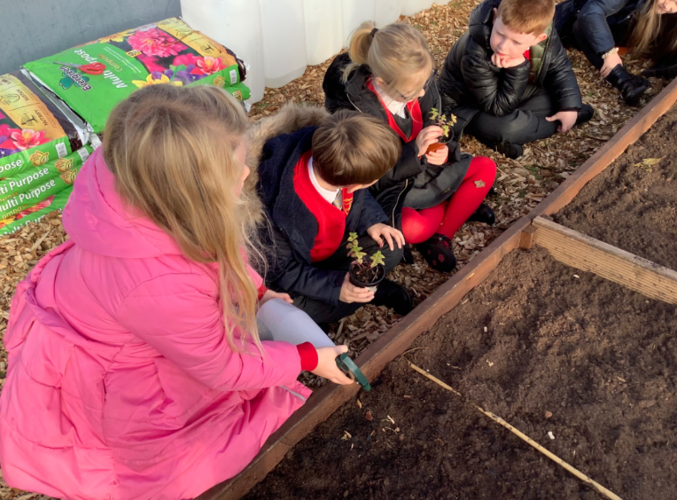

Working Together for Excellence. Page 30

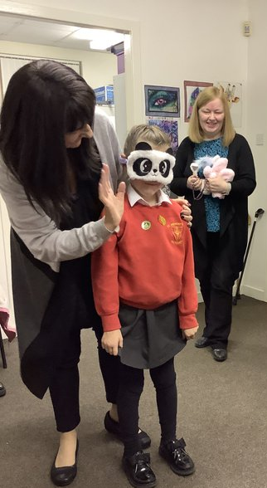

Reporting Examples:

Individual Learners Groups of Learners

- Written reports/tracking reports Assemblies
- Learning conversations with pupil/teacher/parent/carer Open morning and afternoon events
- Pupil reflections on their learning on Seesaw School concerts/shows
- Parent/carer consultation/Parents’ Meetings involving Curriculum workshops led by
parent/teacher/pupil, as appropriate children and staff
- Home/school diaries Social media including Twitter and Seesaw
- Profiling activities Parent Council meetings
- Learning walls and displays School/class newsletters

Parent Council

The Scottish Parliament has passed a law called the Scottish Schools (Parental Involvement) Act 2006 to encourage and support more parents to become involved in their child’s education.

The main aims of the Act are to:
  - Help parents become more involved with their child’s education and learning.
  - Welcome parents as active participants in the life of the school.
  - Provide easier ways for parents to express their views and wishes.

To help achieve these aims, all parents are automatically members of the Parent Forum at their child’s school and are entitled to have a say in selecting the Parent Council (the representative body) to work on behalf of all parents at the school.

The objectives of the Parent Council are:
  - To work in partnership with staff to create a welcoming school which is inclusive for all parents.
  - To promote partnership between the school, its pupils and all its parents.
  - To develop and engage in activities which support the education provided by the school and other matters affecting the education and welfare of pupils.
  - To be involved in the recruitment process for appointing the Head Teacher and Depute Head Teacher of the school.

St. Anthony’s has a very active and highly supportive Parent Council and the full group are displayed on the wall in our main corridor. The present chairperson is Mr S Ring. He can be contacted via the school, by letter or e-mail.

Any parent or carer of a child at the school can volunteer to be a member of the Parent Council. The Head Teacher is the professional adviser to the Parent Council and has a right to attend and speak at Parent Council or Parent Forum meetings.

Working Together for Excellence. Page 31



Any parent or carer of a child at the school can volunteer to be a member of the Parent Council. The Head Teacher is the professional adviser to the Parent Council and has a right to attend and speak at Parent Council or Parent Forum meetings.

For more information on the Parental Involvement Act or to find out about parents as partners in their children’s learning, please contact the school or North Ayrshire Council Education and Youth Employment or visit the Parentzone website on:- https://education.gov.scot/parentzone

Parentzone Scotland is a unique website for parents and carers in Scotland, from early years to beyond school. The website provides up-to-date information about learning in Scotland, and practical advice and ideas to support children’s learning at home in literacy, numeracy, health and wellbeing and science.

Information is also available on Parentzone Scotland regarding additional support needs, how parents can get involved in their child’s school and education. Furthermore, the website has details about schools including performance data for school leavers from S4-S6; and links to the national, and local authority and school level data on the achievement of Curriculum for Excellence levels.

Parentzone Scotland can be accessed at: https://education.gov.scot/parentzone



Working Together for Excellence. Page 32



Section 9: Pupil Data Collection and Protection Policies

The Scottish Government and its partners collect and use information about pupils through the Pupil Census to help to improve education across Scotland. This note explains why we need this information, how we use it and what we do to protect the information supplied to us.

Why do we need your data?
In order to make the best decisions about how to improve our education service, Scottish Government, education authorities and other partners such as the SQA and Skills Development Scotland need accurate, up- to-date data about our pupils. We are keen to help all our pupils do well in all aspects of school life and achieve better examination results. Accurate and up-to-date data allows us to:

- plan and deliver better policies for the benefit of all pupils
- plan and deliver better policies for the benefit of specific groups of pupils
- better understand some of the factors which influence pupil attainment and achievement
- plan and implement targeted approaches to reducing the poverty-related attainment gap
- share good practice
- conduct teacher workforce planning
- target resources better
- enhance the quality of research to improve the lives of young people in Scotland
- provide a window on society, the economy and on the work and performance of Government by:
https://www.gov.scot/publications/pupil-census-supplementary-statistics/

Data policy
Information about pupils’ education is collected through our statistical surveys in partnership between the Scottish Government and Local Authorities through the ScotXed Programme which aims to help schools and Local Authorities by supporting efficient collection, processing and dissemination of statistical information. The Scottish Government then provides analysis of the data to support research, planning, management and monitoring of education services as well as to produce National Statistics publications.

Education data within Scottish Government is managed effectively by secure systems on secure servers and is exploited as a valuable corporate resource, subject to confidentiality restraints. As part of its data policy, Scottish Government will not publish or make publicly available any information that allows individual pupils to be identified, nor will data be used by Scottish Government to take any actions in respect of individuals. Data is held securely and no information on individual pupils can or would be made publicly available by Scottish Government.

The individual data collected by Scottish Government through the Pupil Census is used for statistical and research purposes only.

Working Together for Excellence. Page 33

Your data protection rights
Any sharing or linkage of data will be done under the strict control of Scottish Government, and will be consistent with their data policy and the National Data National Data Linkage Guiding Principles Guiding Principles. Decisions on the sharing or linkage of data will be taken in consultation with relevant colleagues and individuals within and outwith Scottish Government as part of a Data Access Panel. At all times the rights of the individual (children or adults) under the GDPR and other relevant legislation will be ensured. Further information can be found on:

https://www.gov.scot/collections/scottish-exchange-of-data-scotxed/

Concerns
If you have any concerns about the ScotXed data collections you can email the Data Protection & Information Assets Team on dpa@gov.scot or the Head of Education Analytical Services, Mick Wilson, at mick.wilson@gov.scot or by writing to Education Analytical Services, Area 2A-North, Victoria Quay, Leith, EH6 6QQ. Alternative versions of this page are available, on request from the ScotXed Support Office, in other languages, audio tape, Braille and large print.

Alternatively complaints may be raised with the Information Commissioners Office at casework@ico.org.uk.



Working Together for Excellence. Page 34

Important Contacts Appendix 1

Executive Director (Education)
Sam Anson
North Ayrshire Council
Cunninghame House
IRVINE
KA12 8EE
01294 310000

Head of Service (Education)
Andrew McClelland
North Ayrshire Council
Cunninghame House
IRVINE
KA12 8EE
01294 310000

Working Together for Excellence. Page 35

