

SPRINGSIDE EARLY YEARS STUDENT HANDBOOK

OUR
STUDENTS...

We hope at Springside Early Years you have a positive experience. Early Years is the fundamental starting point for every child’s educational journey and you have a key role to play.

·We are looking for student to: Feel welcomed and valued.
To display a caring, nurturing approach towards all of our children and members of the staff team.
To display enthusiasm daily. Show commitment.
Learn, grow and develop as a practitioner.
Have a professional approach to all tasks and situations.
Ask questions to support your understanding and development.
Have fun!

You will have an allocated mentor to support you through your placement work and help if you have any questions. Your mentor will have weekly informal chats and check-ins with you to ensure to support you on your journey.
However feel free to speak to any member of the team if you have any questions or feel you need further support.

“Each child’s needs should be at the centre of how we think about and plan for their unique development. Children have their own ideas and plans, and their brains and bodies are good at seeking out the kinds of activities, environments and encounters that they need to help them develop.”

Realising the Ambition

WHAT WE VALUE

Our vision is to ensure our relationships are positive, responsive and reciprocal, with the individual needs of each child at the heart of our practice and daily experiences.

Play is fundamental to children’s experience and the way in which they explore and discover the world around them. Quality play enables them to develop skills for life and attain a range of developmental milestones on their learning journey. Practitioners have a crucial role in ensuring interactions are engaging, meaningful, offer challenge, are sensitive and responsive to the needs of the individual, differentiate experiences based on individual needs and be a positive, consistent role model.

MEET THE TEAM
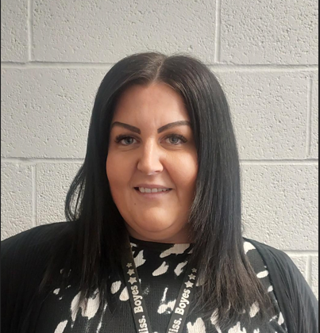
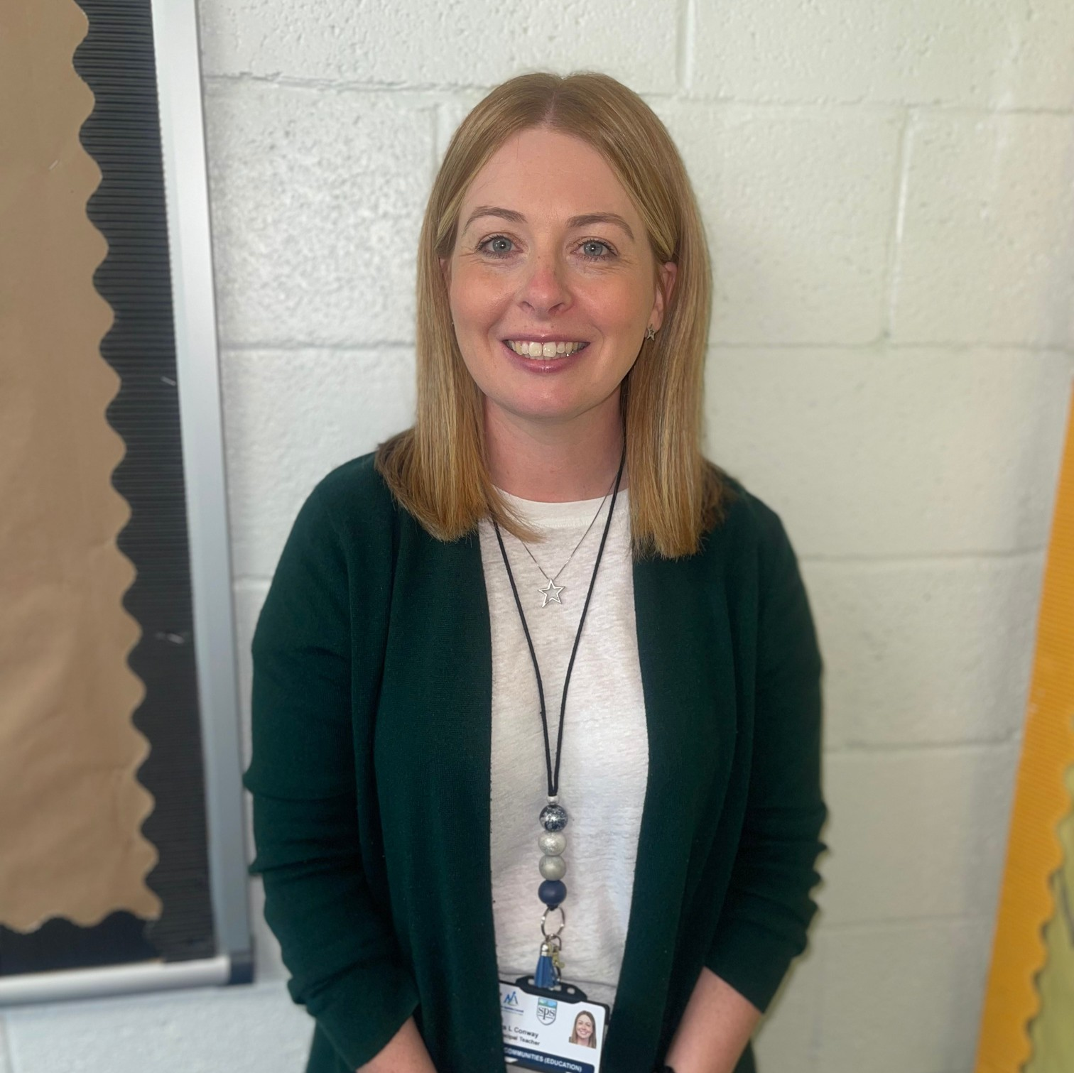

LYNSEY BOYES
Acting Head Teacher



JADE MCILWRAITH (0.8)

Senior Early Years Practitioner

LORNA CONWAY
Principal Teacher


KERRY WALSH (0.2)
Senior Early Years Practitioner

MEET THE TEAM

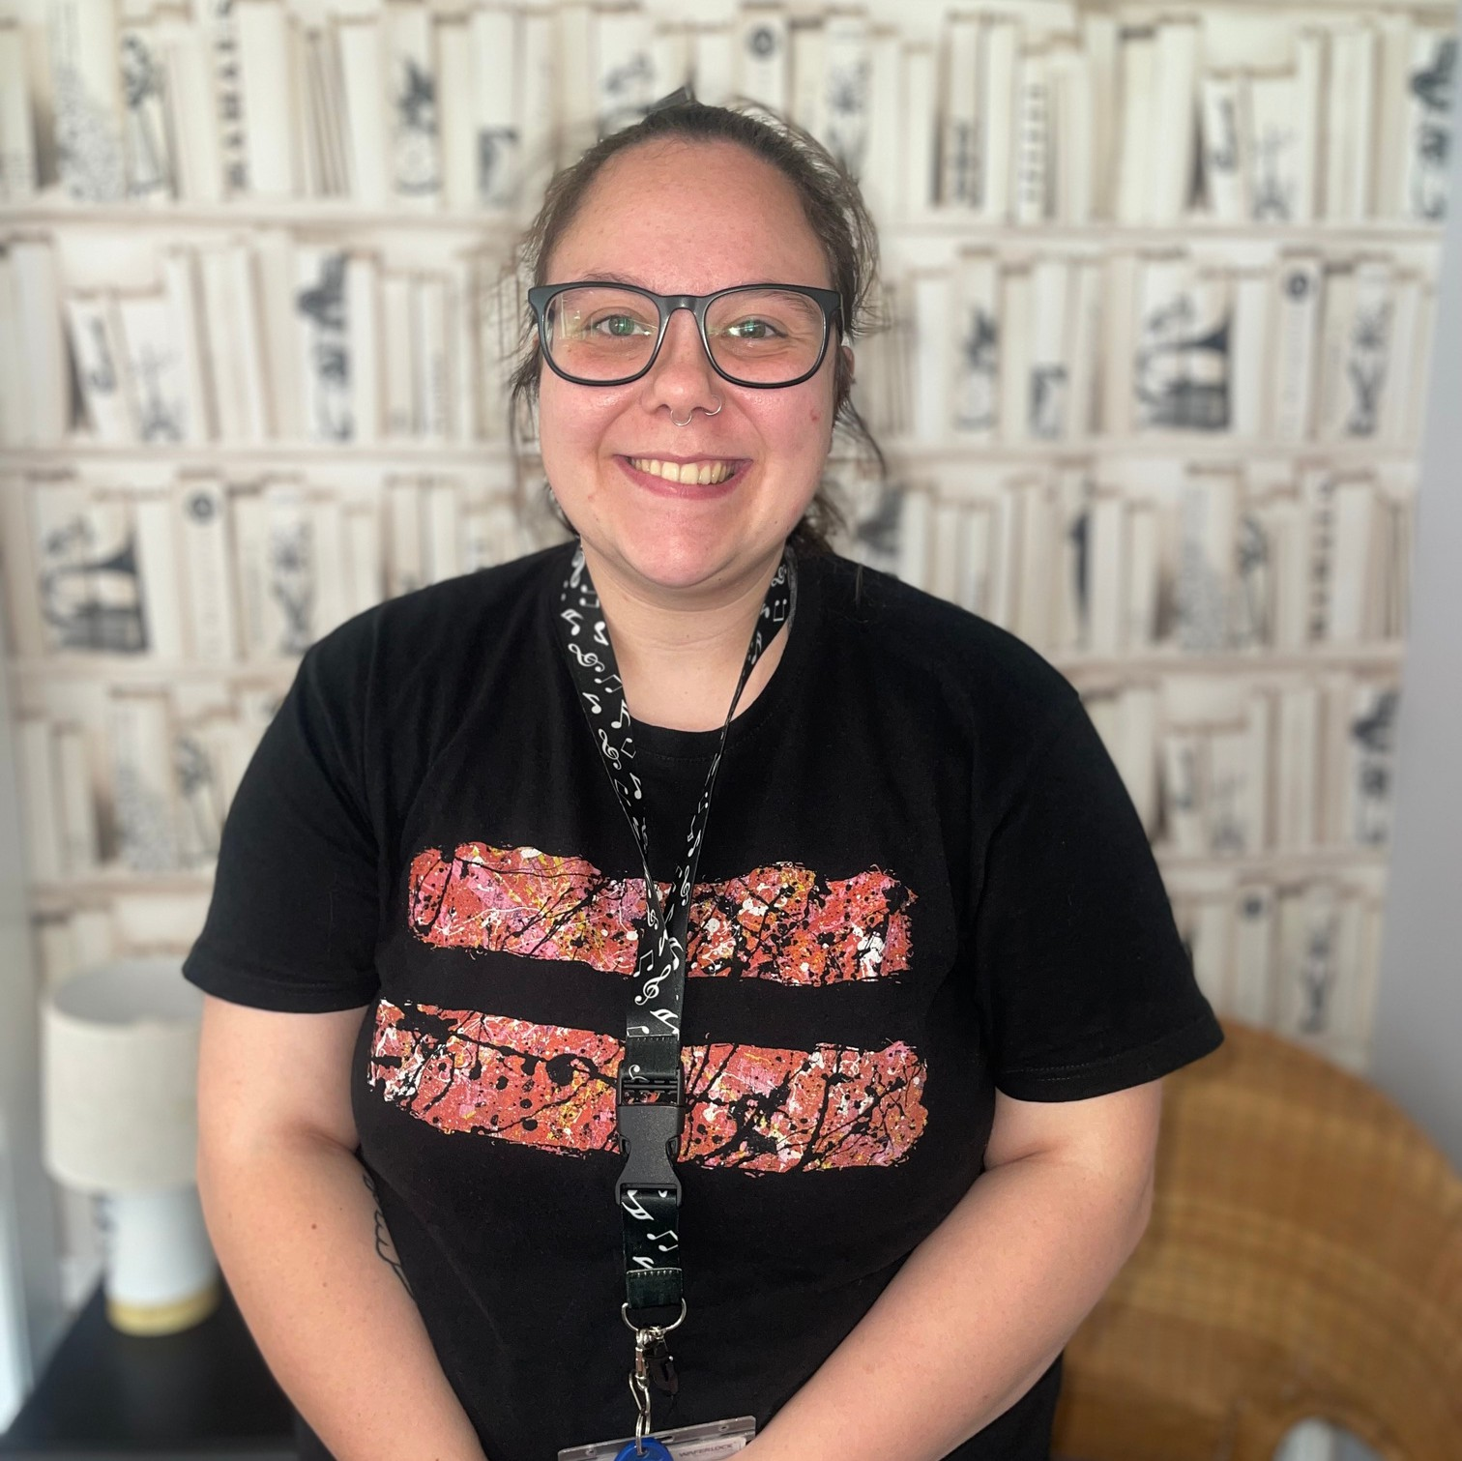

MELISSA YOUNG
Early Years Practitioner

EMMA BARRIE
Early Years Assistant

STUDENT GUIDANCE

WORKING HOURS

Our children attend 9am until 3pm. Students are asked to attend the early years from 8.45am until 3.30pm.
These hours support the daily set up and end of day tasks.
If you are unwell and unable to attend placement you must call 01294 211651 to let us know.
We ask that you prioritise timekeeping and if you are going to be late you let us know as soon as possible.

CONFIDENTIALITY

All information shared at Springside Early Years in relation to children and families must not be shared.
It is essential that you regard all information as confidential. Any breach of confidentiality will be treated seriously and appropriate action in line with North Ayrshire Council’s policy and procedures will be followed and implemented.

FIRE EVACUATION

CHILD PROTECTION
Child protection is paramount within Springside Early Years. If you have any concerns about a child they must be reported immediately to Lynsey Boyes who is our Child Protection Co- Ordinator.
Please ensure you read the child protection policy handbook.

MOBILE PHONES

Mobile phones can be used within your own private time however must not be used in the Early Years playroom.
They must be kept with your personal belongings and not on you when you are on the floor.
On your first visit to the Early Years please familiarise yourself with the fire evacuation procedures. Ensure you know how you would evacuate safely from each room in the building and where the muster point is.

DRESS CODE

We kindly ask that you dress in a comfortable professional manner. Early Years can be messy so please don’t wear anything that you will be upset getting dirty.
Please ensure you bring clothes that will be appropriate for outdoor play as we go outside rain or shine every single day!

