

SPRINGSIDE PRIMARY STUDENT TEACHER HANDBOOK

VISION,
VALUES AND AIMS

Vision
At Springside, we create a happy and safe environment where every child feels valued and supported. We aim for pupils to try their best, achieve excellence, celebrate personal and wider achievements, and develop the skills and confidence to thrive as responsible citizens ready for the future.

Values:
Kindness, Effort, Respect

Aims:
- Raise standards of attainment and achievement for all by providing a variety of stimulating opportunities and experiences.
- Maintain the positive ethos within Springside Primary and Early Years by providing an inclusive, safe and nurturing learning environment.
- To work in partnership with all stakeholders to support each child's learning, well-being, and development, fostering a strong sense of community and shared success.
- Promote high aspirations and a ‘can-do’ attitude, ensuring equity of opportunities.

MEET THE SLT

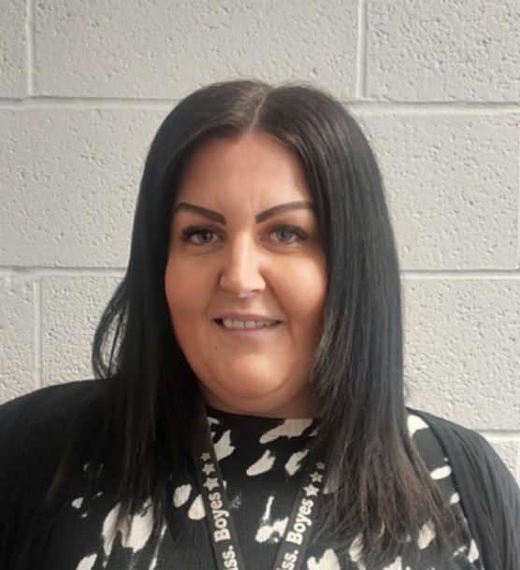
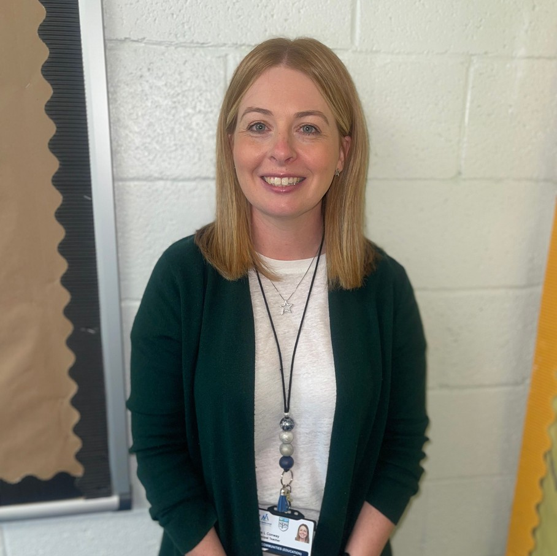

LYNSEY BOYES
Acting Head Teacher
LORNA CONWAY
Principal Teacher

"At Springside Primary, we are committed to supporting student teachers in every way possible during their time with us. We aim to create a welcoming environment, provide guidance, and encourage professional growth to help you excel and thrive in your teaching journey”.
Miss Boyes



OUR
STUDENTS...
"At Springside Primary, we want student teachers to experience a nurturing and supportive environment that fosters positivity, collaboration, and professional development, empowering them to confidently grow and excel in their teaching journey."

·We are looking for student to: Feel welcomed and valued.
To display a caring, nurturing approach towards all of our children and members of the staff team.
To display enthusiasm daily.
Show commitment in and outwith the classroom Learn, grow and develop as a practitioner.
Have a professional approach to all tasks and situations.
Ask questions to support your understanding and development.
Have fun!

You will have an allocated mentor to support you through your placement work and to help if you have any questions. Your mentor will have weekly check-ins with you to support you on your journey.
However feel free to speak to any member of the team if you have any questions or feel you need further support.

"Student teachers are at the heart of shaping the future of education, and we are committed to providing the guidance, resources, and collaborative opportunities they need to thrive and inspire the next generation." Education Scotland

School Information

PUPIL ENTRY AND EXIT SCHOOL REWARD SYSTEM

Primary 1/2/3 pupils line up in the infant playground.

P4/5/6/7 line up in the upper playground.

There is staff rota to collect lines each morning, after break and lunch.

At the end of the school day P1/2/3 pupils are released to parents/carers who enter the infant playground.

P4/5/6/7 pupils leave via the upper playground on their own.

SCHOOL DAY
Hours: 9-3
Break at 10:45 - 11
Lunch 12:30 - 1:15
We have four houses in our school.
Bankhead Corsehill Greenside Kirkland
Pupils earn tokens that are linked to our school values and place them into the token collector located near the school office. Please familiarise yourself with the policy and use this system as appropriate whilst working with us.

Our Positive Relationships Policy is key to ensuring we get it right for our pupils. We celebrate positive behaviour and effort across all classes. We have restorative conversations with pupils when required, to ensure they understand the results of their actions, which will help them make improved decisions in the future.

STUDENT GUIDANCE

WORKING HOURS
Students are asked to attend school from 8.30am until 4pm.
These hours support the daily set up and end of day tasks/marking etc.

If you are unwell and unable to attend placement you must call 01294 211651 to speak to the Head Teacher.

We ask that you prioritise timekeeping and if you are going to be late you let us know as soon as possible.

CHILD PROTECTION
Child protection is paramount within Springside Primary and EYC. If you have any concerns about a child they must be reported immediately to Gordon Wilson who is our Child Protection Co- Ordinator.
Please ensure you read the child protection policy handbook on arrival

CONFIDENTIALITY
All information shared at Springside Primary in relation to children and families must not be shared.
It is essential that you regard all information as confidential. Any breach of confidentiality will be treated seriously and appropriate action in line with North Ayrshire Council’s policy and procedures will be followed and implemented.

FIRE EVACUATION

On your first visit to the primary school, please familiarise yourself with the fire evacuation procedures. Ensure you know how you would evacuate safely from each room in the building and where the muster point is.

DRESS CODE

at the school. We kindly ask that you dress in a
comfortable, professional manner. The

MOBILE PHONES
Mobile phones can be used within your own private time however they must not be used in the classroom.

Phone must be kept with your personal belongings and not on you when you are working with pupils.
primary curriculum can be messy so please don’t wear anything that you will be upset getting covered in chalk/paint etc.
If you are unsure about what to wear please speak to your allocated mentor.

