EDUCATION DIRECTORATE


Head of Service (Education): Andrew McClelland
Cunninghame House, Irvine KA12 8EE
Tel: 01294 310000 www.north-ayrshire.gov.uk

Springside Primary School:
Station Road
Springside

KA11 3AZ
Tel: 01294 211651

Springside

Primary & EYC
September
2025
Newsletter





Welcome!

We would like to say a big welcome back to all of our pupils, families and partners. The first term is already off to a busy start with welcoming our new P1 pupils and families and teachers getting to know their new classes!

Staffing Update

We are delighted to welcome new members of staff to our team - Miss Caitlin McGowan in P5/6, Miss Olivia Bentham in P4/5 and P6/7 and Mrs Jade McIlwraith as our Acting Senior Early Years Practitioner. They have settled in well and are enjoying getting to know our wonderful pupils!

As some of you may already be aware, we have been without a permanent Education Business Assistant for a number of weeks now. I am pleased to say that Mrs Leigh-Ann McIlwhain will be joining us soon to take up the role of EBA. Your support at this time has been greatly appreciated.

We also have a new Senior Manager for Springside – Kirsty Carson. Kirsty has years of experience within North Ayrshire and our school and early years will benefit from her vast experience and knowledge and her absolute commitment to getting it right for our young people.

PEF Staffing

Using feedback from our parent/carer consultation on use of our Pupil Equity Fund, we have used some of our money to fund additional teaching staff. Mrs Laura Havlin and Mrs Kerry Davidson were the preferred candidates for these 2 extra days.

We also used our Pupil Equity Fund to fund a Pupil Support Assistant for 4 additional days. Miss Selina Drysdale will be starting with us shortly.

These additional hours from teaching staff and PSAs will focus on raising attainment in Literacy and Numeracy and supporting Health and Wellbeing.


Thank You!

A big thank you needs to go to our wonderful staff who worked so hard before, during and after the summer to create calm, organised and engaging learning environments for our pupils. This was commented on by Andrew McClelland, Head of Service, during his visit a couple of weeks ago.

Spring Inside and See Learning

A reminder that our first 'Spring Inside and See Learning' session for P1-P7 pupils will take place on Tuesday 30th September from 2:15-2:45pm. This is a great opportunity to see your child’s classroom and meet their teacher. There will be some activities for you to do with your child.

We are aware that some parents/carers may be working or have other commitments and will be unable to attend, however if another family member wishes to come instead, then they are more than welcome, e.g. a grandparent. Due to space, we ask that only one person attends each session.

This year, our Early Years Centre are hosting their Stay and Play sessions in a slightly different format. The Stay and Play Calendar can be found up in the Early Years Reception, for you to add your name to a slot that best suits you. Morning sessions are 9:30 to 10:30am and afternoon sessions are 1:30 until 2:30pm.

We look forward to seeing as many of you at our Spring Inside and See Learning and Stay and Play sessions as possible!


Diary Dates

Based on your feedback, we have created an overview of dates for the full session – as found on the last pages. The overview includes all key events including all of the Spring Inside and See sessions. This is to give as much notice as possible for key dates of events. We hope this helps! Letters
with further information about each event will be sent out in
due course.

Pantomime


This year, we have booked the pantomime ‘Sleeping Beauty’ at the Galleon Centre, Kilmarnock for our Primary 1-7 pupils on Wednesday 3rd December. We are booked for the afternoon performance at 1:30pm. We will travel by coach, leaving the school at 12:45pm. The performance runs until 3:30pm, meaning we will be returning to school at approximately 4:00pm.

Our Parent Council are kindly paying for the buses and our school fund is able to subsidise some of the cost of the trip, making it £12 per pupil. Letters with more information have been sent home.

P.E.

You should have received a letter home with your child’s P.E. days this session. If they haven’t already done so, children are asked to bring in their full P.E. kit as soon as possible. This should include a t-shirt, shorts/leggings and gym shoes and all items should be labelled. These items should be kept within the blue gym bag (provided by the school) which will stay on your child’s peg in school.

We emphasise the importance of bringing in a P.E. kit and having a change of clothing for your child’s personal hygiene and comfort. For a variety of health and safety reasons, we would ask that the gym shoes are kept in school, as inside shoes. This will help to keep our gym hall clean and dry and avoid slips, trips and falls due to mud etc.

School Improvement Plan

Our priorities for school improvement this year are:

Priority 1: To enrich the quality of learning experiences and raise attainment in Literacy and English by enhancing pedagogy and curriculum development.
Priority 2: To enrich the quality of learning experiences and raise attainment in Numeracy and Mathematics by enhancing pedagogy and curriculum development.
Priority 3: To prioritise and promote the positive Health and Wellbeing of children and young people.
Priority 4: To ensure the curriculum is accessible for all and ensure engagement in learning through enhancing the curriculum using digital experiences.

As part of North Ayrshire’s quality assurance framework, our Senior Manager, Kirsty Carson visited the school to provide feedback on our School Improvement Plan and Standards and Quality Report. These will now be shared with our parents, carers and community and be uploaded to our school website.

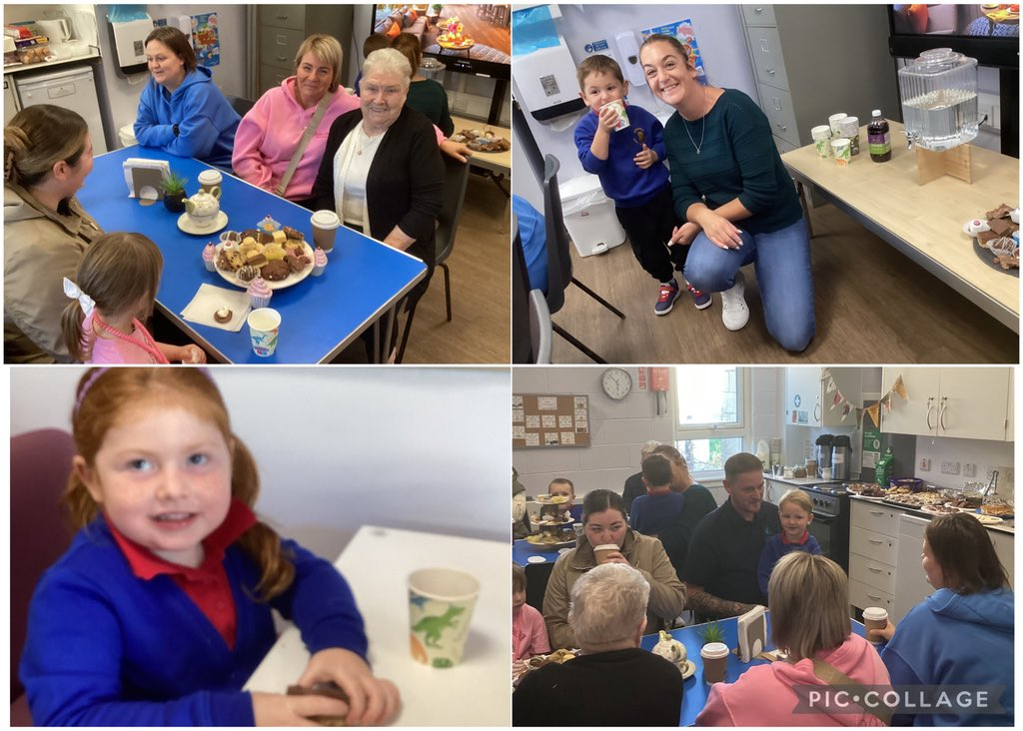
Early Years Macmillan Coffee Morning

Our Early Years Centre hosted a fantastic Macmillan Coffee Morning on Friday 26th September. Parents, carers and families enjoyed some delicious cakes, biscuits and refreshments and a fabulous £89 was raised for the charity.

Thank you to everyone who kindly made donations to this worthy cause.

Harvest Coffee Morning

Last year’s Harvest Coffee Morning was so successful that we have decided to hold another one! Parents, carers and families are invited to join us at the school on Friday 10th October at 9:30pm for some tea, coffee, cake and entertainment from the children. An invite to this has been sent out on Groupcall. We hope to see you all there!

P7 House Captains

We are very proud of our Primary 7 pupils who did a fantastic job with their speeches and interviews for captaincy. They are recognised for putting themselves out of their comfort zones and stepping forward for responsibility. Well done!!

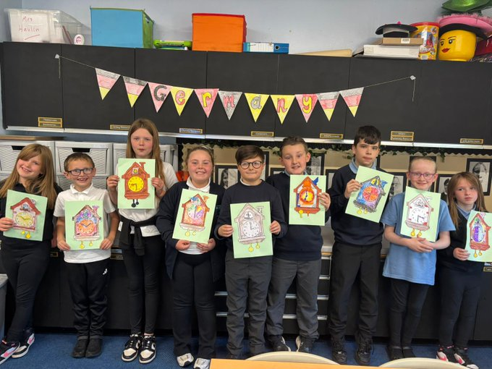
European Day of Languages

We had a fantastic European Day of Languages celebration on Friday 26th September! Each class were given a European country to find out about and they were challenged to learn songs, dances and create artwork based on the country and culture. These creations were then celebrated at a special European Day of Languages assembly. Children even got to taste some European snacks at playtime!

Early Years Vote

Our Early Years Centre have been consulting with their parents and carers on whether first names or surnames should be used for staff. The majority voted for first names to be used. Some of the feedback included; first names are more nurturing, they are easier for children to say, they break down barriers and they build more positive relationships.

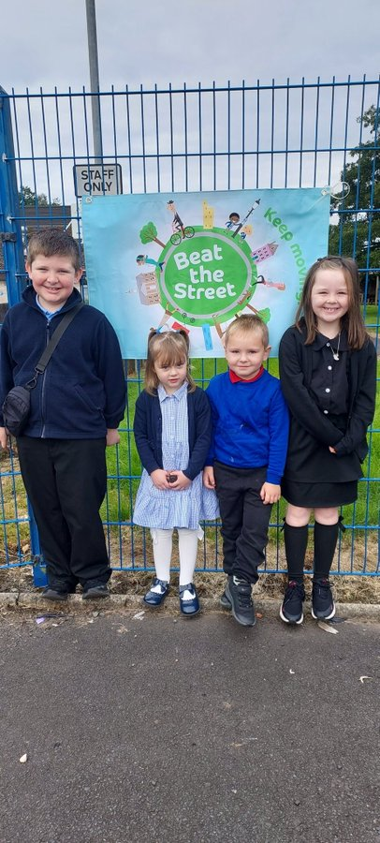
Beat The Street

As part of the Beat the Street game, children in Springside,
Irvine and Dreghorn have been challenged to get points and
win prizes by walking, rolling, running and cycling around
town from 24th September until 5th November. Your child
will have received their Beat the Street card and map along
with an information letter for parents and carers. Parents
must register their child’s card online to join the school
team. Stay safe, active and have lots of fun!
Parent Council Meeting

Our Parent Council have had their first meeting of this session and it was lovely to see some new faces. The next Parent Council meeting is scheduled for Tuesday 7th October at 6pm in the Institute.

DATES FOR YOUR DIARY

DIARY

Tuesday 30th September (2:15-2:45pm) | Spring Inside and See Learning
Friday 3rd October | Dress Down Day (bring an item for foodbank)
Tuesday 7th October | Parent Council Meeting
Friday 10th October (9:30am) | Harvest Coffee Morning
Friday 10th October | School Closes
Monday 20th October | Pupils Return
Monday 20th October (w/b) | Interim Reports go out to parents and carers
Friday 31st October | Halloween Activities Day
Tuesday 11th November (3:30-5:30pm) | Parents’ Afternoon
Friday 14th November | Children In Need
Wednesday 19th November (5:30-7:30pm) | Parents’ Evening
Friday 21st November | Holiday
Monday 24th November | Holiday
Tuesday 25th November | In-Service Day
Wednesday 26th November | Pupils Return
Thursday 27th November | Flu Immunisations
Wednesday 3rd December | P1-P7 Panto ‘Sleeping Beauty’ @ The Galleon Centre
Thursday 4th December | Spring Inside and See Learning
Wednesday 10th December | Christmas Lunch
Tuesday 16th December (pm) | P1-P3 Nativity
Wednesday 17th December (pm) | P6/7 Christmas Party
Thursday 18th December (am) | P1-3 Christmas Party
Thursday 18th December (pm) | P4/5 Christmas Party
Friday 19th December | School Closes
Monday 5th January | Pupils Return
Friday 6th February | Holiday
Monday 9th February | Holiday
Tuesday 10th February | In-Service Day
Wednesday 11th February | Pupils Return
Thursday 12th February | P7 Transition Morning to Greenwood Academy
Wednesday 18th February | Spring Inside and See Learning
Friday 20th February | World Thinking Day (Sunday 22nd February)
Thursday 5th March | World Book Day
Friday 20th March | Red Nose Activities Day
Friday 20th March | P7 Transition – Greenwood Academy Virtual Assembly
Sunday 22nd March | World Water Day
Tuesday 24th March  (3:30-5:30pm) | Parents’ Afternoon
Wednesday 1st April | Easter Celebration (TBC)
Wednesday 1st April  (5:30-7:30pm) | Parents’ Evening
Thursday 2nd April | School Closes
Friday 3rd April – Friday 17th April | Holiday
Monday 20th April | Pupils Return
Monday 4th May | Holiday
Monday 11th – Friday 15th May | Travel Smart Week
Friday 15th May | Spring Inside and See Learning
Monday 18th – Thursday 21st May | P7 Residential Trip to Arran
Monday 25th May | In-Service Day
Tuesday 26th May | Pupils Return
Tuesday 26th May (pm) | Early Years Sports Afternoon
Wednesday 27th May  (Parent/carers invited pm) | Sports Day
Friday 29th May | P7 Transition – Greenwood Academy Virtual Assembly
Monday 1st June  (6:00-7:00pm) | P7 Briefing Evening for Parents at Greenwood Academy
Wednesday 3rd June | P7 Transition – Transition Day at Greenwood Academy
Thursday 4th June | P7 Transition - Transition Day at Greenwood Academy
Wednesday 17th June (pm) | P7 Leavers’ Assembly
Monday 22nd June | P7 Leavers’ Outing
Wednesday 24th June | P7 Pupils vs. Teachers Match and Ice-Cream Van
Thursday 25th June | Early Years Graduation
Friday 26th June | Prizegiving
Monday 29th June | Springside’s Got Talent
Tuesday 30th June | School Closes

