**Maths & Numeracy**

**NUMERACY:** All pupils will read, write, count, sequence and add numbers and items at their own ability level e.g. P1:0-12, 0-21/31 P2:0-31, 51 or 121. P2 pupils will also cover place value and also extend their addition and subtraction strategies.

**MATHS:** pupils will learn to recognise, name and sort a variety of 2D shapes and 3D objects as well as to copy, continue and create patterns. All pupils will also explore Calendar Maths and Data Analysis.

**Home Information Letter Term 1 Session: 2025/26 Primary 1/2 Mrs. McGregor**

**Health & Wellbeing**

This year, our students took the lead in creating our “Bucket Filler” **Class Charter** after learning about the UNCRC Rights of the Child. They voted on the rights they feel are most important, choosing: Have your Say, Be Treated Fairly, Be Safe & Healthy, Rest & Play and Be Yourself. We will also be focusing on how to manage our thoughts and emotions by discussing our feelings and developing helpful strategies.

Our P.E. days continue to be **Monday** and **Wednesday** and this term the pupils will be extending their fundamental movement skills as well as improving their small ball control.

All pupils are required to have their full P.E. kit of gym shoes, t-shirt, shorts, skort and/or leggings this term. It is also appreciated if long hair is tied back and no jewellery is worn on P.E. days.

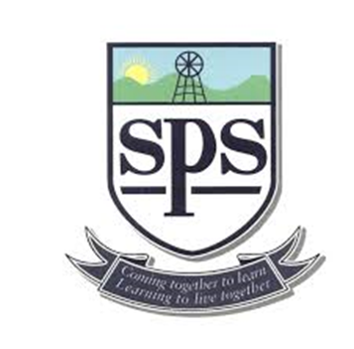

**Expressive Arts**

In Art, we will be experimenting with colour mixing and developing our line drawing skills. We will be using non-pitched percussion instruments in Music and will be learning to keep a steady beat to a simple melody.

**Inter-Disciplinary Learning (IDL):**

This term our interdisciplinary learning theme is **Our School/Our Community** and the pupils will be exploring their school environment, learning about the people who help us, and discovering important places in the local area. Through activities in literacy, numeracy, social science, science and expressive arts, they will develop their understanding of how we all work together to care for and contribute to our school and community.

Should you have any questions or worries about your child, please do not hesitate to get in touch at the end of the school day or by making an appointment at the school office.

Thanks, Mrs. McGregor

**Literacy & English**

**PHONICS:** P1 will revise and extend their phonological awareness through music, rhyme, stories, games and play. They will then progress onto learning their first initial sounds (Phase 2). P2 will extend their spelling, reading and writing skills by revising Phase 3 phonics as well as progressing onto Phase 4 and, for some, Phase 5.

**READING:** P1 pupils will begin initially with wordless readers from our Big Cat reading scheme and this will allow them to develop their discussion skills. P2 pupils will continue to extend their reading and comprehension skills.

**WRITING:** All pupils are learning to write descriptions this term and will then focus on narrative writing.

**HANDWRITING:** Pupils will be given opportunities to strengthen their fine motor skills and receive targeted support to develop their pincer/tripod grip. This will help to encourage good pencil control when forming number and letters. P2 pupils will continue to develop their handwriting by taking part in more challenging pencil control activities.