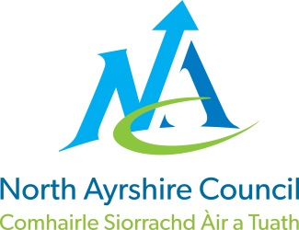
COMMUNITIES & EDUCATION DIRECTORATE

Executive Director: Sam Anson
Cunninghame House, Irvine KA12 8EE
Tel: 01294 310000 www.north-ayrshire.gov.uk


Springside Primary School:
Station Road
Springside
KA11 3AZ
Tel: 01294 211651

Springside

Primary & EYC
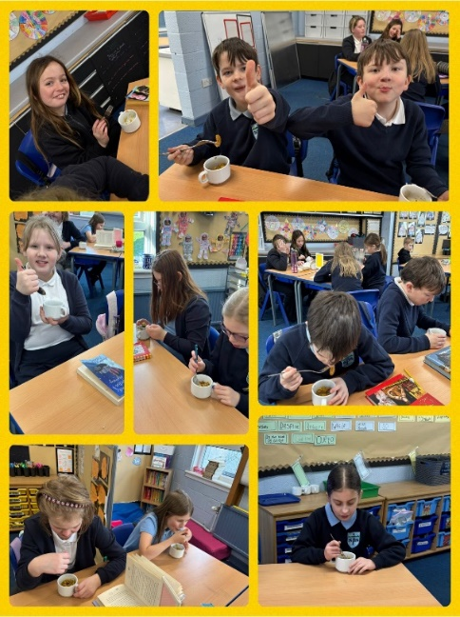
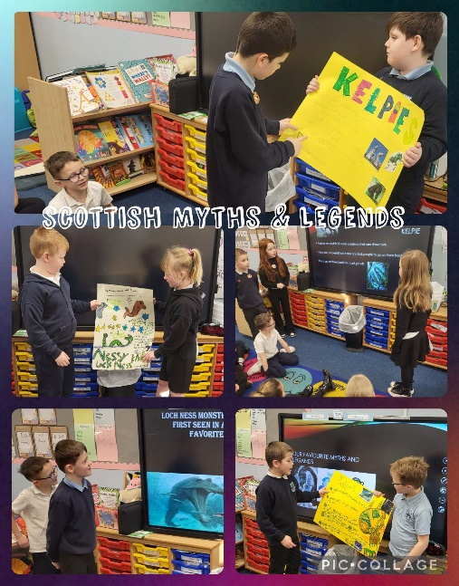
February
2025
Newsletter





Dear Parent/Carer,

I hope you find this newsletter informative and if there is anything you would like clarity on, please pick up the phone and ask to speak to me.

As we step into February, we are excited to share all the wonderful learning experiences and activities happening at Springside Primary and Early Years Centre. There's a lot going on this month, and we can't wait to celebrate our achievements together!
We have been embracing our Scottish heritage through our Scots Poetry celebrations. The children have been learning and performing Scots poems with great enthusiasm, showcasing their fantastic expression and confidence. Well done to everyone who has learned their poem. Our finals afternoon assembly will be held on Wednesday 5th February.
Our IDL topics are in full swing, providing rich, cross-curricular learning opportunities for our pupils. These engaging projects allow children to develop critical thinking, creativity, and teamwork skills while making meaningful connections between subjects.
Across the school, pupils have been exploring new maths concepts. From number patterns to problem-solving strategies, we are fostering a love for mathematics and building strong numeracy skills. Please continue to support your child at home by discussing their learning and encouraging practical applications of maths in daily life. We are currently doing training on the use of Number Talks. The numeracy and maths working party are creating booklets and videos to share with all parents/carers, so look out for these soon!
We are also enhancing our writing lessons with team teaching approaches. This allows pupils to benefit from different teaching styles, shared expertise, and collaborative learning experiences. We look forward to seeing the continued progress our young writers have made in 2024 into 2025.
Thank you for your continued support. We look forward to another exciting and productive month at Springside Primary and EYC!

Best Wishes

Gordon Wilson
Head Teacher
Spring Inside and See Learning

Our next Spring Inside and See Learning will be held on Friday 7th February. We hope to see lots of parents/carers attend. This time you will have a chance to look through your child’s jotters (EYC Targets) and support them in a Free Writing task.

Who is invited?
Parents, carers, grandparents…it’s up to you. However, due to capacity and classroom space we would ask that where possible, only one person attends each session (there are lots over the year). For Health and Safety reasons prams/buggies are not permitted in classrooms. These can be left in the gym hall.

Time:

- EYC Stay and Play: 9:00 – 9:45am
- School: 2:15 – 2:50pm

We hope you are excited to join us on the 7th February and we hope to see a good turnout of parents/carers across the entire school. Children and staff love it when you attend these sessions.

Scots Poems

A huge well done to all pupils who worked hard to learn and recite their Scots poetry last week! Your efforts have been fantastic, and we are proud of you all.
The Scots Poetry Final will take place on Wednesday 5th February, where our top performers will compete. To mark this special occasion, we will be hosting a special assembly, with Mrs. Cook as our main judge.
Good luck to all finalists – we can't wait to hear your performances!
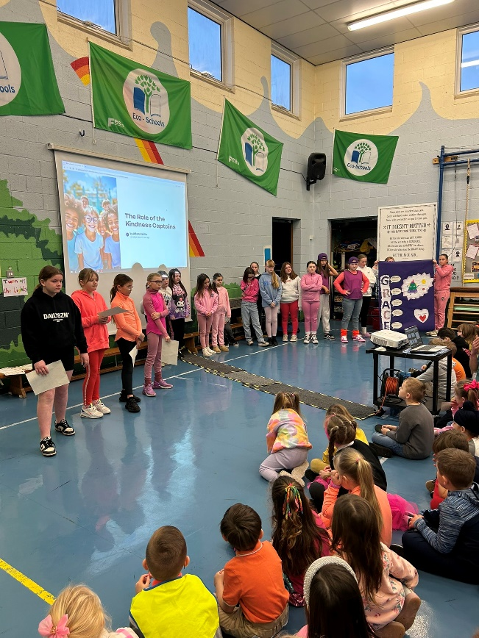
Kindness Captains
Our Kindness Captains are now up and running, using peer mediation to help resolve any issues or incidents in the playground. They have been fantastic in applying our GRACE model to support all pupils with care and respect.
We are incredibly proud that wellbeing remains a key focus in our school, ensuring a positive and supportive environment for everyone.
Keep up the great work, Kindness Captains!

PE Kits
PE Kit Reminder – Be Ready to Move!
To ensure all pupils can fully participate in PE lessons, please remember to bring:
✔ A full PE kit (comfortable sportswear)
✔ A change of footwear (indoor and outdoor shoes)
Wearing the correct kit is essential for safety, comfort, and giving everyone the best experience during physical activities. PE is a vital part of school life, helping to develop fitness, teamwork, and confidence.
Thank you for your support, if you are unable to provide a PE kit for your child please let the school office know and we can support you in this matter.
P1/2 | Monday & Wednesday
P3/4 | Tuesday & Friday
P4/5 | Tuesday & Thursday
P5/6 | Monday & Thursday
P6/7 | Wednesday and Thursday
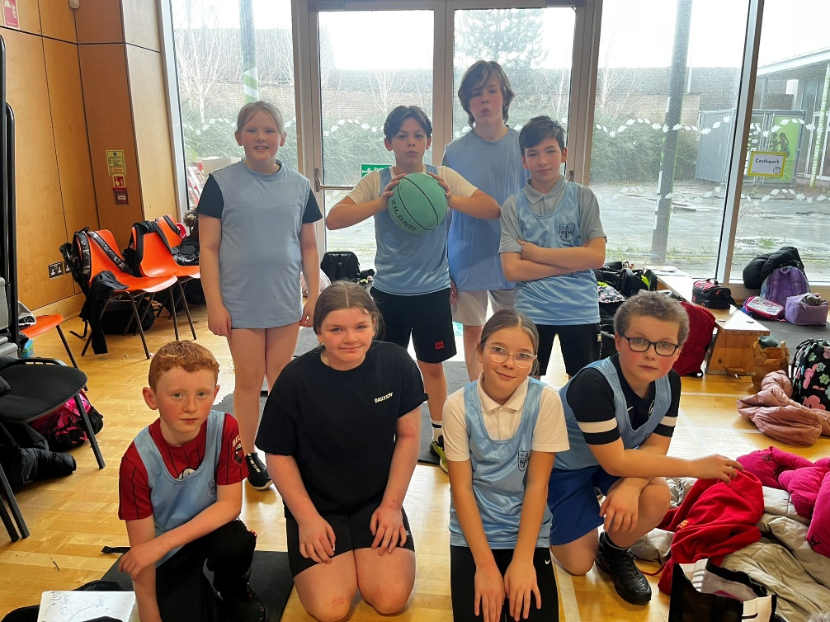

SCHOOL CLUBS
We have lots of exciting after-school clubs running this term, and our pupils have been loving them so far! A huge thank you to Mr. Baillie for overseeing these and to our dedicated staff for running them each week.
If you would like your child to join a club, please let Mrs. Cook in the office know. We’d love to see even more pupils getting involved!

Homework Club - P1-P7 Monday 3-3:30pm

- Cooking Club: P1-P3 Tuesday 3-3:45pm

Arts and Crafts Club: P4-P7 Tuesday 3-3:45pm

- Chess Club: P4-P7 Tuesday 3-3:45pm

Arts and Crafts Club: P1-P3 Thursday 3-3:45pm

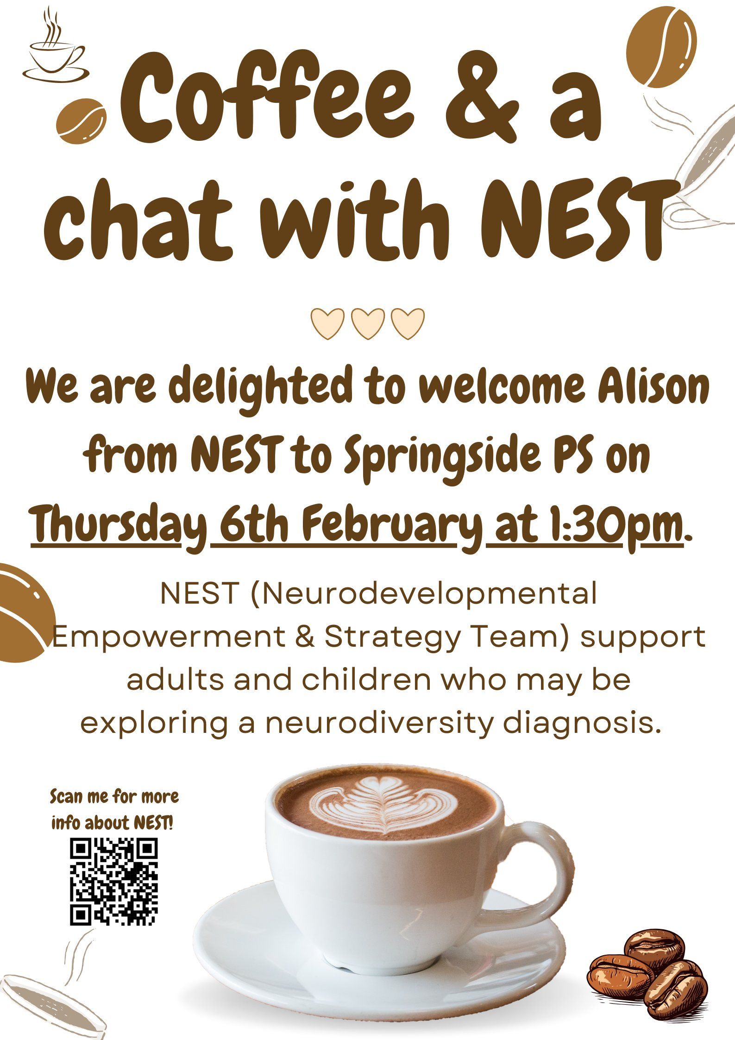

Reminder: No Valuable Items in School
Please do not bring expensive items from home, including mobile phones, jewellery, or other valuables where possible. These items are not needed in school, and pupils bring them in at their own risk.
We appreciate your support in keeping belongings safe and ensuring a focus on learning. Thank you!
Finally

Please find dates attached from now until the end of term and get in touch if there is anything you wish to discuss.

Thank you for your continued support.

Mr. Wilson

Head Teacher

Springside Primary School and EYC

Diary Dates

Wednesday 5th February | Children to recite Burns Poetry (Finals)
Thursday 6th February | NEST Parent/Carer workshop in school.
Friday 7th February | EYC Stay and Play 9:00am – 9:45am
Friday 7th February | Spring Inside and See Learning Session 2:15-2:50pm
Tuesday 11th February | P1 Height and Weight Check – Nursing Service
Wednesday 12th February | P7 Transition Visit to Greenwood Academy (9:15 – 12:15)
Friday 14th February | Fluoride Varnish EYC, P1, P2, P3 & P4
Monday 17th & Tuesday 18th February | School Holiday & In-service Day
Wednesday 19th February | Greenwood Transition – Time to Talk for Parents (Teams)
Friday 21st February | World Thinking Day (Saturday 22nd February) – Brownies, Guides, Beavers, Cubs & Scouts. If your child attends either of these organisations including Sunbeams, Rainbows, Boys’ Brigade etc they can all wear their uniforms on this special day.
Wednesday 26th February | Arran Parent/Carer Information Session 3:05pm
Tuesday 4th March | School and EYC Photo Day
Thursday 6th March | World Book Day 2025 (info to follow as the Reading Engagement Committee plan this day)
Thursday 13th March | EYC Stay and Play 2:15pm – 3:00pm
Friday 14th March | Spring Inside and See Learning Session 2:15-2:50pm
Monday 17th – Thursday 20th March | P7 Arran Residential Experience
Friday 21st March | Class Newsletters to go to Parents/Carers
Friday 21st March | Euroquiz – P6 (4 pupils)
Wednesday 26th March | P7 Transition Visit to Greenwood Academy (9:15 – 12:15)
Wednesday 2nd April | Parents Evening/Learning Conversations 3-9pm
Friday 4th April to Monday 21st April | School stops at 2.30pm for School Easter Holidays
Tuesday 22nd April | Pupils and Staff return to School

