COMMUNITIES & EDUCATION DIRECTORATE
Executive Director: Andrew McLelland
Cunninghame House, Irvine KA12 8EE
Tel: 01294 310000 www.north-ayrshire.gov.uk

Springside Primary School:
Station Road
Springside
KA11 3AZ
Tel: 01294 211651

Springside

Primary & EYC
January
2025
Newsletter

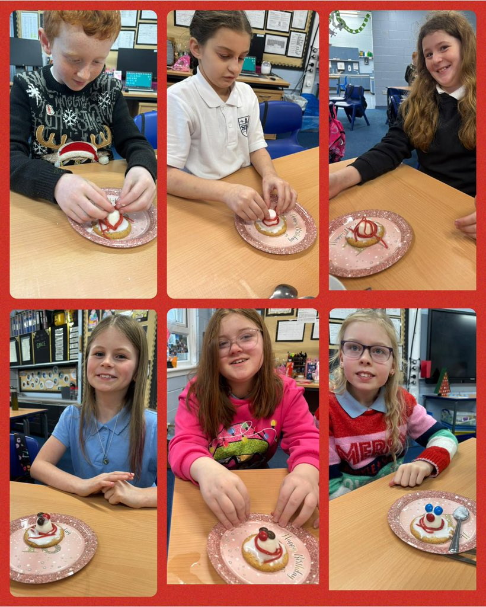
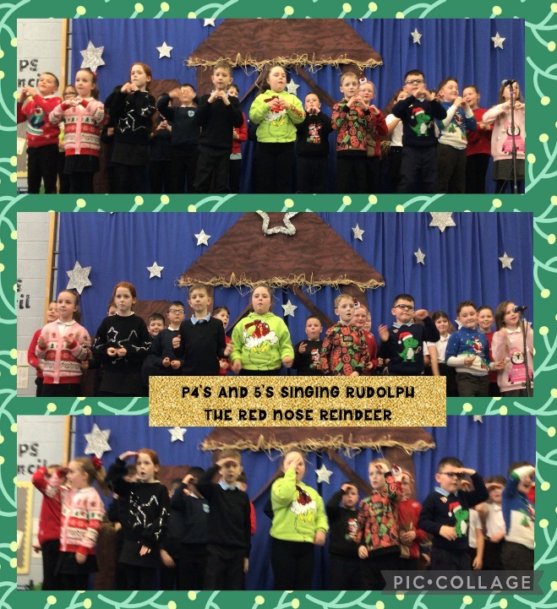

Dear Parents/Carers,
January Newsletter – Head Teacher’s Welcome
Happy New Year and welcome back to an exciting new term at Springside. I hope you all had a restful and enjoyable holiday, spending quality time with loved ones.
This term will focus on developing key skills that are essential for every child’s success. Improving literacy and numeracy will be at the heart of our learning journey, helping pupils build confidence and a strong foundation for their future. Attendance remains a key priority as we know that being present in school every day is vitally important to improve attainment and wellbeing.
Winter is certainly still with us, shorter days and darker evenings. As it remains cold, wet and windy, we ask that you send children to school with layers they can remove, e.g. jumpers, cardigans and that weatherproof jackets are worn everyday as the weather changes quickly in Scotland! Please help yourself to spare uniform items from the school uniform bank or call us and we can pop items in schoolbags if your child requires anything.
We have many exciting activities and initiatives planned to engage and inspire our pupils while challenging them to achieve their very best over the coming weeks and months. Let’s work together to make this term a memorable and rewarding one.
We look forward to working in partnership with you as always.
Warm regards,
Mr Wilson
Head Teacher

Robert Burns
We will be hosting our annual Burns Poetry competition over the coming weeks.
This week pupils will vote on which poem they wish to learn and these will come home in school bags to allow all pupils to practise at home. This activity will help them develop key listening and talking skills.
We are excited to hear all pupils this session and can’t wait to have a scots poetry final afternoon in February.
A huge thank you to all parents/carers in advance for supporting their child at home by practising their poem with them.

NUT FREE SCHOOL

Another reminder is that we are a nut free school. We have several pupils with nut allergies and ask that all families help keep everyone safe.

Please ensure that you child’s play piece/snack/lunch does not contain nuts. This includes Kinder products, Snickers and hazelnut spread on sandwiches.

We thank you for your support with this.

How to set up Twitter/X
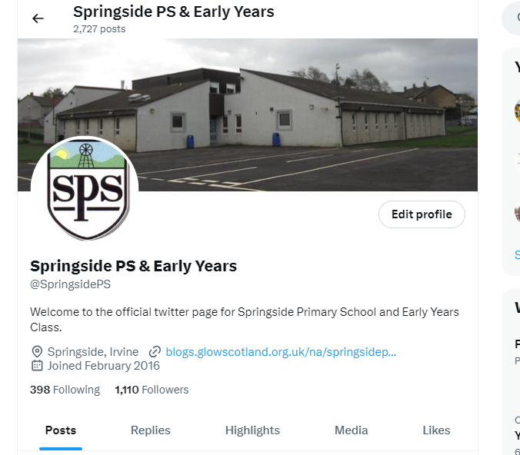
As part of promoting the wider life of the school, each class will be posting on Twitter/X on a weekly basis. This will let parents/carers see what is happening in school, what their child is learning and to find out about any news/information or events that are coming up. Please see the attached link on how to set up a Twitter/X account and then follow @SpringsidePS for all of our updates. How to Create X account 2023 - Formerly knows as Twitter (Full Guide) -Create New Account (youtube.com)

Kindness Captains


Our new Kindness Captains Programme empowers P6/7 pupils as playground leaders, fostering a supportive and inclusive environment. Acting as role models, these young leaders help mediate conflicts, encourage teamwork, and promote positive play among younger students. Through training, they develop essential skills in communication, problem-solving, and empathy. Kindness Captains ensure everyone feels valued and included. Their leadership not only strengthens peer relationships but also cultivates a culture of respect and cooperation. This initiative builds confidence in senior pupils while reinforcing the importance of kindness and responsibility within the school community. Look out for them dressed in Purple in the playgrounds soon!

Homework

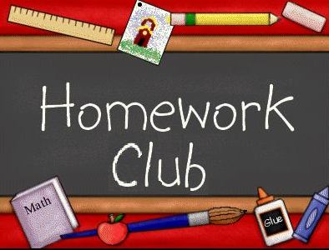
Homework Resumes on Monday!
We’re excited to announce that homework will start back on Monday 13th January, alongside the return of Homework Club. Homework Club offers a supportive environment for pupils to complete set task with their parents/carers with guidance from staff.

Last term, homework participation figures were lower than expected, and we’re keen to improve this term. Regular homework builds vital skills like responsibility and time management, and we encourage pupils and families to get involved. Let’s work together to make this term a success—see you Monday!

Last Term Homework Return Averages:
P1/2 – 54%
P3/4 – 54%
P4/5 – 56%
P5/6 – 51%
P6/7 – 33%
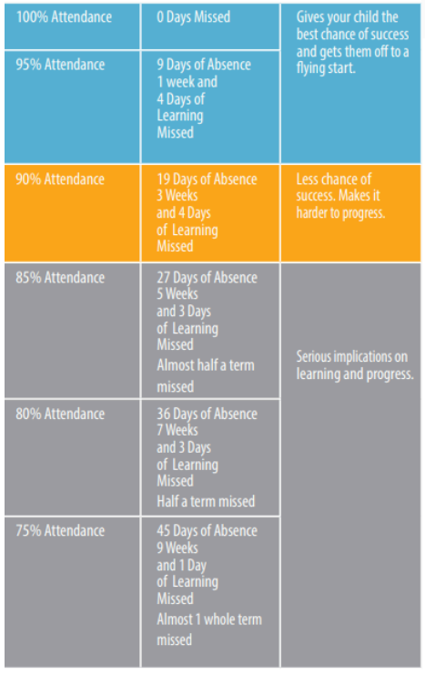
Attendance
At Springside Primary and EYC we want to work together with you to ensure your child makes the best progress that they can. Together we want to make sure that your child is in school and supported to have good attendance patterns. If there are concerns about your child’s attendance we will contact you. Be aware of the impact of regular absences – missing school is missing out.

Attendance figures (in the image to the right) are direct and clear. Missing school impacts massively on children progress. Please ensure where possible you child attends school every day. Anything less than 90% is a concern and will have serious implications on learning. We currently have 42.5% of pupils from across the school sitting under 90%.



Early Years

Early Years registration is now open. Please follow the link to register your child for Springside EYC next session or type North Ayrshire Early Years enrolment into google and follow the link.
https://www.north-ayrshire.gov.uk/education-and-learning/admissions-and-enrolment

P7 Arran Residential
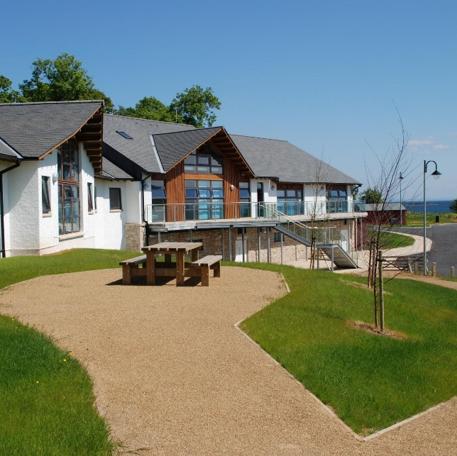
A reminder that the P7 Arran residential trip is approaching on March 17th – 20th! The cost of the trip is approximately £200, as outlined in previous letters. Parent/carers can make payments at the school office and can pay this up over the course of the next 2 months. This exciting opportunity offers valuable experiences for our pupils, and we appreciate your continued support. We know pupils are going to love attending this experience and it will be one of the highlights of their Springside primary experience. If you have any questions or concerns about this trip please contact Mr Wilson to discuss. There will be further information sent out about this trip in due course.

Diary Dates

Beginning of February (date TBC) | Children to recite Burns Poetry
Friday 7th February | EYC Stay and Play 9:00am – 9:45am
Friday 7th February | Spring Inside and See Learning Session 2:15-2:50pm
Wednesday 12th February | P7 Transition Visit to Greenwood Academy (9:15 – 12:15)
Friday 14th February | Fluoride Varnish EYC, P1, P2, P3 & P4
Monday 17th & Tuesday 18th February | School Holiday
Wednesday 19th February | Greenwood Transition – Time to Talk for Parents (Teams)
Friday 21st February | World Thinking Day (Saturday 22nd February) – Brownies, Guides, Beavers, Cubs & Scouts. If your child attends either of these organisations including Sunbeams, Rainbows, Boys’ Brigade etc they can all wear their uniforms on this special day.
Thursday 6th March | World Book Day 2025 (info to follow as the Reading Engagement Committee plan this day)
Thursday 13th March | EYC Stay and Play 2:15pm – 3:00pm
Friday 14th March | Spring Inside and See Learning Session 2:15-2:50pm
Monday 17th – Thursday 20th March | P7 Arran Residential
Friday 21st March | Class Newsletters to go to Parents/Carers
Wednesday 26th March | P7 Transition Visit to Greenwood Academy (9:15 – 12:15)
Wednesday 2nd April | Parents Evening/Learning Conversations 3-9pm
Friday 4th April to Monday 21st April | School stops at 2.30pm for School Easter Holidays
Tuesday 22nd April | Pupils and Staff return to School

