**COMMUNITIES & EDUCATION DIRECTORATE**

**Executive Director: Andrew McLelland**

**Cunninghame House, Irvine KA12 8EE**

**Tel: 01294 310000** [**www.north-ayrshire.gov.uk**](http://www.north-ayrshire.gov.uk)

**Springside Primary School:**

**Station Road**

**Springside**

**KA11 3AZ**

**Tel: 01294 211651**

Springside

Primary & EYC

**December**

**2024**

**Newsletter**

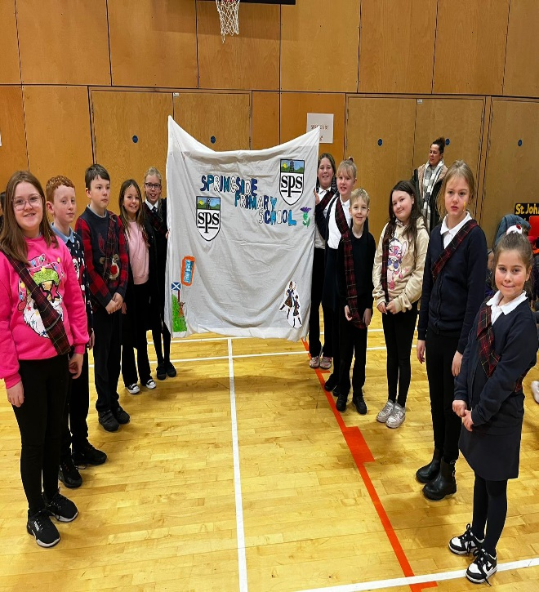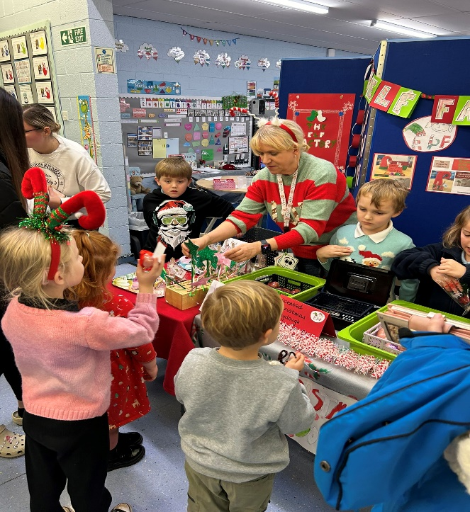

Dear Parents/Carers,

**December Newsletter - A Festive Welcome!**

As we step into the final month of the year, we want to take a moment to express our deepest gratitude for your continued support and involvement. Whether it’s attending events, helping with activities, or encouraging your children, your contributions have made a huge difference and are truly appreciated by all of us.

December is always a magical time in school, and we’re excited to share it with you. From Christmas parties to nativity performances, the month will be filled with opportunities to celebrate the season together. These moments not only bring joy but also create special memories for our children.

We look forward to seeing everyone at the Community Christmas Fayre on Saturday at 11am. Our choir will be there to kick start the events.

Thank you for being such an integral part of our school community. We look forward to ending the term on a high note and sharing the holiday spirit with you all. Wishing everyone a very merry and bright December!

In Partnership,   
*Gordon Wilson*

Head Teacher

**Enterprise & Christmas Fayre**

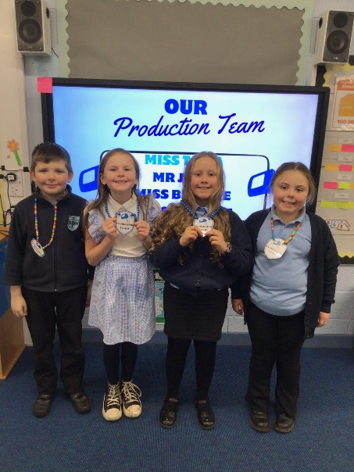Thank you for joining us at the Christmas Fayre! The children thoroughly enjoyed Enterprise Fortnight, where they worked hard to create wonderful products to sell. This experience allowed them to develop valuable skills such as teamwork, creativity, and money management, all while having great fun. The event was a fantastic success, bringing the school community together and raising an incredible amount of money. Your support means so much, and we’re proud of the children’s efforts and achievements. The funds raised will help enrich their learning experiences further. Thank you for making it such a memorable occasion!

**Our New School Values**

We are delighted to share that, after thoughtful contributions and voting from all stakeholders, our new values at Springside are **Kindness, Effort, and Respect**. These values encapsulate the heart of who we are as a school and what we strive to instil in our pupils every day.

We want to thank our parent body for their valuable input on these values during Learning Conversations. Together, we will continue to nurture a supportive and inspiring environment where everyone is encouraged to thrive and succeed.

**Christmas Party Arrangements:**

Christmas parties in primary schools are a magical way to celebrate the festive season with pupils. These events include fun activities like games, crafts, and a visit from Santa Claus (EYC-P3).

Our Christmas Party dates are as follows:

|  |  |  |
| --- | --- | --- |
| Monday 16th December | P6 and P7 Christmas Party | Time: 2pm |
| Tuesday 17th December | P4 and P5 Christmas Party | Time: 2pm |
| Thursday 19th December | EYC, P1, P2 and P3 Christmas Party | Time:  EYC 1:30 – 2:15  P1-P3 2pm – 3pm |

All pupils have the option to come in wearing their party clothes, go home at lunch (being collected and returned to school by an adult) or bring their party clothes in a bag where staff will assist them to get ready.

At the parties children will enjoy a snack, drink and take part in plenty of dancing. I know they will all have a wonderful time.

**Christmas Lunch**

Our Christmas Lunch will be served on **Tuesday, 12th December**! Children can look forward to a delicious festive meal. Office staff will visit classrooms this week to take pre-orders, so everyone gets their favourite option.

**Nativity and Christmas Service**

Join us for our special Christmas Service, featuring a P1-P3 Nativity performance and festive songs by the children (EYC, P4-P7). It’s a wonderful way to celebrate the season together as a school community.

**Chocolate Donations for PTA Tombola**

We’re excited to announce that the **Springside Parent Council** will be holding a tombola at the **Community Fayre this Saturday**! To help make it a success, we kindly ask that pupils bring in a donation of chocolate this **Friday**. In return, they can wear **non-uniform** for the day!

All proceeds from the tombola will go towards supporting our pupils and enriching their school experience. Your generous donations are greatly appreciated – thank you for helping us make this event a fun and successful fundraiser for our school community!

**Early Years**

Panto – Oh… yes it is!

Our Early Years Class children will be heading off to the pantomime on Monday, 4th December! They’ll be leaving school promptly at 9:15 a.m. by bus to see the fantastic production of *Goldilocks and the Three Bears*.

This promises to be a fun experience – a perfect way to kick off the festive season. Please ensure your child arrives on time so we can set off smoothly. We can’t wait to enjoy this special outing together! Children will be back in time for lunch as normal.

**Christmas Shelter Singalong**

Our Early Years Centre pupils are taking part in a special festive activity this December. They will be visiting a local sheltered housing community to sing Christmas songs. This supports us to promote intergenerational learning, fostering connections between our young learners and the elderly residents. 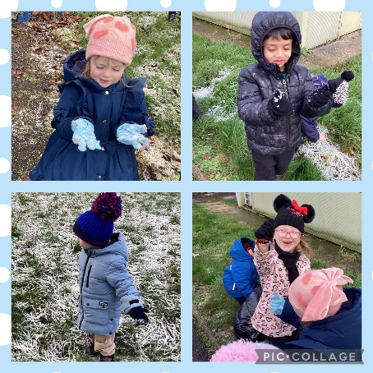

**Christmas Stay and Play**

We’re excited to invite you to our **EYC Christmas Stay and Play** session! Join us on Tuesday 17th from **1:45 p.m. to 2:45 p.m.** for a festive hour of fun and activities with your little ones.

This is an opportunity to share in the joy of the season, explore Christmas-themed play, and create special memories together. We look forward to welcoming you!

**Final Note:**

Should there be any issues, worries or successes that you feel I should be aware of, then please contact me directly by email [gordonwilson@ea365.n-ayrshire.sch.uk](mailto:gordonwilson@ea365.n-ayrshire.sch.uk)

**Diary Dates:**

Please see diary dates from now till the end of December.

Thank you for your continued support.

In partnership,

*Mr Wilson*

*Head Teacher*

*Springside Primary School and EYC*

**DIARY DATES**

|  |  |
| --- | --- |
| **December 2024** | |
| Wednesday 4th December | EYC Panto Day |
| Friday 6th December | School Non-Uniform Day (Chocolate Tombola) |
| Saturday 7th December | Community Christmas Fayre at the Community Centre |
| Thursday 12th December | School and EYC Christmas Lunch |
| Monday 16th December | P6 and P7 Christmas Party |
| Tuesday 17th December | P4 and P5 Christmas Party |
| Wednesday 18th December | Christmas Service and Nativity |
| Thursday 19th December | EYC, P1, P2 and P3 Christmas Party |
| Friday 20th December | School Closes 2:30pm for Christmas Holidays |