**COMMUNITIES & EDUCATION DIRECTORATE**

**Executive Director: Andrew McLelland**

**Cunninghame House, Irvine KA12 8EE**

**Tel: 01294 310000 [www.north-ayrshire.gov.uk](http://www.north-ayrshire.gov.uk)**

**Springside Primary School:**

**Station Road**

**Springside**

**KA11 3AZ**

**Tel: 01294 211651**

Springside

Primary & EYC

**September**

**2024**

**Newsletter**

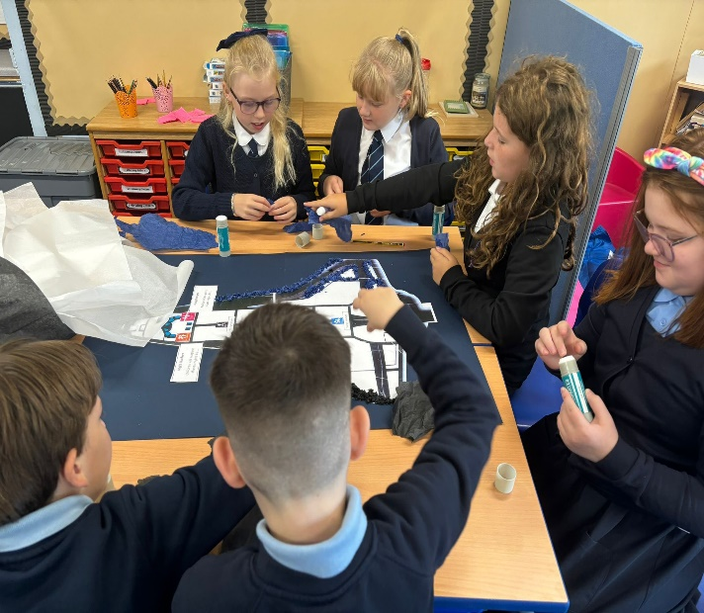 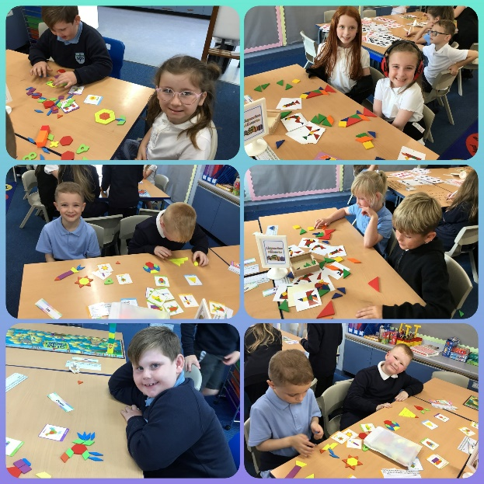

Dear Parent/Carer,

I hope you all had a wonderful summer break (despite the weather). It is always a lovely time for pupils and staff to recharge after a busy last term and for families to spend some quality time together.

It has been an absolute delight to welcome your children back and they have all started the new term so well. All members of staff can’t wait to work with them for the 2024-2025 session. We have lots of new and exciting changes that we have made to the school and EYC this year which you will get to see over the coming months.

Our new Primary 1 pupils have settled excellently and have made a great start to life at Springside Primary School. Equally our new children in the Early Years Centre have started so well and it’s a joy to have them join the Springside Community.

Please take a look at our September newsletter, I hope you find the information useful.

Should there be any major issues, worries or successes that you feel I should be aware of, then please contact me directly by email [gordonwilson@ea365.n-ayrshire.sch.uk](mailto:gordonwilson@ea365.n-ayrshire.sch.uk)

Best Wishes

Mr Wilson

Head Teacher

**Staffing**

|  |
| --- |
| EYC – Mrs Grey/Miss Gilfillan/Miss Barrie |
| P1/2 – Mrs McGregor |
| P3/4 - Miss Reid/Mrs Davidson |
| P4/5 – Miss Gaw |
| P5/6 – Mrs Havlin/Mr Baillie |
| P6/7 – Miss Sneddon/Mr Baillie |

We also have:

* Mrs McCulloch working as our Pupil Support Teacher on a Wednesday.
* Miss Lee working to support Literacy attainment across the school.
* Mrs Lockwood taking PE and Health and Wellbeing lessons.
* Mrs Davidson will also be running short nurture bricks sessions one day per week for selected pupils

**Writing**

We are currently working with North Ayrshire Councils’ Professional Learning Academy to support and challenge writing across the school. This will have a huge impact on staff and pupils over the coming months. This session, all classes will have 2 writing slots per week with 3 teachers in the room to support and challenge learning. We are very fortunate to be able to offer this and hope it will have a significant impact on our learning experiences for pupils (J.K Rowling watch out! Springside pupils are the authors of the future).

**PE Days**

PE will be on the following days for classes:

|  |  |
| --- | --- |
| P1/2 | Monday & Wednesday |
| P3/4 | Tuesday & Friday |
| P4/5 | Tuesday & Thursday |
| P5/6 | Monday & Thursday |
| P6/7 | Wednesday and Thursday |

Can you please ensure pupils bring their full PE kit with them on their allocated days to allow them to fully participate in the fun activities planned for them. If pupils have earrings that can’t be removed please ensure the child has these taped up with Micro-tape to ensure no accidents happen.

**Parent Council**

The next Parent Council meeting is on Tuesday 17th September at 3:15pm at the Institute/Community Centre. This is the first one of the session and it would be amazing to see some new faces come along and support this wonderful team. The work this remarkable group of people do for the school is phenomenal and our trips/discos etc would not run at all without them. Thank you all for everything you do to support our pupils and families.

Healthy Snacks

We are noticing that quite a lot of our pupils are coming to school with 2 or more unhealthy snacks per day including share size bags of Doritos, full bags of Haribo etc. As a health promoting school we really want to try and promote healthy eating to all pupils. Healthy snacks help manage kids' hunger and boost nutrition. The best snacks are low in sugar, fat, and salt. Fresh fruit, low-fat dairy, and protein foods are always good choices. An occasional treat is fine, but please try to give pupils a healthy snack option most of the time. For some fun ideas you can make with your child please click on the link below: [Healthier snacks - Food facts - Healthier Families - NHS (www.nhs.uk)](https://www.nhs.uk/healthier-families/food-facts/healthier-snacks/)

**School Improvement**

This year our school has 3 main priorities:

PRIORITY 1

* To raise attainment for all learners in numeracy and maths.

PRIORITY 2

* To raise attainment for all learners in literacy.

PRIORITY 3

* To ensure universal and targeted supports meet the needs of all learners.

Please find a copy of our School Improvement Plan and our Standards and Quality report on our school website to see a more in depth view of how we will achieve these priorities and our evaluation of achievements from last session. [School Improvement Plan | (glowscotland.org.uk)](https://blogs.glowscotland.org.uk/na/springsideprimary/school-improvement-plan/)

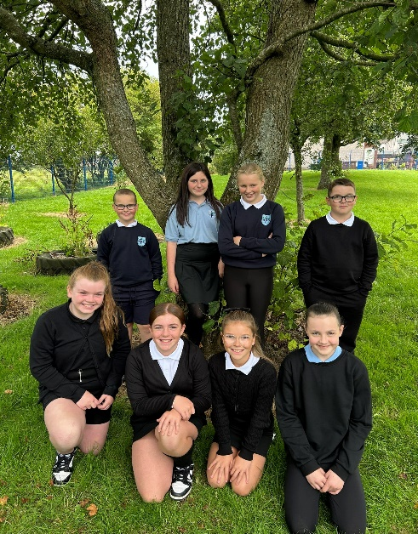

A huge congratulations to our newly elected House and Vice House Captains for the 2024/2025 school session. Their speeches and manifestos were inspiring and they were selected by their peers to help make positive changes to our school. I am excited to work with them over the coming year. Well done to all pupils who tried out for these roles. If your child was unsuccessful, don’t worry as there will be lots more leadership opportunities for them throughout the session.

House and Vice House Captains

**Asda Rewards**

Asda has announced that it is making millions of pounds available to UK primary schools by encouraging families to use its loyalty programme – Asda Rewards.

The supermarket is kicking off each school fund with £50 and offering to top up with an extra £1 for every customer that selects their school. The supermarket is offering to donate 0.5% of the value of any shop done at Asda until 30th November 2024 to customers’ primary school of choice – when they shop using Asda Rewards. If you shop in Asda, please sign up to the cash pot rewards and select our school so we can use any money to support pupils and buy resources. Thanks for your support in advance.

**Pupil Committees**

This session we have aligned our school committees with our School Improvement Plan. Pupils selected which committee they wished to participate in and we are excited to see the action plans they will create after their first meeting next week. Committees are a fantastic way for pupils to help shape and lead the school in developments and by aligning these to our school improvement plan, it means that we will all be travelling in the same direction. Our committees this session are:

1. Eco Committee
2. Digital Leaders
3. Reading for Enjoyment Committee
4. Junior Road Safety Officers
5. Sports Committee



**Spring Inside and See Learning**



Based on feedback from the Parent/Carer Survey given out in January 2024, it was evident that parent/carers were looking to be more involved in knowing what pupils were doing in school. To support this vision we are introducing a new programme called ‘Spring Inside and See Learning’.

These monthly sessions will start on Friday 4th October to give you the opportunity to see your child’s new class, meet their new teacher and join them for a learning based activity.

**Who is invited?**

Parents, carers, grandparents…it’s up to you. However, due to capacity and classroom space we would ask that **where possible**, **only one person attends each session** (there are lots over the year). For Health and Safety reasons prams/buggies are not permitted in classrooms. These can be left in the gym hall.

**Time:**

2:15 – 2:45pm

We hope you are excited to join us on the 4th October and hope to see a good turnout of parents/carers across the entire school. Exciting times ahead at Springside!

We continue to appreciate the support from parents/carers in making sure ALL children wear school uniform. We are proud of this and would want this to continue as it helps to build a sense of belonging to the school. It has been lovely to see all pupils currently wearing this so far this session.

**School Uniform/ Free Uniform Station**

We have a lot of spare uniform in the school. Therefore to support our families, we are hosting a Uniform Station – free of charge to our parents on Thursday 5th September at 3pm – 4pm. Please come into school via the front entrance and make your way to the Gym Hall, where there will be a large amount of uniform that you can take for your child including, jumpers, polos etc at no cost.

We hope to see lots of faces so please drop in, pick up some uniform, and say hello.

**Homework**

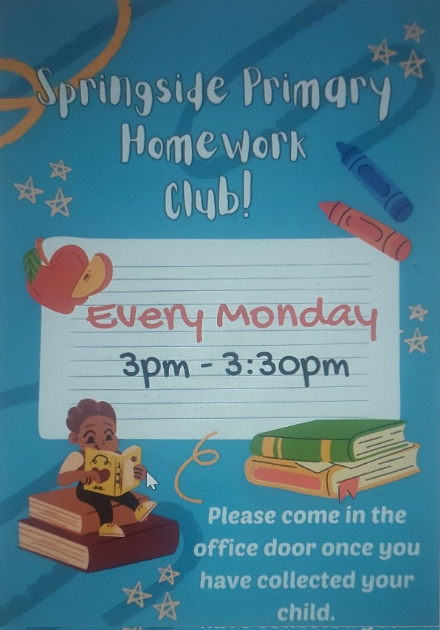

Homework will begin again this week. Last session we surveyed parents, pupils and staff to work out what the best way to tackle homework across the school would be. Each week pupils will be given a reading book, have an online Numeracy and Maths challenge and one written Spelling Task. The expectation is that **all** pupils will complete these three tasks each week. We are keeping a detailed record of returns and will call any families to offer our support as and when required. I urge all parents/carers to support pupils to return homework as this will have an impact on their attainment.

**Return rates last term were not strong so we hope to see a vast improvement for session 2024-2025.**

This session we are also holding a parent/carer & pupil Homework Club on Mondays from 3-3:30pm starting this week. We hope to see as many of you there as possible. Please see Mrs Conway’s Homework Club letter sent last week for more details.

**Apply for Footwear, Clothing and Free School Meals**

North Ayrshire Council provides support/money for families of pupils attending school. They provide free school meals and £126 per child worth of footwear and clothing support for parents who receive certain benefits. Please click on the link to see if you are eligible. It’s a great way to save yourself some money. Link: [Footwear, clothing and free school meals (north-ayrshire.gov.uk)](https://www.north-ayrshire.gov.uk/education-and-learning/grants-and-allowances/footwear-clothing-and-free-school-meals.aspx)

## **P1-P3 Parents – End of School Day at 3pm**

From August 2024, all P1-P3 parents/carers will be welcomed into the school infant playground to collect their child at the end of the day. We feel this is a safer way to release pupils back into your care. Thank you to all parents/carers who have followed this guidance so far. It’s also a great way to grab a quick chat with the class teacher too.

Early Years

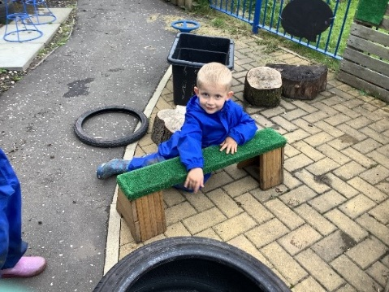Welcome back to all children that previously attended the EYC and a warm welcome to our new children. All children are settling in well and enjoying a range of experiences. The children have been exploring the playroom and outdoors, enjoying all the learning opportunities that we have on offer.

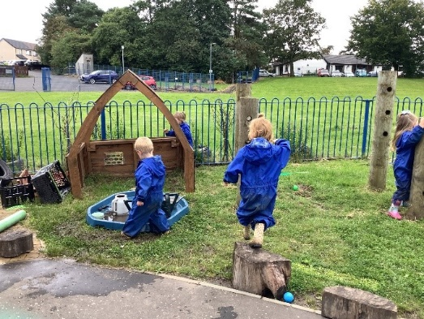We will be sending out a parent workshop questionnaire to find out what you as parents/carers (grandparents, aunties and uncles) would like Springside EYC to put on. We really value family learning events and feel they are hugely beneficial to pupils. Please look out for it! 

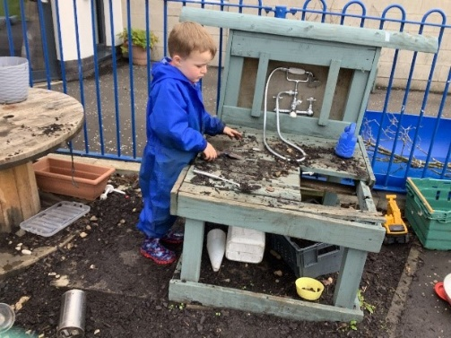

**Diary Dates:**

Please see diary dates from September through to the October Holidays. We will update you with any changes or new dates in the next newsletter. In the meantime please get in touch if there is anything you wish to discuss.

Thank you for your continued support.

In partnership,

*Mr Wilson*

*Head Teacher*

*Springside Primary School and EYC*

**DIARY DATES**

|  |  |
| --- | --- |
| **September/October 2024** | |
| Friday 6th Sep | Class Newsletter sent to Parents |
| Tuesday 17th Sep | Parent Council Meeting 3:15pm |
| Monday 23rd Sep | Staff In-service day – No pupils in school on this day |
| Wednesday 25th Sep | Flu Immunisations today |
| Friday 4th October | Spring inside and See Learning Session – Parent/Carer to visit school |
| Friday 4th October | Fluoride Varnish today – letters to follow |
| Friday 11th October | Harvest Coffee Morning – info to follow |
| Monday 14th October | Start of October Holiday Break |